File Operations

Overview
Files can be read write as in most programming languages.
File Handling is located in the “General Steps” menu.

Protocols

FileOperations
Open different files and print data, filetzpe etc.

System deck:

Protocol:
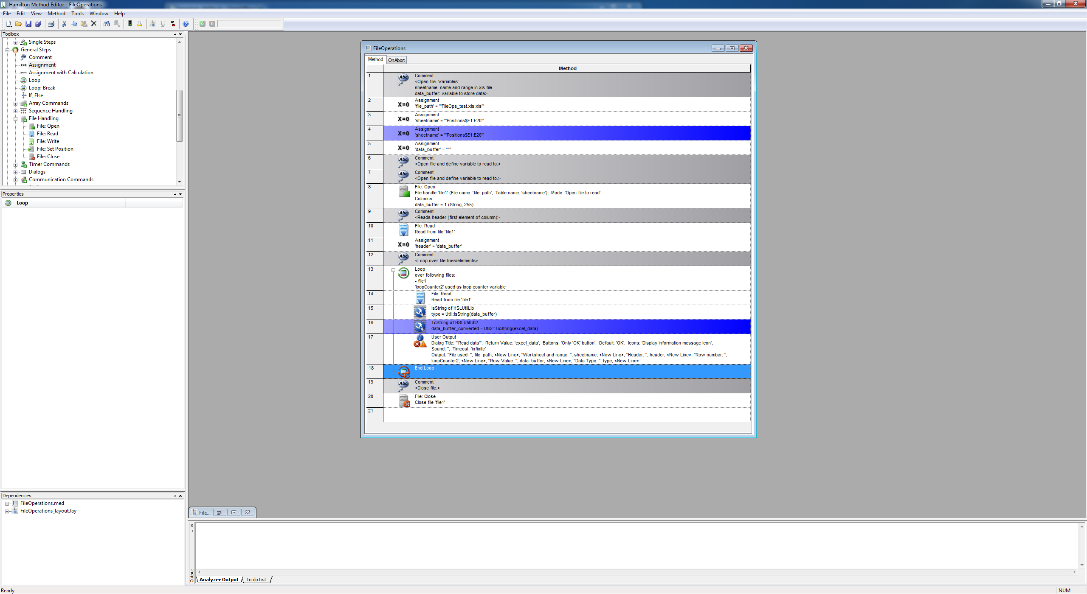
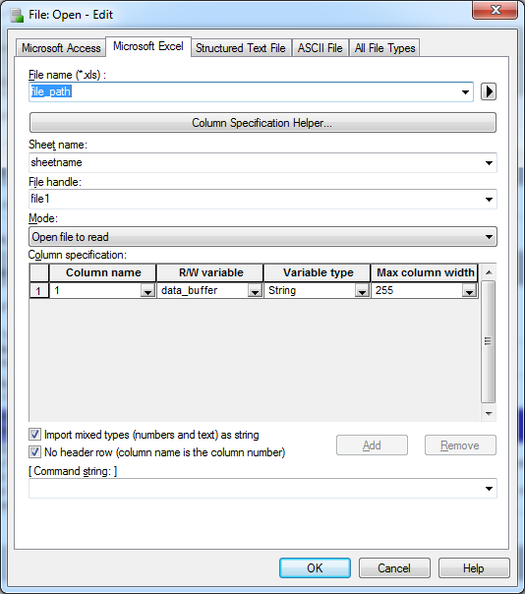

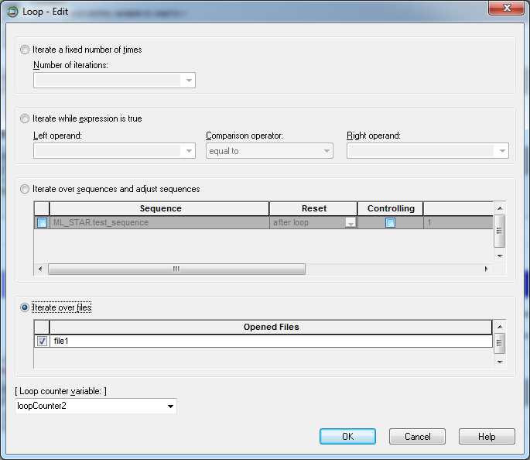

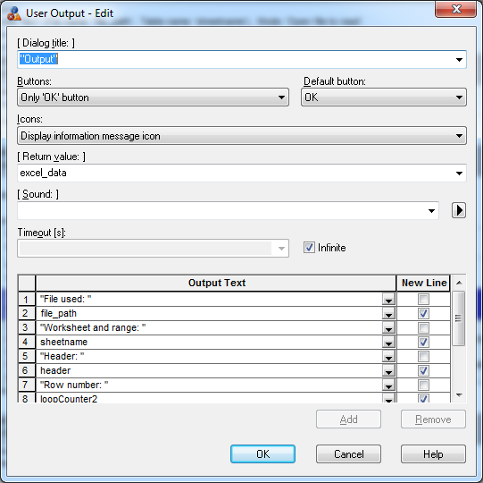

Buggs and Remarks

-To read data a loop has to be created and file handle has to be set to the file read.
-Sometimes if string is read, the variable can not be used properly and read variable has to be forced to string (converting t string using HSLUtils2)
-If data is read from excel file and the column has variable types sometimes read data is not read properly

Sequence Operations

Overview
Sequences are list of positions hamilton robots visits in different operations eg. Dispence, aspire etc. There are so called “managed sequences” that are in built sequences mainlz for pipetts. Unmanaged sequences can be creaqted at will and contain list of positions in a given labware or even multiple labware.
Libraries used: HSLSeqLib, HSLUtils2. Manipulations to sequences from HSL are not written to the deck layout definition file. So in the tutorials modified sequences are saved so the effect of modifications can be seen. When accesing sequences programmatically the following concepts and variables are important:

sequenceObj:
Base class rapresenting sequences.

labwareId :
The name of the labware to be looked up (string). Can be changed manually: system deck->right click on labware->properties->labwareid

positionId:
The name of the position to be looked up (string). Most labware is rastered and rows and colums are marked with a letter and a number (see labware definitions). eg. A3 etc.

ID or sequence position: ordinal number (integer; 1-based) of element in sequence. Numbering starts from 1!!!

DeviceContext: which device is used eg. Microlab starlet, fan etc.

cfgFile: configuration file saved by the Venus software. Fileformat can be xls, csv etc. (xls is most user friendly.

Protocols

1. LoadXls
Load and save sequence files and print sequence parameters into user dialogue. Since tipical file sizes are not larg Excel files are the most user friendly files. Hamilton Venus saves an xls file with the following format:
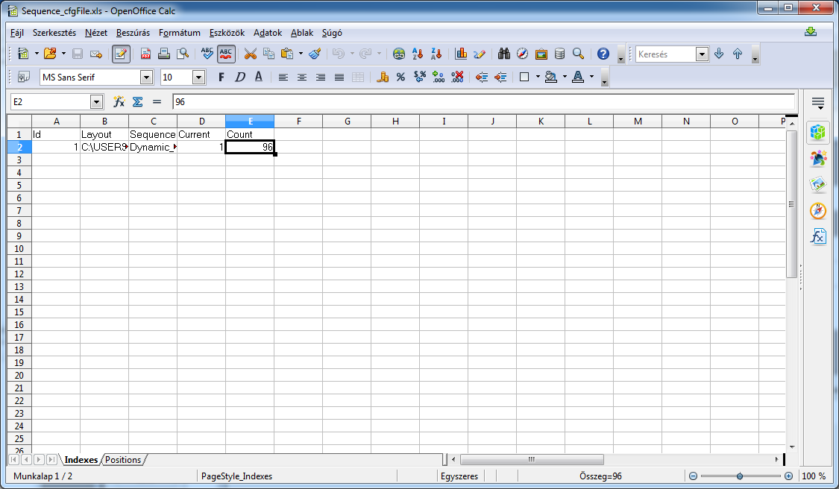
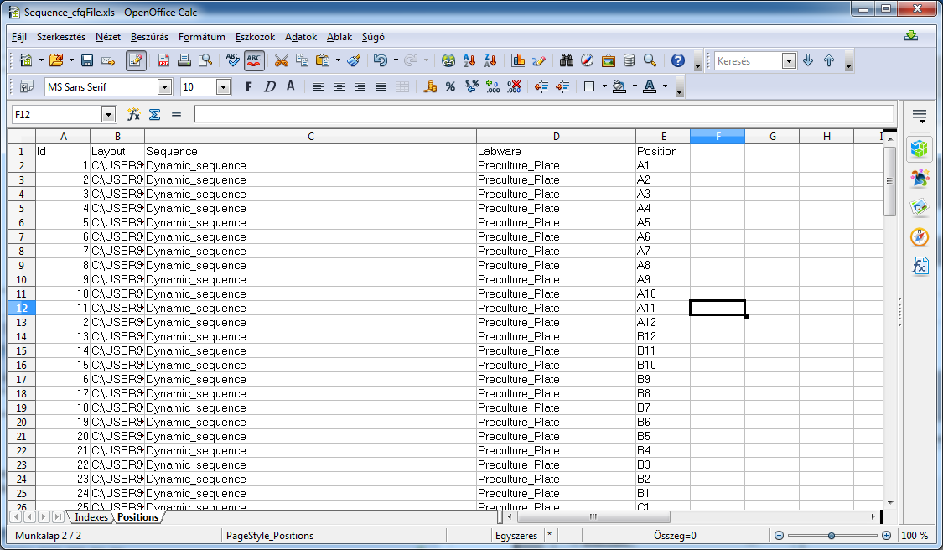

System deck:

Involved Labware:

Protocol:

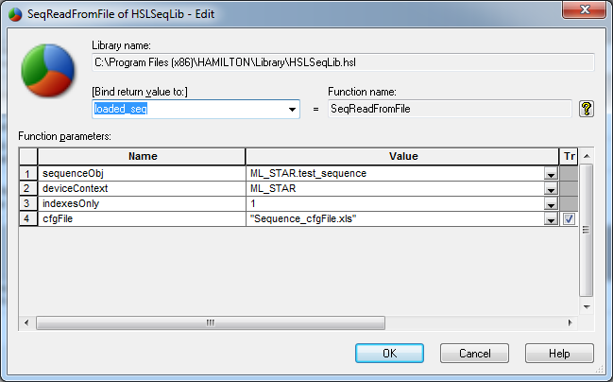

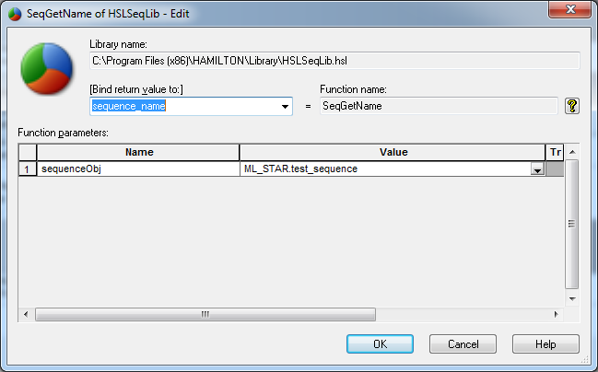
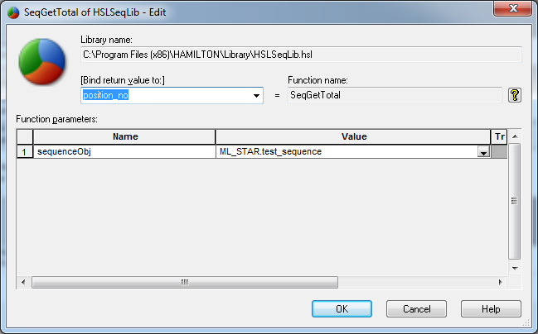

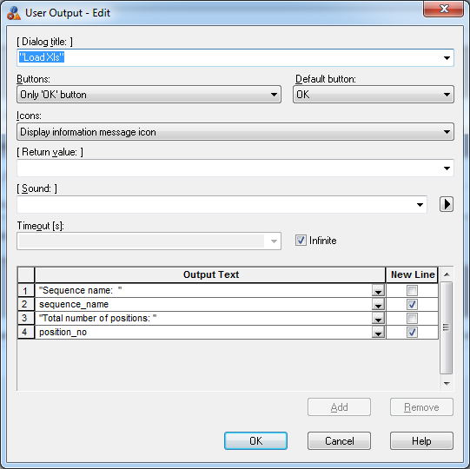
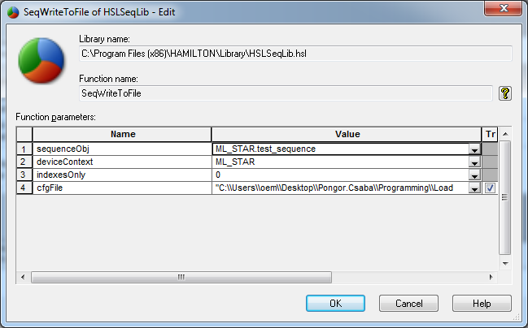

ModSequence
Load position list from an excel file. First replace first element in a given sequence and add to the end of list.

input_file: file path to file that file being read
sheetname: worksheet and range being read
data_buffer:variable to store data
sequence_name: variable with the name of the sequence being modified
labware_name: name of the labware of the positin (in this case not in layout file..just a place holder)

The elements are added to a placeholder labware „Cos_96_FL”, however when actually used the labware should bo inlayout(!!). Look at the order of elements:
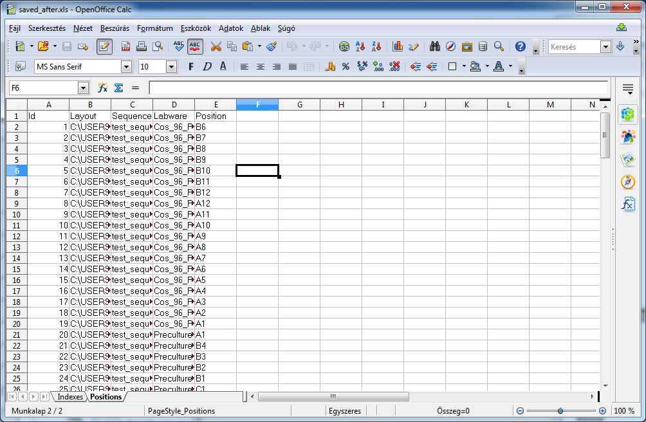
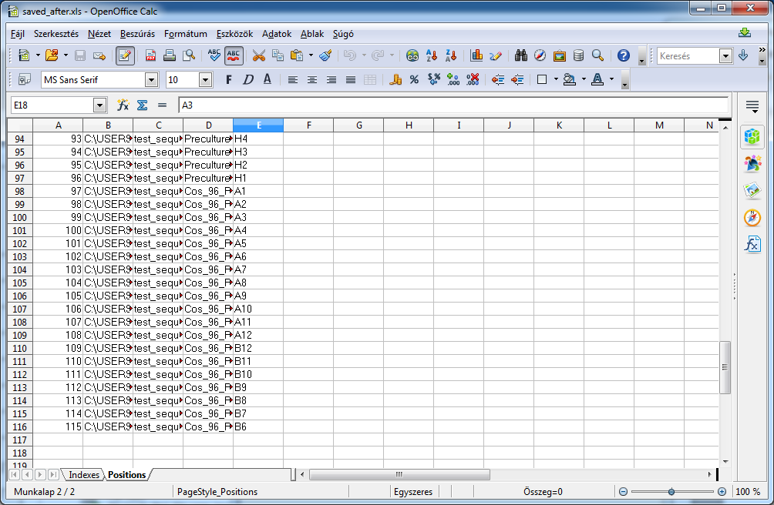
System deck:

Involved Labware:

Protocol:

ModSequence2
Load position list from an excel file, remove elements in a sequence and replace with loaded position list.
input_file: file path to file that file being read
sheetname: worksheet and range being read
data_buffer:variable to store data
sequence_name: variable with the name of the sequence being modified
labware_name: name of the labware of the positin (in this case not in layout file..just a place holder)

The elements are added to a placeholder labware „Cos_96_FL”, however when actually used the labware should bo inlayout(!!).

System deck:

Protocol:

Bugs and Remarks

File and Directory paths: Sy
/If file is in the same dir as method files onlz the filene and extension.
- use double slashes eg. "C:\\Users\\oem\\Desktop\\Dir\\file.xls"
SeqWriteToFile(sequence& sequenceObj, device& deviceContext, variable indexesOnly,variable& cfgFile) void

-Absolute file path has to be given. Using only the filename is used program runs without error but file is not created in the method directory and no other place!!

-If method is run multiple times saving to the same file the following error message pops up

-Output file has to be deleted if one wants to save to file with the same filename.
-Seems like files are onlz closed/written when run-control is closed...untill then files can not be accessed.

SeqLookupPosition( sequence& sequenceObj, variable& labwareId, variable& positionId,
variable start, variable forward) variable

-positionId: If this parameter is empty, only the name of the labware will be taken as the searching criteria.

-sometimes if input is not right eg. Start is set to 0 the returned sequence position (id) is 0 (not a real position..but can screw up the use of the output.

-labwareid does not accept text in the form “some text” even if it should so input has to be done through a string variable

-If positionid is read from file the variable has to be forsed converted using UtilLib2:ToString function

SeqInsertAt(sequence& sequenceObj,variable position,variable& labwareId,variable& positionId) void
SeqAdd(sequence& sequenceObj, variable& labwareId, variable& positionId) void

-If positionid is read from file the variable has to be forsed converted using UtilLib2:ToString function

-If data is read from excel file and the column has variable types sometimes nothing is added/inserted

