Database Programming Project

Date: 05/15/2026

Group Members:

Lili Anna Varga, Eötvös Lóránd Tudományegyetem, Hungary
Kata Krisztina Kóti, Eötvös Lóránd Tudományegyetem, Hungary

lvarga001@ehu.es
kkata001@ehu.es

Subject: Databases
Degree: Informatics Engineering
Academic Year: 2025/2026
School: Facultad de Informática

Table of Contents
Abstract 3
1. Introduction 3
2. Structure of the Software 3
2.1. Classes design 4
2.2 TRANSACTIONS designed by each member of the group 5
3. Testing 6
3.1 Testing Strategy 6
3.2 Query Tests 6
4. Conclusions 7

Abstract

This documentation presents the design and implementation of a relational database system developed as part of a databases programming course project. The system integrates three interconnected schemas: COMPANY, TRAVEL, and RESTAURANTS, managed through a MySQL server and accessed via Java and JDBC.

1. Introduction
The objectives of this project are threefold: first, to create and initialize the database structure using phpMyAdmin or JDBC; second, to populate the schemas with representative test data; and third, to implement a set of meaningful transactions through a Java application. Each group member is responsible for at least five individual transactions: three non-trivial SQL queries (involving techniques such as nesting, grouping, and division), one insert transaction with potential rollback due to foreign key constraints, and one update transaction with possible cascading side effects.

We used GitHub for our project management, you can find the repository under the following link:
https://github.com/Csirkefarhat/DBKotiVarga

2. Structure of the Software
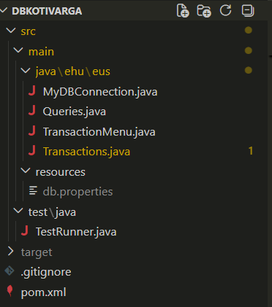

2.1. Classes design
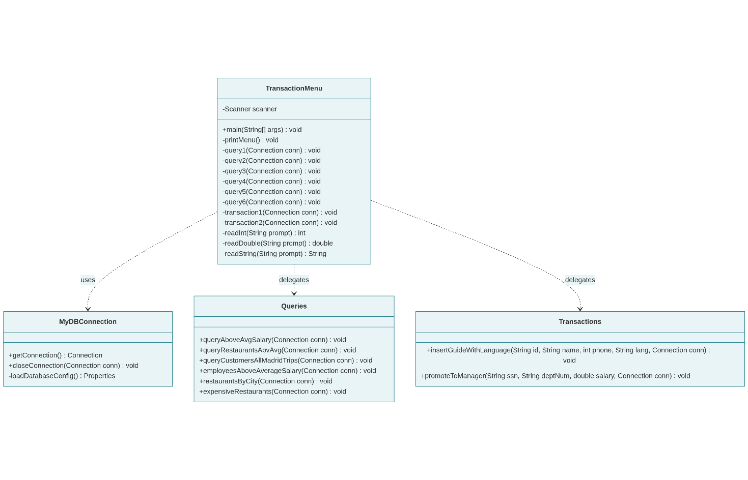
The Java project is structured around four main classes, each with a clearly defined responsibility.

MyDBConnection
This utility class is responsible for establishing and closing the connection to the MySQL database. It loads the JDBC driver (com.mysql.cj.jdbc.Driver) and reads the connection parameters: URL, username, and password from a db.properties file stored on the classpath. Externalizing credentials into a properties file avoids hardcoding sensitive information and simplifies deployment across different environments. The class exposes two static methods: getConnection(), which returns a live Connection object, and closeConnection(Connection), which safely closes it.

TransactionMenu
This is the application's entry point and user interface layer. It contains the main method, which opens a single database connection and runs a loop that repeatedly presents a text-based menu to the user. Each menu option is dispatched through a switch expression to a private handler method, which delegates execution to either the Queries or Transactions class. The class also provides three input-reading helper methods: readInt(), readDouble(), and readString() that validate user input in a loop and prevent runtime errors from malformed entries.

Queries
This class groups all read-only SQL queries. It is subdivided into contributions from each group member.

Transactions
This class handles all write operations on the database, with explicit transaction control.

2.2 TRANSACTIONS designed by each member of the group

2.2.1 Transactions of Lili Anna Varga:
insertGuideWithLanguage (INSERT with Savepoint):
This transaction inserts a new tour guide into the system, which spans two related tables: tourguide and languages. Because languages.GuideId is a foreign key referencing tourguide.GuideId, the guide must exist before a language entry can be linked to it.

Execution flow:
- setAutoCommit(false) is called to begin explicit transaction control, meaning no change is written to the database until commit() is explicitly called.
- The guide is inserted into tourguide with the provided GuideId, guidename, and guidephone.
- A Savepoint named afterGuide is set immediately after the first insert succeeds. This marks a partial checkpoint within the transaction.
- The language is inserted into languages, linking the GuideId to the provided Lang value.
- If everything succeeds, commit() makes both inserts permanent.
Rollback logic:
The use of a Savepoint enables partial rollback:
Failure point | Rollback behaviour | Result
Guide insert fails | Full rollback() (savepoint is null) | Neither guide nor language is inserted
Language insert fails | rollback(afterGuide) + commit() | Guide is kept, language is discarded

promoteToManager (UPDATE with cascading side effects):
This transaction promotes an existing employee to department manager, which requires two coordinated updates across the employee and department tables.

Execution flow:
- setAutoCommit(false) begins the transaction.
- The employee's Salary is updated in the employee table, identified by their Ssn. If no row is updated (employee not found), a SQLException is thrown manually.
- The department table is updated to set Mgr_ssn to the employee's SSN and Mgr_start_date to the current date (CURDATE()). If no row is updated (department not found), another SQLException is thrown.
- If both updates succeed, commit() makes the changes permanent.

Rollback logic:
If either update fails, whether the employee does not exist or the department number is invalid the entire transaction is rolled back. This guarantees atomicity.

2.2.2 Transactions of Kata Krisztina Kóti:
insertDishAndServe (INSERT with savepoint):
This transaction inserts a new dish into the restaurant system and then assigns the dish to a restaurant through the serves table. The transaction spans two related tables: dishes and serves. Since serves.dish references dishes.dish, the dish must exist before it can be served by a restaurant.

Execution flow:
- setAutoCommit(false) is called to start explicit transaction management. Changes are not permanently written until commit() is executed.
- A new dish is inserted into the dishes table with the provided dish, cuisine, category, and difficulty values.
- A Savepoint called afterDish is established once the dish has been successfully inserted, allowing the transaction to return to this state if the second insert fails.
- The restaurant serving information is inserted into the serves table, connecting the restaurname with the new dish and its price.
- If both operations complete successfully, commit() permanently saves the transaction.

Rollback logic:
The transaction uses a Savepoint to support partial rollback behaviour:
- Full rollback(): Dish insertion fails → Neither the dish nor serving relation is inserted
- rollback(afterDish) followed by commit(): Serving insertion fails → The dish remains stored, but the serving relation is removed

increaseITSalaries (UPDATE transaction):
This transaction increases the salary of every employee working in the IT department by 10%. The department is identified dynamically using a subquery on the department table.

Execution flow:
- setAutoCommit(false) enables explicit transaction management.
- An UPDATE statement modifies the Salary column in the employee table.
- The employees affected are selected through a subquery that retrieves the department number (Dnumber) of the department named "IT".
- Each matching employee’s salary is multiplied by 1.10, resulting in a 10% salary increase.
- The number of modified rows is checked. If no employees are updated, a SQLException is thrown manually.
- If the update succeeds, commit() permanently stores the salary changes.

Rollback logic:
If an SQL error occurs during the update operation, the transaction fails and the salary modifications are not committed. This preserves the consistency of employee salary data.

3. Testing

3.1 Testing Strategy
To validate the correctness of both the queries and the transactions, a dedicated TestRunner class was implemented. Rather than relying on manual inspection of query output, the test suite programmatically verifies outcomes by executing additional SQL checks against the database after each operation. The class tracks a global passed and failed counter and prints a structured summary at the end of each run.

3.2 Query Tests
Test 1 — Employees above department average salary
After calling queryAboveAvgSalary(), the test runs a correlated COUNT(*) query to confirm that at least one employee exists whose salary exceeds their department's average. A count of zero would indicate missing or insufficient test data in the EMPLOYEE table.
Test 2 — Restaurants above average revenue
After calling queryRestaurantsAbvAvg(), the test uses a nested aggregation query with a derived subquery to count how many restaurants have a total revenue above the average of all restaurants. The test passes if at least one restaurant qualifies.
Test 3 — Customers who booked only Donostia trips
After calling queryCustomersAllDonostiaTrips(), the test re-executes the relational division logic independently and reports the count of qualifying customers. The test is considered passing as long as no exception is thrown and the query executes correctly, since the result may be zero depending on the data.

3.3 Transaction tests
Test 4 — insertGuideWithLanguage
This test covers all three possible execution paths of the transaction:
Case | Scenario | Expected result
A | Fresh insert of guide T_G01 + language Spanish | Both rows committed, verified in tourguide and languages
B | Duplicate guide T_G01 (already exists) | Full rollback, French language not inserted
C | New guide T_G02, duplicate language Spanish | Partial rollback, guide kept, language inserted only once

Test 5 — promoteToManager
This test validates the atomicity of the two-table update:
Case | Scenario | Expected result
A | Valid SSN 333445555, valid department 5, new salary 99999.99 | Salary updated in employee, Mgr_ssn updated in department
B | Valid SSN 333445555, invalid department 9999 | Full rollback, salary remains unchanged

4. Conclusions
This project successfully integrated three real-world database schemas with a Java/JDBC application, implementing non-trivial SQL queries and ACID-compliant transactions with savepoint-based partial rollback. A particular merit of the project is the TestRunner class, which provides automated, repeatable validation of all transactions across both success and failure scenarios.

Regarding the division of work, both group members independently designed and implemented their own set of three SQL queries, one INSERT transaction, and one UPDATE transaction. Lili Varga took responsibility for the shared infrastructure: the database connection layer (MyDBConnection), the text-based user interface (TransactionMenu), the test suite (TestRunner), and the project documentation.

