# File permissions in Linux

## Project description

The research team must update the file permissions for specific files and directories within the projects directory. The current permissions do not align with the required authorization levels needed for each group and user. Verifying and adjusting these permissions will enhance the security of their system. To accomplish this, I followed the following steps:

## Check file and directory details

Here's how I used Linux commands to check what permissions were set for a specific directory in the file system.

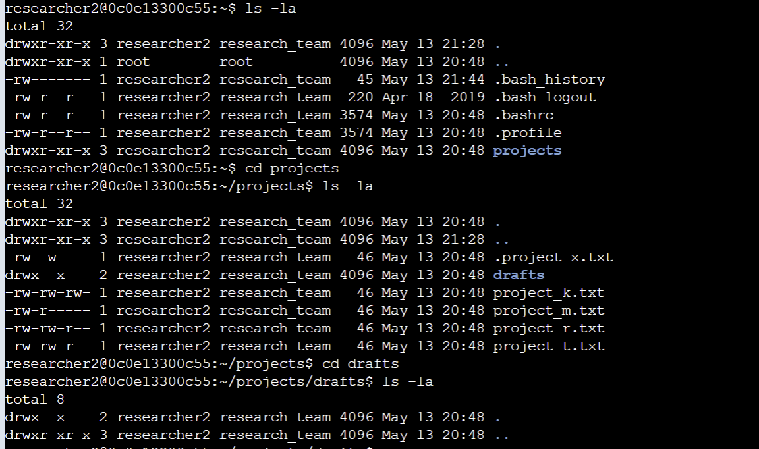

The first line in the screenshot shows the command I used, and the rest of the lines show what came back. The code lists everything in the projects directory. I used "ls" with "-la" to see all the files, including the hidden ones. The output from my command tells me there's a folder called "drafts," a hidden file called ".project_x.txt," and five other project files. The 10-character string at the start of each line shows what permissions are set for each file or folder.

## Describe the permissions string

The 10-character string breaks down to show who can access a file and what they can do with it. Here's what each character means:

- The **1st character:** It's either a 'd' (for directory) or a hyphen '-' (for a regular file).

- The **2nd-4th characters:** They show if the user can read (r), write (w), and execute (x) the file. A hyphen '-' means they can't.

- The **5th-7th characters:** They indicate the same permissions for the group.

- The **8th-10th characters:** They show the permissions for everyone else (other users on the system).

For instance, if a file like project_t.txt has permissions -rw-rw-r--, the first character '-' means it's a file. The 'r' in the second, fifth, and eighth positions means the user, group, and others can read the file. The 'w' in the third and sixth positions means only the user and group can write to it. There are no 'x' (execute) permissions for anyone on project_t.txt.

## Change file permissions

The organization decided that others shouldn't be able to write to any of their files. To comply with this, I checked the file permissions I retrieved earlier. I found that project_k.txt needed its write access for others removed.

Here's how I did it using Linux commands:

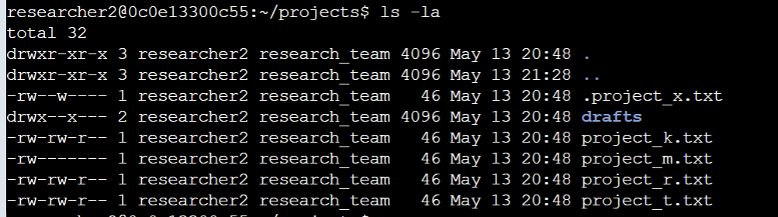

The first two lines in the screenshot show the commands I used, and the rest show what happened when I ran the second command. The chmod command is used to change permissions on files and directories. The first argument specifies which permissions to change, and the second specifies the file or directory. In this case, I removed write permissions for others on the project_k.txt file. Then, I used ls -la to check the updates I made.

## Change file permissions on a hidden file

The research team recently archived .project_x.txt . They want to restrict write access to this project, allowing only read access for the user and group.

Here's how I adjusted the permissions using Linux commands:

The first two lines in the screenshot show the commands I used, and the remaining lines display the output of the second command. I identified .project_x.txt as a hidden file because its name starts with a period (.). In this example, I removed write permissions for both the user and group using chmod commands consecutively and using u-w and g-w respectively. Additionally, I granted read permissions to the group using g+r.



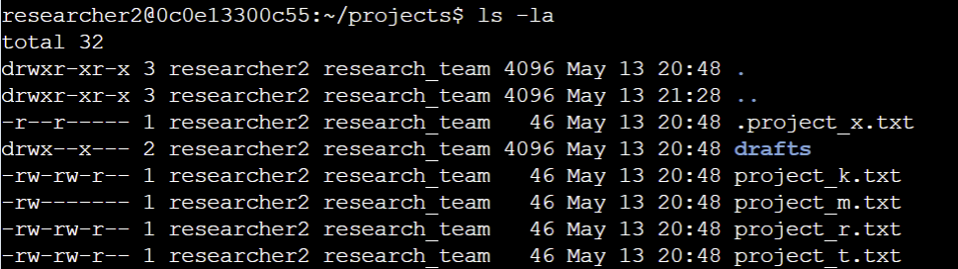

## Change directory permissions

Our organization restricts access to the drafts directory and its contents to only the user researcher2. No other users should have execute permissions.

Here's how I adjusted the permissions using Linux commands:

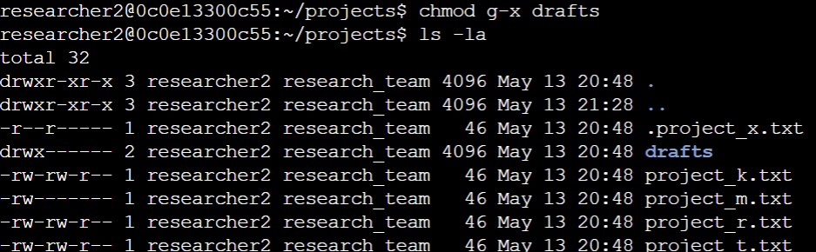

The first two lines in the screenshot show the commands I used, and the subsequent lines display the output of the second command. I had previously identified that the group had execute permissions, so I used the "chmod" command to remove these permissions. Since the user researcher2 already had execute permissions, there was no need to add them again.

## Summary

I adjusted various permissions to align with the authorization requirements set by the organization for files and directories within the projects directory. Initially, I used "ls -la" to assess the existing permissions, which guided my subsequent actions. I then used the "chmod" command multiple times to modify the permissions on these files and directories.