CS-340 Project Two: Grazioso Salvare Dashboard
About the Project
Title: Grazioso Salvare Search and Rescue Dashboard
Overview: This project is a full-stack web application developed for Grazioso Salvare, an international rescue animal training company.
Goal: The application provides an intuitive dashboard interface to filter and identify dogs from the Austin Animal Center dataset that are suitable for specific types of search-and-rescue training (Water, Mountain/Wilderness, and Disaster/Individual Tracking).
Motivation
Purpose: To streamline the identification process for candidate, rescue dogs based on specific breed, age, and sex profiles provided by the client.
Benefits: By automating the filtering process and providing geospatial visualizations (maps) and breed distributions (pie charts), the dashboard reduces user error and training time for Grazioso Salvare staff.
Getting Started
Prerequisites: - MongoDB installed with the Austin Animal Center dataset.
- Python 3.x with libraries: pymongo, pandas, dash, dash-leaflet, and plotly.
- The animal_shelter.py CRUD module in the project directory.
Installation & Tools
MongoDB (The Model): Used as the model component because of its flexible, NoSQL document structure, which is ideal for shelter records where data fields may vary. It provides high performance for the $regex-based breed queries required for this project.
Dash (The View & Controller): The Dash framework was used to provide the web interface. It serves as both the View (HTML/Plotly components) and the Controller (Python callbacks), allowing for a reactive, single-page application experience without requiring JavaScript.
PyMongo: The bridge between the Python Controller and the MongoDB Model.
Usage & Functionality
The dashboard features an interactive layout:
- Radio Buttons: Allow users to filter the entire database by "Rescue Type" (Water, Mountain, Disaster).
- Interactive Data Table: Dynamically updates based on the selected filter and supports native sorting and pagination.
- Geolocation Map: When a row is selected in the table, the map centers on the animal's last known coordinates and provides a popup with the animal's name and breed.
- Breed Distribution Chart: A pie chart that reflects the breed proportions for the currently filtered results.
Challenges & Solutions
Challenge: The dashboard initially failed to connect, showing a "127.0.0.1 refused to connect" error.
Solution: This was resolved by switching the JupyterDash execution mode to mode='external' and binding the host to 0.0.0.0, allowing the virtual environment to proxy the traffic correctly to the web browser.
Screenshots (Required for Rubric)
Note: You must insert your own screenshots here after running the app.
- Dashboard Starting State: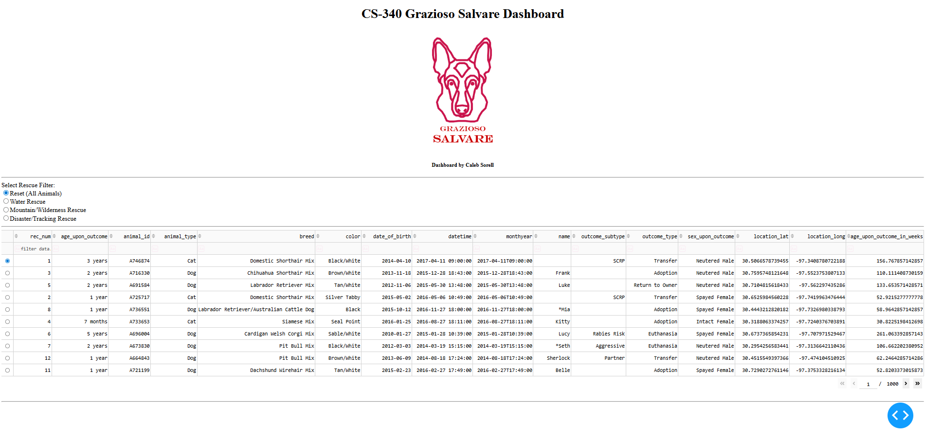
- Water Rescue Filter: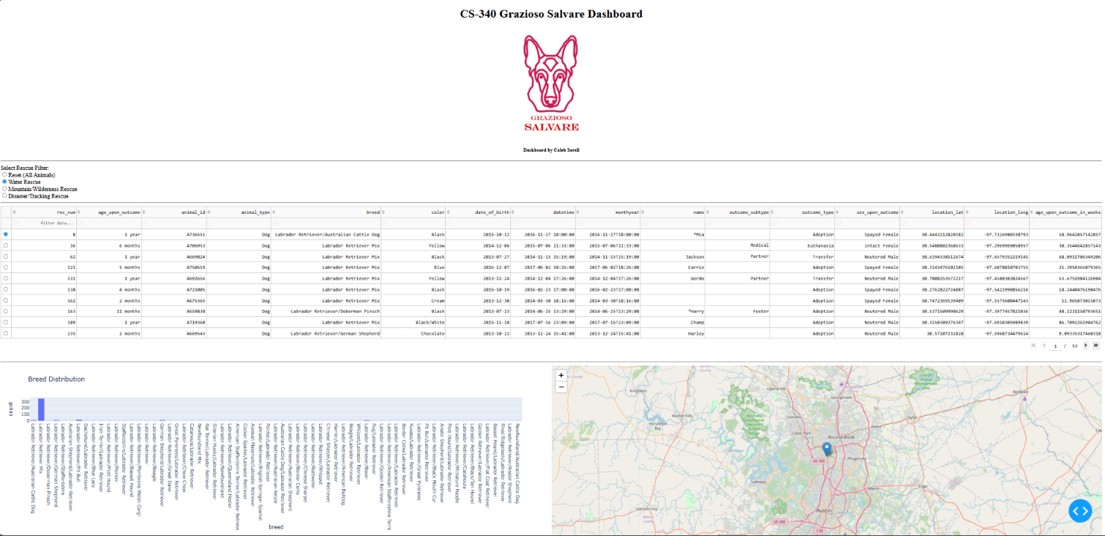
- Mountain/Wilderness Rescue Filter: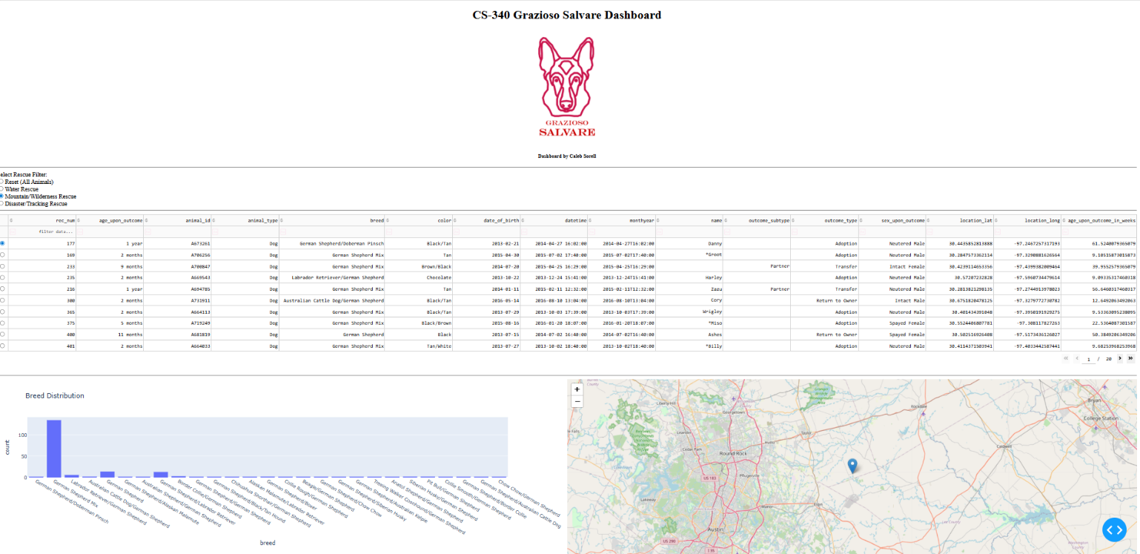
- Disaster/Individual Tracking Filter: 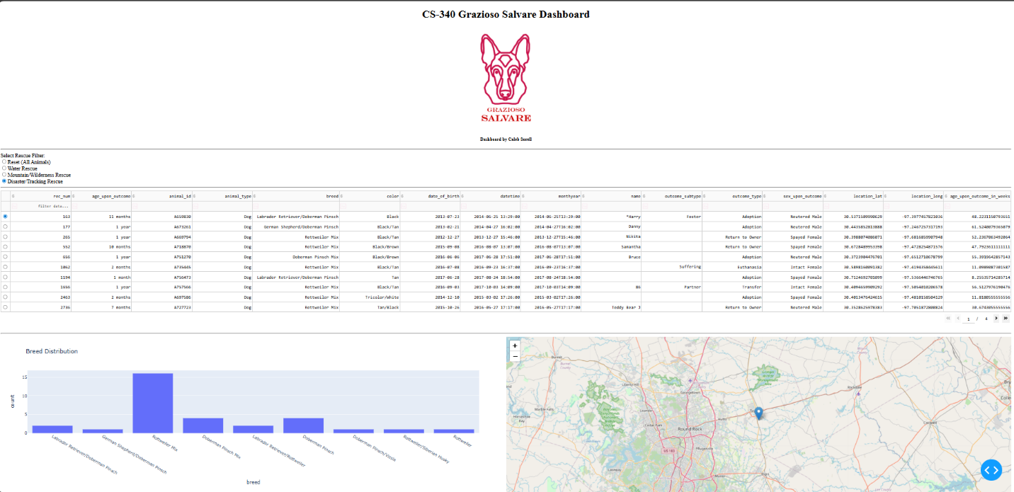
- Reset State: (Showing the dashboard returned to its original unfiltered view).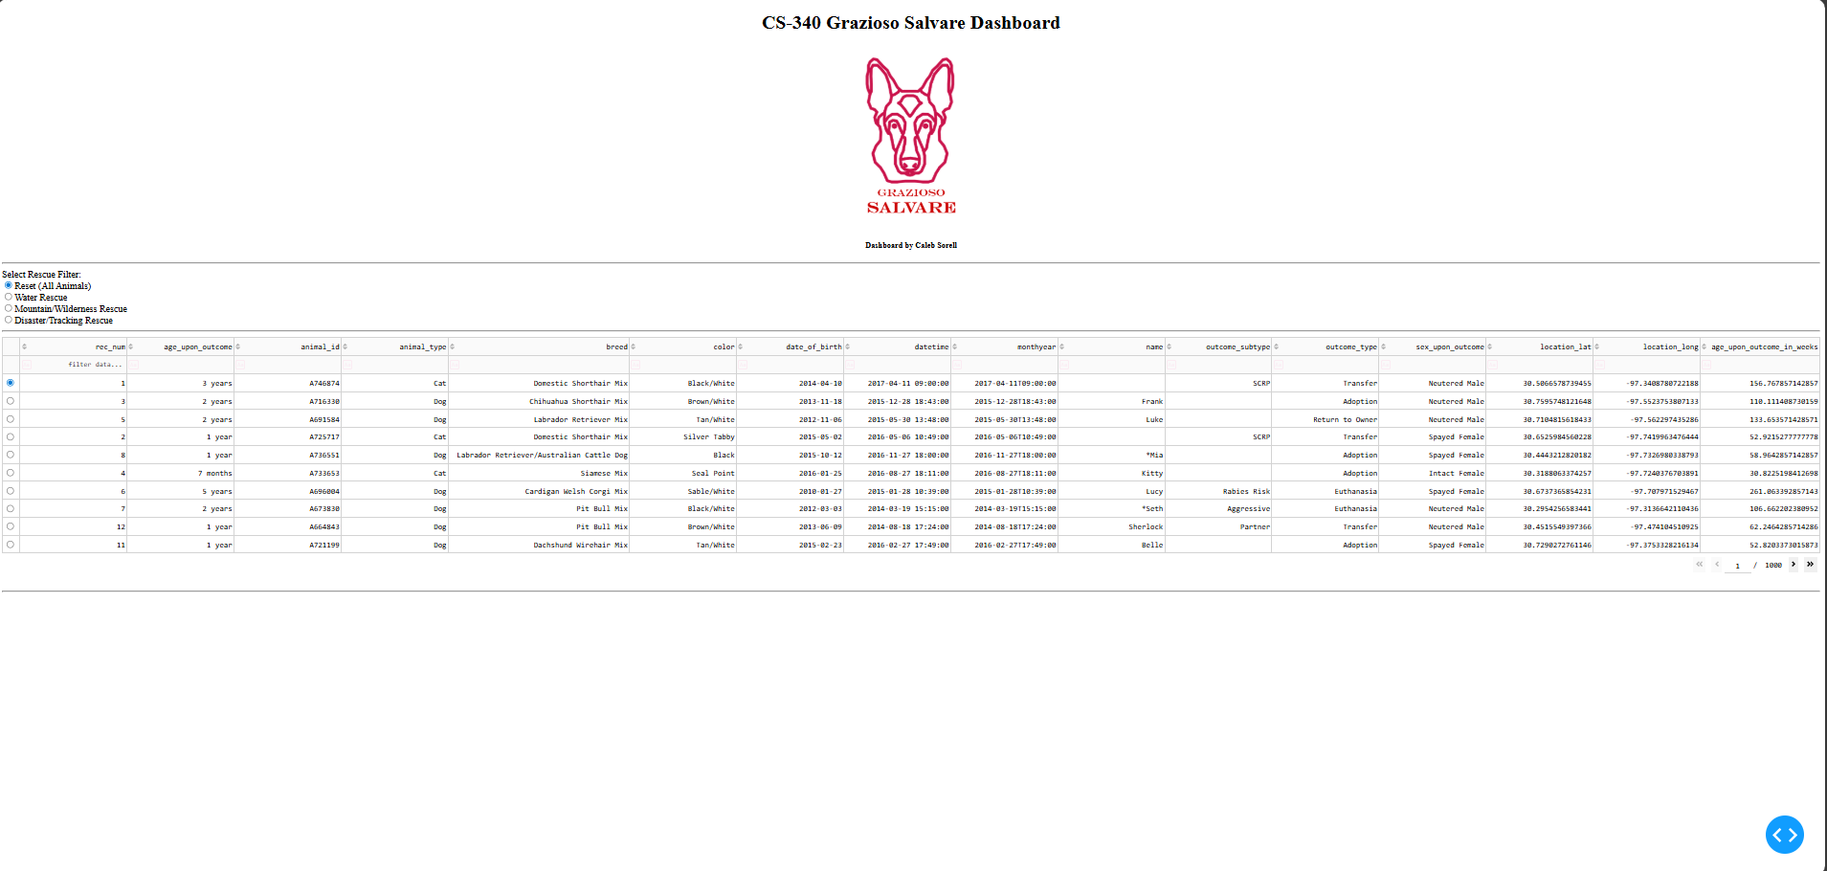
Contact
Developer: Caleb

