THE AI READYIST
From Strategy to a Live Platform
Executive Briefing — the Decision Performance platform
Prepared for: CEO | Date: 23 June 2026 | Status: LIVE

1. Executive summary
Over this programme we moved TheAIReadyist from a strategic idea to a live, operating platform. We settled the category strategy, ratified it as a formal operating model, designed and built the first product — the Executive Signals engine — and launched it into production. As of today it is running, classifying real executive intelligence against our six pillars, and beginning to accumulate the proprietary dataset that our long-term advantage depends on.
Three things are worth holding onto:
- We own a defensible category. AI Readiness is the demand we capture; Decision Performance is the category we own and measure; Constraint Intelligence is the proprietary engine we will earn from evidence.
- The platform is live and human-governed. Signals are gathered, AI-classified and scored automatically every day, but nothing reaches the public without human approval.
- The next advantage is evidence, not features. The build phase is complete. We now enter a disciplined 60-day observation period whose only goal is to accumulate proprietary Decision Performance data.

2. The strategic position
The platform is governed by a single operating model (decision record DR-001). Every current and future asset traces back to it. The discipline of the model is that each concept sits at a different altitude, so they reinforce rather than compete — the market only has to learn two ideas: become AI Ready by improving your Decision Performance.
Layer | Concept | Role
Mission | AI Readiness | The promise and market front door
Category | Decision Performance | What we own, measure and sell
Engine | Constraint Intelligence | The proprietary moat — built later, from evidence
Discipline | Decision Intelligence | Internal method; not the market-facing category
The category thesis we are building toward: “most AI failures are Decision Performance failures.”
Decision Performance is measurable across six dimensions (Quality, Velocity, Accountability, Capability, Value, Resilience), which is precisely what makes it ownable as a category rather than a slogan — and what lets a news signal and a self-assessment eventually speak the same language.

3. What we built
The first product is the Executive Signals engine. Each day it gathers articles from approved enterprise, analyst, telco and executive-leadership sources, classifies each against the six pillars, scores it for executive relevance, and routes the strongest items into an editorial queue for human approval before anything is published. The diagram below shows the whole system — the strategy spine at the top, the live pipeline in the middle, the evidence loop beneath it, and the future components that remain deliberately gated.
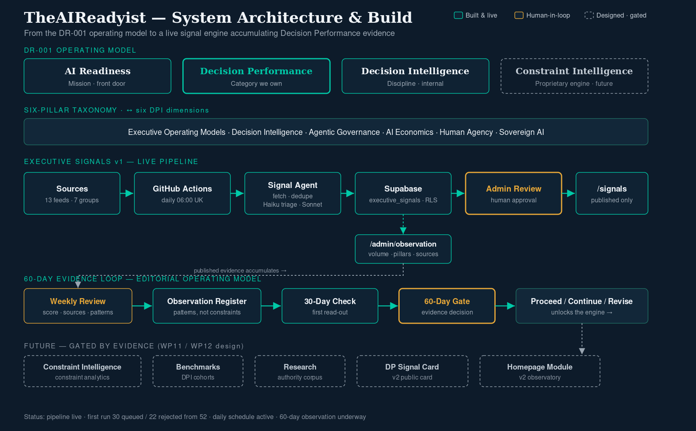
TheAIReadyist system architecture — strategy, live build, evidence loop, and gated future

4. Go-live status
The platform is live in production. The full chain — gather, classify, store, human-review, publish — is verified working, and the daily schedule now runs automatically each morning.

First production run
Metric | Result
Sources gathered from | 13 feeds across 7 source groups
Items fetched | 52
Queued for review | 30
Rejected (low relevance / vendor noise) | 22
Quality | Real, source-grounded signals correctly classified across the pillars

One issue, found and fixed
The first attempts classified nothing — every item was rejected. Investigation traced it to a single cause: the AI service account was out of credit, so the classification calls were declined. This was not a fault in the build; the infrastructure worked throughout. Credit was topped up and automatic reloading enabled, the run was repeated, and classification then worked correctly. The episode is a useful early reminder that the agent depends on a funded AI account — now mitigated by auto-reload and a spend limit.

5. Economics
Running costs are immaterial. The hosting and database sit on free tiers; the only running cost is the AI classification.
Item | Cost
Work to date (failed runs were not billed) | ≈ $0
Per successful daily run | ≈ $0.05 – $0.15
Ongoing operation | ≈ $2 – $6 per month
Hosting & database | Free tier
Figures are estimates based on current usage and AI pricing; cost scales gently with the volume of items processed.

6. The path ahead
The build is finished; the learning begins. For the next 60 days the platform operates under a defined editorial rhythm — a weekly intelligence review, a register of recurring observations, a 30-day read-out, and a 60-day evidence gate. At that gate we decide, on evidence rather than theory, whether to build Constraint Intelligence (the proprietary engine) and the supporting benchmarks and research.
- Now → Day 30: operate daily, review weekly, log recurring patterns (as observations, not yet conclusions).
- Day 30: first structured read-out — which pillars dominate, which sources add value, what themes recur.
- Day 60: evidence gate — proceed to Constraint Intelligence, continue observing, or revise assumptions.

7. What this means for you
The strategic implication is simple: our moat is not the software, which competitors could copy in weeks — it is the accumulating, proprietary Decision Performance dataset and the category authority built on it, which they cannot. The single most valuable thing the platform now does is collect that evidence, consistently and with discipline.
Decisions that sit with you:
- Keep the AI account funded (auto-reload is on; this is now a routine operating cost of a few dollars a month).
- Back the editorial cadence — the weekly review is what turns raw runs into trustworthy evidence.
- Hold the category language — we are “the Decision Performance platform”; AI Readiness is the front door, not the category.
- The Day-60 go/no-go on Constraint Intelligence is the next real investment decision — and it should be made on the evidence we are now collecting.

8. Risks and open items
Item | Status / mitigation
Scoring calibration (first run queued generously) | Tuned editorially in the weekly review — no rebuild needed
Dependency on a funded AI account | Mitigated: auto-reload on, monthly spend limit set
Source coverage (13 of ~47 feeds live) | Remaining feeds verified and enabled over the coming days
Brand vs category (name says Readiness, we own Performance) | Managed as a funnel: Readiness → Decision Performance

9. Governing documents
For the team, the full detail sits in the project workspace:
- DR-001 — Operating Model (the approved decision record).
- Decision Performance Operating Model (WP12) — the canonical strategic architecture.
- Editorial Operating Model v1 (WP13) — how the platform is run day to day.
- Go-Live Completion Report (WP14) — the full technical record of launch.
Bottom line: TheAIReadyist is live, classifying real executive signals against the six pillars, and accumulating the proprietary Decision Performance data that defines success. The next move is to learn from it.

