Nathan Maurer

January 29, 2025

Module 5.2 Assignment

Database Development

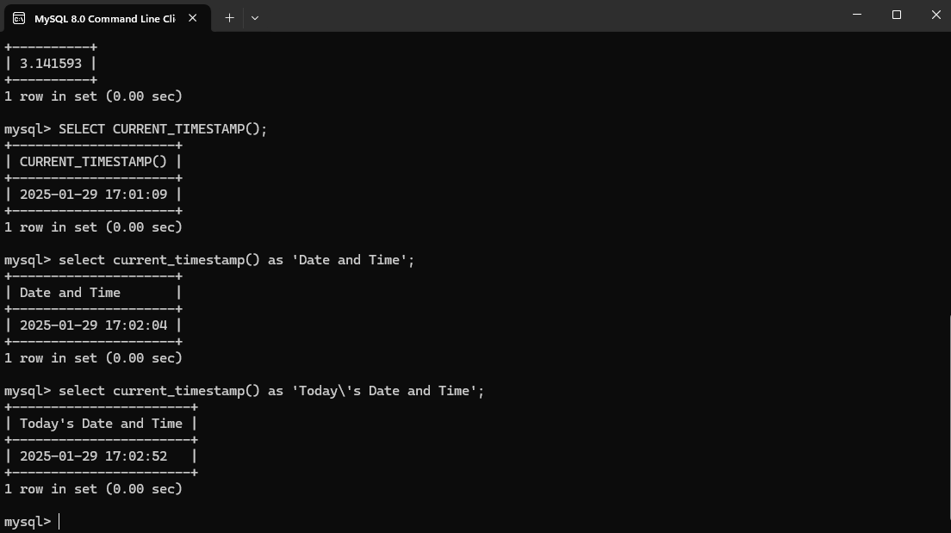

This could be used if the date and time are requested. They would be the date and time of when the function was run.

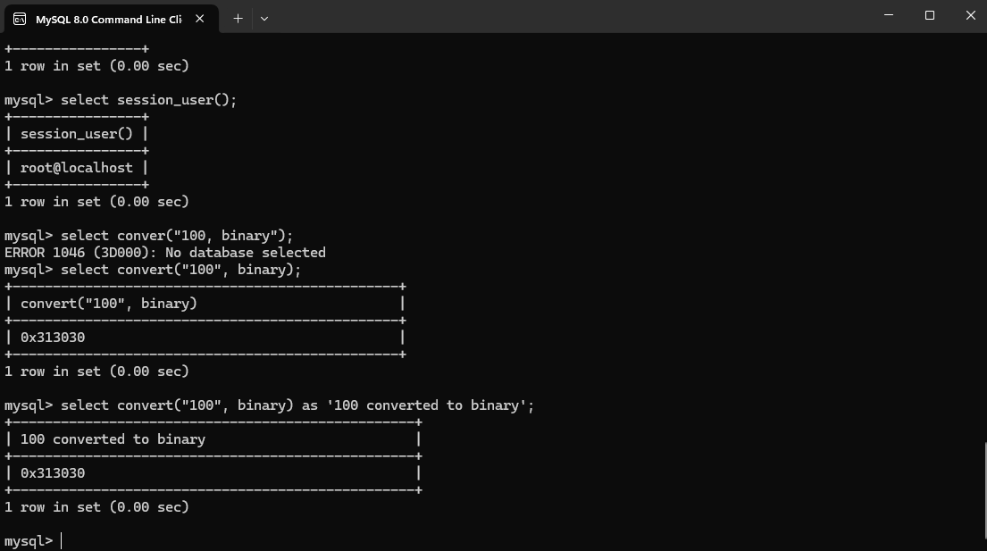

Converting to binary can have many uses, including number conversion in circuit analysis.

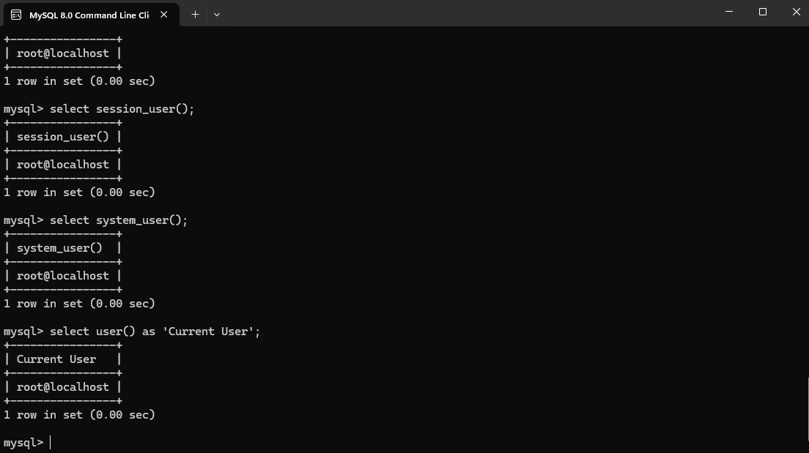

Getting the current user of MySQL simply provides the username of the user currently logged into MySQL.