Title:-

**Performing basic data analysis on ToothGrowth and finding important insights**

# Overview

The purpose of the this data analysis is to analyze the ToothGrowth data set by comparing the guinea tooth growth by supplement and dose. First, I will do exploratory data analysis on the data set. Then I will do the comparison with confidence intervals in order to make conclusions about the tooth growth.

# Load the ToothGrowth data and perform exploratory data analyses

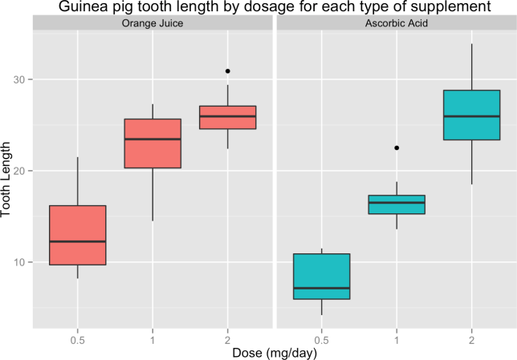

**library**(datasets) data(ToothGrowth) str(ToothGrowth)

dim(ToothGrowth)

head(ToothGrowth) summary(ToothGrowth)

**library**(ggplot2) t = ToothGrowth

levels(t$supp) <- c("Orange Juice", "Ascorbic Acid") ggplot(t, aes(x=factor(dose), y=len)) +

facet_grid(.~supp) +

geom_boxplot(aes(fill = supp), show_guide = FALSE) +

labs(title="Guinea pig tooth length by dosage for each type of supplement", x="Dose (mg/day)",

y="Tooth Length")

**Insights from analyzing boxplots of the tooth length vs Dose grouped by supplement factor:-**

The box plots seem to show, increasing the dosage increases the tooth growth. Orange juice is more effective than ascorbic acid for tooth growth when the dosage is .5 to 1.0 milligrams per day. Both types of supplements are equally as effective when the dosage is 2.0 milligrams per day.

For using t.test there are some underlying assumptions as follows

Normal distribution of the tooth lengths

No other unmeasured factors are affecting tooth length

## Hypothesis #1

Orange juice & ascorbic acid deliver the same tooth growth across the data set.

hypoth1<-t.test(len ~ supp, data = t) hypoth1$conf.int

## [1] -0.1710156 7.5710156

## attr(,"conf.level") ## [1] 0.95

hypoth1$p.value

## [1] 0.06063451

The confidence intervals includes 0 and the p-value is greater than the threshold of 0.05. The null hypothesis cannot be rejected.

## Hypothesis #2

For the dosage of 0.5 mg/day, the two supplements deliver the same tooth growth.

hypoth2<-t.test(len ~ supp, data = subset(t, dose == 0.5)) hypoth2$conf.int

## [1] 1.719057 8.780943

## attr(,"conf.level") ## [1] 0.95

hypoth2$p.value

## [1] 0.006358607

The confidence interval does not include 0 and the p-value is below the 0.05 threshold. The null hypothesis can be rejected. The alternative hypothesis that 0.5 mg/day dosage of orange juice delivers more tooth growth than ascorbic acid is accepted.

## Hypothesis #3

## For the dosage of 1 mg/day, the two supplements deliver the same tooth growth

hypoth3<-t.test(len ~ supp, data = subset(t, dose == 1)) hypoth3$conf.int

## [1] 2.802148 9.057852

## attr(,"conf.level") ## [1] 0.95

hypoth3$p.value

## [1] 0.001038376

The confidence interval does not include 0 and the p-value is smaller than the 0.05 threshold. The null hypothesis can be rejected. The alternative hypothesis that 1 mg/day dosage of orange juice delivers more tooth growth than ascorbic acid is accepted.

## Hypothesis #4

For the dosage of 2 mg/day, the two supplements deliver the same tooth growth

hypoth4<-t.test(len ~ supp, data = subset(t, dose == 2)) hypoth4$conf.int

## [1] -3.79807 3.63807

## attr(,"conf.level") ## [1] 0.95

hypoth4$p.value

## [1] 0.9638516

The confidence interval does include 0 and the p-value is larger than the 0.05 threshold. The null hypothesis cannot be rejected.

# Conclusions :-

Orange juice delivers more tooth growth than ascorbic acid for dosages 0.5 & 1.0. Orange juice and ascorbic acid deliver the same amount of tooth growth for dose amount 2.0 mg/day. For the entire data set we cannot conclude orange juice is more effective that ascorbic acid.