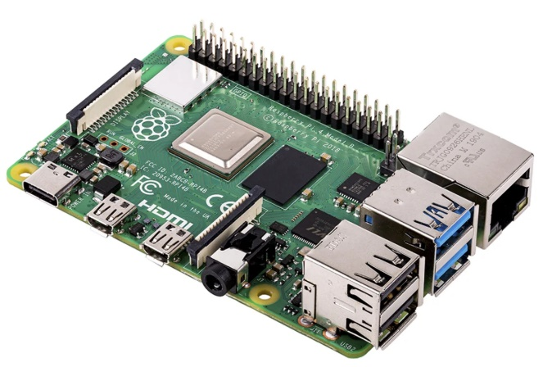**Raspberry pi:**

Bauteil: Raspberry Pi 4 Modell B

1 Stück

<https://at.rs-online.com/web/p/entwicklungskits-prozessor-mikrocontroller/1888310/>

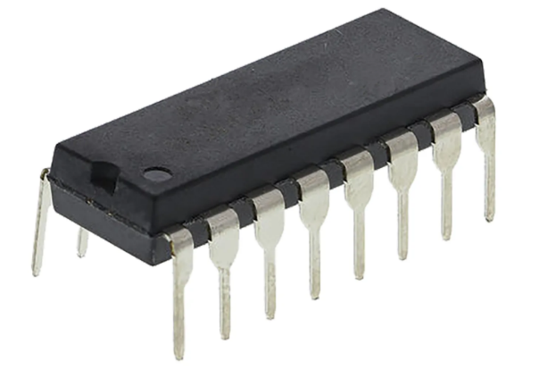

**Analog Digital Umwandler:**

Bauteil: Microchip Technology MCP3208-BI/P Datenerfassungs-IC - Analog-Digital-Wandler (ADC) Extern PDIP-16

1 Stück

[https://at.rs-online.com/web/p/a-d-wandler/3792487/?relevancy-datasearchHistory=%7B"enabled"%3Atrue%7D](https://at.rs-online.com/web/p/a-d-wandler/3792487/?relevancy-datasearchHistory=%7B%22enabled%22%3Atrue%7D)

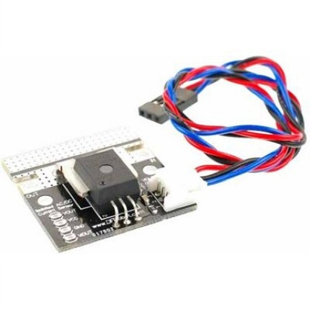**Strommess-Sensor:**

Bauteil: Gravity 50A Stromsensor

1 Stück

https://at.rs-online.com/web/p/products/8660786?cm_mmc=AT-PLA-DS3A-_-google-_-CSS_AT_DE_Halbleiter_Whoop_ME-_-(AT:Whoop!)+Stromschleifen+ICs-_-PRODUCT_GROUP&matchtype=&pla-341566163694&gclid=CjwKCAiA8K7uBRBBEiwACOm4dxBdVTK1IgKRCzOuzI2710UMpp9vxkgCaOImUfQ3lVqo7Ukjcs6B5xoCLUQQAvD_BwE&gclsrc=aw.ds

# Honeywell Stromsensor, Hall-Effekt / 8 → 16 Vdc, Printmontage

https://at.rs-online.com/web/p/products/0650560?cm_mmc=AT-PLA-DS3A-_-google-_-CSS_AT_DE_Automation_Whoop_ME-_-(AT:Whoop!)+Stromsensoren-_-PRODUCT_GROUP&matchtype=&pla-306888286695&gclid=Cj0KCQiAk7TuBRDQARIsAMRrfUaIlQRcsk7sJCA2_tCevv0y4ifXKOjJ4oaFF4pqXKsHRLqOLy9rtBkaAgW7EALw_wcB&gclsrc=aw.ds

# Gravity Analoger AC-Stromsensor mit Strommesszange

1 Stück

https://www.bastelgarage.ch/gravity-analoger-ac-stromsensor-mit-strommesszange?search=gravity%20str