**Documentation**

**SWE Party Playlist Battle (PBB)**

**Time spent with the project**

|  |  |  |
| --- | --- | --- |
| **Date** | **Modifications** | **Effort** |
| 05.02.2021 | *Rest-Server* (due to not finishing on time with the first submission and MTCG) | ~10-12 hours |
| 08.02.2021 | *Creating the Database/Connection the DB* | ~2 hours |
| 10.02.2021 | *Classes/Methods design* | ~2 hours |
| 12.02.2021 | *Game mechanics – Users/Login* | ~1 hour |
| 12.02.2021 | *Game mechanics – Battle* | ~2 hours |
| 15.02.2021 | *Structure the project on the curls* | ~5-7 hours |
| 16.02.2021 | *Additional errors* | ~3 hours |
| 19.02.2021 | *Testing* | ~5 hours |
| 19.02.2021 | *Documentation* | ~2 hours |
| 21.02.2021 | *Submission*(Checking on last details) | ~3 hours |

Link to the video: <https://www.youtube.com/channel/UCuK0LjM-DMQ_aoC_3cLZr6A>

Link to github: https://github.com/Csxabi/PartyPlaylistBattle

**Database Schema**

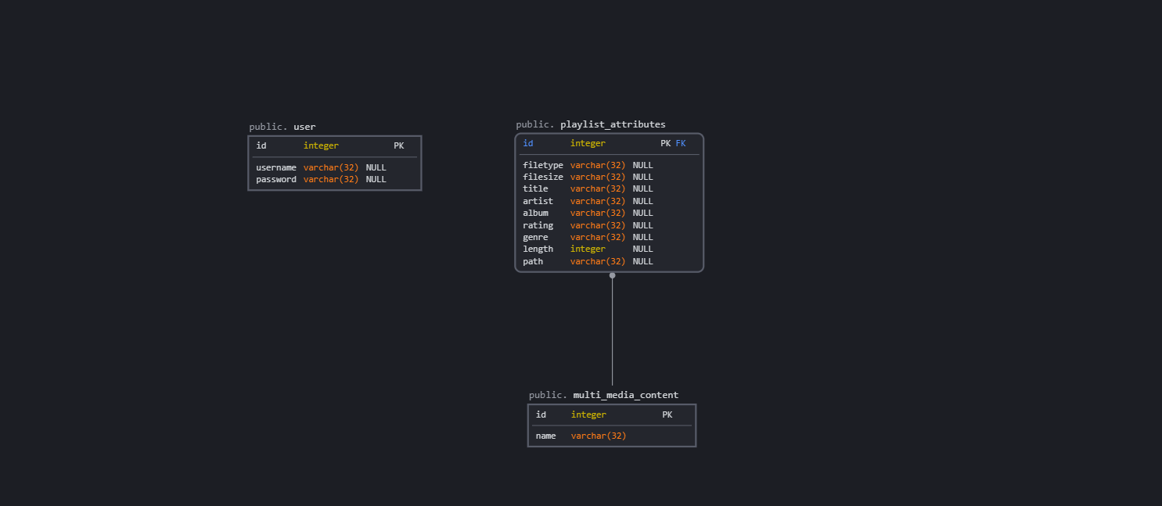

**Lessons Learned/Problems**

Firstly the most important fact I have learned is to structure/manage working time better, this means to be more productive in a single day, spent the amount of work on a day and not splitting up the work time in different days, because this can lead to late submission/passing the deadline. The second most important thing to mention, is to finish my work earlier than the submission date, do avoid unnecessary stress, I really like finishing all my work/homework as fast as I can, the closer I get to the deadline the more unnecessary panicked I get and usually can’t finish it properly.

Talking about the programming languages Java and C# were both new to me, I didn’t have had any working experience with them. Maybe the most important thing why I didn’t finish the first program was that I learned a new programming language(C# and Java) from scratch. This semester I stumbled a lot of new features in software engineering that I didn’t knew before, for example: the testing design (Unit Tests, Integration Tests) or working with a database/JSON Files so I had to spend more time understanding the usage/working principle compared to my colleagues with experience. I have done more research on the second project and decided myself in the end to switch to Java because I have found more useful materials/tutorials on the internet.

Regarded the project I didn’t understand at the beginning how a user becomes an administrator(the way the tournament works) but while advancing through the project I figured it out myself. The Database I have created might be too simple but I couldn’t find any other important information that needs to be stored in the DB. I still had to make the integration tests/curls work, I stopped at that and I just don't know how to do the curls so that they work. The two Unit Test I wrote test pretty much if a user is logged in and if a created user also appears in the Database.

Unfortunately I couldn’t finish the entire project properly, I've tried a lot considering the fact it says we need 5 curls, so I wanted to finish them. If we can't deliver later the entire project, that's best that I can do, and have for now. I am aware that this is probably not enough to be positive, but I am hoping that maybe it is.