CDS Activities

1. Advancing Clinical Decision Support
   1. 促进CDS实践经验的传播，推动CDS的广泛应用
   2. 开发药物-药物相互作用列表，提高药物CDS系统的可用性
   3. 促进跨机构的CDS干预的共享
   4. 明确针对不同专科CDS的目标和挑战
2. 为期2天的CDS研讨会，与会专家就提高CDS的可用性、适用性和有效使用进行了讨论
3. AHIC五个工作组形成了CDS recommendations
4. 国家层面实现 Clinical Decision Support的路线图
   1. 临床知识的可及性
   2. CDS根据的有效利用和应用
   3. 对知识和CDS方法的持续改进
5. 联邦政府赞助的CDS项目的目录
6. CDS Federal Collaboratory 联邦互助会

参考资料

1. <http://www.healthit.gov/policy-researchers-implementers/cds-activities>
2. <http://www.rand.org/health/projects/clinical-decision-support.html>
3. <http://healthit.ahrq.gov/ahrq-funded-projects/clinical-decision-support-initiative>

CDS Implementation

1. How-To Guides：主要分为5个阶段的指南

[Guide 1- Start with a Strong Foundation for CDS [PDF - 202 KB]:](http://www.healthit.gov/sites/default/files/3-4-1-strong-foundation.pdf) 帮助机构确定要不要上CDS。  
[Guide 2- Assemble a CDS Implementation Team [PDF - 158 KB]:](http://www.healthit.gov/sites/default/files/3-4-2-assemble-cds-implem-team.pdf) 在实施CDS或计划实施CDS中需要哪些角色参与  
[Guide 3- Plan for Successful CDS Development, Design, and Deployment [PDF - 191 KB]:](http://www.healthit.gov/sites/default/files/3-4-3-successful-cds.pdf) CDS与工作流程以及机构目标的匹配 [Guide 4- Roll Out Effective CDS Interventions [PDF - 147 KB]:](http://www.healthit.gov/sites/default/files/3-4-4-rollout-effective-cds.pdf) 计划和培训相关的建议。  
[Guide 5-Measure Effects and Refine CDS Interventions [PDF - 173 KB]:](http://www.healthit.gov/sites/default/files/3-4-5-measure-effects-and-refine-cds-interv.pdf) CDS干预效果的测度和管理。包括医生个人的反馈和外部机构的测度报告

1. *经验教训*

[Key Lessons In Clinical Decision Support Implementation](http://www.healthit.gov/sites/default/files/acds-lessons-in-cds-implementation-deliverablev2.pdf) 报告中 按照实施阶段、机构类型和大小进行分类。这份报告是1. Advancing Clinical Decision Support项目的技术报告

*三类工具*

* 1. *工具和图表：图、表、在线工具形式的资源。诸如描述利益方角色的表格、在线的工具和调查问卷、CDS干预类型的图表等*
  2. *HIMSS工作表：根据HIMSS CDS book、Improving Outcomes with Clinical Decision Support: An Implementer’s Guide 第二版 得到的。*
  3. *文献：*

1. *Clinical Decision Support Starter Kit：帮助大家熟悉CDS，提供一个CDS规则实现如何管理的实例，通过这个工具 你可以*
   1. *理解CDS及其原理*
   2. *常用的5种CDS*
   3. *CDS与meaningful use目标的关系*
   4. *如何实施Meaningful use相关的CDS规则*
2. *资源共享：旨在解决小型机构资源有限的问题，帮助他们实施CDS*
3. *经典案例*
4. *Reference Workflow Taxonomy*

*CDS Sharing*

*由ONC赞助的Advancing Clinical Decision Support (ACDS)项目中美国联盟医疗体系（Partners HealthCare System）的Dr. Tonya Hongsermeier提出了一种知识共享服务的标准schema、管理模型和功能架构。其中*

1. *确定知识共享服务KSS的关键需求和特性*
2. *提出管理模型和编辑策略的重要属性*
3. *提出一个基于已有标准的框架*
4. *提出可以表达常见的干预类型的XML schema*
5. *确定现有标准存在的局限性 提出改进意见*
6. *部署第一版KSS*
7. *针对MU中的CDS 干预措施，提供XML的实现，配套XSLT文件可以展示成html形式*

*The Clinical Decision Support Consortium (CDSC)知识管理门户中提供对CDS干预措施的检索，其中既包含非结构化的纯文本形式的临床指南，也包括了结构化的CDS逻辑规则。可以通过学科类型、贡献机构和知识类型等关机词来检索。*

*这个门户网站是由AHRQ赞助的CDSC项目的一部分，目前包含了80种，35个是为ACDS项目开发的，45个是为CDSC项目开发的。涵盖的类型包括了alert/reminders、文档模板、医嘱套餐、参考信息、infobutton、和值集。格式要么是XML格式 要么是HTML形式的。*

*以smoking cessation为关键词*

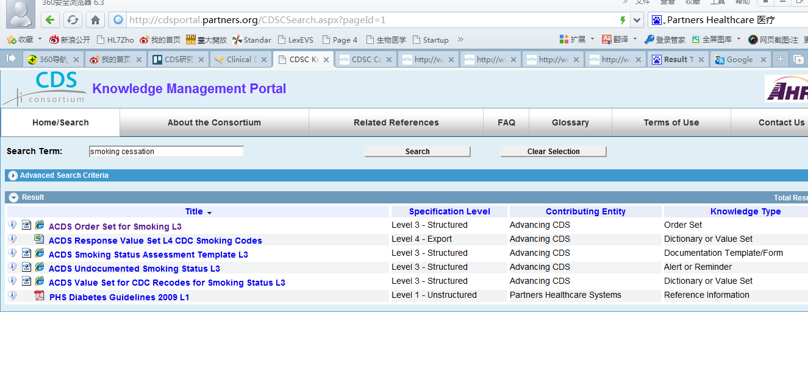

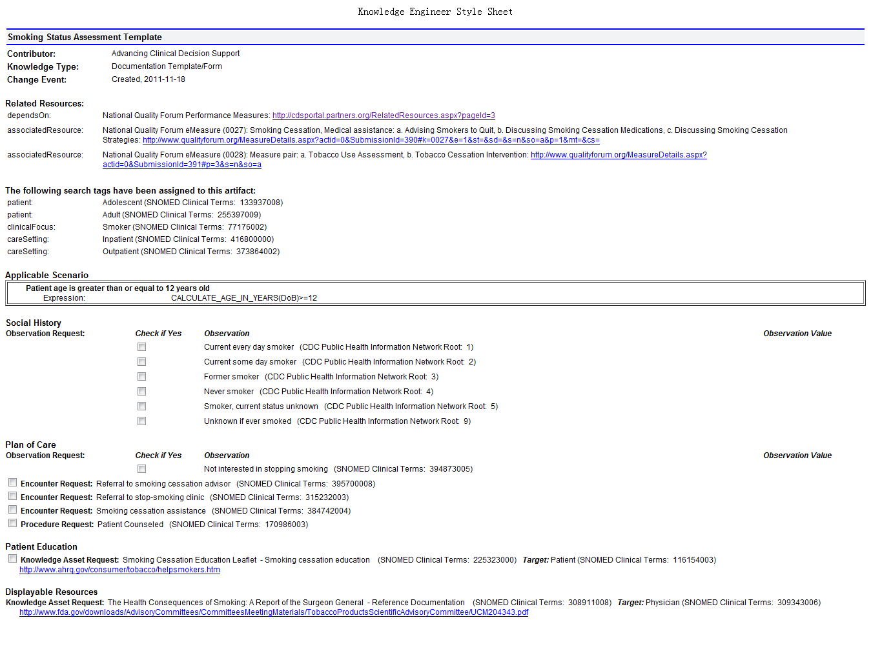

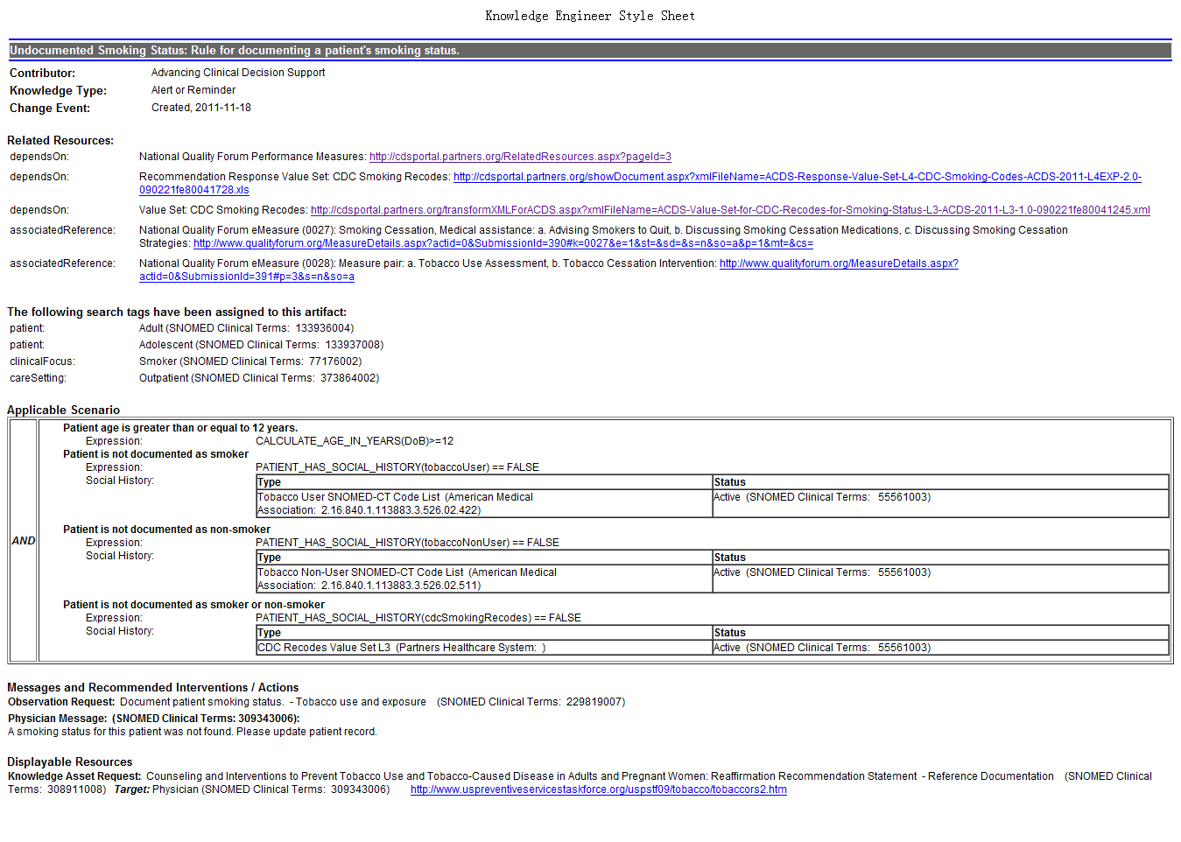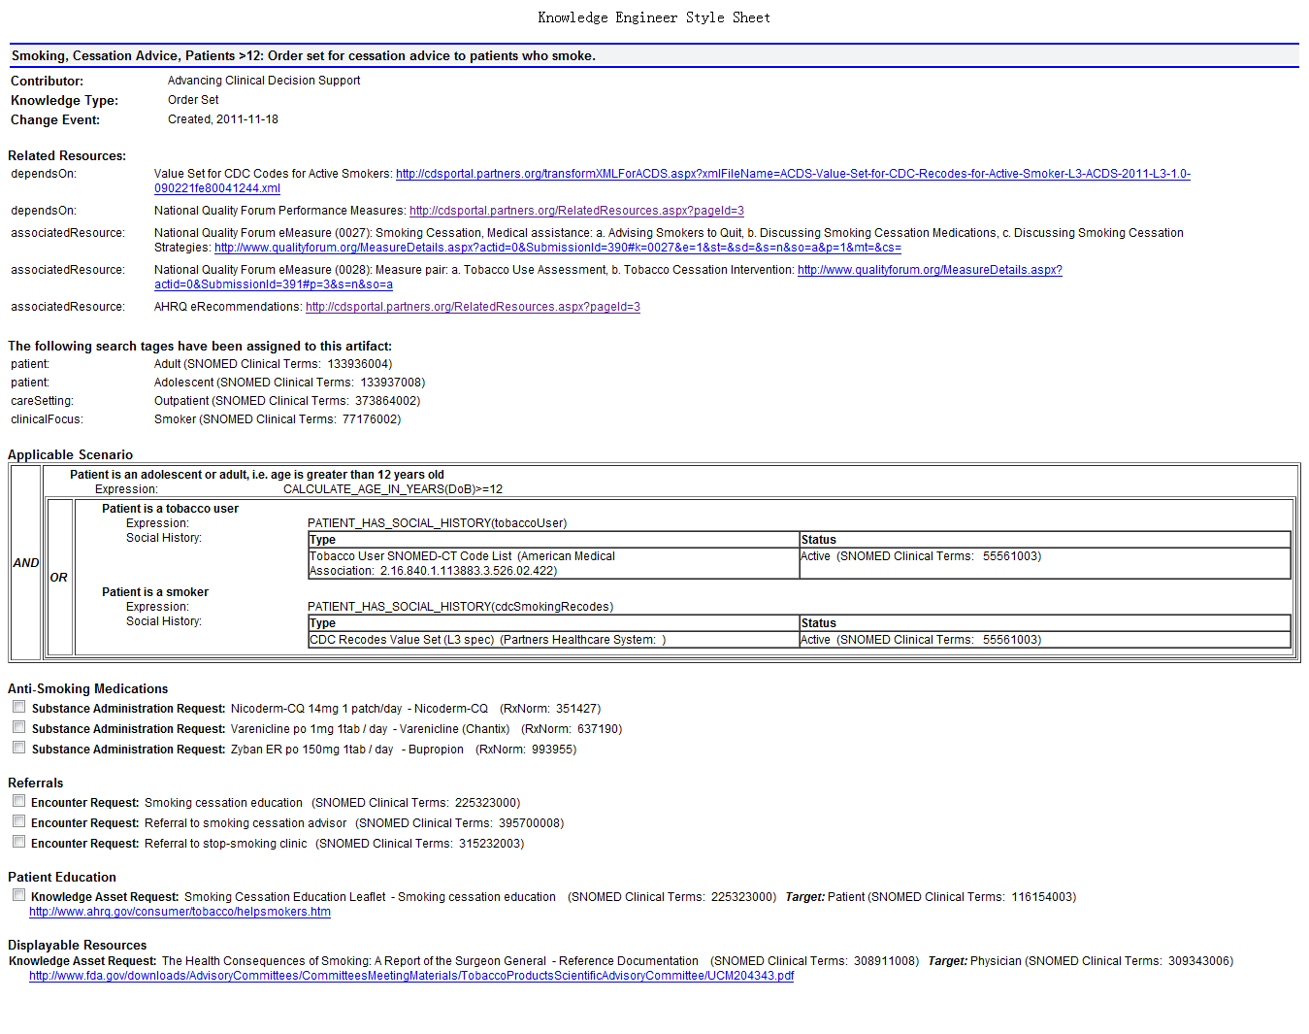



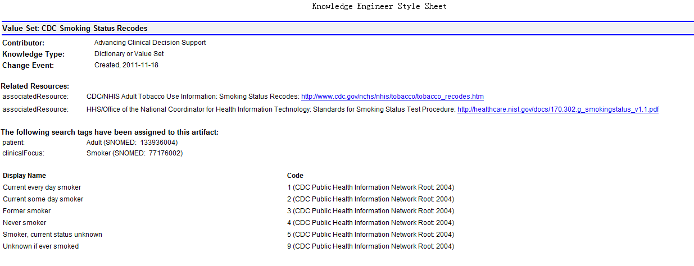

*CDS Starter Kit*

1. *CDS的意义和价值*

*HIMSS中对CDS的定义：利用相关有用的临床知识和患者信息来提高健康保健决策和行为的过程，提高医疗服务质量。*

*Bates DW, Gawande AA. Improving safety with information technology. N Engl J Med. 2003 Jun*

*19;348(25):2526-34.— This article by David Bates and Atul Gawande lays out the many ways in*

*which information technology, including clinical decision support, can improve the quality of*

*care.*

*• Bates DW, Kuperman GJ, Wang S, Gandhi T, Kittler A, Volk L, Spurr C, Khorasani R, Tanasijevic M,*

*Middleton B. Ten commandments for effective clinical decision support: making the practice of*

*evidence-based medicine a reality. J Am Med Inform Assoc. 2003 Nov-Dec;10(6):523-30. Epub*

*2003 Aug 4.— This study suggest the ways in which CDS can be useful for the practice of*

*evidence-based medicine. Furthermore, the ten commandments lay out key considerations for*

*those who plan to implement CDS systems.*

*• Agency for Healthcare Research & Quality (AHRQ), Clinical Decision Support Website – This*

*website includes a library of resources that address pre-implementation planning,*

*implementation of CDS, and post-implementation use. A list of implementation tools and*

*resources, as well as stories from past CDS implementations, are available.*

1. *常见类型*

*CDS工具主要有5大类：*

|  |  |  |  |
| --- | --- | --- | --- |
| *类型* | *目标* | *说明* | *如何使用* |
| *Alert &reminder* | *诊疗过程中提供一些警示信息* | *通常是一些弹出框、特殊布局的提醒列表、字体/颜色的设置变化等。具体设计根据提供的信息类型和重要程度相关。如药物过敏程度是弹出框，通用药物vs名牌药物 则只是字体的变化* | *主要用在处方和时间敏感性保健如年度预防保健筛查* |
| *Order sets* | *按照临床目的实现确定的一组医嘱。医嘱套餐避免了针对某种情况重复指定单个检验、用药等等 提高效率 降低错误* | *套餐医嘱和其他医嘱没什么区别，* | *使得医嘱过程更加高效、标准化* |
| *Infobutton* | *提供HER中出现的术语/词汇参考信息的外链。这种与alert的区别在于 医生是主动式获取 而非被动式推送* | *一般是在关键词旁边有一个小按钮或图标 如* | *只要需要更多信息 就可以用到.如在病情名称、药物名称的旁边 以提供更多信息* |
| *Data display* | *下医嘱或chart审查时 做参考、指导或在恰当时提供病人个案信息。与某个用户动作触发的alert不同，这是由信息触发的* | *针对特殊疾病的健康信息的数据展示 如糖尿病flowsheet或者撰写新处方时过敏状态的展示。也可能是dashboard的形式或者是科室的监测系统 如ED监测* | *不是通过提供一个alert或者是简化下医嘱的过程，而是提供能够指导医师做出更可靠选择的信息来辅助决策* |
| *Documentation template文档模板* | *用以采集信息的结构化的电子表单。如果它们用作支持通用文档目的、支持后续工作流中的其他工具或者支持诸如质控等临床目的*  *文档模板也可以看作一种CDS* | *就是有很多字段 可以键入信息的电子表单。可以是自由文本 抑或是下拉菜单形式* | *任意数据采集中都可以使用* |

1. *CDS与meaningful use的关系*

*如果广泛使用，CDS能提高医疗服务的质量。HIMSS对CDS的定义更加宽泛，而MU中则具体得多：CDS是一种HIT功能，基于EHR，在恰当的时间为涉及临床诊疗的医务人员提供事先整理和过滤好的一般信息和针对个体的信息，以此来提高医疗水平。*

*CMS和ONC所启动的EHR 的meaningful use的刺激计划是实现这个目标很重要的一步。新成立的区域的Extension center旨在帮助实施和有效使用EHR。在MU中，安装通过认证的EHR，同时上报数据，以证明自己能够有效使用EHR，合格的医疗机构就可以拿到一笔奖励。2011-2012年上报的MU准则已经确定了，下一阶段也就是2013-2015年的准则即将设定。*

*MU2011准则中要求实现药物-药物和药物-过敏交互和对以及实现一个CDS alert 规则，能够追踪该rule的符合性。*

*ADVANCING CLINICAL DECISION SUPPORT*

*Key Lessons In Clinical Decision Support Implementation*

*第一部分：简介*

1. *CDS背景*
   1. *ACDS*
2. *CDS实践经验教训收集的方法学*
   1. *目标文献的审查*
   2. *专家顾问委员会申请资源*
   3. *与固定的CDS实施人员和其他业务专家进行讨论*
   4. *收集CDS实施的资源和经验教训*
3. *CDS实践中的经验教训*
   1. *证据的层次*
   2. *阐释报告的结构*
   3. *召集利益方和交流目标*
   4. *评估实施的准备程度*
   5. *评估CDS实施团队*
   6. *选择高效的临床领导*
   7. *达到医师配合和支持*
   8. *与工作流程整合*
   9. *成功展示的计划*
   10. *培训和技术支持*
   11. *监管和评估CDS对临床的影响*
   12. *知识管理*

*第二部分：总结*

*第三部分：参考文献*

*附录*

1. *典型案例的经验总结*
2. *CDS相关文献的检索和审核策略*
3. *有关CDS的文献审核结果*

[美国联盟医疗体系成员单位简介](http://baike.baidu.com/link?url=UcECHqoR9KUYVaw4Nq24CZklgcskmjStXVR0CiWjiE1sw9E6DjX8VEiOeArwlk_vG5DZ9O2X_hjOHXHt4U0-oK" \l "2)

[哈佛大学医学院附属麻省总医院](http://baike.baidu.com/link?url=UcECHqoR9KUYVaw4Nq24CZklgcskmjStXVR0CiWjiE1sw9E6DjX8VEiOeArwlk_vG5DZ9O2X_hjOHXHt4U0-oK#2_1)

[哈佛大学医学院附属布列根和妇女医院](http://baike.baidu.com/link?url=UcECHqoR9KUYVaw4Nq24CZklgcskmjStXVR0CiWjiE1sw9E6DjX8VEiOeArwlk_vG5DZ9O2X_hjOHXHt4U0-oK#2_2)

[哈佛大学医学院附属丹娜法伯肿瘤医院](http://baike.baidu.com/link?url=UcECHqoR9KUYVaw4Nq24CZklgcskmjStXVR0CiWjiE1sw9E6DjX8VEiOeArwlk_vG5DZ9O2X_hjOHXHt4U0-oK#2_3)

[哈佛大学医学院附属麦克莱恩医院](http://baike.baidu.com/link?url=UcECHqoR9KUYVaw4Nq24CZklgcskmjStXVR0CiWjiE1sw9E6DjX8VEiOeArwlk_vG5DZ9O2X_hjOHXHt4U0-oK#2_4)

[哈佛大学医学院附属斯波尔丁康复医院](http://baike.baidu.com/link?url=UcECHqoR9KUYVaw4Nq24CZklgcskmjStXVR0CiWjiE1sw9E6DjX8VEiOeArwlk_vG5DZ9O2X_hjOHXHt4U0-oK#2_5)

*CDS联盟*

*概述:*

*2008年3月到2013年7月 由AHRQ赞助的科研项目。旨在对跨机构和跨EHR技术平台的临床决策支持和知识管理的最佳实践进行评估、定义、演示。*

*研究方向：*

1. *知识管理生命周期评估*

*分析和确定从临床指南到具体的决策支持的整个知识管理生命周期的最佳实践。通过参与机构这方面的实践进行调研，分析学术界和工程上的最佳实践。关注点有3个：* USPSTF预防医疗的临床指南、CAD和糖尿病慢病管理。

1. *知识转化和知识标准*

*主要关注知识表达、数据表示、人可读知识内容的规范和web服务中内容表达。*

*首先是对参与方的实践经验进行对比分析和评估。最终定义一种知识表达的格式和表示用药、问题和症状、过敏、预先指示、检验结果等数据表达格式。也应包括对web服务架构的规范。*

1. *知识管理门户和仓库*

*利用知识管理门户来统一开发、共享和管理CDS试点项目中用到的知识制品。有人可读和web服务2种*

1. *CDS服务和知识内容*

*为了验证上面1-3中的最佳实践、设计了2种产品间的2个试点项目：*

1. *根据*USPSTF预防医疗的临床指南，利用上面提到的最佳实践，为健康维护和预防疾病的筛检开发整套的CDS服务
2. *这个试点主要关注的是慢病管理的决策支持。*
3. *评估*

*只要是对这几个研究方向的项目进行评估*

knowledge management lifecycle and the knowledge specification 通过同行评审进行

KM Portal and Repository通过用户满意度、性能、知识工程的效率来评估

CDS services 试点项目是通过概念验证的组件、可用性、用户满意度评估进行的

*希望除了合同中要求的这些之外，能够通过正规测评对项目进行评估。*

1. *推广*

*实现了上述4大研究目标，我们发表了一些论文、制作了一些PPT以及给AHRQ的报告。*

*官网：*[*http://www.partners.org/cird/cdsc/*](http://www.partners.org/cird/cdsc/)

*成员：* [32 member institutions](http://www.partners.org/cird/cdsc/collaborating_organizations.asp): 8 healthcare institutions, 10 academic institutions, and 14 vendors.

## Academic and Healthcare Institutions:

## [CIRD at Partners HealthCare](http://www.partners.org/cird/cdsc/collaborating_organizations.asp#none)

## [CQA at Partners HealthCare](http://www.partners.org/cird/cdsc/collaborating_organizations.asp#none)

## [DGIM at Brigham and Women's Hospital](http://www.partners.org/cird/cdsc/collaborating_organizations.asp#none)

## [Geisinger](http://www.partners.org/cird/cdsc/collaborating_organizations.asp#none)

## [Illinois Gastroenterology Group](http://www.partners.org/cird/cdsc/collaborating_organizations.asp#none)

## [Kaiser Permanente](http://www.partners.org/cird/cdsc/collaborating_organizations.asp#none)

## [Main Line Health](http://www.partners.org/cird/cdsc/collaborating_organizations.asp#none)

## [Mayo Clinic](http://www.partners.org/cird/cdsc/collaborating_organizations.asp#none)

## [MITRE](http://www.partners.org/cird/cdsc/collaborating_organizations.asp#none)

## [Mount Sinai Medical Center](http://www.partners.org/cird/cdsc/collaborating_organizations.asp#none)

## [Oregon Health & Science University](http://www.partners.org/cird/cdsc/collaborating_organizations.asp#none)

## [Regenstrief Institute](http://www.partners.org/cird/cdsc/collaborating_organizations.asp#none)

## [University of Medicine and Dentistry, New Jersey](http://www.partners.org/cird/cdsc/collaborating_organizations.asp#none)

## [The University of Texas Health Science Center at Houston and Oregon Health Sciences University](http://www.partners.org/cird/cdsc/collaborating_organizations.asp#none)

## [University of Utah Health Sciences Center](http://www.partners.org/cird/cdsc/collaborating_organizations.asp#none)

## [Vanderbilt University Medical Center](http://www.partners.org/cird/cdsc/collaborating_organizations.asp#none)

## [Veterans Health Administration](http://www.partners.org/cird/cdsc/collaborating_organizations.asp#none)

## [WVP Health Authority](http://www.partners.org/cird/cdsc/collaborating_organizations.asp#none)

## Vendors:

## [Accenture](http://www.partners.org/cird/cdsc/collaborating_organizations.asp#none)

## [Applied Pathways](http://www.partners.org/cird/cdsc/collaborating_organizations.asp#none)

## [AT&T](http://www.partners.org/cird/cdsc/collaborating_organizations.asp#none)

## [Duodecim Medical Publications](http://www.partners.org/cird/cdsc/collaborating_organizations.asp#none)

## [EBSCO Publishing](http://www.partners.org/cird/cdsc/collaborating_organizations.asp#none)

## [Evinance](http://www.partners.org/cird/cdsc/collaborating_organizations.asp#none)

## [GE Healthcare](http://www.partners.org/cird/cdsc/collaborating_organizations.asp#none)

## [InterSystems](http://www.partners.org/cird/cdsc/collaborating_organizations.asp#none)

## [Meliorix](http://www.partners.org/cird/cdsc/collaborating_organizations.asp#none)

## [newMentor](http://www.partners.org/cird/cdsc/collaborating_organizations.asp#none)

## [NextGen](http://www.partners.org/cird/cdsc/collaborating_organizations.asp#none)

## [Philips](http://www.partners.org/cird/cdsc/collaborating_organizations.asp#none)

## [Siemens](http://www.partners.org/cird/cdsc/collaborating_organizations.asp#none)

## [Truven Health Analytics](http://www.partners.org/cird/cdsc/collaborating_organizations.asp#none)

## [Wolters Kluwer Health](http://www.partners.org/cird/cdsc/collaborating_organizations.asp#none)

## 项目相关的成果

## Governance管理

## 通过了[CDS Consortium Steering Committee Charter](http://www.partners.org/cird/cdsc/images/Steering%20Committee%20Charter.pdf" \t "_blank).

## 认可了Content Governance Committee's (CGC) Editorial Policies，是进行内容共享、提交、修改CDS内容的指导性文件。

## 成员有32个：8家医疗机构、10家学术机构和14家供应商

## [Knowledge Management](http://www.partners.org/cird/cdsc/accomplishments.asp#none)知识管理

## 构建了CDS知识管理门户网站

## 开发了知识门户发布协议和用户协议

## 发布了111种制品：19种Level1的 3个L2的，33个L3的，56个L4的制品

## 发布内容来自

## Structured Care Recommendations (eRecs).

## Advancing CDS (ACDS) project content, funded by ONC, in the CDS Consortium L3 format.

## L1 artifacts were retrieved from the Centers for Disease and Control (CDC) website and pertain to their CDS immunizations initiative, which includes suggested schedules for immunizations in all patient populations.

## 开发了eRoom 协作平台

## 开发了知识管理和CDS网站评估工具

## 对CDS联盟成员的知识管理生命周期进行了评估

* + [The state of the art in clinical knowledge management: An inventory of tools and techniques](http://www.ncbi.nlm.nih.gov/pmc/articles/PMC2895508/)
  + [Identifying best practices for clinical decision support and knowledge management in the field](http://www.ncbi.nlm.nih.gov/pubmed/20841797)
  + [Comparison of clinical knowledge management capabilities of commercially-available and leading internally-developed electronic health records](http://www.ncbi.nlm.nih.gov/pmc/articles/PMC3063202/)
  + [Recommended practices for computerized clinical decision support and knowledge management in community settings: a qualitative study](http://www.ncbi.nlm.nih.gov/pmc/articles/PMC3334687/)
  + [Studying the Vendor Perspective on Clinical Decision Support](http://www.ncbi.nlm.nih.gov/pmc/articles/PMC3243293/)
  + [Clinical decision support in small community practice settings: a case study](http://www.ncbi.nlm.nih.gov/pmc/articles/PMC3197983/)
  + [Multiple Perspectives on the Meaning of Clinical Decision Support](http://www.ncbi.nlm.nih.gov/pmc/articles/PMC3041401/)

## 对项目实施前后进行实地考察 厂商和客户

* + [Using a Service Oriented Architecture Approach to Clinical Decision Support: Performance Results from Two CDS Consortium Demonstrations](http://www.ncbi.nlm.nih.gov/pmc/articles/PMC3540488/)
  + [Standard practices for computerized clinical decision support in community hospitals: a national survey](http://jamia.bmj.com/content/early/2012/06/14/amiajnl-2011-000705.full)
  + [A pilot study of distributed knowledge management and clinical decision support in the cloud](http://www.ncbi.nlm.nih.gov/pubmed/23545327)

[**Knowledge Translation and Specification**](http://www.partners.org/cird/cdsc/accomplishments.asp#none)

## 定义了一个四层知识框架： [A multi-layered framework for disseminating knowledge for computer-based decision support](http://www.ncbi.nlm.nih.gov/pubmed/22052898)

* + 开发了表达病人信息和临床指南的模型
  + 可以表达规则、文档模板、医嘱套餐和infobutton等特殊内容的schema

## 开发了web形式的知识管理工具[(KAT)](http://www.partners.org/cird/cdsc/images/Knowledge%20Authoring%20Tool.pdf" \t "_blank).

## [CDS Services](http://www.partners.org/cird/cdsc/accomplishments.asp#none)

## 将CDS联盟现有的基于web的CDS服务升级为企业级临床规则服务ECRS

## 完成了CCD factory的开发和测试

## 为后续开发实现提供了详尽的文档

## 在Longitudinal Medical Record[(LMR)](http://www.partners.org/cird/cdsc/images/LMR.pdf) at Partners HealthCare (PHS), [Careweb](http://www.partners.org/cird/cdsc/images/Careweb.pdf" \t "_blank) EHR at Regenstrief Institute (RI), and [NextGen's EHR](http://www.partners.org/cird/cdsc/images/Nextgen.pdf" \t "_blank) at WVP Health Authority实现了CDS服务

## 开发了服务集成和内容共享的框架：[A legal framework to enable sharing of Clinical Decision Support knowledge and services across institutional boundaries](http://www.ncbi.nlm.nih.gov/pubmed/22195151" \t "_blank)

## [Demonstrations](http://www.partners.org/cird/cdsc/accomplishments.asp#none)试点

## 完成了在PHS和RI第一阶段第二阶段的试点

## 进行了跨机构的服务性能和可用性评估

## [Dashboards](http://www.partners.org/cird/cdsc/accomplishments.asp#none)

## 开发了供应商和设计人员的[dashboards](http://www.partners.org/cird/cdsc/images/Dashboard%20Preview.pdf" \t "_blank)

## 开发了CDS Dashboard开发指南 [(DDG)](http://www.partners.org/cird/cdsc/images/Dashboard%20Development%20Guide.pdf).

## 完成了通用型和PHS中针对冠状动脉疾病、高血压和糖尿病的dashborad规范。

## 利用开源dashborad程序开发了dashboard原型

## [Recommendations](http://www.partners.org/cird/cdsc/accomplishments.asp#none)

## 针对CDS相关标准规范 给出了一些建议

* + [A Set of Preliminary Standards Recommended for Achieving a National Repository of Clinical Decision Support Interventions](http://www.ncbi.nlm.nih.gov/pmc/articles/PMC2815391/)
  + [A Conceptual Architecture for National Standards-based Clinical Decision Support Integration and Syndication](http://www.partners.org/cird/cdsc/images/Recommendations%20for%20CDSC%20Stakeholders.pdf)

## 针对CDS可靠性以及合法性问题给出了一些建议

## [Implementation recommendations related to the legal and liability issues surrounding clinical decision support](http://www.partners.org/cird/cdsc/images/Recommendations%20Legal.pdf)

## 对于相关利益方给出了一系列最佳实践和建议

* + [Recommendations for the ONC Health Information Technology Policy Committee](http://www.partners.org/cird/cdsc/images/Recommendations%20for%20the%20ONC%20HIT%20Policy%20Committee.pdf)
  + [Recommendations for Quality Measure Developers Regarding Translation of Clinical Knowledge](http://www.partners.org/cird/cdsc/images/Recommendations%20for%20Quality%20Measure%20Developers.pdf)
  + [Recommendations for Medical Specialty Societies Regarding Adoption and Use of State-of-the-Art Electronic Health Records with Point-of-Care Clinical Decision Support](http://www.partners.org/cird/cdsc/images/Recommendations%20for%20Medical%20Societies.pdf)
  + [Governance for clinical decision support: case studies and recommended practices from leading institutions](http://www.ncbi.nlm.nih.gov/pmc/articles/PMC3116253/)
  + [The state of the art in clinical knowledge management: An inventory of tools and techniques](http://www.ncbi.nlm.nih.gov/pmc/articles/PMC2895508/)
  + [Identifying best practices for clinical decision support and knowledge management in the field](http://www.ncbi.nlm.nih.gov/pubmed/20841797)
  + [Comparison of clinical knowledge management capabilities of commercially-available and leading internally-developed electronic health records](http://www.ncbi.nlm.nih.gov/pmc/articles/PMC3063202/)
  + [Development and evaluation of a comprehensive clinical decision support taxonomy: comparison of front-end tools in commercial and internally developed electronic health record systems](http://www.ncbi.nlm.nih.gov/pubmed/21415065)

## [Dissemination](http://www.partners.org/cird/cdsc/accomplishments.asp#none)推广

发表了很多文章和PPT 如下；

|  |
| --- |
| CDS Consortium Journal Publications **2013**   * Jones JB, Stewart WF, Darer JD, Sittig DF. [Beyond the threshold: real-time use of evidence in practice.](http://www.ncbi.nlm.nih.gov/pubmed/23587225)  BMC Med Inform Decis Mak. 2013;13(1):47. Epub 2013 Apr 15. * Dixon BE, Simonaitis L, Goldberg HS, Paterno MD, Schaeffer M, Hongsermeier T, Wright A, Middleton B. [A pilot study of distributed knowledge management and clinical decision support in the cloud.](http://www.ncbi.nlm.nih.gov/pubmed/23545327)  Artif Intell Med. 2013; Epub 2013 Mar 29.   **2012**   * Wright A, Feblowitz JC, Pang JE, Carpenter JD, Krall MA, Middleton B, Sittig DF. [Use of Order Sets in Inpatient Computerized Provider Order Entry Systems: A Comparative Analysis of Usage Patterns at Seven Sites.](http://www.ncbi.nlm.nih.gov/pubmed/22819199)  Int J Med Inform. 2012 Nov;81(11):733-45. Epub 2012 July 18. * Ash J, Sittig DF, Guappone KP, Dykstra R, Richardson J, Wright A, Carpenter J, McMullen C, Shapiro M, Bunce A, Middleton B.[Recommended practices for computerized clinical decision support and knowledge management in community settings: a qualitative study.](http://www.ncbi.nlm.nih.gov/pmc/articles/PMC3334687/)  BMC Med Inform Decis Mak. 2012;12:6. Epub 2012 Feb 14. * Ash J, McCormack JL, Sittig DF, Wright A, McMullen C, Bates DW. [Standard practices for computerized clinical decision support in community hospitals: a national survey.](http://www.ncbi.nlm.nih.gov/pubmed/?term=Standard+practices+for+computerized+clinical+decision+support+in+community+hospitals%3A+a+national+survey)  J Am Med Inform Assoc. 2012 Nov-Dec;19(6):980-7. Epub 2012 Jun 15.   **2011**   * Boxwala AA, Rocha BH, Maviglia S, Kashyap V, Meltzer S, Kim J, Tsurikova R, Wright A, Paterno MD, Fairbanks A, Middleton B. [A multi-layered framework for disseminating knowledge for computer-based decision support.](http://www.ncbi.nlm.nih.gov/pubmed?term=A%20multi-layered%20framework%20for%20disseminating%20knowledge%20for%20computer-based%20decision%20support.)  J Am Med Inform Assoc. 2011 Dec;18 Suppl 1:i132-9. Epub 2011 Nov 3. * Sittig DF, Wright A, Meltzer S, Simonaitis L, Evans RS, Nichol WP, Ash JS, Middleton B. [Comparison of clinical knowledge management capabilities of commercially-available and leading internally-developed electronic health records.](http://www.ncbi.nlm.nih.gov/pubmed/21329520)  BMC Med Inform Decis Mak. 2011 Feb 17;11(1):13. * Wright A, Sittig DF, Ash JS, Bates DW, Feblowitz J, Fraser G, Maviglia SM, McMullen C, Nichol WP, Pang JE, Starmer J, Middleton B. [Governance for clinical decision support: case studies and recommended practices from leading institutions.](http://www.ncbi.nlm.nih.gov/pubmed/21252052)  J Am Med Inform Assoc. 2011 Mar 1;18(2):187-94. Epub 2011 Jan 20. * Wright A, Sittig DF, Ash JS, Feblowitz J, Meltzer S, McMullen C, Guappone K, Carpenter J, Richardson J, Simonaitis L, Evans RS, Nichol WP, Middleton B. [Development and evaluation of a comprehensive clinical decision support taxonomy: comparison of front-end tools in commercial and internally developed electronic health record systems.](http://www.ncbi.nlm.nih.gov/pubmed/21415065)  J Am Med Inform Assoc. 2011 May 1;18(3):232-42. Epub 2011 Mar 17. * Ash JS, Sittig DF, Wright A, McMullen C, Shapiro M, Bunce A, Middleton B. [Clinical decision support in small community practice settings: a case study.](http://www.ncbi.nlm.nih.gov/pubmed/21504995)  J Am Med Inform Assoc. 2011 Apr 19. [Epub ahead of print]. * Kantor M, Wright A, Burton M, Fraser G, Krall M, Maviglia S, Mohammed-Rajput N, Simonaitis L, Sonnenberg F, Middleton B.[Comparison of Computer-based Clinical Decision Support Systems and Content for Diabetes Mellitus.](http://aci.schattauer.de/en/home/issue/special/manuscript/16418)  Applied Clinical Informatics. 2011;2(3):284-303.   **2010**   * Sittig DF, Wright A, Simonaitis L, Carpenter JD, Allen GO, Doebbeling BN, Sirajuddin AM, Ash JS, Middleton B. [The state of the art in clinical knowledge management: An inventory of tools and techniques.](http://www.ncbi.nlm.nih.gov/pubmed/19828364?itool=EntrezSystem2.PEntrez.Pubmed.Pubmed_ResultsPanel.Pubmed_RVDocSum&ordinalpos=1)  Int J Med Inform. 2010 Jan; 79(1):44-57. * Sittig DF, Wright A, Tsurikova R, Ash JS, Middleton B.[Recommendations for clinical guideline developers regarding clinical decision support-related standards.](http://oto.sagepub.com/content/143/1_suppl/61.2.full)  Proc Guidelines International Network 2010 appearing in Otolaryngol Head Neck Surg 2010;143(1S1):61-2. * Ash JS, Sittig DF, Dykstra R, Wright A, McMullen C, Richardson J, Middleton B. [Identifying best practices for clinical decision support and knowledge management in the field.](http://www.ncbi.nlm.nih.gov/pubmed/20841797)  Stud Health Technol Inform. 2010;160(Pt 2):806-10. * McMullen CK, Ash JS, Sittig DF, Bunce A, Guappone K, Dykstra R, Carpenter J, Richardson J, Wright A. [Rapid Assessment of Clinical Information Systems in the Healthcare Setting. An Efficient Method for Time-pressed Evaluation.](http://www.ncbi.nlm.nih.gov/pubmed/21170469)  Methods of Information in Medicine. 2010;50(2):1-9. * Kim M, Turechek Z, Boxwala A, Hongsermeier T, Krall M, Sonnenberg F, Wright A, Middleton B, Maviglia S. Definition of a Metadata Model for a Multi-Layered Clinical Practice Guideline Representation Framework. International Journal of Functional Informatics and Personalised Medicine. Aug 2010.   **2009**   * Wright A, Sittig DF, Ash JS, Sharma S, Pang JE, Middleton B.[Clinical Decision Support Capabilities of Commercially-available Clinical Information Systems.](http://www.ncbi.nlm.nih.gov/pubmed/19567796?ordinalpos=2&itool=EntrezSystem2.PEntrez.Pubmed.Pubmed_ResultsPanel.Pubmed_DefaultReportPanel.Pubmed_RVDocsum)  J Am Med Inform Assoc. 2009 Sept-Oct; 16(5): 637-44. * Middleton B. [The Clinical Decision Support Consortium.](http://www.ncbi.nlm.nih.gov/pubmed/19745260?itool=EntrezSystem2.PEntrez.Pubmed.Pubmed_ResultsPanel.Pubmed_RVDocSum&ordinalpos=2)  Stud Health Technol Inform. 2009; 150: 26-30.   **2008**   * Wright A, Bates DW, Middleton B, Hongsermeier T, Kashyap V, Thomas SM, Sittig DF. [Creating and sharing clinical decision support content with Web 2.0: Issues and Examples.](http://www.ncbi.nlm.nih.gov/pubmed/18935982?ordinalpos=9&itool=EntrezSystem2.PEntrez.Pubmed.Pubmed_ResultsPanel.Pubmed_DefaultReportPanel.Pubmed_RVDocsum)  J Biomed Inform. 2009 Apr; 42(2): 334-46.  CDS Consortium Conference Papers **2012**   * Paterno MD, Goldberg HS, Simonaitis L, Dixon BE, Wright A, Rocha BH, Ramelson HZ, Middleton B. [Using a Service Oriented Architecture Approach to Clinical Decision Support: Performance Results from Two CDS Consortium Demonstrations.](http://www.ncbi.nlm.nih.gov/pmc/articles/PMC3540488/) AMIA Annu Symp Proc. 2012 Nov 3;2012:690-8.   **2011**   * Sittig DF, Wright A, Ash JS, Middleton B. [A set of preliminary standards recommended for achieving a national repository of clinical decision support interventions.](http://www.ncbi.nlm.nih.gov/pubmed?term=A%20Set%20of%20Preliminary%20Standards%20Recommended%20for%20Achieving%20a%20National%20Repository%20of%20Clinical%20Decision%20Support%20Interventions) AMIA Annu Symp Proc. 2009 Nov 14;2009:614-8. * Ash J, Sittig D, McMullen C, McCormack J, Wright A, Bunce A, Wasserman J, Mohan V, Cohen D, Shapiro M, Middleton B.[Studying the Vendor Perspective on Clinical Decision Support.](http://www.ncbi.nlm.nih.gov/pubmed?term=Studying%20the%20Vendor%20Perspective%20on%20Clinical%20Decision%20Support.)  AMIA Annu Symp Proc. 2011;2011:80-7. Epub 2011 Oct 22. * Hongsermeier T, Maviglia S, Tsurikova L, Bogaty D, Rocha RA, Goldberg H, Meltzer S, Middleton B. [A Legal Framework to Enable Knowledge Sharing and Clinical Decision Support Services across Institutional Boundaries.](http://www.ncbi.nlm.nih.gov/pubmed?term=A%20Legal%20Framework%20to%20Enable%20Knowledge%20Sharing%20and%20Clinical%20Decision%20Support%20Services%20across%20Institutional%20Boundaries.)  AMIA Annu Symp Proc. 2011;2011:925-33. Epub 2011 Oct 22.   **2010**   * Paterno M, Mavigla S, Ramelson H, Schaeffer M, Rocha B, Hongsermeier T, Wright A, Goldberg H. [Creating Shareable Decision Support Services: An Interdisciplinary Challenge.](http://www.ncbi.nlm.nih.gov/pubmed/21347049)  AMIA Annu Symp Proc. 2010 Nov 13;2010:602-6. * Richardson J, Ash J, Sittig DF, Wright A, Dkystra R. [Multiple Perspectives on the Meaning of Clinical Decision Support.](http://www.ncbi.nlm.nih.gov/pubmed/21347119)  AMIA Annu Symp Proc. 2010 Nov 13;2010:1427-31. * Wright A, Sittig DF, Carpenter J, Krall M, Pang J, Middleton B.[Order Sets in Computerized Physician Order Entry Systems: an Analysis of Seven Sites.](http://www.ncbi.nlm.nih.gov/pubmed/21347107)  AMIA Annu Symp Proc. 2010 Nov 13;2010:892-6.   **2009**   * Boxwala A, Rocha B, Maviglia S, Wright A, Pang JE, Middleton B.[Multilayered knowledge representation as a means to disseminating knowledge for use in clinical decision-support systems.](http://www.partners.org/cird/cdsc/images/S18-Boxwala.pdf)  Paper presented at: 2009 AMIA Spring Congress; 2009 May 28-30; Orlando, Florida. * Sittig D, Wright A, Ash J, Middleton B. [A Set of Preliminary Standards Recommended for Achieving a National Repository of Clinical Decision Support Interventions.](http://www.ncbi.nlm.nih.gov/pubmed/20351928)  Paper presented at: AMIA 2009 Annual Symposium; 2009 Nov 14-18; San Francisco, California.  CDS Consortium Conference Posters **2012**   * Kaminsky M, Wright A, Paterno M, Rocha B, Goldberg H, Tsurikova L, Middleton B. [Relationship between Continuity of Care Document Size and Patient Age.](http://www.partners.org/cird/cdsc/images/2012_AMIA_Wright.pdf)  Poster session presented at: AMIA Annual Symposium; 2012 Nov 3-7; Chicago, Illinois.   **2010**   * Meltzer S, Sittig DF, Wright A, Middleton B. [Assessment of the Clinical Knowledge Management Capabilities of Nine Commercially-available Electronic Health Records.](http://www.partners.org/cird/cdsc/images/2010_AMIANOW_CKMCapabilities.pdf)  Poster session presented at: AMIA NOW!; 2010 May 25-27; Phoenix, Arizona. * Sittig DF, Wright A, Meltzer S, Middleton B. A Preliminary Assessment of the Clinical Knowledge Management Capabilities of Commercially-available Electronic Health Records. Poster session presented at: 13th International Congress on Medical Informatics; 2010 Sept 12-15; Cape Town, South Africa. * Meltzer S, Boxwala A, Middleton B. [Evaluation of a Multilayered Knowledge Representation Using the GuideLine Implementability Appraisal.](http://www.partners.org/cird/cdsc/images/GLIA_Evaluation.pdf)  Poster session presented: AMIA Annual Symposium; 2010 Nov 13-17; Washington, DC. * Turechek Z, Maviglia S, Wright A, Saleem J, Simonaitis L, Fraser G, Krall M, Sonnenberg F, Middleton B. [Sharing is caring: Why collaboration is the key to overcoming decision support content management and development barriers.](http://www.partners.org/cird/cdsc/images/2010_AMIA_CDSC_CGCPoster.pdf)  Poster session presented at: AMIA Annual Symposium; 2010 Nov 13-17; Washington, DC.   **2009**   * Pang JE, Wright A, Sharma S, Sittig DF, Middleton B. Clinical Decision Support Capabilities of Commerical EHR Systems. Poster session presented at: 2009 AMIA Spring Congress; 2009 May 28-30; Orlando, Florida. * Pang JE, Wright A, Sharma S, Sittig DF, Middleton B. What are the Decision Support Capabilities of Commercial EHR Systems? Results of a Survey of Nine CCHIT-Certified Systems. Poster session presented at: Society of General Internal Medicine 32nd Annual Meeting; 2009 May 13-16; Miami Beach, Florida.   **2008**   * Paterno M, Schaeffer M, Van Putten C, Wright A, Chen E, Goldberg H. [Challenges in creating an enterprise clinical rules service.](http://www.ncbi.nlm.nih.gov/pubmed/18999221?dopt=Citation)  AMIA Annu Symp Proc. 2008 Nov 6:1086. PMID: 18999221.  CDS Consortium Conference Panels **2012**   * Middleton B. From Guidelines to Clinical Decision Support: A Unified Approach to Translating and Implementing Knowledge Panel. Achieving Health IT Adoption and Effective Use: Approaches to Knowledge Sharing from the CDS Consortium. Panel session presented at: AMIA Annual Symposium; 2012 Nov 16-20; Chicago, IL.   **2010**   * Middleton B. Accelerating the Translation of Knowledge into Clinical Decision Support: Four National Demonstration Projects. Panel session presented at: 13th International Congress on Medical Informatics; 2010 Sept 12-15; Cape Town, South Africa. * Middleton B, Maviglia S, Hongsermeier T, Goldberg H, Wright A, Einbinder J. [A Clinical Decision Support Consortium Demonstration: From Rule Authoring, to Knowledge Repository and Portal, to Two Different EMRs: Partners Healthcare and the Regenstrief Institute.](http://www.partners.org/cird/cdsc/images/2010_AMIA_CDSCTheatreDemo.pdf)  Panel session presented at: AMIA Annual Symposium; 2010 Nov 13-17; Washington, DC.   **2009**   * Wright A, Sittig D, Tsurikova R, Middleton B. [Knowledge Management for Clinical Decision Support.](http://www.partners.org/cird/cdsc/images/05302009%20AMIA%202009%20Spring%20Clinical%20Knowledge%20Management%20Panel-1.pdf) Panel session presented at: 2009 AMIA Spring Congress; 2009 May 28-30; Orlando, Florida. * Middleton B, Shiffman R, Greenes R. Accelerating the Translation of Knowledge into Clinical Decision Support: Three National Demonstration Projects. Panel session presented at: AMIA 2009 Annual Symposium; 2009 Nov 14-18; San Francisco, California. * Wright A, Bates DW, Middleton B, Nichol P, Sittig DF. Governance for Clinical Decision Support. Panel session presented at: AMIA 2009 Annual Symposium; 2009 Nov 14-18; San Francisco, California.   **2008**   * Wright A, Bates DW, Middleton B, Thomas S, Sittig DF. Web 2.0 and Clinical Decision Support. Panel presented at: AMIA Annual Symposium; 2008 Nov 8-12; Washington, DC.  CIRD Publications  * [CIRD Publications](http://www.partners.org/cird/StaffPrj.asp?cBox=Pubs) |

每年的HIMSS 大会上都有CDS联盟会议[CDSC Dissemination](http://www.partners.org/cird/cdsc/dissemination.asp)