# CCD与VMR的区别

|  |  |  |
| --- | --- | --- |
|  | VMR | CCD |
| 目标 | 为了给机器自动处理  一般而言 必须要有可编码信息 文本和图片是不必要的 | 为了给人看  一般而言 文本图片是必须的 编码信息是不必要的 |
| 完整性 | 通过文档规范的模板来确定；同时支持发送仅有信息让DSS来判断 | 利用文档规范中的模板来确定特定场景下的完整性 |
| Verboseness | vMR is capable of filtering / searching for what is useful for a designed use case within a complete history, and could also search “summaries” | CCD profile templates are designed to avoid extraneous information for their designed use case and often include purposed “summaries” |
| Document Element Templates | vMR also will likely use templates for presenting information using semantics built on HL7 v3 RIM, but may not need to use all of the metadata structures used by CCD | CCD uses element templates for presenting information in HL7 v3 format, with semantics built on the HL7 v3 RIM, and showing a lot of metadata to ensure semantic consistency |
| 文档组织结构 | 可以按LOINC代码来组织，但是没有必要。自动处理过程支持相关信息的检索/过滤。更适合用内容结构来分类如观察、手术、用药、医嘱、图片等 这样子XML是一平面结构 结构么有ccd复杂也没有那么多多余属性 | 利用LOINC代码来组织 但是各个地区、国家和场景中都可能存在差异 |

# Vmr与RIM模型的关系

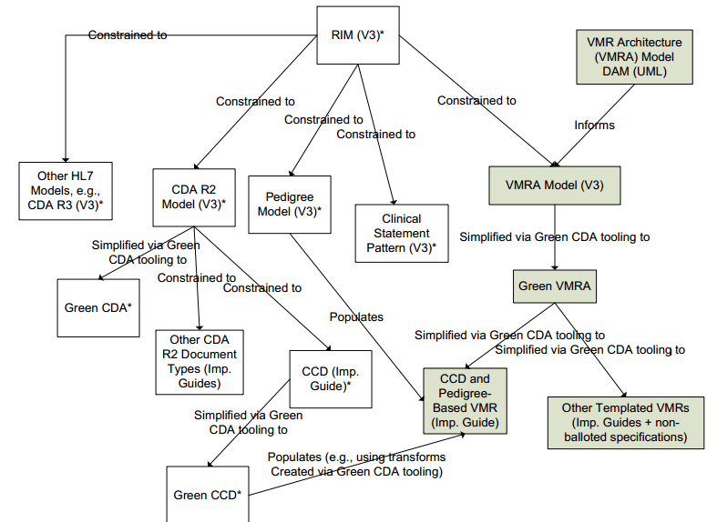

# VMR输入输出分析

2007年HL7 CDS工作组启动了CDS VMR的计划 旨在确定如何在临床信息系统和CDSS服务组件传输数据。

最开始考虑的慢病管理的业务场景 主要是分析2型糖尿病，高血压，乳腺癌和无症状性颅内动脉瘤四种需要哪些数据项 解决输入是什么，DSS服务会反馈些什么，解决输出是什么，理论依据是慢病管理的临床指南。

结论如下：

1: 2型糖尿病; 2: 高血压; 3: 乳腺癌风险评估; 4: 无症状性颅内动脉瘤

|  |  |  |  |  |  |
| --- | --- | --- | --- | --- | --- |
| Vmr 输入 | 场景  1 | 2 | 3 | 4 | HL7 Care Record DSTU对应的字段 |
| Patient - Identifier | X | X | X | X | Patient.id |
| Patient - Gender | X | X | X | X | CareStatement Observation |
| Patient - Date of Birth | X | X | X | X | Person.birthTime |
| Patient – Height; Weight; Blood Pressure | X | X | X | X | CareStatement Observation |
| Patient - Race | X |  | X | X | Person.raceCode |
| Patient – Symptoms | X |  | X | X | CareStatement Observation |
| Patient – Diagnoses (past; present) | X | X | X | X | CareStatement Observation |
| Patient – Allergies |  |  |  |  | CareStatement Observation |
| Patient – Lab Test Results | X | X | X | X | CareStatement Observation |
| Patient – Genetic Results |  |  | X | X | Clinical Genomics Genotype |
| Patient-Radiology Results | X | X | X | X | CareStatement Observation |
| Patient – Surgical Procedures | X |  | X | X | CareStatement Procedure |
| Patient - Medications | X | X | X | X | CareStatement SubstanceAdministration |
| Patient - Pregnancy Status | X |  | X | X | CareStatement Observation |
| Patient – Menopausal Status | X |  | X | X | CareStatement Observation |
| Patient – Wish to have additional children | X |  | X | X | CareStatement Observation |
| Patient – Smoking Status |  | X | X | X | CareStatement Observation |
| Family History of Disease: - Relative Id | X | X | X | X | Clinical Genomics Pedigree |
| Family History of Disease: - Relative Type | X | X | X | X |  |
| Family History of Disease: - Relative Diagnosis | X | X | X | X |  |
| Family History of Disease: - Age of Onset | X | X | X | X |  |
| Family History of Disease: - Age at Death | X | X | X | X |  |
| Clinical Examination– Assessment/Observation Description | X |  |  | X | CarePlan: PlannedCare ObservationIntent |
| Clinical Examination – Assessment/Observation Recommendation | X |  |  | X | CarePlan: PlannedCare ObservationIntent |
| Answers to Risk Assessment  Questionnaires | X | X | X | X | CarePlan: PlannedCare ObservationIntent |
| Request for CDS Risk Assessment |  |  | X |  | CarePlan ProcedureIntent |
| CDS Recommended Action  Confirmed Or Declined | X | X | X | X | CarePlan: PlannedCareActIntent |

输出

|  |  |  |  |  |  |
| --- | --- | --- | --- | --- | --- |
| vMR  CDS输出 | 1 | 2 | 3 | 4 | HL7 Care Record DSTU对应的字段 |
| Patient - Identifier |  |  |  |  | Patient.id |
| Risk Assessment Questions & Potential Responses |  |  |  |  | CarePlan: DefinedCare ObservationDefinition |
| CDS Alerts |  |  |  |  | CarePlan ActDefinition |
| CDS Decision Recommendations**: |  |  |  |  | CarePlan ActDefinition |
| - Supporting Arguments |  |  |  |  | To be decided |
| - Argument Pros & Cons |  |  |  |  | To be decided |
| - Provenance for Arguments |  |  |  |  | To be decided |
| CDS Recommended Actions  (Dynamically Generated Order Set) |  |  |  |  | CarePlan: DefinedCare ActDefinition |
| Executable Guideline State Audit File |  |  |  |  | To be decided |
| **Types of CDS Recommendations |  |  |  |  |  |
| CDS Differential Diagnosis |  |  |  |  |  |
| - Diagnosis Options |  |  |  |  | CarePlan: DefinedCare ObservationDefinition |
| - Supporting arguments |  |  |  |  | To be decided |
| - Provenance for Arguments |  |  |  |  | To be decided |
|  |  |  |  |  |  |
| CDS Risk Determination: |  |  |  |  |  |
| - Risk Assessment Score (numeric) |  |  |  |  | CarePlan: DefinedCare ObservationDefinition |
| - Risk Assessment Options (categoric) |  |  |  |  | CarePlan: DefinedCare ObservationDefinition |
| - Supporting Arguments |  |  |  |  | To be decided |
| - Provenance for Arguments |  |  |  |  | To be decided |
| CDS Disease Stage/Classification: |  |  |  |  |  |
| - Disease Stage Options |  |  |  |  | CarePlan: DefinedCare ObservationDefiniton |
| - Supporting Arguments |  |  |  |  | To be decided |
| - Provenance for Arguments |  |  |  |  | To be decided |
| **Types of CDS Recommendations |  |  |  |  |  |
| CDS Therapeutic Recommendations |  |  |  |  |  |
| - Drug Therapy Options |  |  |  |  | CarePlan: DefinedCare SubstanceAdmnDefinition |
| - Non-drug Therapy Options |  |  |  |  |  |
| Procedures |  |  |  |  | CarePlan: DefinedCare  ProcedureDefinition |
| - Supporting arguments |  |  |  |  | To be decided |
| - Provenance for Arguments |  |  |  |  | To be decided |
| CDS Target/Goals: |  |  |  |  |  |
| - Target/Goal Options |  |  |  |  | CarePlan: DefinedCare ObservationDefinition ObservationGoal |
| - Supporting Arguments |  |  |  |  | To be decided |
| - Provenance for Arguments |  |  |  |  | To be decided |
| CDS Follow-up Recommendations |  |  |  |  |  |
| - Follow-up Options |  |  |  |  | CarePlan: DefinedCare EncounterDefinition |
| - Supporting Arguments |  |  |  |  | To be decided |
| - Provenance for Arguments |  |  |  |  | To be decided |
| CDS Clinical Progress |  |  |  |  |  |
| - Clinical Progress Options |  |  |  |  | CarePlan: DefinedCare  ObservationDefinition |
| - Supporting arguments |  |  |  |  | To be decided |
| - Provenance for Arguments |  |  |  |  | To be decided |

备注：

1. CareStatement表示向CDS服务提供的病人数据
2. CarePlan DefinedCare表示CDS服务输出，提供的临床指南的建议
3. CarePlan PlannedCare表示医务人员对于临床指南中建议的反馈