Christian Todhunter

06/02/2020

IT FDN 100 A

Assignment07

<https://github.com/CtodGit/IntroToProg-Python-Mod08>

Objects and Files

# Introduction to Module 08

In Module08, we learn all about objects and classes. We have used objects in past assignments but not to this intensity. This assignment was tough! I am a day late… again. I ran out of time basically, but I got working code that uses objects in a list, prints their attribute values to a file, then populates a list with objects again.

For classes we reviewed the standard class pattern, which came in handy for writing the code for the Product Class. Let’s get to the assignment though.

## The Assignment Requirements

We were given a starter file that had some classes and starter code already in it. There were to-do notes that acted as a guide, along with the pseudo-code at the end of the file. We were supposed to print a menu, let the user chose, then get data from the user to populate object attributes, store the object to a list, write the data to a file, and all of that was also done in reverse for opening a file with existing data.

# First there were Dictionaries

My biggest tribulation for this assignment was that I had working code 6 hours ago. It technically used an object but then almost immediately took the data from the object and stored it in a dictionary row, which then populated a list. When first reading through the assignment I thought this was all that was needed, however after more thought I decided the intent was to do the same without the use of dictionaries, so I started making changes and, while I learned a lot, this was my main reason for spending probably 15 hours in-all on this assignment. For reference, you can view a screen shot of assignment 6 where we did pretty much the same with dictionaries below, see Figure 1:

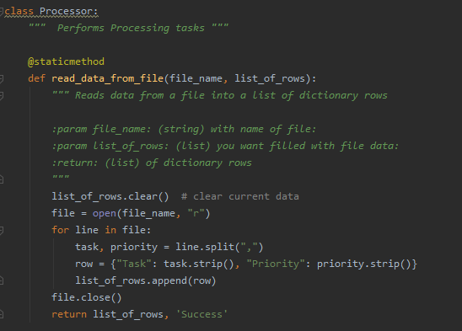

Figure : Assignment06 example with dictionaries

# p1 = row

P1 = row. That was my big epiphany. I was trying to unpack each row in the file like it was a dictionary item or tuple, only to realize I could use the attributes of the Product Class I created to unpack it instead. Compared to Figure 1, you can see how the code gets simpler when using objects:

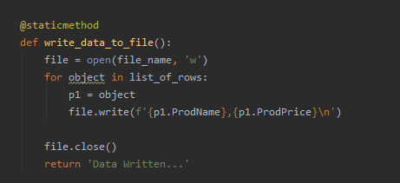

Figure : Objects compared to Figure 1 Assignment 06

Once I realized Python was recognizing the list item in list_of_rows as an object, I realized I could assign each row in object name and this would be similar to creating a new object and using the attributes to enter or pull data from it.

# My Approach to Learning for this Assignment

For this assignment I took the same approach as in past assignments. I watched the video, read the text, checked out the linked webpage in the assignment file. For whatever reason I just wasn’t realizing that python could detect the type of object in the list, in this case, a TypeError lead me to the solution, when I was trying to split rows and it notified my type object does not split.

# formatting the Text File

This was my next issue that I spent a lot of time on. For whatever reason, I could not overwrite the __str__() method and have the attribute values from the object print to the screen or write to the file in the desired comma delimited format. Below is a screen shot of some test code that I got to work, but the same would strangely not work in my Assignment08.py code. See Figure 3 below:

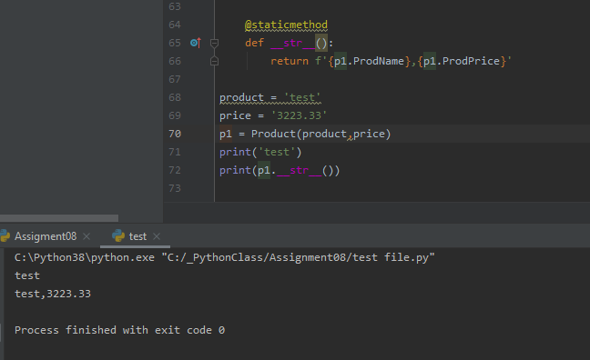

Figure : Test Code for __str__() overwrite

As can be seen in Figure 3, the code in the test file RAN as expected, but when I took the same approach in my assignment code I kept getting p1 not defined errors… I honestly expected this in my test file but, who knows, I would like to know more on how overwriting this method works and to see an example of it executed properly.

# Working Code

Well, eventually, I finally got the code to work. Below is an example of it running in PyCharm (see Figure 4):

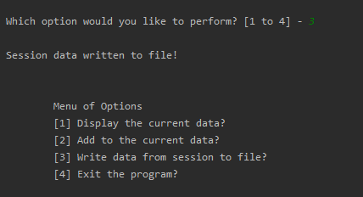

Figure : Writing Data, PyCharm

Also below is another example of the program running in command line (see Figure 5):

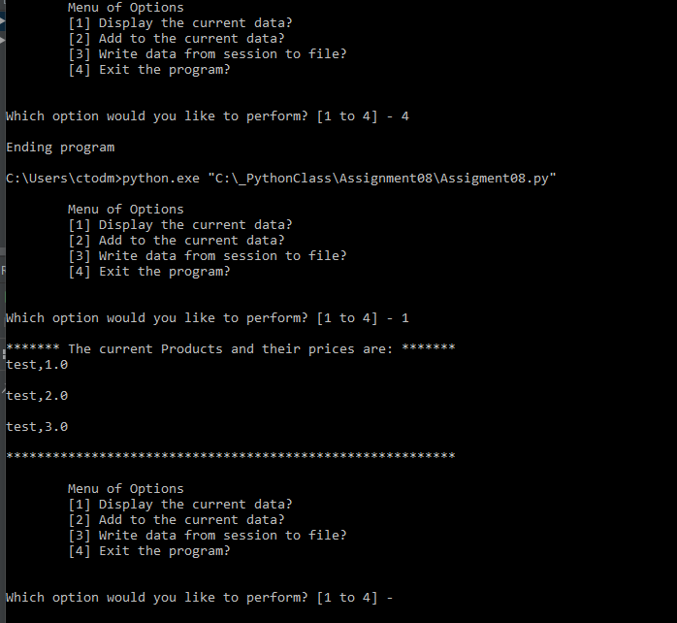

Figure : Assignment08 running in CMD

# Conclusion

Well, there is not much I have to say other than this was a pretty challenging assignment for me. I am glad I decided to take this class because these last couple assignments have taught me a lot. I can see the benefit of object-oriented programming and Classes, as they make the code much more reusable down the road. Looking forward to the next assignment, but I am also fearing it a little ha-ha.