Artificial Intelligence

BS (CS)_SUMMER_2024

Lab_06 Manual

# Learning Objectives:

1. Informed Search Overview
2. Greedy Search
3. A* Search
4. Coding Example for Greedy and A*

# Informed Search

Informed search algorithms, also known as heuristic search algorithms, use problem-specific knowledge to find solutions more efficiently than uninformed search algorithms. These algorithms make use of a heuristic function to estimate the cost of reaching the goal from a given state.

**Heuristics function:** Heuristic is a function which is used in Informed Search, and it finds the most promising path. It provides an **estimate** of the cost from a given node to the goal node. The heuristic method, however, might not always give the best solution, but it guaranteed to find a good solution in reasonable time. Heuristic function estimates how close a state is to the goal. It is represented by **h(n)**, and it calculates the **cost of an optimal path between the pair of states**. The value of the heuristic function is always positive.

Admissibility of the heuristic function is given as:

**h(n) <= h*(n)**

**Here h(n) is heuristic cost, and h*(n) is the estimated cost. Hence heuristic cost should be less than or equal to the estimated cost.**

Two popular informed search algorithms are Greedy Search and A* (A-star).

## Greedy Search:

Greedy Search is an informed search algorithm that always chooses the path that appears to be the best at the current moment. It evaluates each state based solely on the heuristic function, without considering the cost of reaching that state. While Greedy Search can find solutions quickly, it may not always find the optimal solution.

### STEP BY STEP GUIDE:

1. Initialize the *open* list with the *initial* state and its *heuristic* value.
2. Initialize the closed list as empty.
3. While the *open* list is *not empty*:
   * Remove the state with the lowest heuristic value from the *open* list.
   * If the *state* is the *goal* state, *return* the path to the *goal*.
   * Otherwise, *expand* the *state* and add its neighbors to the *open* list with their *heuristic*

values.

* + Add the current *state* to the *closed* list.

1. If the *open* list is *empty* and the goal state has not been found, *return failure*.

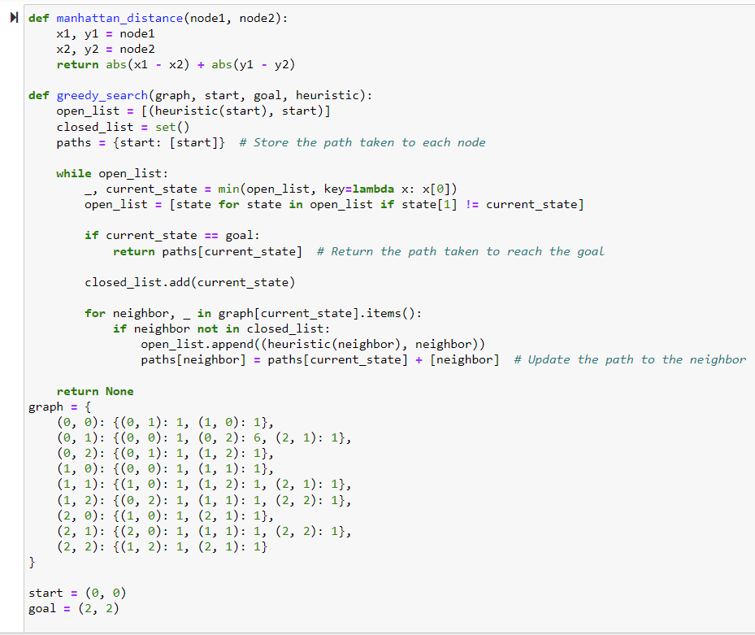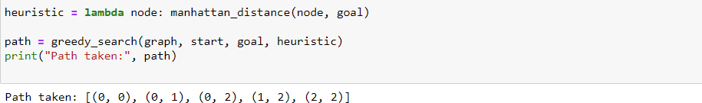

## A* Search:

A* is a widely used informed search algorithm that efficiently finds the lowest cost path between two nodes in a graph, but it incorporates heuristic information for the guided search. A* combines the cost to reach a node from the start node (g(n)/g_score) and a heuristic estimate of the cost to reach the goal from that node (h(n)/h_score). It selects nodes to expand based on the sum of g_score and h_score (which is f(n)/ f_score), choosing the node that minimizes this sum.

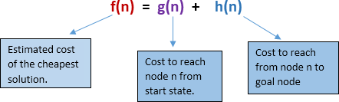A* uses a heuristic function to estimate the cost from each node to the goal. This heuristic guides the search towards the goal, making A* more efficient than UCS in many cases.

### STEP BY STEP GUIDE:

1. Initialize the open list with the initial state and its f-score to be the heuristic estimate from the initial state to the goal.
2. Initialize the closed list as empty.
3. While the open list is not empty:
   * Remove the state with the lowest f-score from the open list.
   * If the state is the goal state, return the path to the goal.
   * Otherwise, expand the state and add its neighbors to the open list with updated f scores.
   * Add the current state to the closed list. If the open list is empty and the goal state has not been found, return failure.
4. If the open set is empty and the goal has not been reached, return failure.

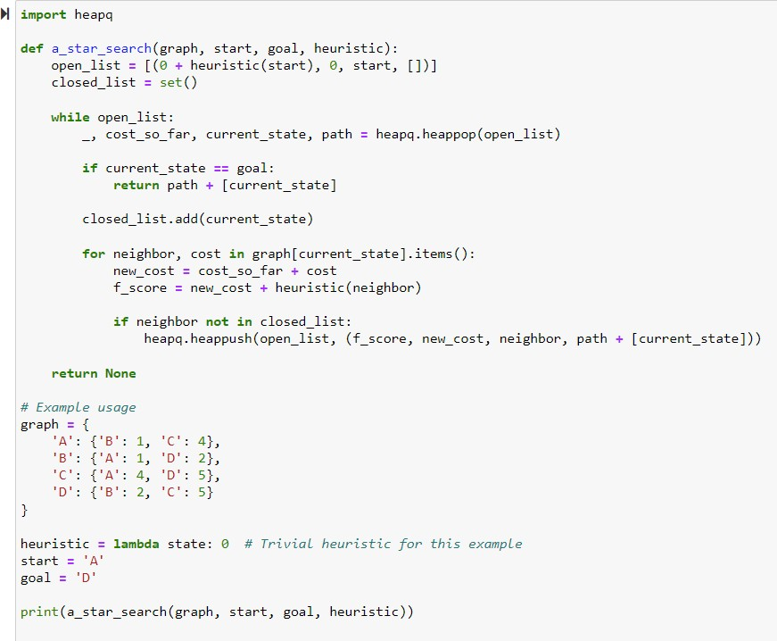

## Coding Example for Greedy and A* Searches:

### Finding Distance Between States

import math import heapq

# City map with distances between neighboring cities city_map = {

'New York': {'Philadelphia': 80, 'Boston': 215}, 'Philadelphia': {'New York': 80, 'Washington D.C.': 135}, 'Boston': {'New York': 215, 'Providence': 50},

'Washington D.C.': {'Philadelphia': 135, 'Richmond': 95},

'Providence': {'Boston': 50}

}

# Euclidean distance between cities (approximation) def euclidean_distance(city1, city2):

city_coords = {

'New York': (40.7128, -74.0060),

'Philadelphia': (39.9526, -75.1652),

'Boston': (42.3601, -71.0589),

'Washington D.C.': (38.9072, -77.0369),

'Providence': (41.824, -71.4128)

}

lat1, lon1 = city_coords[city1] lat2, lon2 = city_coords[city2]

return math.sqrt((lat2 - lat1)**2 + (lon2 - lon1)**2)

#Greedy Search

def greedy_search(start_city, goal_city, heuristic):

open_list = [(heuristic(start_city, goal_city), start_city)] closed_list = set()

path = {start_city: [start_city]} # Store the path taken to each city

while open_list:

_, current_city = min(open_list, key=lambda x: x[0])

open_list = [state for state in open_list if state[1] != current_city]

if current_city == goal_city:

return path[current_city] # Return the path taken to reach the goal closed_list.add(current_city)

for neighbor, _ in city_map[current_city].items():

if neighbor not in closed_list: open_list.append((heuristic(neighbor, goal_city), neighbor))

path[neighbor] = path[current_city] + [neighbor] # Update the path to the neighbor return None

#A* Search

def a_star_search(start_city, goal_city, heuristic):

open_list = [(0, start_city)] closed_list = set() cost_so_far = {start_city: 0}

path = {start_city: [start_city]} # Store the path taken to each city

while open_list:

_, current_city = heapq.heappop(open_list)

if current_city == goal_city:

return path[current_city] # Return the path taken to reach the goal closed_list.add(current_city)

for neighbor, distance in city_map[current_city].items():

new_cost = cost_so_far[current_city] + distance

if neighbor not in cost_so_far or new_cost < cost_so_far[neighbor]: cost_so_far[neighbor] = new_cost

f_score = new_cost + heuristic(neighbor, goal_city) heapq.heappush(open_list, (f_score, neighbor))

path[neighbor] = path[current_city] + [neighbor] # Update the path to the neighbor return None

#Performing Searches start_city = 'New York' goal_city = 'Washington D.C.' heuristic = euclidean_distance

greedy_path = greedy_search(start_city, goal_city, heuristic) a_star_path = a_star_search(start_city, goal_city, heuristic)

print("Greedy Search Path:", greedy_path) print("A* Search Path:", a_star_path)