CD Archive
(Java 2 Assignment)

Student: Joel Gallaher
Date: 02/11/2020

Unit: ICTPRG523
Teacher: Mark O’Reilly

Contents

IPO Chart 4
TOE Chart 5
Stylised Data Flow 5
Selected Pseudo Code 6
Displaying and Saving Records 6
DisplayRecord (CurrentRecord) 6
SaveRecord (CurrentRecord) 6
File data handling methods – read and write file 7
ReadFile 7
WriteFile 7
Navigation Button Code 8
First 8
Last 8
Previous 8
Next 9
Navigation Button Code 10
New 10
Save 10
Exit 10
Delete 10
Find 11
Structured Chart(s) 12
Managing the GUI elements 12
Managing the user Actions 12
Class diagram 13
Testing 14
Test Plan 14
Test Cases: 15
Evidence of Debugging 16
System generated program documentation 17
User Manual for: Sample IP Database 18
Example 1 … (Partial sample only) 18
Example 2 … (Partial sample only) 19

IPO Chart

Input | Process | Output | Storage
CDRecords from the data file:  - Title, Author, Location, Barcode, Description, Loan status | - Open the file  - Read the first line  - Save the entry into a CDRecord stored in an ArrayList.  - Repeat until there are no lines to be read. | - Load the ArrayList data to a Jtable and display it on screen. | Data File  Temporary storage in ArrayList
- New Item button  - Enter data – Title, Author, Location, Barcode, Description, Loan status  - Save/Update button | - Clear the JtextFields needed for new data to be entered.  - User to enter new information.  - Save the entered data as a CDRecord in the ArrayList and the ArrayList to the data file. | - Display the new CDRecord as a row in the Jtable. | Data file  Updated records temporarily stored in ArrayList
- Search String and Search button | - Filter the Jtable rows using a TableRowSorter displaying only those that contain a match for the search string. | - CDRecords that contain the text in the search string are displayed on screen.
- By Title, By Author, By Barcode buttons. | - Sort the CDRecords in the ArrayList by the selected value through a sorting algorithm.  - Call TableModel method fireTableDataChanged(). | Jtable displays newly sorted ArrayList on screen. | Updated records temporarily stored in ArrayList
- Process Log button | - JtextArea is cleared of previous text and appended with strings from doubly linked list. | JtextArea displays process log entries on screen. | Process Logs temporarily stored in Doubly Linked List
- Pre/In/Post Order buttons | - CDRecords from ArrayList are added to a new BinaryTree using the Barcode as the key.  - BinaryTree is traversed in the order according to the button that was pressed and CDRecords are stored in a new ArrayList.  - JtextArea cleared of previous text and appended with each CDRecord in the ArrayList. | JtextArea displays traversed CDRecords on screen. | New BinaryTree temporary stores CDRecords.  After traversal, ArrayList temporarily stores CDRecords.
- Display button  - Save button | - A HashMap is populated with all CDRecords from ArrayList using the Barcode as the Key.  - JTextArea cleared of previous text and appended with the entire HashMap.  - Each entry in the HashMap is written as a line in a text file. | JTextArea displays long string of the HashMap on screen. | HashMap temporarily stores CDRecords.  Text file holds saved HashMap entries.
- Retrieve,  - Remove,  - Return,  - Add to Collection,  - Random Collection,  - Mostly Sorted,  - Reverse Order buttons  - Process button | - Message sent to Automation Console with instructions to manipulate the physical CDs. A CD can be retrieved for loaning, returned after a loan, removed for deletion, added as a new CD. A section of CDs can be sorted through the selected sorting algorithm.  - Message processed by the Automation Console and returned once the instructions are completed.  - Messages sent and received are added as a String to the Doubly Linked List of process logs. | JTextArea displays process log entries on screen. | Doubly Linked List temporarily stores messages as process logs.
- Exit button | - Closes only the appropriate Console window. Both consoles have a separate exit button each. | Console window closes, exiting the application. | Temporary ArrayList, HashMap and other variables are lost. Data file storing CDRecords and Text file storing HashMap entries remain on Disk.

TOE Chart

Task | Object | Event
Load CDRecords from data file | ArrayList | Open
Clear TextFields ready for new entry | New Item button | Click
Save the current entry and then all entries to a clean copy of the data file | Save/Update button | Click
Display the current selected entry for editing or processing | Jtable cdRecordTable | Click
Filter the table to find a specific record | Search button | Click
Sort the table by Title/Author/Barcode | By Title, By Author, By Barcode buttons | Click
Display process logs | Process Log button | Click
Display binary tree traversal | Pre/Post/In Order buttons | Click
Display hash map | Display button | Click
Save hash map to text file | Save button | Click
Retrieve CD to be loaned | Retrieve button | Click
Remove CD to be deleted | Remove button | Click
Return CD from being loaned | Return button | Click
Add new CD to collection | Add to Collection button | Click
Sort section of CD collection from random | Random Collection Sort button | Click
Sort section of CD collection from mostly sorted | Mostly Sorted Sort button | Click
Sort section of CD collection from reverse order | Reverse Order Sort button | Click
Process command sent from Automation Console | Process button | Click
Exit program | Exit button | Click

Selected Pseudo Code
NOTE: At least 6 non-trivial sets of pseudo code are required.

loadRecordList(filepath)
Create new ArrayList variable
Read lines of data from file at filepath
while the next line is not null
Split each line of data into a string array
Create a new CDRecord using the data in the array
add the CDRecord to the ArrayList
return the ArrayList of CDRecords

saveRecordList(filepath, ArrayList)
For each CDRecord in the ArrayList
convert the data from the CDRecord into a string
write the string at the filepath location
write a new line
Flush the BufferedWriter
Close the BufferedWriter

clearRecordPanel()
Clear the title text field
Clear the author text field
Clear the section text field
Clear the X text field
Clear the Y text field
Clear the barcode text field
Clear the description text field
Clear the temporary CDRecord

populateCreateRecordPanel(CDRecord)
Create temporary CDRecord from CDRecord given to the function
Set title text field to title from CDRecord
Set author text field to author from CDRecord
Set section text field to section from CDRecord
Set X text field to X from CDRecord
Set Y text field to Y from CDRecord
Set barcode text field to barcode from CDRecord
Set description text field to description from CDRecord

preOrderButton.addActionListener(button click event)

Instantiate new binary tree
For each CDRecord in the ArrayList
Insert the CDRecord in the binary tree
Traverse the binary tree using pre order traversal adding nodes visited to a new ArrayList
For each node in the ArrayList
Append the node’s data to the process log’s text area.

displayButton.addActionListener(button click event)

For each CDRecord in the ArrayList
Put the CDRecord in the recordHashMap using the Barcode as the key.
Append recordHashMap to the process log’s text area as a single string.

Data Flow Diagrams
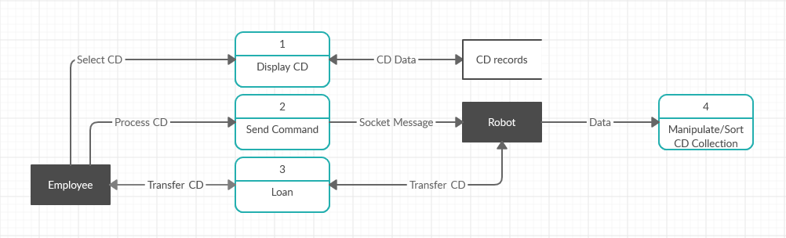

Structured Chart(s)

Class diagram
(Using ESSModel.EXE (supplied in Third Party Material)):

See attached file: essscreenshots

Testing

Test Plan

The approach to testing that will be used is as follows:

- Review the project requirements
- Prepare a solution design
- Develop the required application.
- Unit testing – test each component (method / class) as it is being developed
- Integrated Testing - Prepare a set of data (test cases) to check how the application will behave when appropriate data is read in and entered via the screen.
- Prepare several sets of data (test cases) to check how the application will behave when data that will generate exceptions is read in from the data file.
- Enter several sets of data (test cases) to check how the application will behave when data that will generate exceptions is entered via the screen.
- System Testing – Deploy the application to a computer system / network / web host site similar to that of the client’s and retest selected test cases.
- Acceptance Testing - Deploy the application to the client’s computer system / network / web host site and look to the client to retest using sample live data.
- Archive the test plan, test cases and results to an appropriate backup location.

Test Cases:

Sample data file 1 – Correct operation of load records:

ID;Title;Author;Section;X;Y;BarCode;Description;OnLoan
1;Busn History 2015;Management;B;1;57;43783278;Business History - tax records, events and achievements in 2015;No
2;Busn History 2016;Management;B;1;58;43783279;Business History - tax records, events and achievements in 2016;No
3;Busn History 2017;Management;B;1;59;43784280;Business History - tax records, events and achievements in 2017;No
4;Client A's Project;Dev Team;D;4;7;43784761;Client A's project files and copyright material.;No

Data read and loaded correctly into ArrayList of CDRecords. Correct format is semicolon separated values in the order: ID -> Title -> Section -> X -> Y -> Barcode -> Description -> OnLoan

Sample data file 2 – Testing for exceptions:

ID,Title,Author,Section,X,Y,BarCode,Description,OnLoan
1,Busn History 2015,Management,B,1,57,43783278,Business History - tax records, events and achievements in 2015,No
2,Busn History 2016,Management,B,1,58,43783279,Business History - tax records, events and achievements in 2016,No
3,Busn History 2017,Management,B,1,59,43784280,Business History - tax records, events and achievements in 2017,No
4,Client A's Project,Dev Team,D,4,7,43784761,Client A's project files and copyright material.,No

Index out of bounds exception when separating values by comma. Some titles and descriptions contain commas so this is an undesirable method of value separation.

Additional sample data entries – Correct operation:

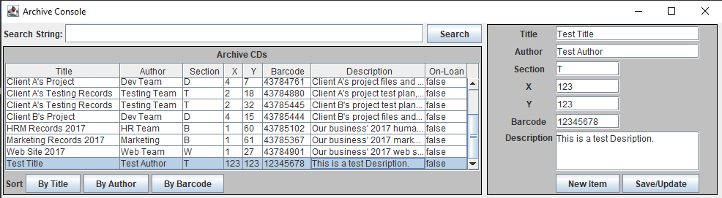

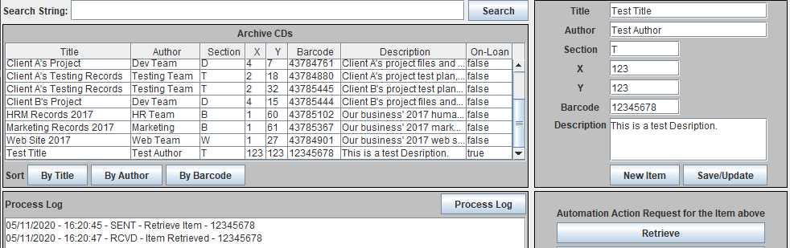

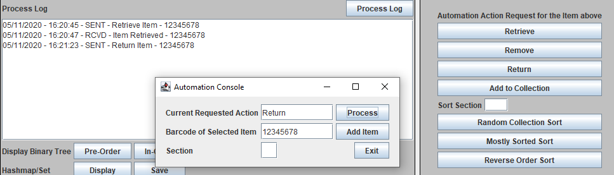

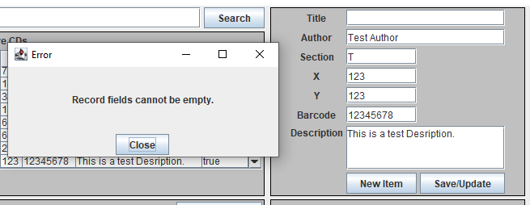

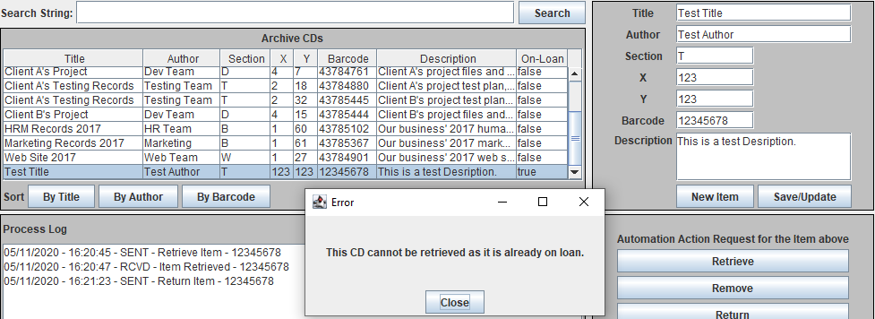

Additional sample data entries – Testing for exceptions:

Using a semicolon should not be done when entering or editing CD data. Design has taken into account possible use of commas as being more common than a semicolon so the record storage file uses semicolons as the value separator. Entering a semicolon in CD data fields will cause load errors and possible data loss.

Only 1 Action Request can be processed at a time. If a second Action Request is sent to the Automation Console, the first Request will be overwritten in the Automation Console and only the second request will be able to be processed. The first Request will need to be resent to be successfully processed.

Additional tests of each of the application buttons:

Search: Correctly filters the table rows by the inputted string. Table filter does not reset when an empty search string is entered. Must add rowfilter reset functionality.

By Title/Author/Barcode: Correctly uses modified sorting algorithm and sorted array list is reflected in updated table view.

New Item: Correctly clears text fields required for entering new CD data.

Save/Update: Correctly updates edited CD to array list. Correctly adds new CD to array list. Does not update the view of the table data. Must implement table data changed method to update table view. Correctly saves updated array list of CDs to specified data file.

Retrieve/Remove/Return/Add: Correctly sends formatted message to server. Message returned from server is correctly added to the process log. Does not stop a CD from being retrieved if it is already on loan among other similar issues. Must add action validation so that only requests that can be actioned are sent.

Random/Mostly/Reverse Sort: Correctly sends formatted message to server. Message returned from server is correctly added to the process log. Does not stop an invalid Section selection from being sent. Must add action validation so that only requests to sort valid sections are sent.

Process Log: Correctly clears the text area then displays the process log in the text area.

Pre/In/Post Order: Correctly populates a binary tree and traverses it using the correct traversal method and shows the data in the text area.

Display: Correctly adds all CD records to a hash map then retrieves the hash map entries and displays them in the text area.

Save: Correctly writes the hash map to a text file as one long string.

Process: Correctly returns messages confirming the completion of all action requests.

Results of testing:

Testing has revealed several areas that need further development before the application will be ready for publishing. Most functions were tested successfully. One issue remains with the file system we have decided to use but it has been chosen as the least dangerous option. We will add validation when the user tries add or edit a CD with an empty text field or using a semicolon in one of the text fields and show an error window informing the user how to add or edit a CD correctly. We will also add validation to the action requests panel to check a CD’s status before sending a possibly invalid request (loaning or removing a CD that is already loaned, returning a CD that is not on loan, adding a CD that already exists in the collection, sorting an invalid section).

Evidence of Debugging

Two to three screen images demonstrating debugging:

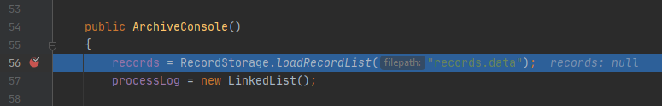

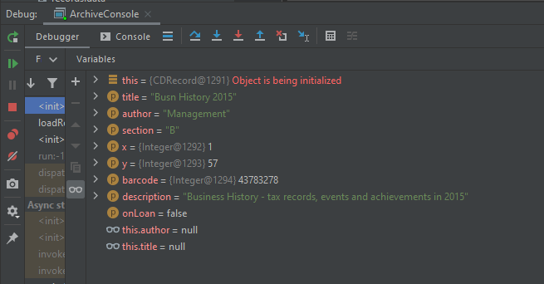

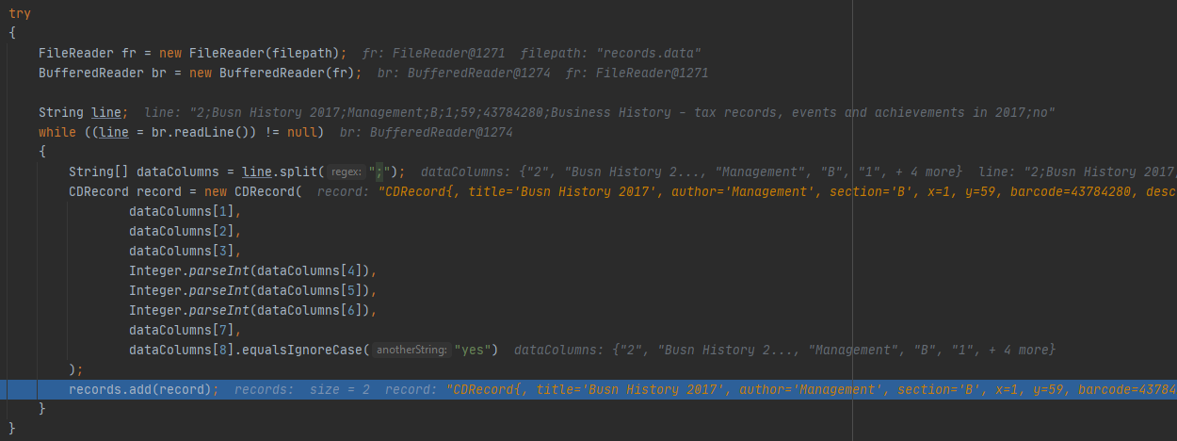

System generated program documentation

See Javadoc folder.

Evidence of using Version Control Software

Screenshot of GitHub repository.

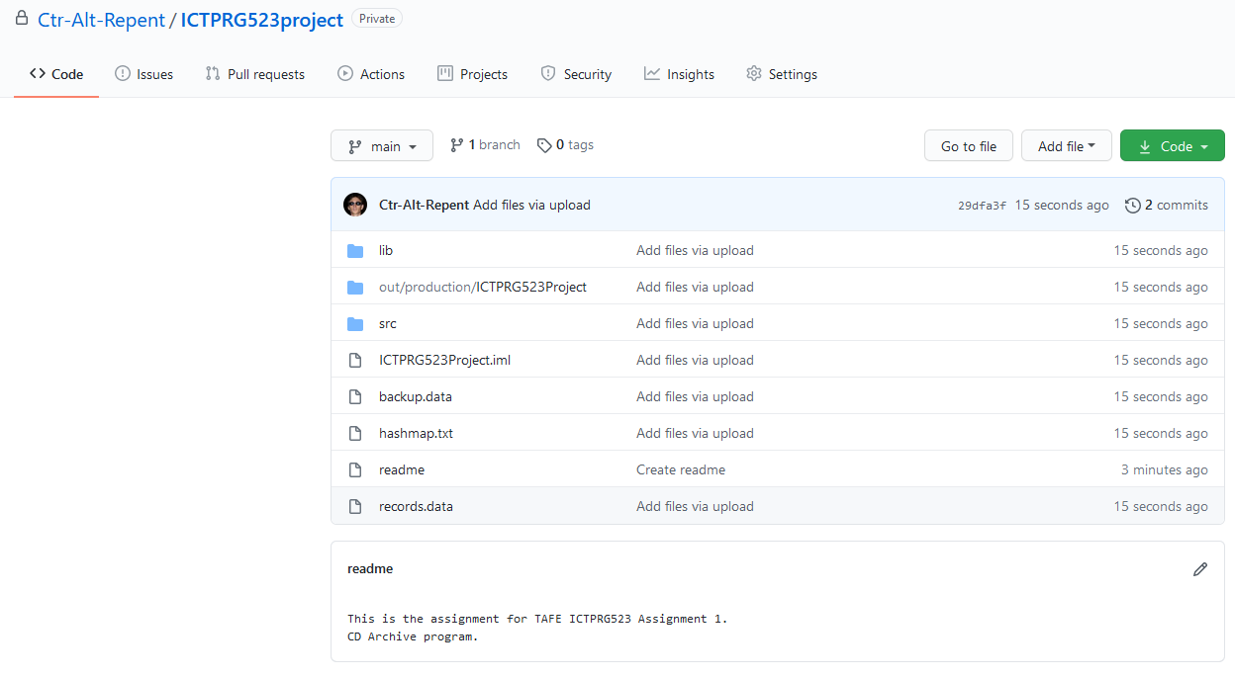

User Manual for: CD Archive Management Program
Prepared for: Sample Business/Organisation
Author: <Joel Gallaher>
Date Prepared: 6/11/2020

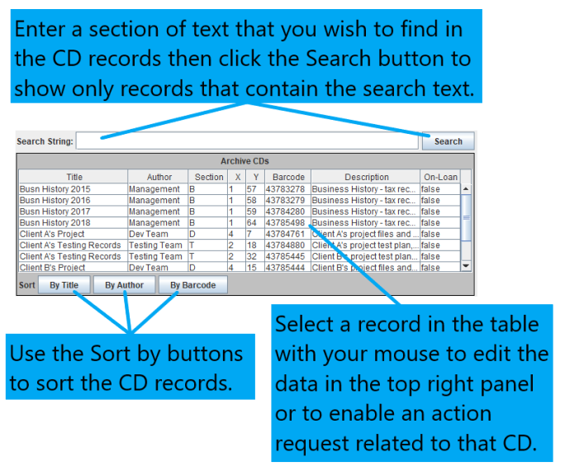

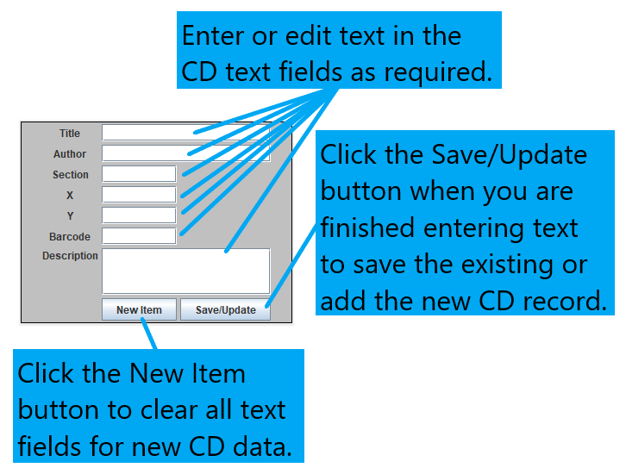
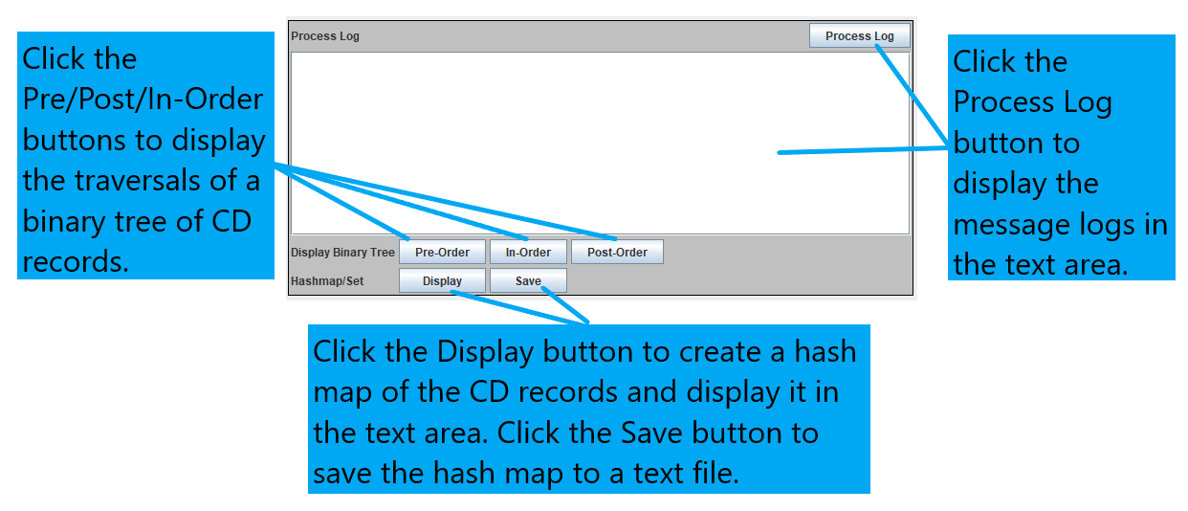
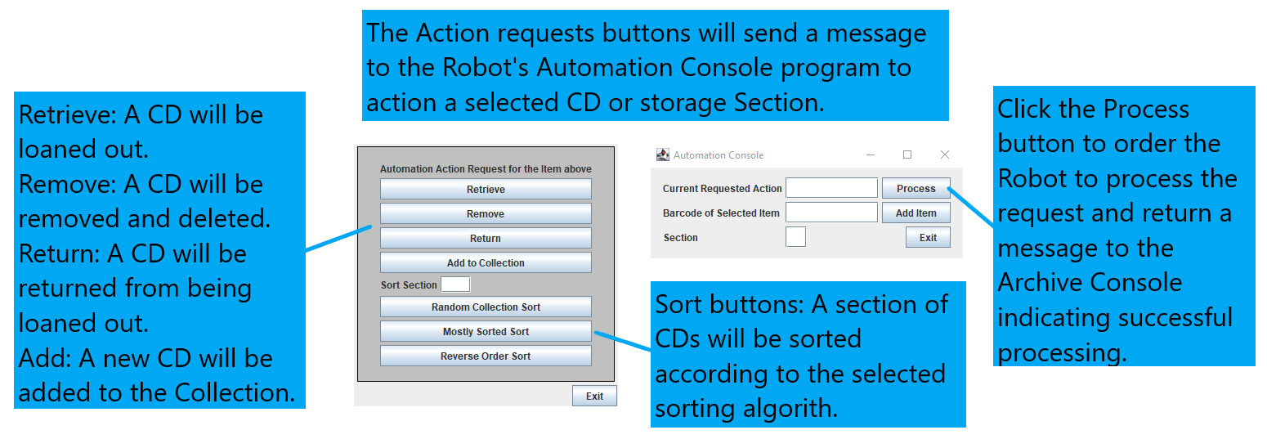

Evidence of correspondence with your Manager and Client
--------------------------------------------------------------------------------------------------------------------------------------
To: Project Manager
From: Joel Gallaher (Lead Programmer)
CC: Software Development Team
Date: 17/10/2020
Subject: Project specifications, templates and guidelines.
--------------------------------------------------------------------------------------------------------------------------------------
Hello Project Manager,

I am requesting that you send me the program specifications, Implementation template, technical
report template, business case scenario and programming guidelines before beginning work on
developing the project application.

Regards,
Joel Gallaher
--------------------------------------------------------------------------------------------------------------------------------------
Joel Gallaher (Lead Programmer)
joel.gallaher@gmail.com
--------------------------------------------------------------------------------------------------------------------------------------

--------------------------------------------------------------------------------------------------------------------------------------
To: Project Managers
From: Joel Gallaher (Lead Programmer)
CC: Software Development Team
Date: 17/10/2020
Subject: Third party libraries.
--------------------------------------------------------------------------------------------------------------------------------------
Hello Project Manager,

I am proposing to use the third party library for StringUtils provided by Apache Commons. This library
is free to use under the Apache Commons License and provides useful methods for dealing with Strings
and data validation of the CD data.
Following your approval I will email the client regarding the use of this library.

Regards,
Joel Gallaher
--------------------------------------------------------------------------------------------------------------------------------------
Joel Gallaher (Lead Programmer)
joel.gallaher@gmail.com
--------------------------------------------------------------------------------------------------------------------------------------
--------------------------------------------------------------------------------------------------------------------------------------
To: Client
From: Joel Gallaher (Lead Programmer)
CC: Software Development Team
Date: 17/10/2020
Subject: Third Party Libraries.
--------------------------------------------------------------------------------------------------------------------------------------
Hello Client,

I am emailing to advise you that we are using a third party library in the development of your product.
This external library is free to use under the Apache Commons License. The Commons library gives
us the use of several programming methods to ensure the level of data validation meets your product
requirements.

Regards,
Joel Gallaher
--------------------------------------------------------------------------------------------------------------------------------------
Joel Gallaher (Lead Programmer)
joel.gallaher@gmail.com
--------------------------------------------------------------------------------------------------------------------------------------

--------------------------------------------------------------------------------------------------------------------------------------
To: Project Manager
From: Joel Gallaher (Lead Programmer)
CC: Software Development Team
Date: 17/10/2020
Subject: Project development complete.
--------------------------------------------------------------------------------------------------------------------------------------
Hello Project Manager,

I am confirming that the development process is complete and meets all current client requirements
after testing and further development and debugging and a second round of testing was carried out.
The product is ready to be deployed to the client’s systems.

Current known issues regard the action requests being uncompleted if a second request is sent before
the first can be processed. Another area of concern may appear if the Client wishes to run the
Archive Console program from more than one machine. Without updating the Automation console
multiple processes sent from different machines will again override other requests or be overwritten
by newer requests before they can be processed as the Automation Console has no request queue.

Regards,
Joel Gallaher
--------------------------------------------------------------------------------------------------------------------------------------
Joel Gallaher (Lead Programmer)
joel.gallaher@gmail.com
--------------------------------------------------------------------------------------------------------------------------------------
--------------------------------------------------------------------------------------------------------------------------------------
To: Client
From: Joel Gallaher (Lead Programmer)
CC: Software Development Team
Date: 17/10/2020
Subject: Project development complete.
--------------------------------------------------------------------------------------------------------------------------------------
Hello Client,

I am emailing to confirm that the development stage of your product is complete and ready to be deployed
to your systems. Please speak to our Project Manager to confirm a deployment schedule for your product.

Regards,
Joel Gallaher
--------------------------------------------------------------------------------------------------------------------------------------
Joel Gallaher (Lead Programmer)
joel.gallaher@gmail.com
--------------------------------------------------------------------------------------------------------------------------------------

