目录
// nginx.conf 2
//获取真实ip： 6

目前长短连接交互，我都是协议里带上子服务器的私有域名来定向请求的，确保同一台服务器处理
这个代理服务器配置肯定要很好才行，不然宕机了不是完了.估计后面还得在子服务器上加层dns负载均衡

session没做同步，打算用nginx 的iphash来路由同一个客户端的请求..

基本配置upstream结构：
https://www.nginx.com/resources/wiki/start/topics/examples/loadbalanceexample/
实际部署：nginx.conf：
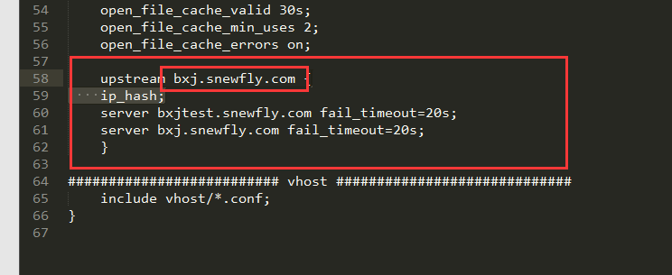

slb.snewfly.com.conf：
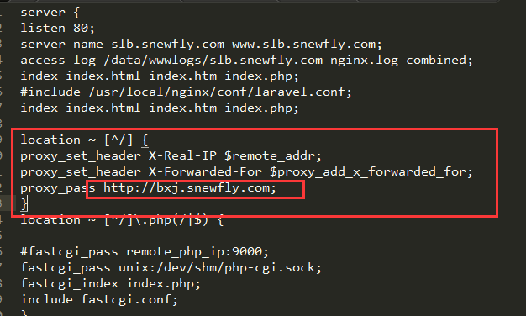

实际生产中由于session同步问题，采用iphash：而不是权重
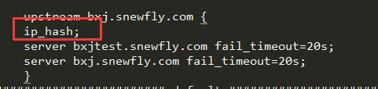

唯一的坑是名字必须是域名中的第二个，多个域名的还有待研究
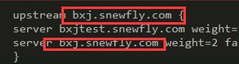

// nginx.conf
//正确配置，记得去掉default
user www www;
worker_processes auto;

error_log /data/wwwlogs/error_nginx.log crit;
pid /var/run/nginx.pid;
worker_rlimit_nofile 51200;

events {
use epoll;
worker_connections 51200;
multi_accept on;
}

http {
include mime.types;
default_type application/octet-stream;
server_names_hash_bucket_size 128;
client_header_buffer_size 32k;
large_client_header_buffers 4 32k;
client_max_body_size 1024m;
sendfile on;
tcp_nopush on;
keepalive_timeout 120;
server_tokens off;
tcp_nodelay on;

fastcgi_connect_timeout 300;
fastcgi_send_timeout 300;
fastcgi_read_timeout 300;
fastcgi_buffer_size 64k;
fastcgi_buffers 4 64k;
fastcgi_busy_buffers_size 128k;
fastcgi_temp_file_write_size 128k;

#Gzip Compression
gzip on;
gzip_buffers 16 8k;
gzip_comp_level 6;
gzip_http_version 1.1;
gzip_min_length 256;
gzip_proxied any;
gzip_vary on;
gzip_types
text/xml application/xml application/atom+xml application/rss+xml application/xhtml+xml image/svg+xml
text/javascript application/javascript application/x-javascript
text/x-json application/json application/x-web-app-manifest+json
text/css text/plain text/x-component
font/opentype application/x-font-ttf application/vnd.ms-fontobject
image/x-icon;
gzip_disable "MSIE [1-6]\.(?!.*SV1)";

#If you have a lot of static files to serve through Nginx then caching of the files' metadata (not the actual files' contents) can save some latency.
open_file_cache max=1000 inactive=20s;
open_file_cache_valid 30s;
open_file_cache_min_uses 2;
open_file_cache_errors on;

upstream bxj.snewfly.com {
server bxjtest.snewfly.com weight=1 fail_timeout=20s;
server bxj.snewfly.com weight=2 fail_timeout=20s;
}
######################## default ############################

########################## vhost #############################
include vhost/*.conf;
}

//错误示范（多了default，导致nginx走本地ip/test）
user www www;
worker_processes auto;

error_log /data/wwwlogs/error_nginx.log crit;
pid /var/run/nginx.pid;
worker_rlimit_nofile 51200;

events {
use epoll;
worker_connections 51200;
multi_accept on;
}

http {
include mime.types;
default_type application/octet-stream;
server_names_hash_bucket_size 128;
client_header_buffer_size 32k;
large_client_header_buffers 4 32k;
client_max_body_size 1024m;
sendfile on;
tcp_nopush on;
keepalive_timeout 120;
server_tokens off;
tcp_nodelay on;

fastcgi_connect_timeout 300;
fastcgi_send_timeout 300;
fastcgi_read_timeout 300;
fastcgi_buffer_size 64k;
fastcgi_buffers 4 64k;
fastcgi_busy_buffers_size 128k;
fastcgi_temp_file_write_size 128k;

#Gzip Compression
gzip on;
gzip_buffers 16 8k;
gzip_comp_level 6;
gzip_http_version 1.1;
gzip_min_length 256;
gzip_proxied any;
gzip_vary on;
gzip_types
text/xml application/xml application/atom+xml application/rss+xml application/xhtml+xml image/svg+xml
text/javascript application/javascript application/x-javascript
text/x-json application/json application/x-web-app-manifest+json
text/css text/plain text/x-component
font/opentype application/x-font-ttf application/vnd.ms-fontobject
image/x-icon;
gzip_disable "MSIE [1-6]\.(?!.*SV1)";

#If you have a lot of static files to serve through Nginx then caching of the files' metadata (not the actual files' contents) can save some latency.
open_file_cache max=1000 inactive=20s;
open_file_cache_valid 30s;
open_file_cache_min_uses 2;
open_file_cache_errors on;

upstream bxj.snewfly.com {
server bxjtest.snewfly.com weight=1 fail_timeout=20s;
server bxj.snewfly.com weight=2 fail_timeout=20s;
}
######################## default ############################
server {
listen 80;
server_name _;
access_log /data/wwwlogs/access_nginx.log combined;
root /var/www/html/InLamp/public;
index index.html index.htm index.php;
include /usr/local/nginx/conf/laravel.conf;
location /nginx_status {
stub_status on;
access_log off;
allow 127.0.0.1;
deny all;
}
location ~ [^/]\.php(/|$) {
#fastcgi_pass remote_php_ip:9000;
fastcgi_pass unix:/dev/shm/php-cgi.sock;
fastcgi_index index.php;
include fastcgi.conf;
}
location ~ .*\.(gif|jpg|jpeg|png|bmp|swf|flv|ico)$ {
expires 30d;
access_log off;
}
location ~ .*\.(js|css)?$ {
expires 7d;
access_log off;
}
}

########################## vhost #############################
include vhost/*.conf;
}

//获取真实ip：
<?php

//测试负载均衡的ip地址
echo 'HTTP_HOST'.$_SERVER['HTTP_HOST'].',REMOTE_ADDR '.$_SERVER["REMOTE_ADDR"].',SERVER_NAME'.$_SERVER['SERVER_NAME'].',getClientIP'.getClientIP();

/**
* 获取客户端ip
*/
function getClientIP() {
$ip = "unknown";
/*
* 访问时用localhost访问的，读出来的是“::1”是正常情况。
* ：：1说明开启了ipv6支持,这是ipv6下的本地回环地址的表示。
* 使用ip地址访问或者关闭ipv6支持都可以不显示这个。
* */
if (isset($_SERVER)) {
if (isset($_SERVER["HTTP_X_FORWARDED_FOR"])) {
$ip = $_SERVER["HTTP_X_FORWARDED_FOR"];
} elseif (isset($_SERVER["HTTP_CLIENT_ip"])) {
$ip = $_SERVER["HTTP_CLIENT_ip"];
} else {
$ip = $_SERVER["REMOTE_ADDR"];
}
} else {
if (getenv('HTTP_X_FORWARDED_FOR')) {
$ip = getenv('HTTP_X_FORWARDED_FOR');
} elseif (getenv('HTTP_CLIENT_ip')) {
$ip = getenv('HTTP_CLIENT_ip');
} else {
$ip = getenv('REMOTE_ADDR');
}
}
if(trim($ip)=="::1"){
$ip="127.0.0.1";
}
return $ip;
}

