教程
http://fideloper.com/ubuntu-beanstalkd-and-laravel4
http://lvwenhan.com/laravel/395.html
/usr/bin/beanstalkd -l 127.0.0.1 -p 11300
1、进入laravel目录，安装
$ cd /path/to/laravel/application
$ composer require pda/pheanstalk ~2.0

在将laravel的queue.php设置下
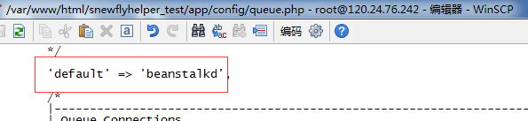
2、写处理功能的类
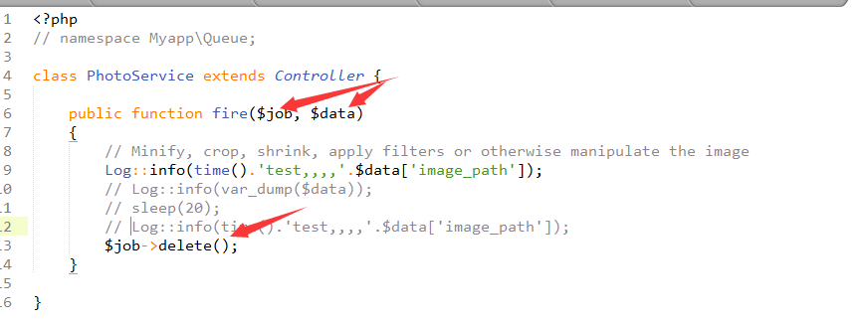
3、写函数执行queue
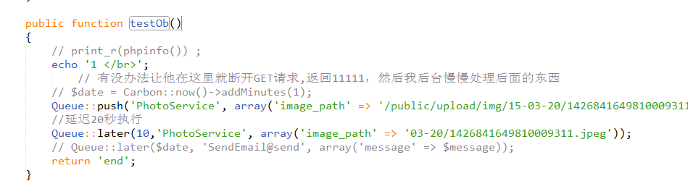

这样并不是后台运行的，还必须安装supervisor
First, we'll install it:
# Debian / Ubuntu:
$ sudo apt-get install supervisor
Next, we'll configure it. We need to define a process to listen to.
$ sudo vim /etc/supervisor/conf.d/myqueue.conf
Add this to your new conf file, changing file paths and your environment as necessary:
[program:myqueue]
command=php artisan queue:queue
directory=/path/to/laravel
stdout_logfile=/path/to/laravel/app/storage/logs/myqueue_supervisord.log
redirect_stderr=true
autostart=true
autorestart=true

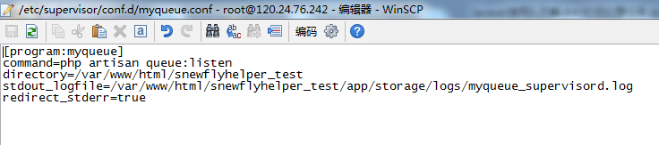

然后执行
$ sudo supervisorctl
> reread # Tell supervisord to check for new items in /etc/supervisor/conf.d/
> add myqueue # Add this process to Supervisord
> start myqueue # May say "already started"
stop myqueue

remove myqueue
Now the "myqueue" process is on and being monitored.
搞定！！

Xiangguanmingling
Php artisan queue::XXXX

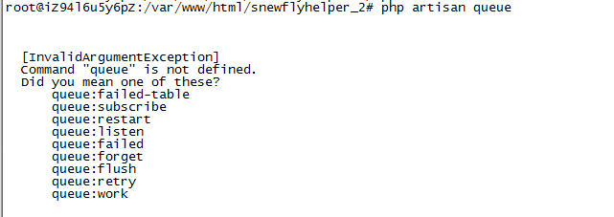

其中
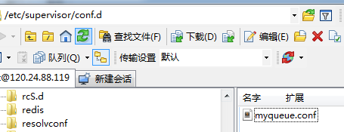
[program:myqueue]
command=php artisan queue:listen
directory=/var/www/html/snewflyhelper_2
stdout_logfile=/var/www/html/snewflyhelper_2/app/storage/logs/myqueue_supervisord.log
redirect_stderr=true
autostart=true
autorestart=true

优化失败次数
[program:bxjqueue]
command=php artisan queue:listen --tries=3
directory=/var/www/html/InLamp
stdout_logfile=/var/www/html/InLamp/storage/logs/bxjqueue_supervisord.log
redirect_stderr=true
autostart=true
autorestart=true

2016-01-07（格外注意env下的变量必须改）（最终redis配置跑不起来[已解决，服务器内存不足原因，开启swap就行了]）

安装 redis
如composer require predis/predis或者在composer配置如下：
"predis/predis": "^1.0",

http://www.tuicool.com/articles/eIr22uN

基于 Redis 实现任务队列的基本配置和使用

配置文件
我们仍然从配置文件开始，首先我们需要在配置文件中配置默认队列驱动为Redis，队列配置文件是 config/queue.php ：
该配置文件第一个配置项 default 用于指定默认的队列驱动，这里我们将其值改为 redis 。
'default' => env('QUEUE_DRIVER', 'redis'),

failed 配置项用于配置失败队列任务存放的数据库及数据表。这里我们需要按照自己的数据库配置对其做相应修改。

/var/run/supervisor.sock

php artisan queue:listen --tries=3
Php.ini需要关闭proc_open\proc_get_status的禁用

总结：php7下laravel出毛病了

When Things Go Wrong
If an exception is thrown while the job is being processed, it will automatically be released back onto the queue so it may be attempted again. The job will continue to be released until it has been attempted the maximum number of times allowed by your application. The number of maximum attempts is defined by the --tries switch used on the queue:listen or queue:work Artisan jobs. More information on running the queue listener can be found below.

遇到找不到.sock 的话
应该是设置的配置文件不对，比如少了logs/bxjqueue_supervisord.log文件或者没有写的权限或者配置路径不对。。。
修改完后：
sudo service supervisor restart

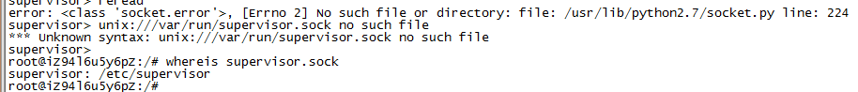

Queue.php中配置失败记录及数据库

'failed' => [
'database' => 'mysql', 'table' => 'job_failure',
],
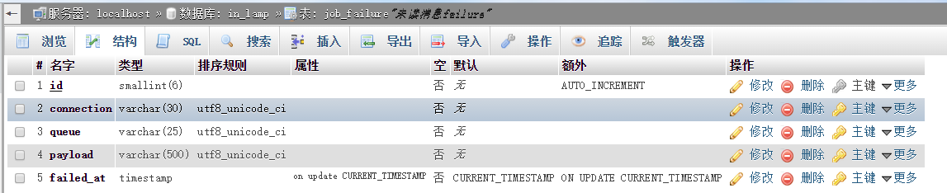

[program:myqueue]
command=php artisan queue:listen --tries=3
directory=/var/www/html/InLamp/InLamp
stdout_logfile=/var/www/html/InLamp/InLamp/storage/logs/bxjqueue_supervisord.log
redirect_stderr=true
autostart=true
autorestart=true

如果发现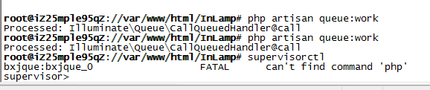
找不到命令的话，可以看下php的位置在哪里
[program:bxj-worker]
process_name=%(program_name)s_%(process_num)02d
command=/usr/local/php/bin/php /var/www/html/InLamp/artisan queue:work --sleep=3 --tries=3 --daemon
autostart=true
autorestart=true
user=root
numprocs=4
redirect_stderr=true
stdout_logfile = /var/www/html/InLamp/storage/logs/bxjqueue.log
stdout_logfile_maxbytes = 10MB

特别注意queue:work模式会导致时间停留，log日志停留（都可以解决的），不符合条件慎用。。
可以换回，但是效率不高
[program:bxjqueue]
command=php artisan queue:listen --tries=3
directory=/var/www/html/InLamp
stdout_logfile=/var/www/html/InLamp/storage/logs/bxjqueue_supervisord.log
redirect_stderr=true
autostart=true
autorestart=true
stdout_logfile_maxbytes = 10MB
user=root
numprocs=1
process_name=%(program_name)s_%(process_num)02d
然后重新配置下绝对路径即可
详细配置参数参看
http://www.tuicool.com/articles/y2iAze
配置项示例如下，后面我们会详细创建一个独有的Laravel配置
; Sample supervisor config file.
;
; For more information on the config file, please see:
; http://supervisord.org/configuration.html
;
; Note: shell expansion ("~" or "$HOME") is not supported. Environment
; variables can be expanded using this syntax: "%(ENV_HOME)s".

[unix_http_server] ; supervisord的unix socket服务配置
file=/tmp/supervisor.sock ; socket文件的保存目录
;chmod=0700 ; socket的文件权限 (default 0700)
;chown=nobody:nogroup ; socket的拥有者和组名
;username=user ; 默认不需要登陆用户 (open server)
;password=123 ; 默认不需要登陆密码 (open server)

;[inet_http_server] ; supervisord的tcp服务配置
;port=127.0.0.1:9001 ; tcp端口
;username=user ; tcp登陆用户
;password=123 ; tcp登陆密码

[supervisord] ; supervisord的主进程配置
logfile=/tmp/supervisord.log ; 主要的进程日志配置
logfile_maxbytes=50MB ; 最大日志体积，默认50MB
logfile_backups=10 ; 日志文件备份数目，默认10
loglevel=info ; 日志级别，默认info; 还有:debug,warn,trace
pidfile=/tmp/supervisord.pid ; supervisord的pidfile文件
nodaemon=false ; 是否以守护进程的方式启动
minfds=1024 ; 最小的有效文件描述符，默认1024
minprocs=200 ; 最小的有效进程描述符，默认200
;umask=022 ; 进程文件的umask，默认200
;user=chrism ; 默认为当前用户，如果为root则必填
;identifier=supervisor ; supervisord的表示符, 默认时'supervisor'
;directory=/tmp ; 默认不cd到当前目录
;nocleanup=true ; 不在启动的时候清除临时文件，默认false
;childlogdir=/tmp ; ('AUTO' child log dir, default $TEMP)
;environment=KEY=value ; 初始键值对传递给进程
;strip_ansi=false ; (strip ansi escape codes in logs; def. false)

; the below section must remain in the config file for RPC
; (supervisorctl/web interface) to work, additional interfaces may be
; added by defining them in separate rpcinterface: sections
[rpcinterface:supervisor]
supervisor.rpcinterface_factory = supervisor.rpcinterface:make_main_rpcinterface

[supervisorctl]
serverurl=unix:///tmp/supervisor.sock ; use a unix:// URL for a unix socket
;serverurl=http://127.0.0.1:9001 ; use an http:// url to specify an inet socket
;username=chris ; 如果设置应该与http_username相同
;password=123 ; 如果设置应该与http_password相同
;prompt=mysupervisor ; 命令行提示符，默认"supervisor"
;history_file=~/.sc_history ; 命令行历史纪录

; The below sample program section shows all possible program subsection values,
; create one or more 'real' program: sections to be able to control them under
; supervisor.

;[program:theprogramname]
;command=/bin/cat ; 运行的程序 (相对使用PATH路径, 可以使用参数)
;process_name=%(program_name)s ; 进程名表达式，默认为%(program_name)s
;numprocs=1 ; 默认启动的进程数目，默认为1
;directory=/tmp ; 在运行前cwd到指定的目录，默认不执行cmd
;umask=022 ; 进程umask，默认None
;priority=999 ; 程序运行的优先级，默认999
;autostart=true ; 默认随supervisord自动启动，默认true
;autorestart=unexpected ; whether/when to restart (default: unexpected)
;startsecs=1 ; number of secs prog must stay running (def. 1)
;startretries=3 ; max # of serial start failures (default 3)
;exitcodes=0,2 ; 期望的退出码，默认0,2
;stopsignal=QUIT ; 杀死进程的信号，默认TERM
;stopwaitsecs=10 ; max num secs to wait b4 SIGKILL (default 10)
;stopasgroup=false ; 向unix进程组发送停止信号，默认false
;killasgroup=false ; 向unix进程组发送SIGKILL信号，默认false
;user=chrism ; 为运行程序的unix帐号设置setuid
;redirect_stderr=true ; 将标准错误重定向到标准输出，默认false
;stdout_logfile=/a/path ; 标准输出的文件路径NONE＝none;默认AUTO
;stdout_logfile_maxbytes=1MB ; max # logfile bytes b4 rotation (default 50MB)
;stdout_logfile_backups=10 ; # of stdout logfile backups (default 10)
;stdout_capture_maxbytes=1MB ; number of bytes in 'capturemode' (default 0)
;stdout_events_enabled=false ; emit events on stdout writes (default false)
;stderr_logfile=/a/path ; stderr log path, NONE for none; default AUTO
;stderr_logfile_maxbytes=1MB ; max # logfile bytes b4 rotation (default 50MB)
;stderr_logfile_backups=10 ; # of stderr logfile backups (default 10)
;stderr_capture_maxbytes=1MB ; number of bytes in 'capturemode' (default 0)
;stderr_events_enabled=false ; emit events on stderr writes (default false)
;environment=A=1,B=2 ; process environment additions (def no adds)
;serverurl=AUTO ; override serverurl computation (childutils)

; The below sample eventlistener section shows all possible
; eventlistener subsection values, create one or more 'real'
; eventlistener: sections to be able to handle event notifications
; sent by supervisor.

;[eventlistener:theeventlistenername]
;command=/bin/eventlistener ; 运行的程序 (相对使用PATH路径, 可以使用参数)
;process_name=%(program_name)s ; 进程名表达式，默认为%(program_name)s
;numprocs=1 ; 默认启动的进程数目，默认为1
;events=EVENT ; event notif. types to subscribe to (req'd)
;buffer_size=10 ; 事件缓冲区队列大小，默认10
;directory=/tmp ; 在运行前cwd到指定的目录，默认不执行cmd
;umask=022 ; 进程umask，默认None
;priority=-1 ; 程序运行的优先级，默认-1
;autostart=true ; 默认随supervisord自动启动，默认true
;autorestart=unexpected ; whether/when to restart (default: unexpected)
;startsecs=1 ; number of secs prog must stay running (def. 1)
;startretries=3 ; max # of serial start failures (default 3)
;exitcodes=0,2 ; 期望的退出码，默认0,2
;stopsignal=QUIT ; 杀死进程的信号，默认TERM
;stopwaitsecs=10 ; max num secs to wait b4 SIGKILL (default 10)
;stopasgroup=false ; 向unix进程组发送停止信号，默认false
;killasgroup=false ; 向unix进程组发送SIGKILL信号，默认false
;user=chrism ; setuid to this UNIX account to run the program
;redirect_stderr=true ; redirect proc stderr to stdout (default false)
;stdout_logfile=/a/path ; stdout log path, NONE for none; default AUTO
;stdout_logfile_maxbytes=1MB ; max # logfile bytes b4 rotation (default 50MB)
;stdout_logfile_backups=10 ; # of stdout logfile backups (default 10)
;stdout_events_enabled=false ; emit events on stdout writes (default false)
;stderr_logfile=/a/path ; stderr log path, NONE for none; default AUTO
;stderr_logfile_maxbytes=1MB ; max # logfile bytes b4 rotation (default 50MB)
;stderr_logfile_backups ; # of stderr logfile backups (default 10)
;stderr_events_enabled=false ; emit events on stderr writes (default false)
;environment=A=1,B=2 ; process environment additions
;serverurl=AUTO ; override serverurl computation (childutils)

; The below sample group section shows all possible group values,
; create one or more 'real' group: sections to create "heterogeneous"
; process groups.

;[group:thegroupname]
;programs=progname1,progname2 ; 任何在[program:x]中定义的x
;priority=999 ; 程序运行的优先级，默认999

; The [include] section can just contain the "files" setting. This
; setting can list multiple files (separated by whitespace or
; newlines). It can also contain wildcards. The filenames are
; interpreted as relative to this file. Included files *cannot*
; include files themselves.

;[include]
;files = relative/directory/*.ini

