教程
http://fideloper.com/ubuntu-beanstalkd-and-laravel4
http://lvwenhan.com/laravel/395.html
/usr/bin/beanstalkd -l 127.0.0.1 -p 11300
1、进入laravel目录，安装
$ cd /path/to/laravel/application
$ composer require pda/pheanstalk ~2.0

在将laravel的queue.php设置下
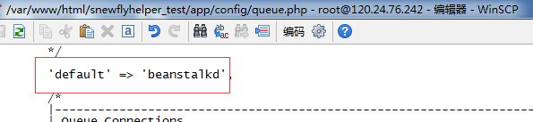
2、写处理功能的类
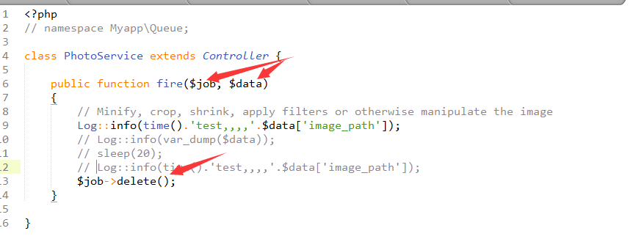
3、写函数执行queue
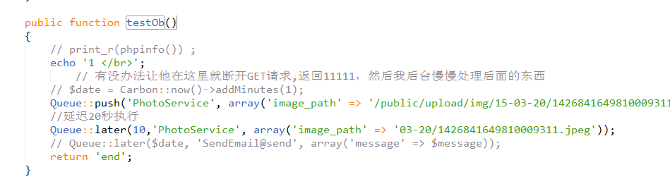

这样并不是后台运行的，还必须安装supervisor
First, we'll install it:
# Debian / Ubuntu:
$ sudo apt-get install supervisor
Next, we'll configure it. We need to define a process to listen to.
$ sudo vim /etc/supervisor/conf.d/myqueue.conf
Add this to your new conf file, changing file paths and your environment as necessary:
[program:myqueue]
command=php artisan queue:queue
directory=/path/to/laravel
stdout_logfile=/path/to/laravel/app/storage/logs/myqueue_supervisord.log
redirect_stderr=true
autostart=true
autorestart=true

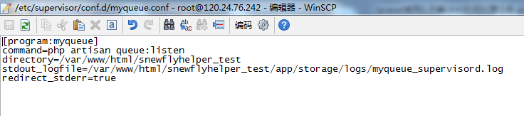

然后执行
$ sudo supervisorctl
> reread # Tell supervisord to check for new items in /etc/supervisor/conf.d/
> add myqueue # Add this process to Supervisord
> start myqueue # May say "already started"
Now the "myqueue" process is on and being monitored.
搞定！！

Xiangguanmingling
Php artisan queue::XXXX

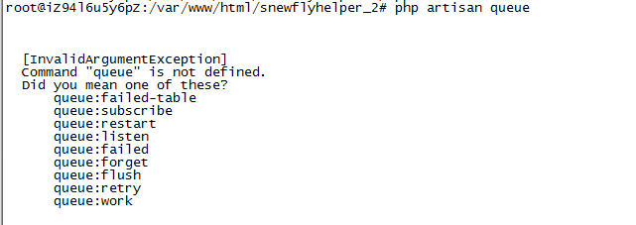

其中
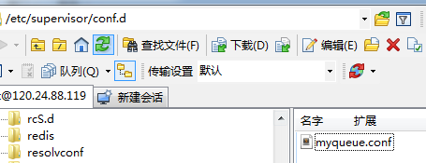
[program:myqueue]
command=php artisan queue:listen
directory=/var/www/html/snewflyhelper_2
stdout_logfile=/var/www/html/snewflyhelper_2/app/storage/logs/myqueue_supervisord.log
redirect_stderr=true
autostart=true
autorestart=true

