用一下方法成功了
CREATE USER bajian IDENTIFIED BY "334945804";

GRANT ALL PRIVILEGES ON *.* TO 'bajian'@'120.24.76.242'WITH GRANT OPTION;

GRANT ALL PRIVILEGES ON *.* TO 'bajian'@'120.24.76.242'IDENTIFIED BY '334945804' WITH GRANT OPTION;
FLUSH PRIVILEGES ;

千万注意！！ 下面的要注释掉
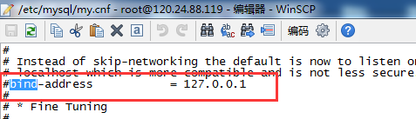
然后
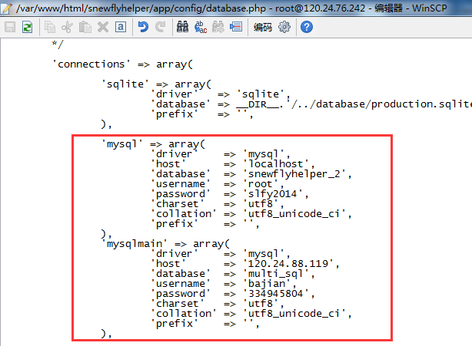

最后
