whereis sftp-server
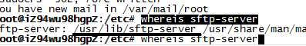
sudo /usr/lib/sftp-server
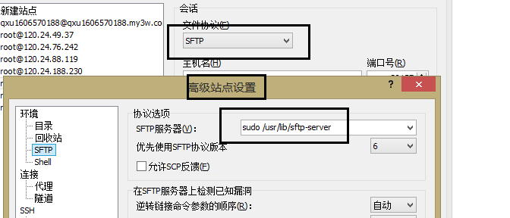

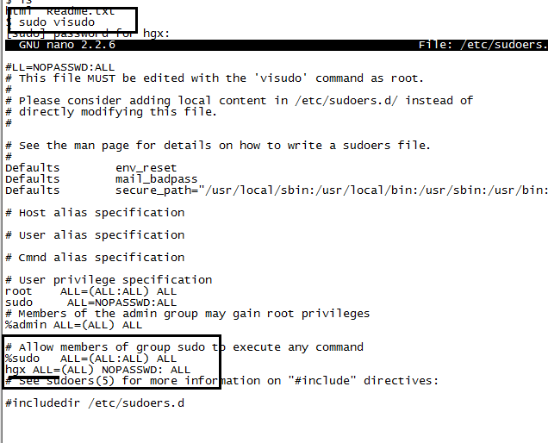
Ok

参考
http://blog.chinaunix.net/uid-25452915-id-373807.html
http://blog.sina.com.cn/s/blog_493c80b00101fgqd.html

http://site.leshou.com/s/371132.html

