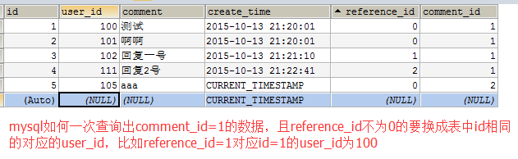

SELECT *, IF(reference_id>0,(SELECT user_id FROM comment_test WHERE id=a.reference_id),0) AS reference_userid FROM comment_test a WHERE comment_id=1

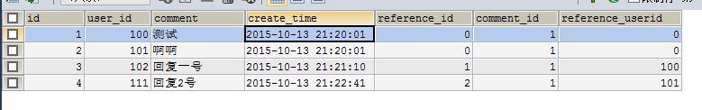
这是我的解法，有没更优做法有待请教出题的师兄
或者

SELECT *, CASE WHEN a.reference_id>0 THEN (SELECT user_id FROM comment_test WHERE id=a.reference_id) ELSE 0 END AS reference_userid FROM comment_test a WHERE comment_id=1

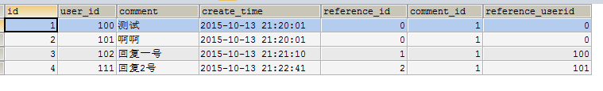

IF表达式
IF(expr1,expr2,expr3)
如果 expr1 是TRUE (expr1 <> 0 and expr1 <> NULL)，则 IF()的返回值为expr2; 否则返回值则为 expr3。IF() 的返回值为数字值或字符串值，具体情况视其所在语境而定。
select *,if(sva=1,"男","女") as ssva from taname where sva != ""

