



PROJECT REPORT

PYTHON  
  
Economic Background & Student Outcomes

|  |  |  |  |
| --- | --- | --- | --- |
| **Created By:** | Parth Satvekar | **Approved By:** | <Domain Lead Name> |
| **Created On:** | 06-07-2025 | **Approved On:** | DD-MMM-YYYY |

**INDEX**

**1** **PROJECT DETAILS** 2

**2** **SUMMARY** 2

**3** **INTRODUCTION** 2

3.1 Background 2

3.2 Stakeholders 2

3.3 Objectives 2

**4** **METHODOLOGY** 2

4.1 Considerations & Assumption 3

4.2 Approach 3

4.3 Activities 3

**5** **TARGETTED V/S ACHIEVED OUTPUT** 3

**6** **CONCLUSION** 3

**7** **APPENDICES** 4

7.1 Appendix A – Title 4

# **PROJECT DETAILS**

|  |  |  |  |
| --- | --- | --- | --- |
| **Project Name** | Economic Background & Student Outcomes | | |
| **Project Sponsor** |  | | |
| **Project Manager** |  | | |
| **Start Date** | 23-06-2025 | **Completion Date** | 07—07-2025 |

# **SUMMARY**

This project was expected to deliver a comprehensive analysis of student data from the Cloud Consulage internship program. The goal was to uncover insights related to academic performance, technical skills, family background, and event participation, using Python-based data analysis and visualization techniques. The project was needed to help stakeholders identify trends that can guide future internship program improvements, targeted student support, and selection criteria refinement. In the long term, the benefits will include data-driven decision-making for internship program design, more effective student engagement strategies, and enhanced visibility of key factors influencing student outcomes.

# **INTRODUCTION**

## Background

The project aimed to analyze data collected from student participants in the Cloud Consulage internship program. The problem was to explore relationships between student demographics, academic metrics (such as CGPA), technical skills, and participation in internship-related events. The analysis was intended to support data-backed recommendations that could improve future program design and student experience.

## Stakeholders

The main stakeholders for this project included:

* Cloud Consulage Internship Program Management Team – to use insights for program planning and student selection.
* Participating Students – as beneficiaries of improved engagement and support strategies.
* Recruitment & Talent Acquisition Teams – to align internship outcomes with industry requirements.

## Objectives

The project objectives, as referenced in the Project Charter, were to:

* + Load, clean, and prepare the internship dataset for analysis.
  + Generate descriptive statistics and visualizations to summarize key metrics (e.g., CGPA, family income, Python experience).
  + Explore correlations between variables such as family income and CGPA, leadership skills and expected salary.
  + Identify significant patterns in student participation in events and performance across colleges and cities.
  + All objectives have been successfully achieved. No major changes to the objectives were made during the course of the project.

# **METHODOLOGY**

## Considerations & Assumption

* It was assumed that the data provided was accurate, complete, and representative of the internship participants.
* The mapping of family income categories to numeric values was based on midpoints or logical estimates due to the absence of precise numerical data.
* Visualizations were assumed to be sufficient for identifying meaningful trends without the need for complex machine learning models.

## Approach

A structured, exploratory data analysis (EDA) approach was adopted. The problem was broken down into manageable tasks: data loading, preprocessing, statistical summarization, and visualization. This conceptual approach allowed for clear understanding of data characteristics and relationships before drawing conclusions or recommendations.

## Activities

* Requirement review and dataset understanding.
* Dataset loading and cleaning.
* Data transformation (e.g., income mapping, leadership flag creation).
* Generating descriptive statistics.
* Creating visualizations (bar charts, histograms, scatter plots, boxplots, pairplots).
* Correlation analysis.
* Documentation of findings and preparation of the development log.

# **TARGETTED V/S ACHIEVED OUTPUT**

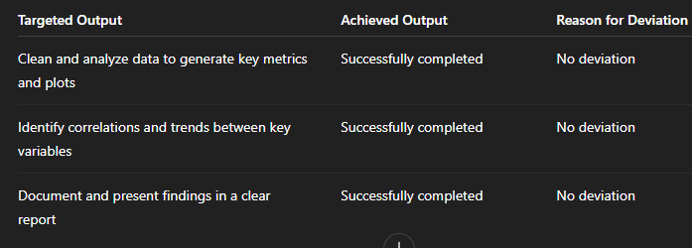

# **CONCLUSION**

The project findings will assist stakeholders in understanding the characteristics of students in the internship program and how various factors such as academic performance, skills, and background relate to their expectations and engagement. The analysis can guide future program improvements, student targeting strategies, and help align program outcomes with organizational objectives. Future scope includes extending the analysis to interactive dashboards, integrating with live data, or applying machine learning for predictive insights.

# **APPENDICES**

## Appendix A – Code Snippets

