Farah Younas

Python Lab
Object Oriented Programming

Table of Contents
Objective 2
Create a Class 2
Create an Object 2
Delete Objects 2
Multiple Objects 2
The pass Statement 2
The __init__() Method 3
Default Values in __init__() 3
Multiple Parameters 4
Access Modifiers 4
Types of Access Modifiers 4
1. Public Access Modifier 4
2. Protected Access Modifier 5
3. Private Access Modifier 5
Inheritance 6
Types of Inheritance 7
1. Single Inheritance 7
2. Multiple Inheritance 8
3. Multilevel Inheritance 9
4. Hierarchical Inheritance 10
5. Hybrid Inheritance 12
Exercise: Banking Account Management System 13
Exercise - Types of Inheritance in Python 14
Polymorphism 15
Exercise: Payment System Using Polymorphism 15
Abstraction in Python 16
Abstract Base Class 16
Exercise: ATM System Using Abstraction 16

Objective

Create a Class
Create a class named MyClass, with a property named x:
Program
class MyClass:
x = 5

Create an Object
Now we can use the class named MyClass to create objects:
Program
p1 = MyClass()
print(p1.x)

Delete Objects
You can delete objects by using the del keyword:
Delete the p1 object:
Program
del p1

Multiple Objects
You can create multiple objects from the same class:
Create three objects from the MyClass class:
Program
p1 = MyClass()
p2 = MyClass()
p3 = MyClass()
print(p1.x)
print(p2.x)
print(p3.x)

The pass Statement
class definitions cannot be empty, but if you for some reason have a class definition with no content, put in the pass statement to avoid getting an error.
Program
class Person:
pass

The __init__() Method
All classes have a built-in method called __init__(), which is always executed when the class is being initiated.
The __init__() method is used to assign values to object properties, or to perform operations that are necessary when the object is being created.
The __init__() method is called automatically every time the class is being used to create a new object.
Create a class named Person, use the __init__() method to assign values for name and age:
class Person:
def __init__(self, name, age):
self.name = name
self.age = age
p1 = Person(“Emily”, 36)
print(p1.name)
print(p1.age)
Without the __init__() method, you would need to set properties manually for each object:
Create a class without __init__():
Program
class Person:
pass
p1 = Person()
p1.name = ”Tobias”
p1.age = 25
print(p1.name)
print(p1.age)

Default Values in __init__()
You can also set default values for parameters in the __init__() method:
Set a default value for the age parameter:
Program
class Person:
def __init__(self, name, age=18):
self.name = name
self.age = age
p1 = Person(“Emily”)
p2 = Person(“Tobias”, 25)
print(p1.name, p1.age)
print(p2.name, p2.age)

Multiple Parameters
The __init__() method can have as many parameters as you need:
Program:
class Person:
def __init__(self, name, age, city, country):
self.name = name
self.age = age
self.city = city
self.country = country
p1 = Person(“Linus”, 30, ”Oslo”, ”Norway”)
print(p1.name)
print(p1.age)
print(p1.city)
print(p1.country)

Access Modifiers
Access modifiers in Python control which parts of a class can be accessed from outside the class, from within the class, or by subclasses. They help control how data and methods are accessed and used.

Types of Access Modifiers

Public Access Modifier
- Members (variables or methods) declared as public can be accessed from anywhere in the program.
- By default, all members are public in Python.

class Person:
def __init__(self, name, age):
self.personName = name
self.personAge = age

def displayAge(self):
print(“Age: “, self.personAge)

obj = Person(“John”, 20)
print(“Name: “, obj.personName)
obj.displayAge()
Explanation:
- personName and personAge are public variables, so they can be accessed directly from outside the class (obj. personName).
- displayAge() is a public method, so it can be called normally using obj.displayAge().
- In Python, class members are public by default, so both the variables and the methods will appear when you check dir(obj).

Protected Access Modifier
- A member is considered protected if its name starts with a single underscore (_).
- Convention only: It suggests that the member should not be accessed outside the class except by subclasses.
- Still, Python allows direct access if explicitly called.

class Student:
def __init__(self, name, roll, branch):
self._name = name
self._roll = roll
self._branch = branch

def _displayRollAndBranch(self):
print(“Roll: “, self._roll)
print(“Branch: “, self._branch)

class subClass(Student):
def displayDetails(self):
print(“Name: “, self._name)
self._displayRollAndBranch()

obj = subClass(“John”, 1706256, “IT”)
obj.displayDetails()

Explanation:
- _name, _roll, and _branch are protected members, meant to be used within the class and subclasses.
- _displayRollAndBranch() is a protected method, accessed by the subClass.
- Python allows direct access (e.g., obj._name), but by convention, it’s avoided.

Private Access Modifier
- A member is private if its name starts with double underscores (__).
- Python does not enforce strict privacy — instead, it uses Name Mangling.
- The interpreter renames __var to _ClassName__var internally.
Note: A name like __age__ (double underscores at both start and end) is not private. It is treated as a special ‘dunder’ name in Python and name mangling does not apply to it.

class Person:
def __init__(self, name, roll, branch):
self.__name = name
self.__roll = roll
self.__branch = branch

def _displayDetails(self):
print(“Name: “, self.__name)
print(“Roll: “, self.__roll)
print(“Branch: “, self.__branch)

def accessPrivateFunction(self):
self._displayDetails()

obj = Person(“John”, 1706256, “IT”)
obj.accessPrivateFunction()
print(obj._Person__name)

Explanation:
- __name, __roll, __branch: private variables
- __displayDetails(): private method
- Direct access from outside will raise AttributeError
- Access allowed inside the class or via name mangling (obj._Geek__name)

Inheritance
- One of the major advantages of Object Oriented Programming is re-use. Inheritance is one of the mechanisms to achieve the same.
- Inheritance allows programmer to create a general or a base class first and then later extend it to more specialized class. It allows programmer to write better code.
- Using inheritance you can use or inherit all the data fields and methods available in your base class. Later you can add you own methods and data fields, thus inheritance provides a way to organize code, rather than rewriting it from scratch.
- In object-oriented terminology when class X extend class Y, then Y is called super/parent/base class and X is called subclass/child/derived class. One point to note here is that only data fields and method which are not private are accessible by child classes. Private data fields and methods are accessible only inside the class.
Syntax
class BaseClass:
Body of base class
class DerivedClass(BaseClass):
Body of derived class
Example
Let’s create couple of classes to participate in examples:
- Animal: Class simulate an animal
- Cat: Subclass of Animal
- Dog: Subclass of Animal

In Python, constructor of class used to create an object (instance), and assign the value for the attributes. Constructor of subclasses always called to a constructor of parent class to initialize value for the attributes in the parent class, then it starts assign value for its attributes.

class Animal:
def __init__ (self, name):
self.name = name
def eat(self, food):
print(f”{self.name} is eating {food}”)

class Dog(Animal):
def fetch(self, thing):
print(f”{self.name} goes after the {thing}!”)

class Cat(Animal):
def swatstring(self):
print(f”{self.name} shreds the string!”)

#create an object of Dog and Cat
d = Dog(‘Ranger’)
c = Cat(‘Meow’)

# call methods
d.fetch(‘Ball’)
c.swatstring()
d.eat(‘Dog Food’)
c.eat(‘Cat Food’)

Types of Inheritance

Single Inheritance
Single inheritance enables a derived class to inherit properties from a single parent class, thus enabling code reusability and the addition of new features to existing code.
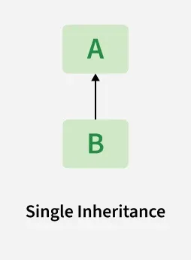

#Base class
class Parent:
def func1(self):
print(“This function is in Parent Class”)

#Derived class
class Child(Parent):
def func2(self):
print(“This function is in Child Class”)

#Driver code
obj = Child()
obj.func1()
obj.func2()

Explanation
- The Child class inherits the method func1() from Parent.
- It also has its own method func2().
- This shows how one class can extend another using single inheritance.

Multiple Inheritance
When a class can be derived from more than one base class this type of inheritance is called multiple inheritances. In multiple inheritances, all the features of the base classes are inherited into the derived class.
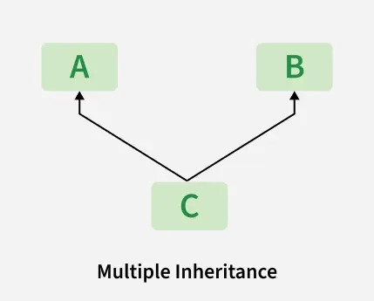

class Mother:
def __init__ (self, mothername):
self.mothername= mothername

class Father:
def __init__ (self, fathername):
self.fathername= fathername

class Son(Mother, Father):
def __init__(self, mothername, fathername):
Mother.__init__(self, mothername)
Father.__init__(self, fathername)
def parents(self):
print(f”Mother: {self.mothername}, Father: {self.fathername}”)
son = Son(“Alex”, “Bob”)
son.parents()

Explanation:
- Son inherits from both Mother and Father.
- It can access both mothername and fathername.
- This demonstrates how a class can combine functionalities from multiple sources.

Multilevel Inheritance
In multilevel inheritance, features of the base class and the derived class are further inherited into the new derived class. This is similar to a relationship representing a child and a grandfather.

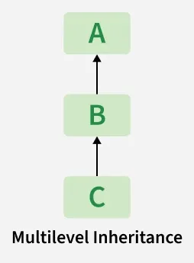

class GrandFather:
def __init__ (self, grandFatherName):
self.grandFatherName = grandFatherName

class Father(GrandFather):
def __init__ (self, FatherName, grandFatherName):
self.FatherName = FatherName
super().__init__(grandFatherName)

class Son(Father):
def __init__ (self, SonName, FatherName, grandFatherName):
self.sonName = SonName
super().__init__(FatherName, grandFatherName)

def display(self):
print(f”Son: {self.sonName}”)
print(f”Father: {self.FatherName}”)
print(f”Grand Father: {self.grandFatherName}”)

s1 = Son(“Jack”, “Bob”, “William”)
s1.display()

Explanation:
- Son inherits from Father, and Father inherits from Grandfather.
- Each constructor passes values up the inheritance chain using explicit constructor calls.
- All ancestor class attributes are accessible from the bottom-most class (Son).

Hierarchical Inheritance
When more than one derived class are created from a single base this type of inheritance is called hierarchical inheritance. In this program, we have a parent (base) class and two child (derived) classes.
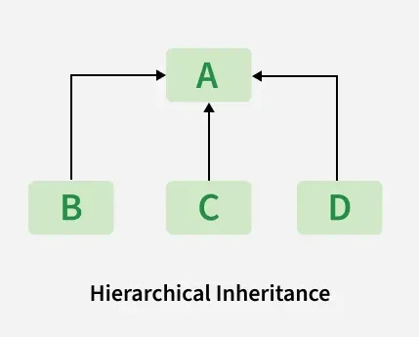

class Father():
def __init__ (self, FatherName):
self.FatherName = FatherName
class Son(Father):
def __init__ (self, SonName, FatherName):
self.sonName = SonName
super().__init__(FatherName)
def display(self):
print(f”Son: {self.sonName}”)
print(f”Father: {self.FatherName}”)
class Daughter(Father):
def __init__ (self, DaughterName, FatherName):
self.DaughterName = DaughterName
super().__init__(FatherName)
def display(self):
print(f”Daughter: {self.DaughterName}”)
print(f”Father: {self.FatherName}”)

s1 = Son(“Jack”, “Bob”)
d1 = Daughter(“Helen”, “Bob”)
s1.display()
d1.display()

Explanation:
- Both Child1 and Child2 inherit from the same Parent class.
- Each child can access the func1() method of Parent, but also has its own specific method.
- This pattern is useful when multiple classes need the same base functionality but also have unique behaviors.

Hybrid Inheritance
Hybrid inheritance is a combination of more than one type of inheritance. It uses a mix like single, multiple, or multilevel inheritance within the same program. Python’s method resolution order (MRO) handles such cases.
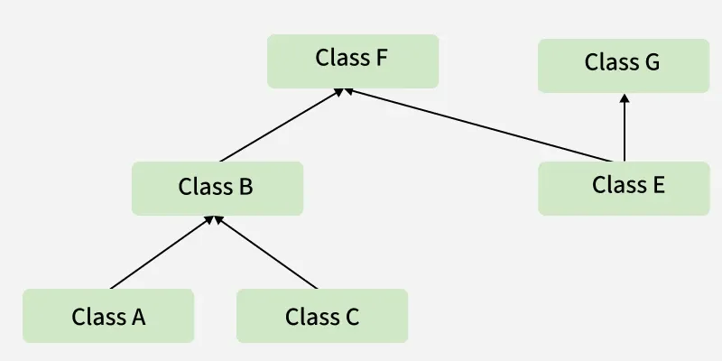
class Person:
def show_person(self):
print(“This is a person”)
class Student(Person):
def study(self):
print(“Student is studying”)

class Employee:
def work(self):
print(“Employee is working”)

class Teacher(Person, Employee):
def teach(self):
print(“Teacher is teaching”)

class UndergraduateStudent(Student):
def attend_class(self):
print(“Undergraduate student is attending class”)

class PostgraduateStudent(Student):
def conduct_research(self):
print(“Postgraduate student is conducting research”)
# Undergraduate student
student1 = UndergraduateStudent()
student1.show_person()
student1.study()
student1.attend_class()
# Postgraduate student
student2 = PostgraduateStudent()
student2.show_person()
student2.study()
student2.conduct_research()
# Teacher
teacher = Teacher()
teacher.show_person()
teacher.work()
teacher.teach()

Exercise: Banking Account Management System
A bank wants to develop a simple Bank Account Management System to store customer account information and perform common banking operations.
Every bank account has an account number, customer name, and account balance. The system should allow customers to:
- View their account details.
- Deposit money into their account.
- Withdraw money from their account.
- Prevent a customer from withdrawing more money than the available balance.
The bank also offers Savings Accounts. A Savings Account has all the features of a normal bank account, but it also provides additional functionality. Customers with a Savings Account should be able to:
- Calculate the interest earned based on their current balance and an interest rate.
- Display that the account is a Savings Account.
Task
Design and implement this system using Python classes and inheritance.
Your program should:
- Create a class to represent a general bank account.
- Include a constructor to initialise the account number, customer name, and balance.
- Implement methods for displaying account details, depositing money, and withdrawing money.
- Create a separate class to represent a Savings Account.
- Use single inheritance so that the Savings Account inherits the common functionality of the Bank Account.
- Add Savings Account-specific functionality for calculating interest.
- Create a Savings Account object and demonstrate all available operations.
Sample scenario:
A customer named John opens a Savings Account with account number SA1001 and an initial balance of $5,000. The customer deposits $1,000, withdraws $500, and then calculates the interest at a rate of 5%.

Exercise: Types of Inheritance in Python
Instructions: For each problem, identify the type of inheritance and implement the classes in Python.
Exercise 1
A company wants to develop a simple employee management system. The system should store an employee's name and employee ID. A manager is also an employee, but a manager has additional information about the department they manage. Create suitable Python classes to represent this relationship. Use a constructor to initialise the required information and create a manager object to display all the details.
Exercise 2
A university wants to develop a student information system. Every person in the university has a name. A student is a person and has an additional student ID. A postgraduate student is a student and has an additional research topic. Design and implement suitable Python classes for this system. Create a postgraduate student object and display the person's name, student ID, and research topic. Use super() where appropriate.
Exercise 3
A university employs different types of employees. All employees have a name and employee ID. However, lecturers have a teaching subject, administrators have a department, and technicians have a technical specialisation. Create suitable Python classes to represent these employees. Create objects for a lecturer, administrator, and technician and display their information.
Exercise 4
A university needs to maintain information about students from two different areas: academic information and contact information. Academic information includes the student's programme and GPA, while contact information includes the student's email address and phone number. Create suitable Python classes so that a student can have information from both areas. Create a student object and display all of the student's academic and contact information.
Exercise 5
A hospital wants to develop a system to manage information about its staff and patients. Every person in the hospital has a name. A doctor is a person and has a doctor ID, while a nurse is also a person and has a nurse ID. A senior nurse can have both the characteristics of a nurse and additional information related to their role, such as a ward they supervise. Design and implement suitable Python classes to represent these relationships. Create a SeniorNurse object and display all relevant information. Use constructors and super() where appropriate. Finally, identify the type of inheritance used and draw a class diagram before implementing the solution.
Exercise 6
Design a small real-world system of your choice, such as a hospital, banking system, university, online shopping system, or transport system. Your system should contain at least four classes and demonstrate at least two different types of inheritance. Draw the class diagram first and then implement the classes in Python. Use constructors, inheritance, super(), and appropriate methods. Finally, create objects and demonstrate that the inheritance relationships work correctly.

Polymorphism
Polymorphism means “many forms” and allows the same method, function or operator to behave differently depending on the object or data it works with. This flexibility helps create more reusable, maintainable and scalable code.
class Animal:
def sound(self):
return “Some generic sound”

class Dog(Animal):
def sound(self):
return “Bark”

class Cat(Animal):
def sound(self):
return “Meow”

# Polymorphic behavior
animals = [Dog(), Cat(), Animal()]
for animal in animals:
print(animal.sound())

Exercise: Payment System Using Polymorphism
Problem Statement
A company wants to develop a simple payment system. Customers can pay using different payment methods:
- Credit Card
- PayPal
- Bank Transfer
Each payment method should have a make_payment() method, but the way the payment is processed is different for each method.
Your task is to use polymorphism to design this payment system.
Requirements
Create the following classes:
- CreditCard
- PayPal
- BankTransfer

Abstraction in Python
- Abstraction is the process of hiding implementation details and exposing only the essential functionality to the user.
- It is used to hide the implementation details from the user and expose only necessary parts, making the code simpler and easier to interact with.

Abstract Base Class
- Abstract Base Class (ABC) is used to achieve data abstraction by defining a common interface for its subclasses.
- It cannot be instantiated directly and serves as a blueprint for other classes.
- Abstract classes are created using abc module and @abstractmethod decorator, allowing developers to enforce method implementation in subclasses while hiding complex internal logic.
from abc import ABC, abstractmethod
class Animal(ABC):
@abstractmethod
def sound(self):
pass
class Dog(Animal):
def sound(self):
print(“Dog barks”)
class Cat(Animal):
def sound(self):
print(“Cat meows”)

Exercise: ATM System Using Abstraction
Problem Statement
A bank wants to develop a simple ATM system. Customers should be able to perform basic operations such as:
- Insert their card
- Enter their PIN
- Check their balance
- Withdraw money
The customer should only need to know what operation to perform, without knowing the internal details of how the ATM communicates with the bank’s database or verifies the transaction.
To model this system, create an abstract class ATM that defines the essential operations an ATM must provide.
Create a subclass called BankATM that implements these operations.
Requirements
- Create an abstract class called ATM.
- Define the following abstract methods:
- insert_card()
- enter_pin()
- check_balance()
- withdraw(amount)
- Create a BankATM class that inherits from ATM.
- Implement all the abstract methods in BankATM.
- Create an object of BankATM and perform the operations.

