**Study on electron impact differential cross section from Xe2+ and N2+ in the non-relativistic limit**

Kaustav Bhattacharjee, 20311013, MSP

1. **Introduction**

The Schultz and Reinhold code [1] for calculation of differential cross sections of ions or atoms as a function of scattering angle of electrons has significant potential for improvement. We convert the code from FORTRAN to Python and make additions to it, the results of which we present here.

1. **Theoretical Background**

The differential (scattering) cross section is defined as the ratio of the intensity of radiant energy scattered in a given direction to the incident irradiance. It has the symbol $$\frac{dσ}{dΩ}$$ and the dimensions of area per unit solid angle. We calculate it in Hartree Atomic Units, a system of natural units of measurement. We consider the D.R. Schultz and C.O. Reinhold code [1], where the Garvey et al. parameterized Hartree-Fock model potential [2] is used to solve the radial Schrödinger equation to obtain scattering phase shifts and angular differential cross sections for elastic scattering. In their approach, an independent electron model is assumed, neglecting the multichannel nature of the collision, spin-orbit effects, polarization, and electron exchange. In this model, the potential is given as

$$V\left(r\right) = 2\frac{\left[\left(N − 1\right)\frac{1}{1 + \frac{1}{\left(\frac{η}{ξ}\right)\left(e^{ξr} − 1\right)}} − Z\right]}{\frac{1}{1 + \frac{1}{\left(\frac{η}{ξ}\right)\left(e^{ξr} − 1\right)}}}$$,

where N is the total number of electrons in the atom or ion. The parameters $$ξ$$ and $$η$$ are optimized for the range of atoms and ions under consideration.

1. **Present Work**

It is apparent that the potential function can be replaced by pre-calculated potential functions for specific atoms or ions. To do this, we update the code from FORTRAN 77 to Modern FORTRAN and reproduce the results published in the paper. Next, we convert the code to Python and ascertain the same results.

The Garvey et al. potential [2] is now replaced by static potential, which is obtained by precisely integrating over electron density data considered atom or ion. We do so first for Xe2+, whose electron density calculated by obtaining ionic wave functions using multi-configuration Dirac-Fock (MCDF) approximation is obtained from Mahato et al [3]. We now include a non-Coulombic potential: exchange potential. It is calculated using the formula given by Furness and McCarthy [4],

$$V_{ex} = \frac{1}{2}\left\{E − V_{st}\left(r\right)\right\} − \frac{1}{2}{\left[{\left\{E − V_{st}\left(r\right)\right\}}^{2} + 4πρ\left(r\right)\right]}^{\frac{1}{2}}$$,

where E is the incident electron energy, $$V_{st}$$ is the static potential and $$ρ$$ is the electron charge density at distance *r* from the center of the atom or ion. We compare these differential cross section values to those obtained by the Rutherford formula, the measurements taken by McKenna and Williams [5] and the values from the scattering model of Mahato et al [3].

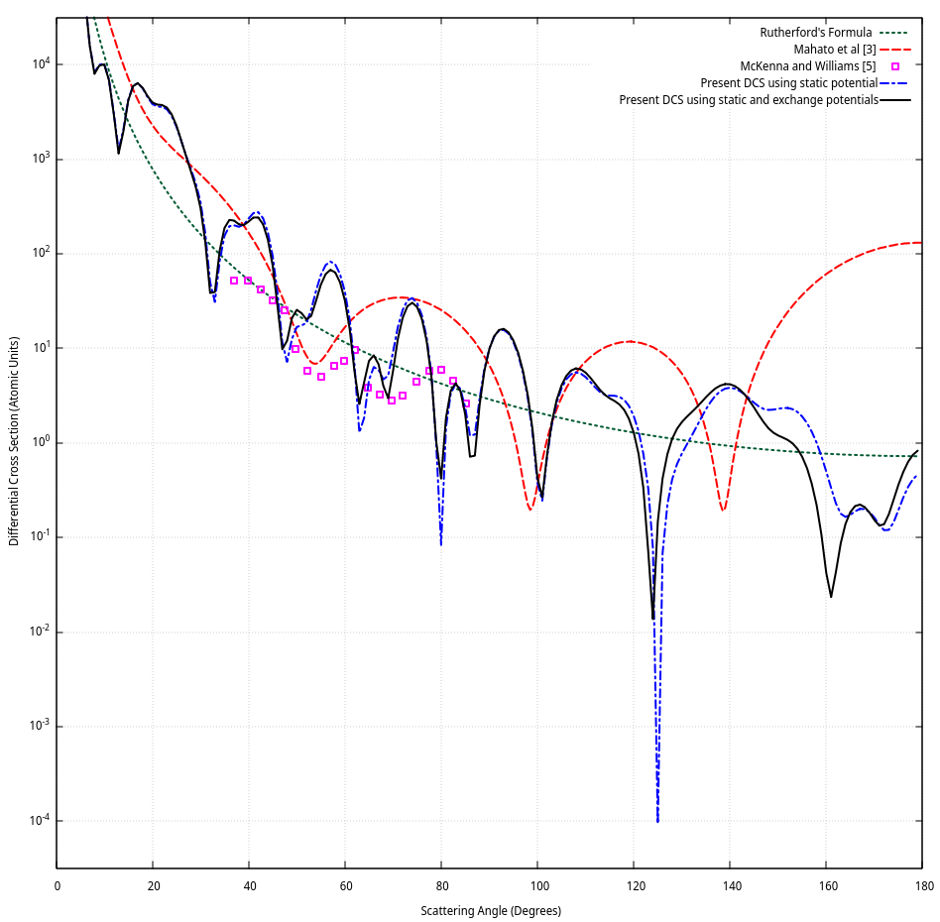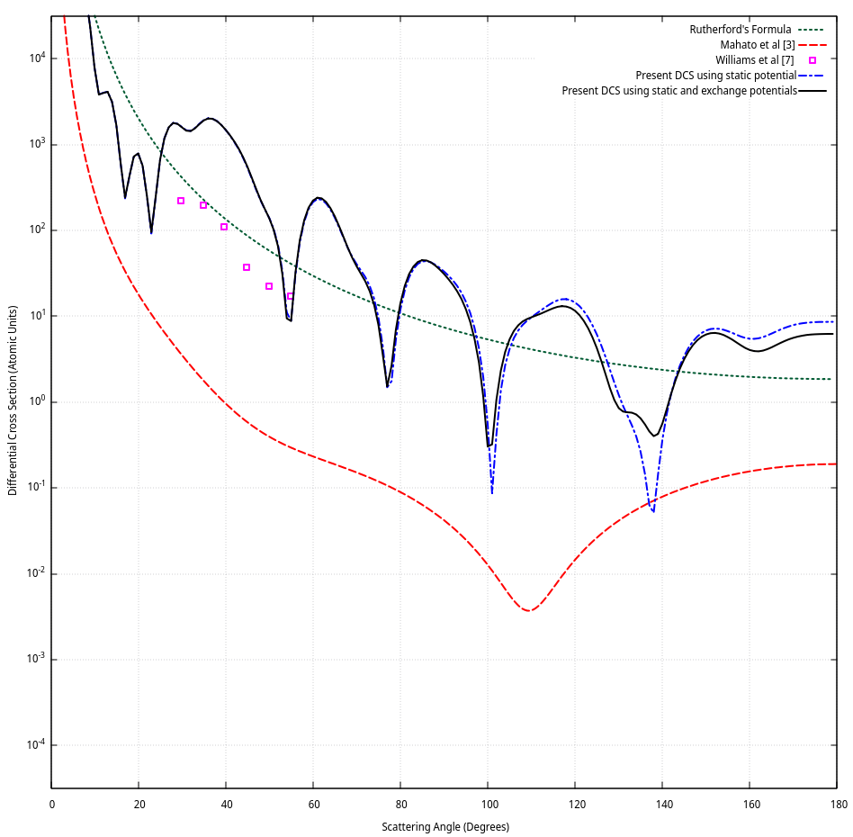

**Figure 1**  **Figure 2**

**Figure 1**: Electron impact differential cross sections for Xe2+ ion, **Figure 2**: Electron impact differential cross sections for N2+ ion.

Next, we consider another ion N2+, and calculate the differential cross section values using the static and exchange potentials. If sufficient data is available, we can also calculate the polarization potential for this ion using the formula for Buckingham potential [6],

$$V_{pol}\left(r\right) = −\frac{α_{d}}{2{\left(r^{2} + d^{2}\right)}^{2}}$$,

where $$α_{d}$$ is the dipole polarizability, and use it to calculate the differential cross section values, which are compared to those obtained by the Garvey et al. potential function, the measurements taken by Williams et al [7], values from the scattering model of Mahato et al [3] and the Rutherford formula.

1. **Conclusion**

The modified Schultz and Reinhold program gives us values of differential cross section that are satisfactorily close to experimental values. We can expand on this work by calculating the differential cross sections for other atoms and ions. We have this program available for the scientific community to calculate differential cross section values for atoms or ions in concern. The program can be changed to include other methods of calculating potential too. Their similarity to the experimental data can give an indication of how accurate the potential function is.

1. **References**

[1] D.R. Schultz, C.O. Reinhold, Computer Physics Communications 114 (1998) 342-355

[2] R.H. Garvey, C.H. Jackman, A.E.S. Green, Phys. Rev. A 12 (1975) 1144.

[3] D. Mahato, L. Sharma, R. Srivastava, Int. J. Quantum Chem. 2021, e26815

[4] J B Furness and I E McCarthy 1973 J. Phys. B: Atom. Mol. Phys. 6 2280

[5] P McKenna and I D Williams 2001 Phys. Scr. 2001 370

[6] F Salvat 2003 Phys. Rev. A 68, 012708 (2003)

[7] I D Williams et al 1997 Phys. Scr. 1997 119

|  |  |
| --- | --- |
|  |  |
| Kaustav Bhattacharjee | Prof. Rajesh Srivastava |