# **Predict the number of shared bikes by weather conditions**

## 1. Introduction

Bike sharing systems are a new generation of traditional bike rentals where the whole process from membership, rental and return back has become automatic. The welcome public service which allows people to borrow a bike from a dock and return it in another place. Until 2017, there’re over 500 bike sharing systems with 500,000 bikes around the world. Today, there exists great interest in these systems due to their important role in traffic, environmental and health issues.

Apart from interesting real-world applications of bike sharing systems, the characteristics of data being generated by these systems make them attractive for the research. Different from other transport services, the duration of trip, start and end time arrival positions are explicitly recorded in these systems. These features make bike sharing system a virtual sensor network which can be used for sensing mobility of a city. Through this research, we expect to find any factors that influence people’s choice of using shared bicycles or not and predict how many times the bike sharing system would be used in a time period in Washington, DC.

## 2. Data Description

### 2.1 Data Source

There’re 3 data resources we would use:

1. 2011-2012 Bike Sharing in Washington D.C. Dataset from Kaggle: This dataset contains the hourly and daily count of rental bikes between years 2011 and 2012 in [Capital bikeshare system](https://www.capitalbikeshare.com/system-data) in Washington, DC with the corresponding weather and seasonal information. There’re 17379 rows in this dataset and each row is a record for an hour in year 2011 and 2012. The variables are shown below:

|  |  |
| --- | --- |
| **Name** | **Description** |
| Instant | Record index |
| dteday | Date |
| Season | Season (1:springer, 2:summer, 3:fall, 4:winter) |
| yr | Year (0: 2011, 1:2012) |
| mnth | Month (1 to 12) |
| hr | Hour (0 to 23) |
| holiday | weather day is holiday or not (extracted from [Holiday Schedule](http://dchr.dc.gov/page/holiday-schedule)) |
| weekday | Day of the week |
| Workingday | If day is neither weekend nor holiday is 1, otherwise is 0 |
| weathersit | * 1: Clear, Few clouds, Partly cloudy, Partly cloudy * 2: Mist + Cloudy, Mist + Broken clouds, Mist + Few clouds, Mist * 3: Light Snow, Light Rain + Thunderstorm + Scattered clouds, Light Rain + Scattered clouds * 4: Heavy Rain + Ice Pallets + Thunderstorm + Mist, Snow + Fog |
| temp | Normalized temperature in Celsius. The values are derived via:  (t-t_min)/(t_max-t_min), t_min=-8, t_max=+39 (only in hourly scale) |
| atemp | Normalized feeling temperature in Celsius. The values are derived via: (t-t_min)/(t_max-t_min), t_min=-16, t_max=+50 (only in hourly scale) |
| hum | Normalized humidity. The values are divided to 100 (max). |
| windspeed | Normalized wind speed. The values are divided to 67 (max). |
| casual | Count of casual users |
| registered | Count of registered users |
| cnt | Count of total rental bikes including both casual and registered |

Link: <https://www.kaggle.com/marklvl/bike-sharing-dataset#hour.csv>

1. 2017 Bike Sharing in Washington D.C Dataset from capital bikeshare: With year 2011-2012’s sharing bike dataset as training set, we would use year 2017’s data as test set. This dataset contains trip history data in year 2017 from capital bike share. There’re 8738 rows in this dataset and each row is a record for bike sharing. The variables are shown below:

|  |  |
| --- | --- |
| **Name** | **Description** |
| Duration | Duration of the trip |
| Start Date | Includes start date and time |
| End Date | Includes end date and time |
| Start Station | Includes start station name and number |
| End Station | Includes end station name and number |
| Bike Number | Includes ID number of bike used for the trip |
| Member Type | Indicates whether user was a "registered" member or a "casual" rider |

Link: <https://www.capitalbikeshare.com/system-data>

1. 2017 Daily Observations of Arlington County, VA Weather History from weather underground: The second dataset lack corresponding weather information so we use web scraping tools to build the third dataset as a supplement. This dataset contains weather information of each hour in 2017 and have these variables:

|  |  |
| --- | --- |
| **Name** | **Description** |
| Date | Date |
| Hour | Hour |
| TF | Feeling temperature |
| Humidity | Humidity |
| WindSpeed | Windspeed |
| weather | Description of the weather |

Link: <https://www.wunderground.com/history/daily/us/va/arlington-county/KDCA/date/2017-1-1>

The second and third dataset were combined to build a dataset with same important variables as that of the first dataset.

## 3. Data pre-processing

The 2011-2012 bike sharing in Washington DC dataset was provided and cleaned by Kaggle contributor Mark Kaghazgarian while the second data was a raw dataset with no weather information. Also, each row in the second dataset is a record of a specific bike sharing while in the first dataset, all the bike sharing records were counted in hours. So we grouped the data in the second dataset according to the variable Start Date. We also dropped the variables which are not contained in the first dataset.

Then we used chrome driver and beautiful soup to scrape the observed weather information in 2017 from the website weather underground. It took about 6 hours to scrape all the information because loading the website takes a longtime. The normal observe time of this observation station was on the 52nd minute in each hour so we chose all the normal observations and drop others to avoid repetition.

The second and third datasets were combined and converted into a new dataset named as “hour2017.csv”. This dataset has a structure same as the first dataset and has only time, weather information and count of total rental bikes. Also we normalized the feeling temperature, humidity and windspeed in the same way as the description of the first dataset.

## 4. Exploratory Data Analysis

### 4.1 DC dataset

In the first part, we will explore ‘hour.csv’ file. This data set records the hourly weather conditions and the number of shared bikes used between 2011 and 2012.

### 4.1.1 Basic analysis

We did not find NA values in the dataset, which means we can use the dataset directly for analysis.

### 4.1.2 How many people use bike sharing in each season?

The count of season bike using shows below:

|  |  |  |
| --- | --- | --- |
| Season Id | Season Name | Number of using |
| 1 | Spring | 471,348 |
| 2 | Summer | 918,589 |
| 3 | Autumn | 1,061,129 |
| 4 | Winter | 841,613 |

As shown in the figure, most people using shared bicycles in autumn, followed by summer, winter, and spring.

### 4.1.3 How many people use bike sharing on holidays and non-holidays?

We use averages for comparison, because the number of holidays and non-holidays is different.

The count of holidays and non-holidays bike using shows below:

|  |  |  |
| --- | --- | --- |
| Holiday variable | Whether it is a holiday | Number of using |
| 0 | Non-holiday | 190.42858 |
| 1 | Holiday | 156.87000 |

As shown in the figure, the average number of bikes used by people during holidays and non-holidays is very close, indicating that people will often use bikes during holidays or non-holidays.

### 4.1.4 How many people use bike sharing on different weather type?

The count of different weather bike using shows below:

|  |  |  |
| --- | --- | --- |
| Weather id | Weather type | Number of using |
| 1 | Clear, Few clouds, Partly cloudy, Partly cloudy | 2,338,173 |
| 2 | Mist + Cloudy, Mist + Broken clouds, Mist + Few clouds, Mist | 795,952 |
| 3 | Light Snow, Light Rain + Thunderstorm + Scattered clouds, Light Rain + Scattered clouds | 158,331 |
| 4 | Heavy Rain + Ice Pallets + Thunderstorm + Mist, Snow + Fog | 223 |

As shown in the figure, the better the weather, the more people use it.

### 4.1.5 How many people use bike sharing in each hour?

As shown in the figure, in daily life, the peaks of people's use of shared bicycles are 8 AM and 5-6 PM, with 261,001 and 336,860 to 309,772 people, respectively.

We can better observe this phenomenon in the line chart.

### 4.1.6 How many people use bike sharing in each weekday?

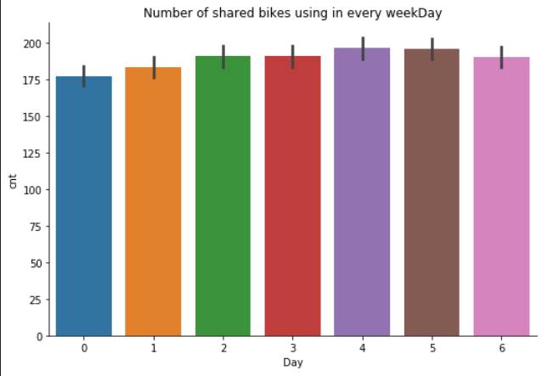

As shown in the figure, the number of shared bicycles used by people is very close every day, indicating that in daily life, shared bicycles are used every day.

### 4.1.7 How many people use bike sharing in each month?

The count of month bike using shows below:

|  |  |  |  |
| --- | --- | --- | --- |
| Month | Count | Month | Count |
| 1 | 134,933 | 7 | 344,948 |
| 2 | 151,352 | 8 | 351,194 |
| 3 | 228,920 | 9 | 345,991 |
| 4 | 269,094 | 10 | 322,352 |
| 5 | 331,686 | 11 | 254,831 |
| 6 | 346,342 | 12 | 211,036 |

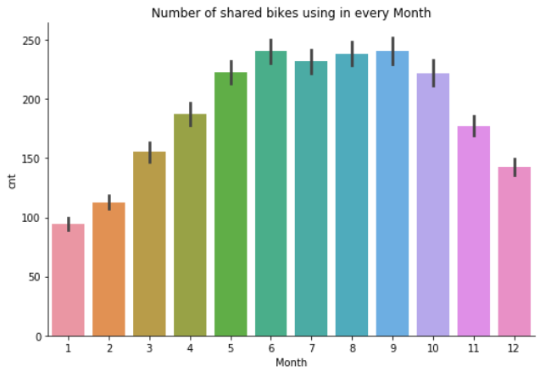

As shown in the figure , the peak period of bicycle sharing is concentrated in June to September.

### 4.1.8 Observe registered users and occasional registered users

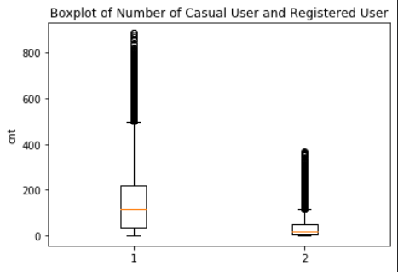

1 for registered users, 2 for accidental registered users

It can be seen from the box and violin charts that the number of registered users is far more than the number of accidental registrations, indicating that many people often use shared bicycles.

### 4.1.9 How many people use bike sharing on different weather condition?

After comprehensively comparing the analysis results of weather conditions, we can conclude that the most people use bicycle sharing when the temperature is high, the more people use it when the wind speed is low, and the most people use it when the humidity is high. But when these factors reach extreme values, the number of sharing bicycles people used is the least.

### 4.1.10 correlation matrix of DC dataset

Through this figure, we use appropriate features for modeling

### 4.2 DC2017 dataset

In the first part, we will explore ‘hour2017.csv’ file. This data set records the hourly weather conditions and the number of shared bikes used in 2017.

### 4.2.1 How many people use bike sharing in each hour?

As shown in the figure, in daily life, the peaks of people's use of shared bicycles are 8 AM and 5 PM, with 299,108and 415,574 people, which is very similar to data recorded in 2011 and 2012.

We can better observe this phenomenon in the line chart.

### 4.2.2 How many people use bike sharing on different weather condition?

In the 2017 record, the impact of weather conditions on the use of shared bicycles has not changed much. Compared with the changes in 2011-2012, people will use shared bicycles more when the wind speed is moderate.

## 5. Modeling

### 5.1 Regression Part I: Linear regression model

After we import the data from ‘dc’ bike sharing from 2011 to 2012, we will create dummy variables for categorial type variable 'weather' and 'season'. Since for categorial type variable the symbolized number does not represent higher value from 1 to 4. Also for the ‘hour’, we will use the C() function in the formula to automatically create the dummy instead of input x one by one.

For the 'season' variable, we will use temperate as dependent variable to compare temperature for each season using s_4 as the benchmark. And the result is rank of average temperature for four seasons from low to high is : s_1, s_4, s_2, s_3.

Then for the linear regression model, we will use all variables showing in the data set and 'cnt' (the total number of people rent the sharing bike) as the dependent variable and it will be the same for the regression tree in the later part. The result is showing as below:

We can see that the highest number of people using share bike is around 17:00 pm which is the time that most people will go home from work. And for X0 to X5, it separately represents 'holiday', 'workingday', 'TF', 'TFF', 'Humidity', 'WindSpeed'. We can see that more people choose to use sharing bike during work day than holiday and the higher the temperate with lower humidity and windspeed, more people would like to use shared bike as commute method.

Also, in order to have deeper understanding of our data for casual user and registered user we have separated the season and temperature effect, working day and holiday to avoid multicollinearity. The following are the four models we build:

# 1. ('holiday', 'TF', 'Humidity')

For casual users, We can see from the result that on holiday there are more casual users renting bike. Also, the higher temperature and lower humidity, more casual users will rent the bike.

# 2. ('holiday', 'Humidity', 's_1', 's_2', 's_3')

More casual users rent bike on holidays when humidity is low and in season that has higher rank in temperature

# 3. ('workingday', 'TF', 'Humidity')

More casual users are less likely to rent bike on workingday and if they do more casual users rent bike when temperature is high and humidity is low

# 4. ('workingday', 'Humidity', 's_1', 's_2', 's_3')

More casual users are less likely to rent bike on workingday and if they do more casual users rent bike when humidity is low and season have higher rank in temperature

For registered users, We can see from the result that on holiday there are less registered users renting bike. Since for the registered user, the main reason they register is that they will use a lot and we can imagine those people are because of work commute need. In this case, when it comes to holiday, those people will just rest and not using bikes. Also, the higher temperature, more casual users will rent the bike.

# 1. ('holiday', 'TF', 'Humidity')

Less registered users rent bike on holidays and if they do, more people will rent bike when temperature is high and humidity is low

# 2. ('holiday', 'Humidity', 's_1', 's_2', 's_3')

Less registered users rent bike on holidays and if they do, more people will rent bike when humidity is low. the rank of the number of people renting bikes for each season from low to high is s_1, s_2, s_4, s_3. This is different from the result we get from 'TF' (previously we have the temperature order from low to high as s_1, s_4, s_2, s_3)

# 3. ('workingday', 'TF', 'Humidity')

More registered users are renting bike on workingday when humidity is low and seasons have higher rank in temperature

# 4. ('workingday', 'Humidity', 's_1', 's_2', 's_3')

More registered users are renting bike on workingday when humidity is low. And the rank of the number of people renting bikes for each season from low to high is s_1, s_2, s_4, s_3. This is different from the result we get from 'TF' (previously we have the temperature order from low to high as s_1, s_4, s_2, s_3)

### 5.2 Regression Part II: Regression tree model

We will use the same variables in the OLS model for comparison and split the dc dataset into 80% train, 20% test. The following is the result we have for instantiating a Decision Tree Regressor.

Then we will compare the performance with OLS, and we will use Root Mean Square Error to see which model has a better fit. we can see from the result that regression tree has lower RMSE and higher score which means that it has better model fit. The unit of RMSE is same as dependent variable. If your data has a range of 0 to 100000 then RMSE value of 3000 is small, but if the range goes from 0 to 1, it is pretty huge.

In this case, we have RMSE around 130 and the range of casual users is from 0 to 977, it is about 0.1 of the largest number and the R-squared is 0.6, which shows that it is also a good fit for the total user

Also, we will evaluate the list of Mean Square Error obtained by 10-fold CV, we can see from the result that training set and test set have similar amount of RMSE which means that the model we built is a good one. And the regression tree is better than the linear regression.

In order to have deeper valuation of our model, we will separate the situation for working days and holidays as we did in the liner regression model, and the dependent variable will be ‘cnt’(the total number of people rent the sharing bike) The result are the similar as shown above for the day only in working day.

Then we will use ‘casual’ as dependent variable for another valuation. And the result is showing below:

In this case, we have RMSE around 30 and the range of casual users is from 0 to 367, it is about 0.1 of the largest number and the R-squared is 0.3, which shows that it is also a good fit for the casual user. And the regression tree is better than the linear regression.



In order to have deeper valuation of our model, we will separate the situation for working days and holidays as we did in the liner regression model, and the dependent variable will be ‘casual’ The result are similar as shown above for the day only in working day.

### 5.3 Prediction

After we compared our models with two regression, we will use the web scrapping data from 2017 weather and bike sharing to see how our model performs. And we use original dc data as train set and dc 2017 data as test set. The variables will be ‘TF’, ‘humidity, ‘windspeed’, and ‘hour’, and the dependent variable is ‘cnt’. We can see from the result that the linear regression model is better than the regression tree model instead and the RMSE has increased a lot from around 120 to around 440. And the training set RMSE are much lower than the test set RMSE which means that we have over-fitting the data. And the reason is because that we do not have enough variables as we did in the previous data set of dc (which contains over 10 different variables). If we do not have the limitation of online sourcing data set of web scrapping and have more variables, we can have better prediction

