# Web Authoring and Design



Name：Cheng Tianyu

ID：201632110208

Class：软件工程(中外)162班

Email：[584639928@qq.com](mailto:584639928@qq.com)

# Subject：Web Authoring and Design

1. Introduction

In my sophomore year I had a new course - web design. Through the study in class and self-study in my spare time, I made my first website gradually. This site is about CSS and HTML. I will share my code and tips below. I hope I can help you.

1. Content
2. Structure of the website

<html>

<head>

<title>**title**</title>

<meta http-equiv="Content-Type" content="text/html; charset=gb2312" /><meta name="keywords" content=""**Keyword** />

<meta name="description" content="**introduce**" />

</head>

<body>

**Body text**

</body>

</html>

This is the most basic composition of HTML, consisting of two main blocks of HEAD and BODY。We can add code to the BODY to make the site the way we want it to be。

② DIV

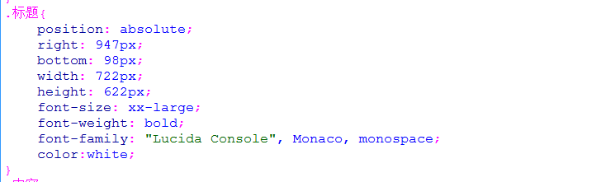

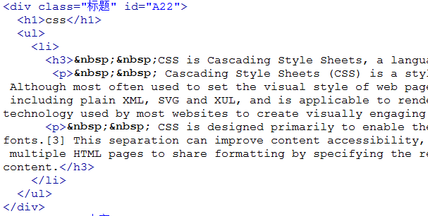

I extracted an example from my code to introduce div.Div tags can separate documents into separate, distinct parts。I've added class= "标题" in the label "div >" And I defined the 标题 in the head tag。We can modify the properties in the title to get the block I want. For example, background color, size, location, etc

③ Hit special effects

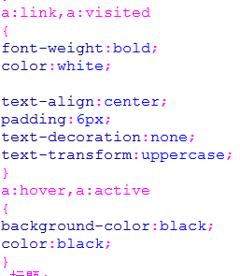 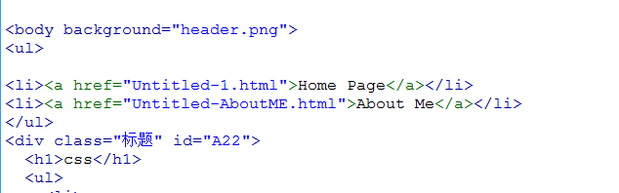

From my code can go to, I in the head is to define a, is defined when I hover over there will be a special effects, and the effects of all goals are effective with links. By this definition, the system automatically changes the color of the target when I move the mouse to a linked target. I think it's a simple special effect. But it's also very difficult for beginners

④ Tag

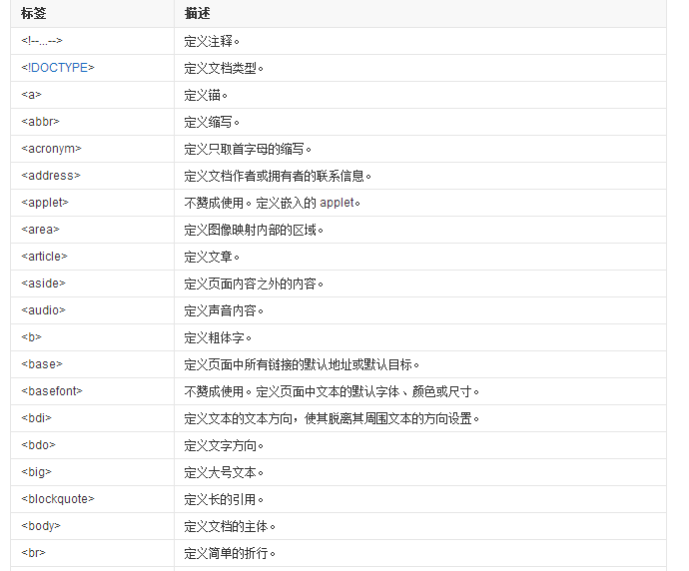

I found some tags on the site。Tags are important in web design. Master the label to be a good design site。Next I'll introduce the commonly used tags

<a> This tag is responsible for links

<br>The tag is an empty tag, which can be inserted into a simple newline character.

<p> is called the start tag, </p> is called the closing tag

<head>This is the header file containing the < HTML >

<body>This is the source part of the HTML language, which is basically the center part of the web page, which is the part of the page that you see

<html>This element informs the browser that it is an HTML document itself

....................

1. Conclusion

I'm just a beginner. I don't know much about special effects and how to do it. But I have a certain understanding of the structure of web pages, "div >," and so on.I hope my report will help youI hope you can find my shortcomings and inform me to correct themFinally, I think I will learn more about web design in the future