Curate — Sprint 9 QA & Screenshots Report
Team CuRaTe · github.com/CuRaTe-team80/Curate
Member: Tharukshi (Member 7)
Branch: sprint9/m7-qa-and-screenshots
Scope: Toast notifications, Notifications/Activity page, live presence, recently-viewed-boards dropdown
Date: 12 September 2026

1. Summary
Full click-through QA of the real-time and activity-tracking features was completed against a local environment (Vite dev server + Express + Socket.io + local MongoDB). Three of four areas passed cleanly. One bug was found in the Notifications/Activity feed: every user action is logged twice, once correctly and once as a false "another user" echo of the same action. The root cause was traced to the Socket.io broadcast handler and flagged for the backend owners, since a proper fix requires server-side changes outside this QA pass's scope.

2. Results at a glance
Section | Area | Result
A | Toast notifications | Pass
B | Notifications / Activity page | Bug found
C | Live presence | Pass
D | Recently-viewed-boards dropdown | Pass

3. Section-by-section detail

Section A — Toast notifications
Result: Pass
- Performing an action that should trigger a toast (labeling a sample) shows a styled confirmation popup in the bottom-right corner.
- The toast disappears automatically after a few seconds with no manual action needed, confirmed by waiting and re-checking without interacting with the page.
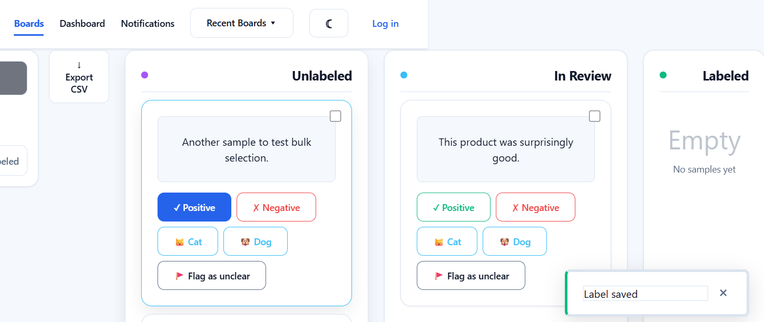
Fig. 1 — Toast confirmation shown after labeling a sample

Section B — Notifications / Activity page
Result: Bug found
- The Notifications page loads correctly as a scrollable "Activity Center" feed with timestamped entries and a "Clear history" option.
- New actions do appear live at the top of the feed without a manual refresh — this part works as intended.
However, every single labeling action produced two entries at the same timestamp: "Label saved" and "A sample was updated by another user" — even with only one user and one browser tab involved. This was reproduced consistently across multiple separate test actions.
Root cause identified: in useSocket.js, the server's sampleUpdated Socket.io event is broadcast to all connected clients, including the one that made the original change. The client-side handler unconditionally logs every sampleUpdated event as "by another user," with no check for whether the update actually originated from a different session.
Fix status: not applied. A correct fix requires the server to include the originating socket/user ID in the broadcast payload so the client can distinguish its own echoed update from a genuine change by someone else. This touches server-side broadcast logic outside this ticket's client-only QA scope, so it has been documented and handed off rather than patched directly.
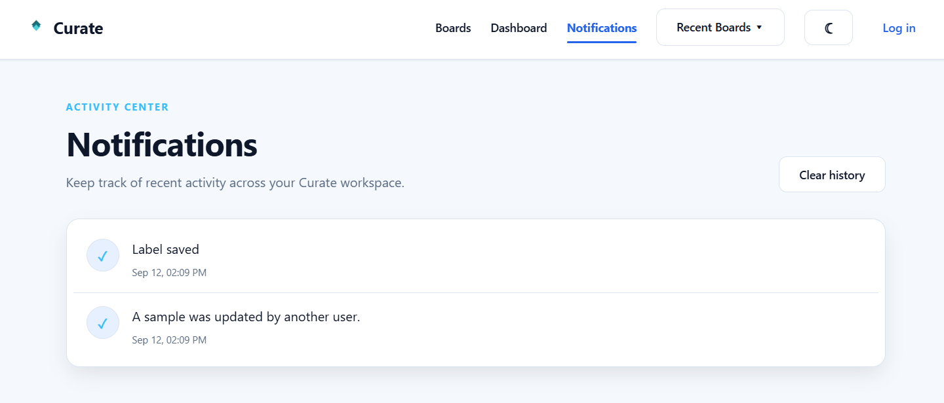
Fig. 2 — A single label action produced two entries: the real one and a false "another user" echo

Section C — Live presence
Result: Pass
- Opening the same board in two separate sessions (a normal window and an incognito window) shows two avatar circles under "Viewing now", confirming both sessions are tracked in real time.
- Closing one session correctly drops its avatar from the presence bar, leaving only the remaining session's avatar — confirmed with a follow-up screenshot after closing the second window.
- Minor note: both avatars showed the same initial ("A"), since neither test session was logged in with a distinct account. Not a bug — just an untested case for distinguishing named users.
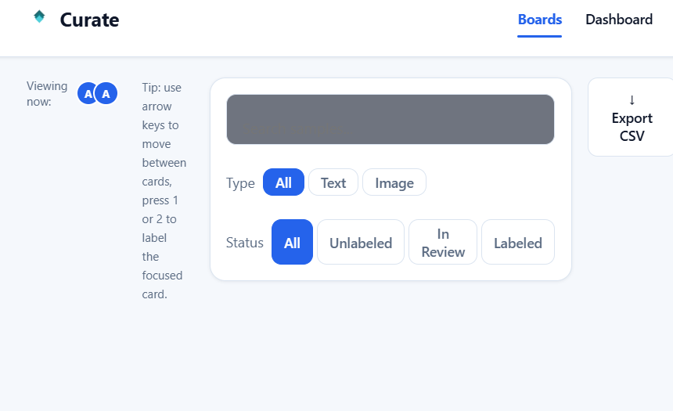
Fig. 3 — Two avatars shown while both sessions view the same board
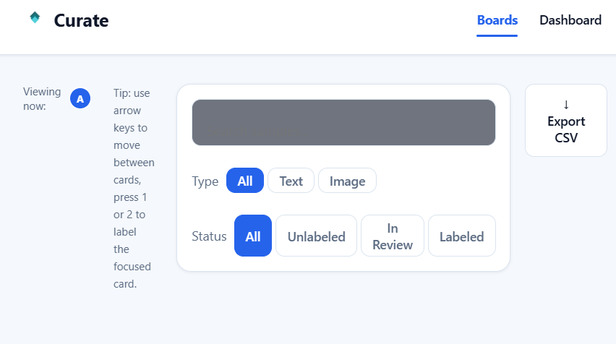
Fig. 4 — Avatar count drops to one after the second session closes

Section D — Recently-viewed-boards dropdown
Result: Pass
- The "Recent Boards" dropdown lists boards visited during the session.
- Clicking an entry in the dropdown navigates directly to that board.
- Visiting a second, newly created board added it to the top of the list, confirming both multi-board tracking and most-recent-first ordering.
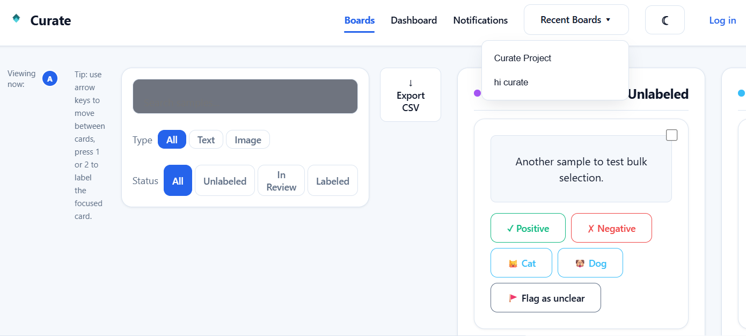
Fig. 5 — Recent Boards dropdown showing both visited boards, most recent first

4. Handoff notes for Isiwara / Bhanuka
- Notifications duplicate-echo bug (Section B) needs a server-side fix: include the originating socket/user ID when broadcasting sampleUpdated, and have the client skip the "another user" toast/log entry when the ID matches its own socket.
- Presence avatars currently can't distinguish different named users while unauthenticated — worth a quick check once real logged-in accounts are used for the final demo/screenshots.

5. Conclusion
Real-time and activity-tracking features are largely working well — toasts, live presence, and the recent-boards dropdown all behaved correctly and consistently across repeated tests. One real bug was found and fully root-caused in the Notifications feed; it has been documented with a suggested fix for the team members who own the affected server-side code. Screenshots above are ready for inclusion in the Assignment 03 final report.

