Social Media Marketing Performance Analytics (2024)
Executive Report for Leadership Review
Prepared by: Data Analyst Candidate | Date: 2026-02-13

1. Executive Summary
This report summarizes cross-platform social media performance in 2024 and identifies the key drivers of reach, engagement, and click-through behavior. The analysis consolidates post-level performance across Facebook, Instagram, LinkedIn, TikTok, X.com, and YouTube, and evaluates differences by content type, content category, posting time (day/hour), hashtags, and region. Because click/CTR tracking is not available for every post, conversion results are reported as Tracked Only and interpreted alongside Tracking Coverage.

2. Topline KPIs (All Platforms, 2024)
Metric | Value
Total Engagement | 646M
Total Views | 4.8B
Total Impressions | 5.77B
Average Engagement Rate | 15.28%
Average CTR (Tracked Only) | 0.61%
Note: CTR is reported as Tracked Only. Tracking Coverage should be monitored when interpreting click-based insights.

3. Key Findings

3.1 Content Performance
- Content category efficiency differs materially: Educational and Customer Story content show the highest engagement efficiency (Engagement per 1K Impressions).
- Hashtags that maximize impressions (reach) are not always the same as those that maximize clicks (conversion). Separate awareness vs conversion tagging strategies are recommended.
- Post type performance varies by platform; therefore, content format should be tailored by platform rather than using a single global mix.
Content category efficiency (Engagement per 1K Impressions):
Content Category | Engagement per 1K Impressions
Educational | 166.0
Customer Story | 165.5
Event / Webinar | 117.0
Product Promotion | 96.5
Entertainment | 62.1

3.2 Time & Region Intelligence
- Posting efficiency changes by day and hour. Heatmap analysis highlights consistent high-performing windows and avoids reliance on a single average posting time.
- Regional conversion intent differs: Tracked CTR is highest in Japan (0.68%) and the UK (0.65%), and lowest in the USA (0.55%).
- Video consumption is consistently higher than live-stream consumption across regions, indicating that video should remain the default format while live is reserved for targeted use cases.
Tracked CTR by Region (Top to Bottom):
Region | Avg CTR (Tracked Only)
Japan | 0.68%
UK | 0.65%
Germany | 0.63%
Australia | 0.61%
Brazil | 0.60%
India | 0.60%
Canada | 0.58%
USA | 0.55%

4. Recommendations
- Adopt platform-specific format playbooks
Use the platform x post type view to prioritize the best-performing formats per platform; avoid a single global format strategy.
- Shift content mix toward high-efficiency categories
Increase publishing share for Educational and Customer Story content (top Eng/1K). Redesign low-efficiency categories before scaling.
- Operationalize posting windows
Use the day x hour heatmap to define primary and secondary posting windows. Maintain platform-specific schedules based on hourly patterns.
- Prioritize CTA-driven content in high-intent regions
Focus conversion-oriented posts and landing pages in regions with higher tracked CTR (e.g., Japan, UK).
- Improve measurement discipline
Standardize link tracking (UTMs) to increase Tracking Coverage and make CTR comparable across platforms, regions, and campaigns.

5. Methodology & Data Model
Workflow: Python (EDA + Cleaning) -> SQL (Business Analysis) -> Power BI (Star Schema + DAX Measures). Power BI uses a fact table for post performance and dimension tables for Date, Platform, Region, and Content attributes to enable fast slicing and consistent metrics.

6. Data Quality Notes
- CTR/Clicks are not available for all posts. Conversion metrics are reported as Tracked Only and should be interpreted with Tracking Coverage.
- Volume-driven comparisons can be biased by posting frequency. Efficiency metrics (Engagement per 1K Impressions) are used to support fair comparisons.
- Hashtag performance can be sensitive to sample size; low-volume hashtags should be validated before scaling.

Appendix: Dashboard Pages
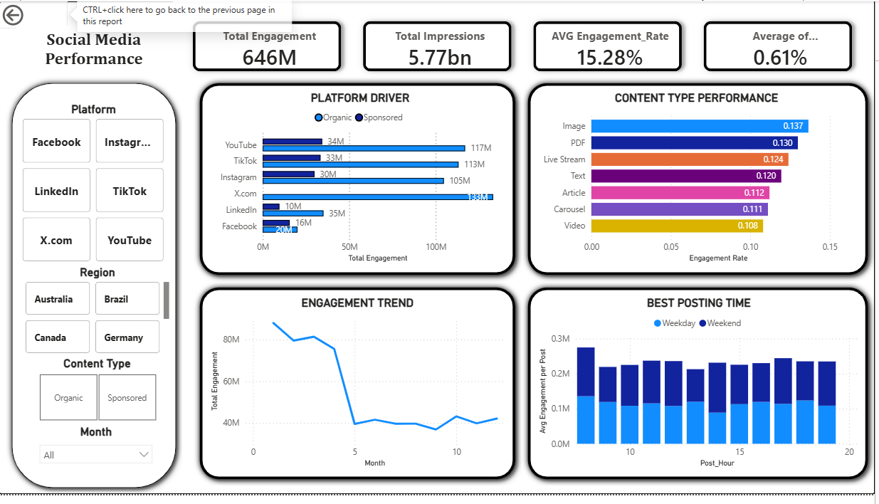
Figure A1. Executive Overview
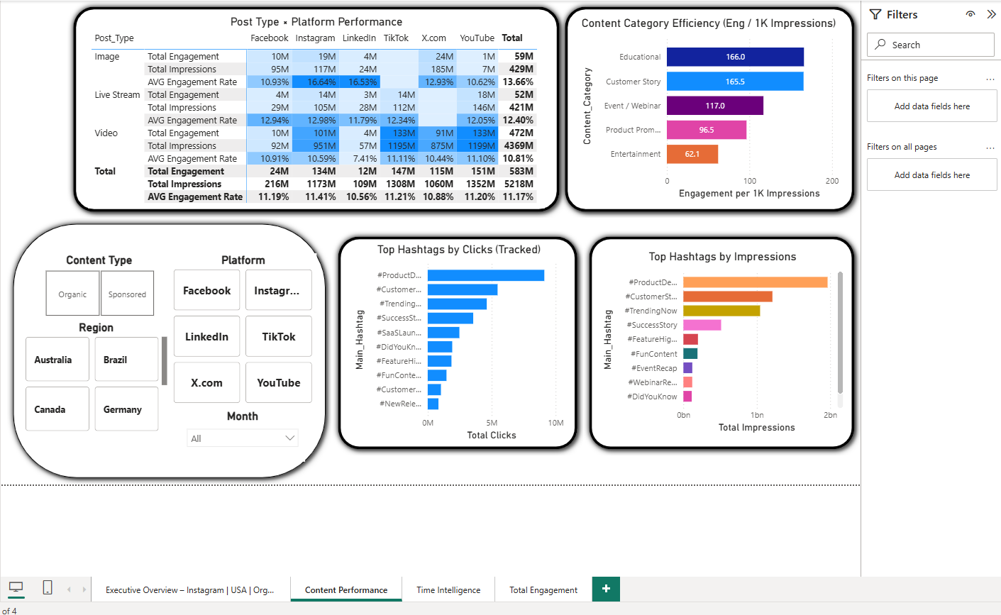
Figure A2. Content Performance
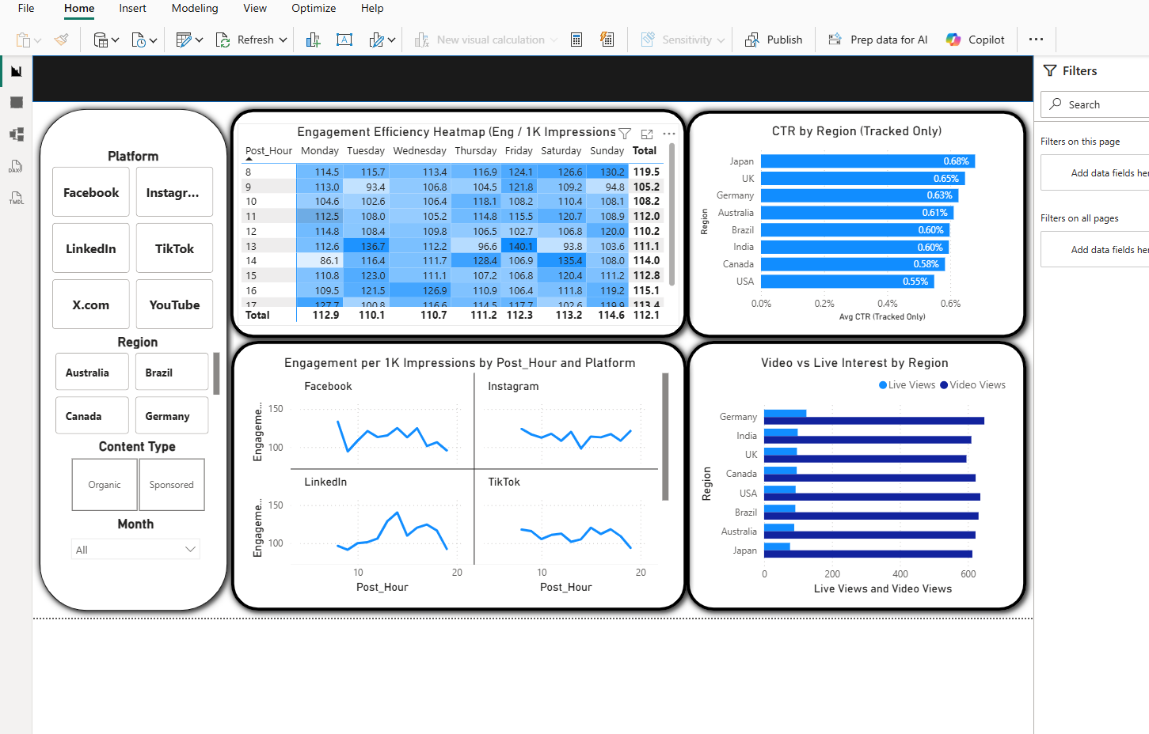
Figure A3. Time Intelligence

