2nd TLS Capture
This capture shows a live TLS 1.3 session between your host 172.16.**.** and a remote server 144.2.15.21, with the filter tls applied. The highlighted packet is TLSv1.3 Application Data, meaning the handshake is already complete and the two endpoints are exchanging fully encrypted content over TCP port 443.
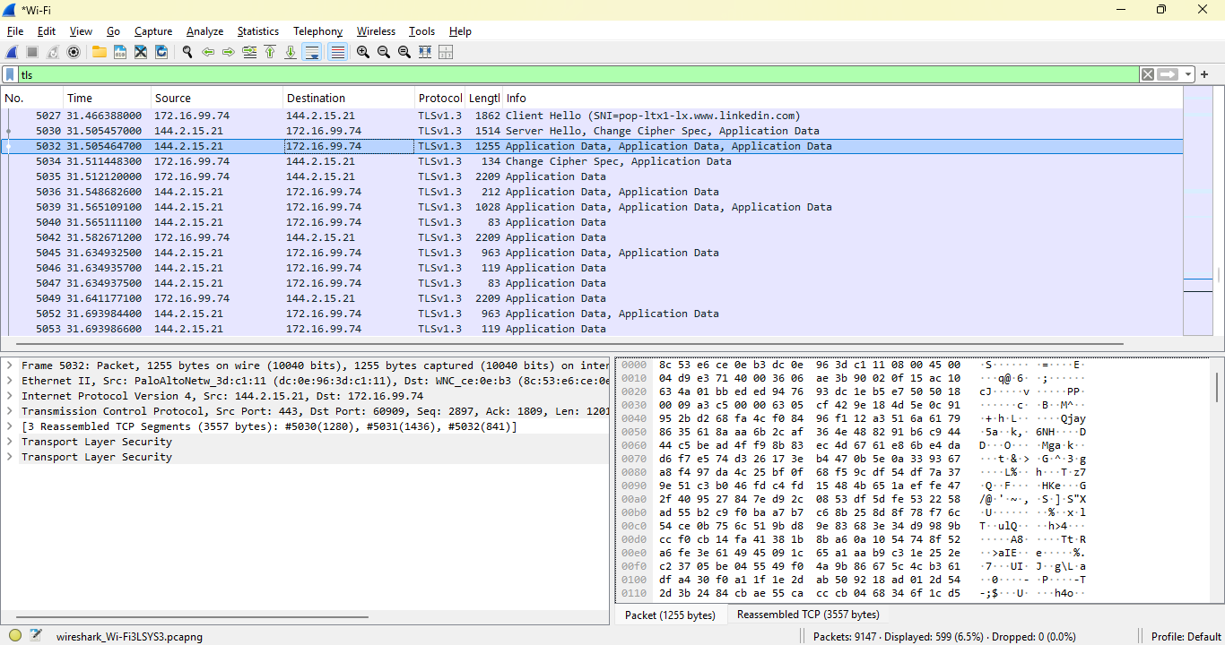
This capture shows a TLSv1.3 Application Data packet from a remote server (144.2.15.21) to my host (172.16.**.**) over TCP port 443. The TLS handshake has already been completed, and the endpoints are exchanging encrypted content. Wireshark identifies the protocol as TLSv1.3 and labels the payload as Application Data, but the actual content is not visible because it is encrypted. This demonstrates how modern HTTPS traffic appears in Wireshark and highlights that, even without decryption, analysts can still observe metadata such as IP addresses, protocol versions, and packet sizes.
What this specific packet tells:
- Source / Destination:
  - Source: 144.2.15.21 (remote server)
  - Destination: 172.16.**.** (your machine)
- Protocol: TLSv1.3
- Length: 1255 bytes of Application Data
- Transport:
  - Ethernet II
  - IPv4
  - TCP (likely 443 on the server side)
So this is encrypted data coming back from the server to us—probably part of a web page, API response, or some other HTTPS content.
TLS 1.3 vs what we saw earlier
In earlier captures we had TLS 1.2; here we’ve got TLS 1.3, which:
- Encrypts more of the handshake (less visible metadata).
- Is faster and more secure.
- Is now the default for most modern browsers and services.
Wireshark can still identify:
- That it’s TLS 1.3.
- That this is Application Data.
- But it cannot decrypt the payload without keys—so the hex pane looks like random bytes.
How to interpret this as a SOC / network analyst
Even though the content is encrypted, we can still read a lot from this:
- Who our machine is talking to (144.2.15.21).
- How much data is being transferred (1255 bytes here, plus other packets).
- Which protocol version is in use (TLS 1.3).
- Direction of flow (server → client in this packet).
From a security perspective, we’d ask:
- Is 144.2.15.21 a known, legitimate service?
- Is this volume and pattern of TLS traffic normal for this host?
- Does this IP show up in threat intel feeds?
From a performance/troubleshooting perspective, we’d look at:
- Retransmissions (tcp.analysis.retransmission).
- Latency between packets.
- Packet sizes and fragmentation.

