# Installation

Start Install package: DdeWin32Setup.msi

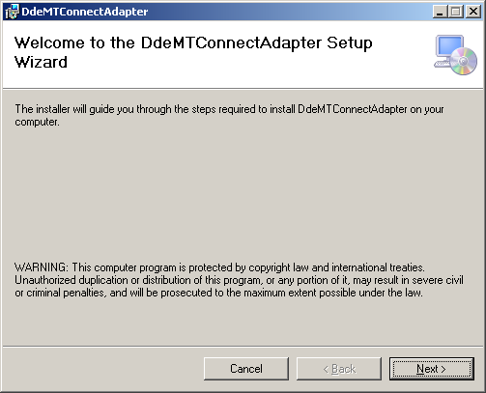

The adapter is coded as a 32bit application, which works well in a 64 bit operating system (like windows 7):

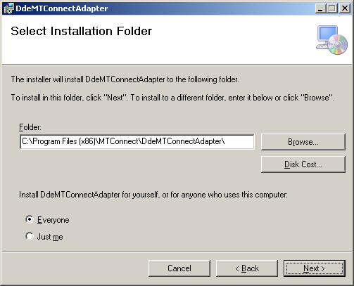

Be patient the installation can take some time. You will see this screen “thinking”

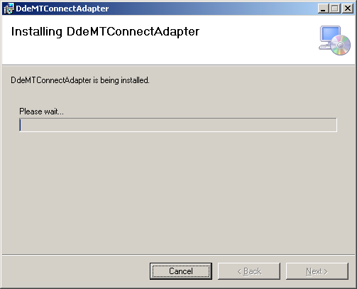

When done you will see:

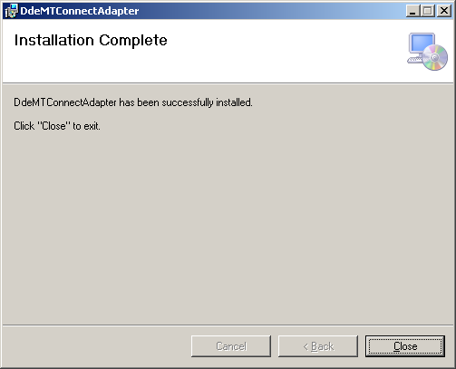

# Notes

This MTConnect Adapter install package will work for both 32 bit and 64 bit Windows machines! For windows 7 and 64 bit machines, it installs into the directory: C:\Program Files (x86)\MTConnect\DdeMTConnectAdapter with the following file:

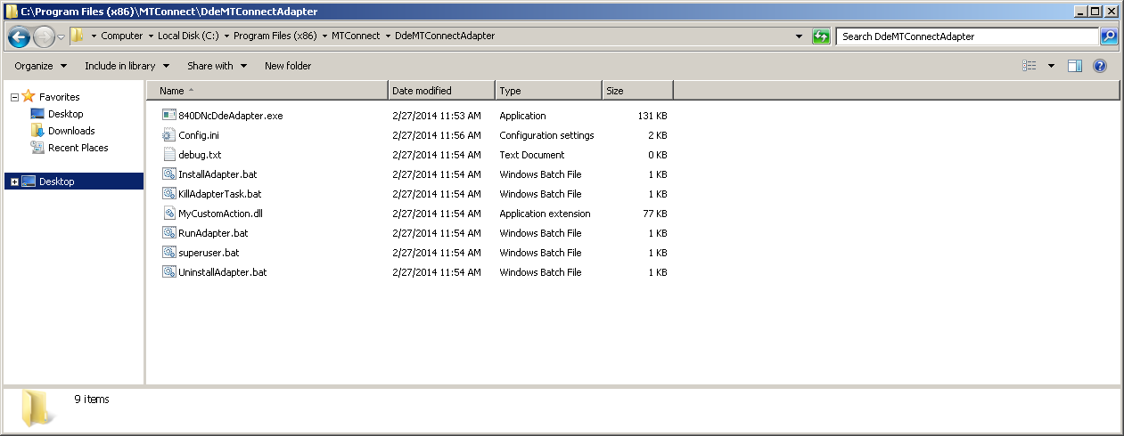

After the msi installation is done, the MTConnectDDEAdapter service should also be installed and running.

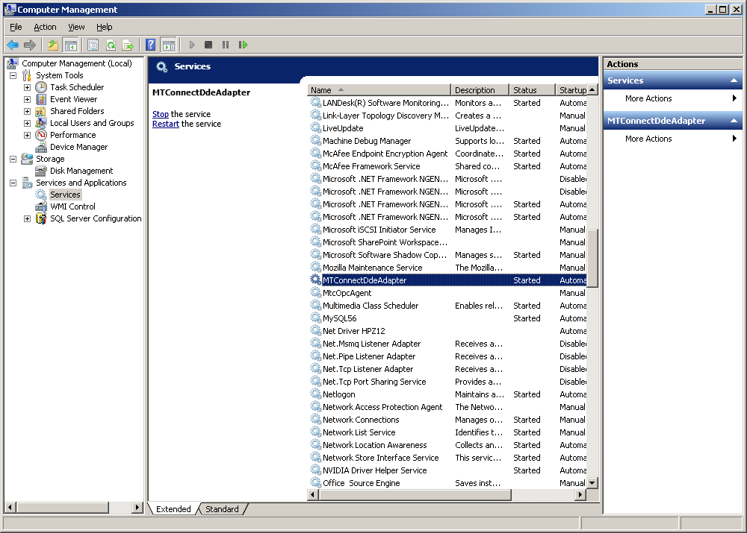

Note, the MTConnectDDEAdapter will check to make sure the firewall is not blocking port 7878:

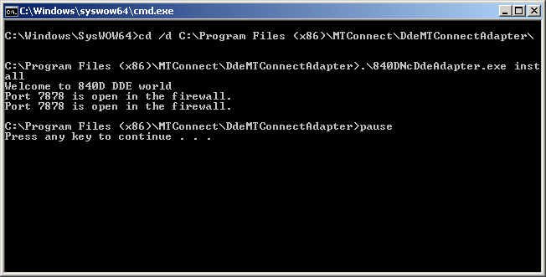

In config.ini the main thing is it looks for the cnc (and ndde.exe) to be running before it does any data collection. For powerline, maschine.exe is correct. Not sure for solutionline.

In config.ini:

cnc=maschine.exe

For solutionline, change the following ini parameter to:

cnc=HKCmd.exe

which has been done in the installation msi script.

After it is determined that the 840D CNC is running, the next step is to see if the connection to the 840D data is running. This is done by the application ncdde.exe. Within the configuration Config.ini the file ncdde can be set by the ini parameter: spawndde under the section GLOBALS.

mSpawnDDE=config.GetSymbolValue("GLOBALS.spawndde", "ncdde.exe").c_str();

The file config.ini contains the following parameters:

[GLOBALS]

app=ncdde

topic=machineswitch

port = 7878

sleep=2000

cnc=maschine.exe

tags =GENERIC

ResetAtMidnite=false

Spawndde=F:\mmc2\ncdde.exe

[GENERIC]

Tag.Sample.Xabs=/Channel/MachineAxis/actToolBasePos[1]

Tag.Sample.Yabs=/Channel/MachineAxis/actToolBasePos[2]

Tag.Sample.Zabs=/Channel/MachineAxis/actToolBasePos[3]

Tag.Event.controllermode =/Bag/State/opMode

Tag.Event.execution=/Channel/State/progStatus

Tag.Event.Tool_number=/Channel/State/actTNumber

Tag.Sample.Srpm=/Channel/Spindle/cmdSpeed[1]

Tag.Sample.Sovr=/Channel/Spindle/speedOvr[1]

Tag.Sample.path_feedratefrt=/Channel/State/actFeedRateIpo

Tag.Sample.path_feedrateovr=/Channel/State/feedRateIpoOvr

Tag.Event.program=/Channel/ProgramInfo/ProgName

Tag.Event.block=/Channel/ProgramInfo/Block[0]

Enum.controllermode.0=MANUAL

Enum.controllermode.1=MANUAL_DATA_ENTRY

Enum.controllermode.2=AUTOMATIC

Enum.power.0=OFF

Enum.power.1=ON

Enum.execution.0=IDLE

Enum.execution.1=interrupted

Enum.execution.2=PAUSED

Enum.execution.3=EXECUTING

Enum.execution.4=IDLE

Enum.execution.5=IDLE

The ncdde.exe is now installed from a win32 solutionline to simplify where the location of the exe is located.