Steps to Install MtcOpcAgent for Siemens 840D

Thisi document describes how to install the 64-bit implementation of MtcOpcAgent for reading status from a Siemens 840D Powerline CNC using remote Simnumerik OPC connection to read data from CNC.

1. Ping remote machine to make sure it is running and available on the network.
2. Now comes the bad part – DCOM. Use TestDCOM to make sure you can ping the CNC ip, and then CONNECT to create a connection to the OPC server. If not, don't bother going any farther, as you will need to "fix" you DCOM permissions.
3. Install OPC Core Components 3.00 Redistributable (x64)

Rename "OPC Core Components Redistributable (x64).msx"

to "OPC Core Components Redistributable (x64).msi", double click and install.

1. Microsoft Visual C++ 2010 Redistributable Package (x64) installs runtime components of Visual C++ Libraries required to run applications developed with Visual C++ on a computer that does not have Visual C++ 2010 installed. You can find it here: <http://www.microsoft.com/en-us/download/details.aspx?id=14632>

Rename vcredist_x64.exg to vcredist_x64.exe and run.

1. Install the Agent (which reads status data from the CNC using OPC and displays using http). Run the installation msi script.

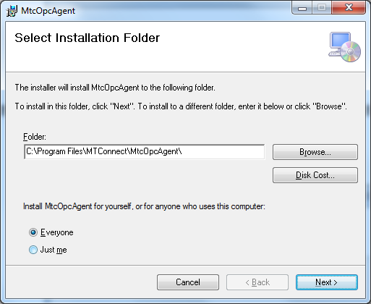

1. Input the ip of the CNC and the name you want to use to describe it as a device, e.g., M2132 (no spaces or fancy characters please!), for example:

192.168.24.4,127.0.0.1

M1,M2

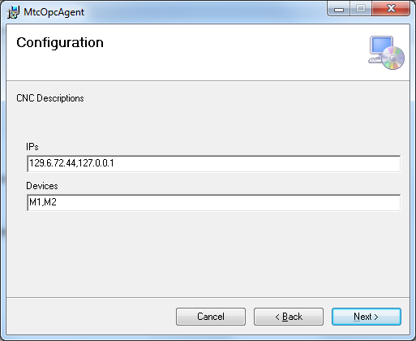

1. Next you will need to verify that the MtcOpcAgent has been installed as a service, and then start it (because you probably didn't have sufficient privileges to install services onto the Windows 7 box.

First, check if the service is not installed, navigate to the folder "C:/Program Files/MTConnect/MtcOpcAgent" and find the MtcOpcAgent.exe.

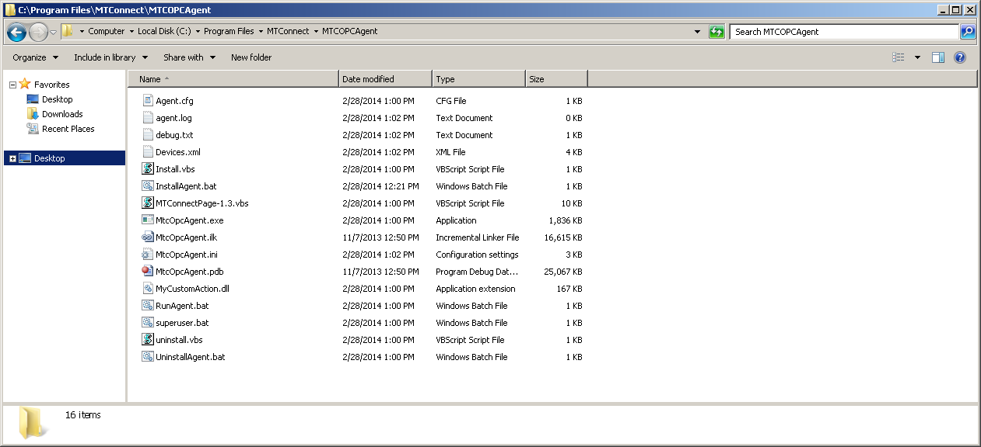

Verify that the configuration parameters are correct, open MtcOpcAgent.ini in notepad, and confirm highlighted text below matches what was entered during installation:

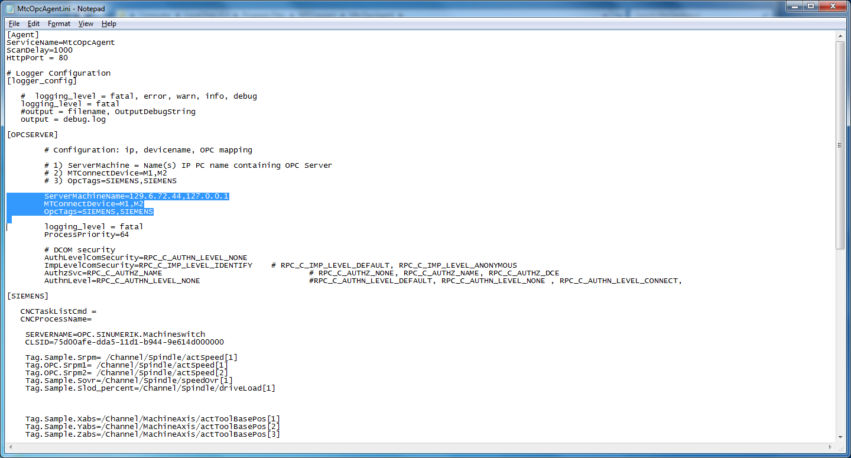

Next, check to see if MtcOpcAgent service is in Windows Service Control Manager (SCM):

Right-click My Computer -> Services and Applications -> Services

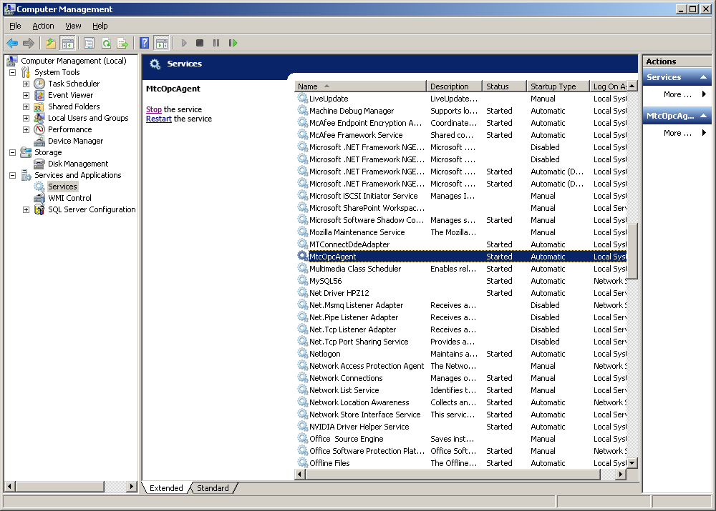

If MtcOpcAgent is not in SCM, install it:

Runas Install.bat as administrator (right click the bat file and click run as administrator).

🟏🟏🟏 PLEASE READ 🟏🟏🟏

You need to let the MtcOpcAgent.exe be allowed to pass through the firewall. DCOM needs port 135 opened. Let MtcOpcAgent.exe , but Runas administrator RunAgent.bat (and respond yes to the Firewall question to allow it through) or follow these directions from Microsoft:

Note: You need to let the MtcOpcAgent.exe be allowed to pass through the firewall. DCOM needs port 135 opened. and MtcOpcAgent.exe opened in the firewall.

Runas administrator RunAgent.bat (and respond yes to the Firewall question to allow it through)

Or follow these directions from Microsoft:

### To allow a program to communicate through Windows Firewall

1. Open Windows Firewall by clicking the **Start** button Picture of the Start button, and then clicking **Control Panel**. In the search box, type **firewall**, and then click **Windows Firewall**.
2. In the left pane, click **Allow a program or feature through Windows Firewall**.

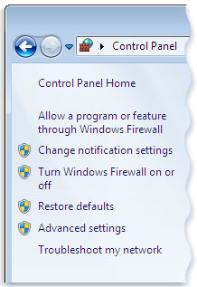Left pane of Windows Firewall

1. Click **Change settings**. Administrator permission required If you're prompted for an administrator password or confirmation, type the password or provide confirmation.
2. Select the check box next to the program you want to allow, select the network locations you want to allow communication on, and then click **OK**.
3. Start the MtcOpcAgent service: double click the service entry and click start

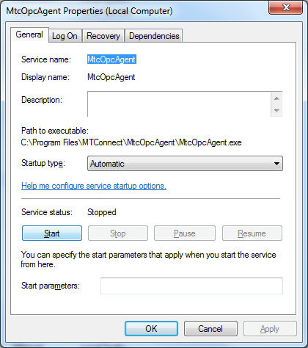

Hopefully it has started and there are not problems.