TASK33

Ex.1

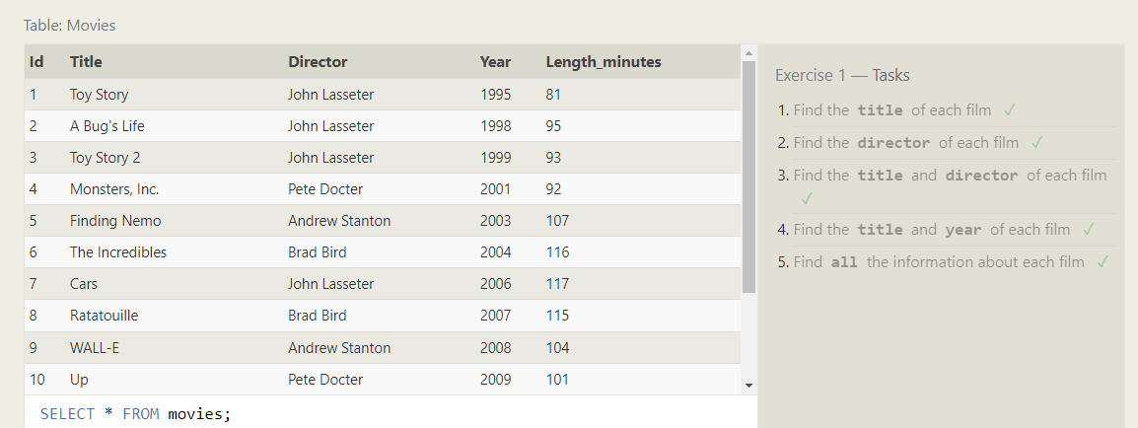

Ex.2

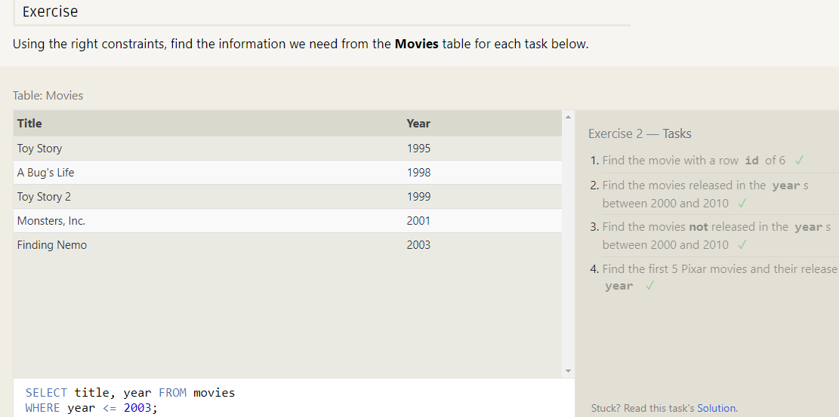

EX.3

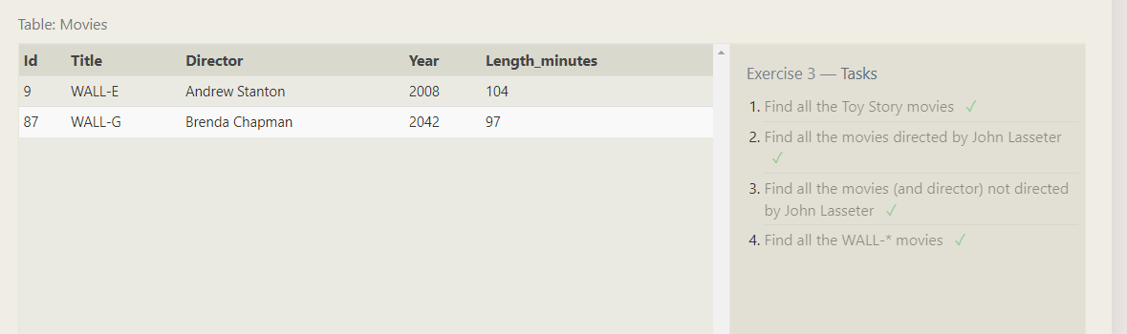

Ex.4

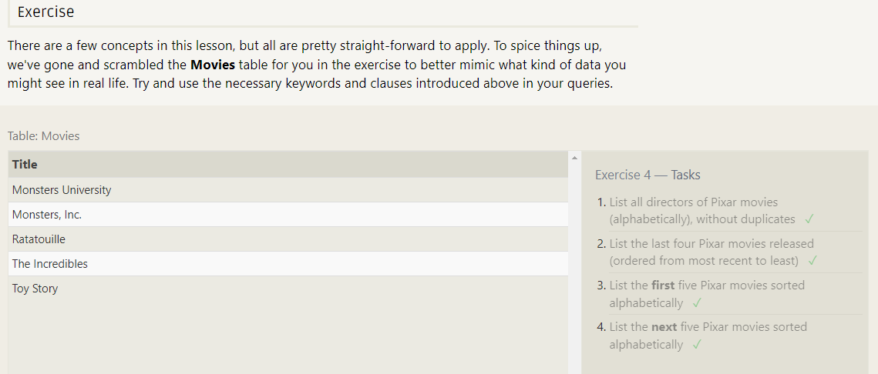

EX.5

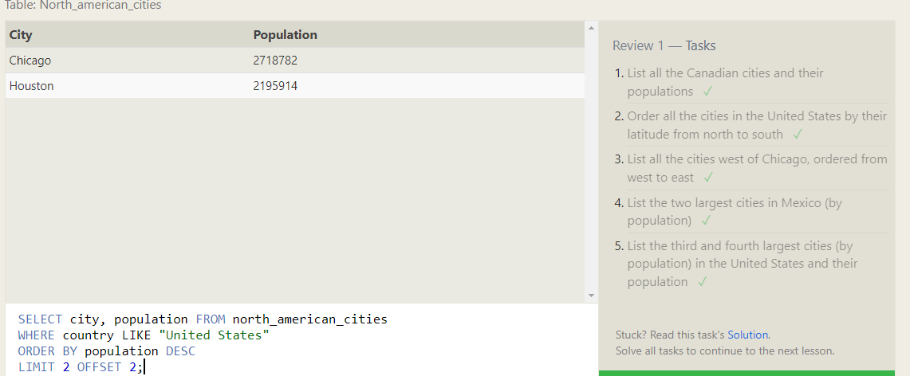

Ex.6

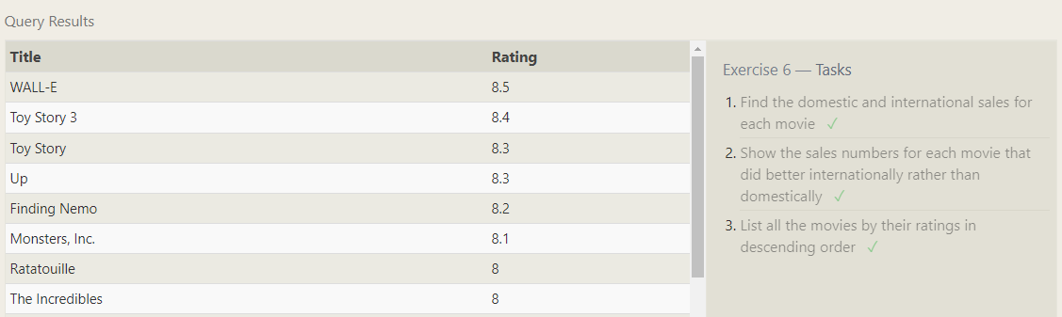

Ex.7

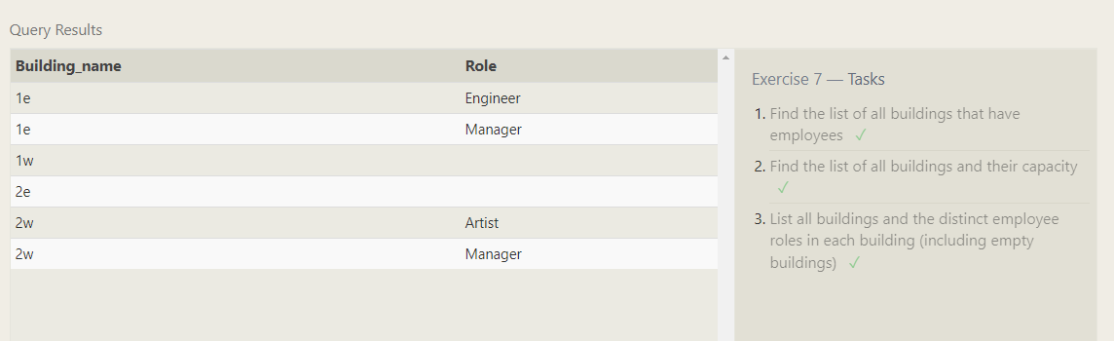

Ex.8

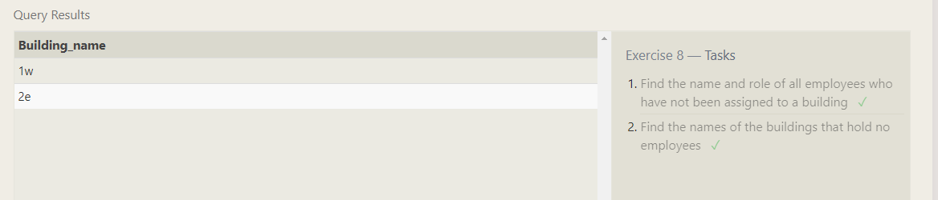

Ex.9

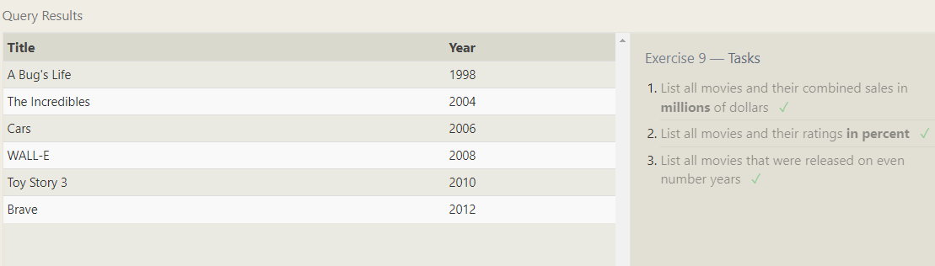

Ex.10

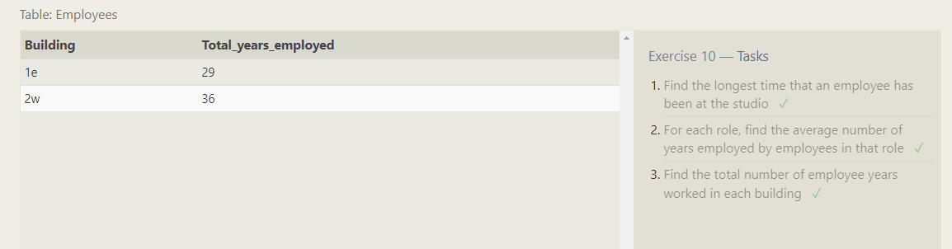

Ex.11

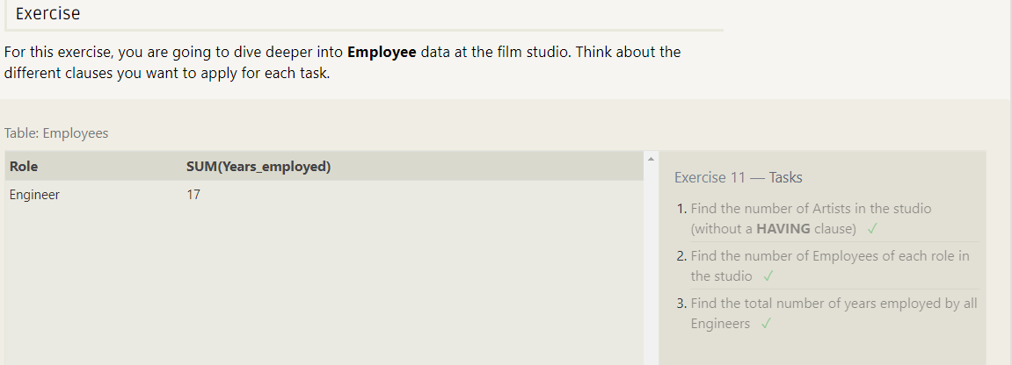

Ex.12

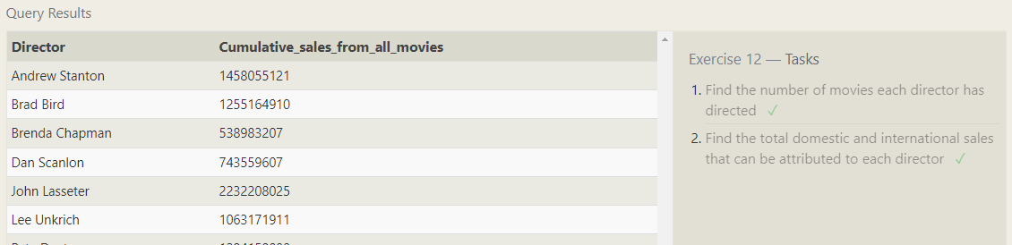

Ex.13

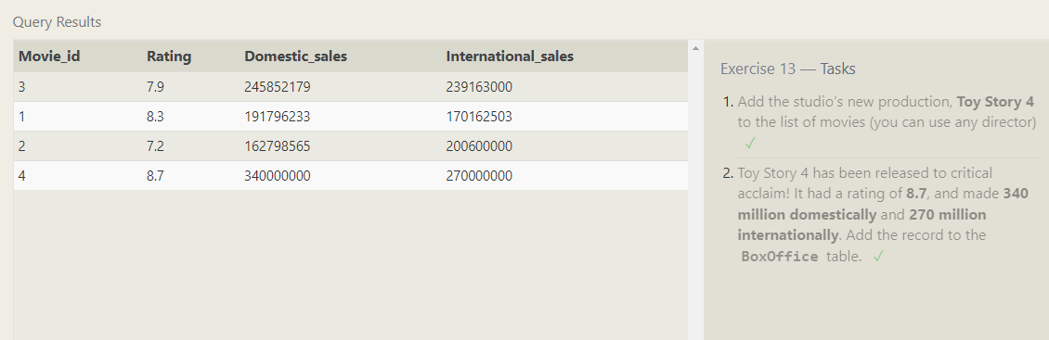

Ex.14

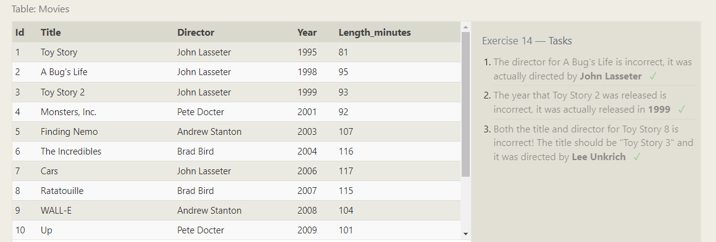

Ex.15

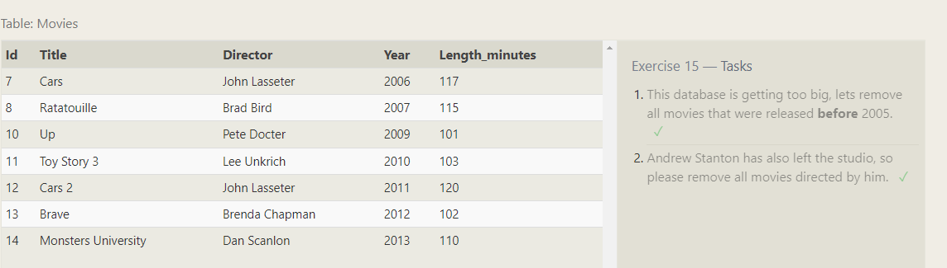

Ex.16

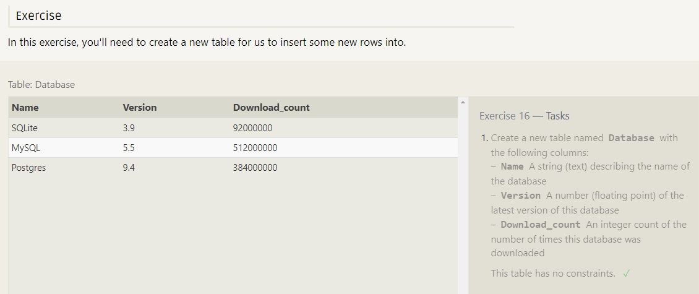

Ex.17

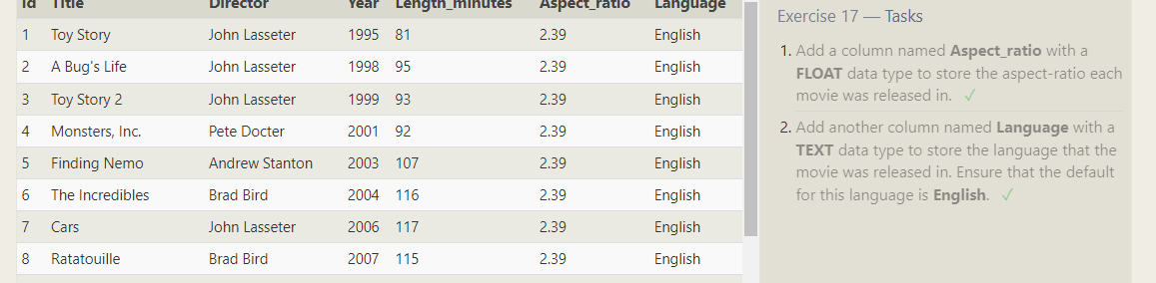

Ex.18

