Phase-1

Employee Master

1. Employee Number : Auto incremented (Primary key) – Read Only
2. Employee First Name (Mandatory) – Text – Varchar (50)
3. Employee Last Name (Mandatory) – Text – Varchar (50)
4. Employee DOJ – Date field – Mandatory – Date Field
5. Employee DOB – Mandatory – Date Field **(18 years check)**
6. Employee Department – Dropdown – Mandatory – Foreign Key Department Master
7. Employee Location -Dropdown – Mandatory – Foreign Key Location Master
8. Employee Email – Mandatory – Email validation
9. Employee Phone Number – Only Numeric – Numeric validation – Numeric (10)
10. **Gender (Male/Female)**

Department Master

1. Department ID – Auto incremented (Primary key) – Read Only
2. Department Name - Text – Mandatory - Varchar (100)

Location Master

1. Location ID – Auto incremented (Primary key) – Read Only
2. Location Name - Text – Mandatory - Varchar (100)

Basic CRUD operation

For Delete confirmation pop up

For Add and Update Success message

Validation for phone number and email

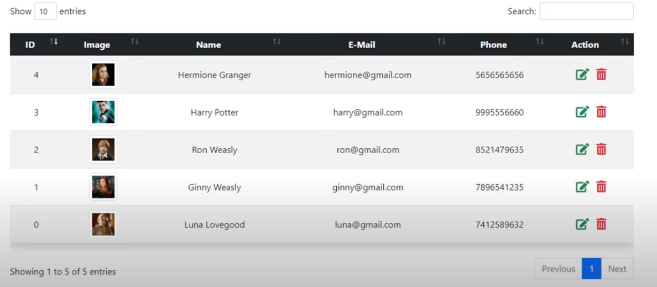

Phase-2