1.源码下载地址：

<https://github.com/LLK/scratch-blocks>

使用git clone到Scratch3.0文件夹下

2.Windows下安装node.js

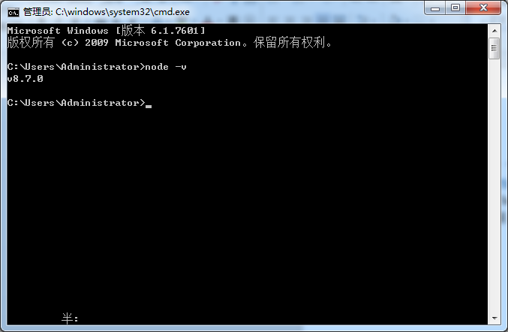

安装npm

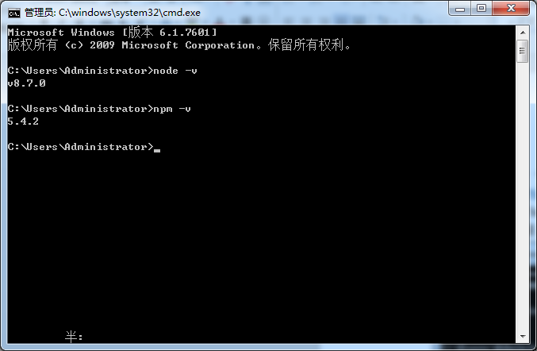

安装cnpm

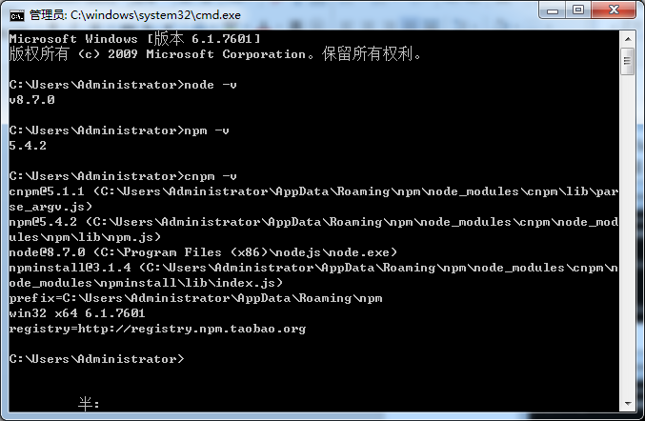3.在F:/Scratch3.0/scratch-blocks/目录下，按住shift键，点击鼠标右键，打开命令窗口。

4.安装全局webpack包:cnpm install webpack –g

5.安装依赖包：cnpm install

如果途中报错，不需要理会。在进入F:/Scratch3.0/scratch-blocks/目录下找到F:\Scratch3\scratch-blocks\node_modules\google-closure-library，把里面的东西全部复制到新建文件夹closure-library下即可。

再次cnpm install。

6.运行python编译，（python版本是2.7.13）

Python build.py

7.运行webpack

Webpack

python build.py

This will export multiple files including:

blockly_uncompressed_vertical.js

blockly_uncompressed_horizontal.js

blockly_compressed_vertical.js

blockly_compressed_horizontal.js

blocks_compressed.js

msg/js/en.js

These can then be used in your project by updating the HTML of your application:

<script src="blockly_compressed_horizontal.js"></script>

<script src="blocks_compressed.js"></script>

<script src="msg/js/en.js"></script>

8.打开F:\Scratch3\scratch-blocks\tests文件夹下，打开vertical_playground.html即可在浏览器下查看效果。