**Module Five Assignment**

In this assignment, you need to convert your objects for the application into class files.   Create a class file for:

* A Student
* A Teacher
* A UProgram*(C# uses Program as the name of the class that contains Main() so we must use a different class name here)*
* A Degree
* A Course

Transfer the variables you created in Module 1 into these class files.  Ensure that you encapsulate your member variables in the class files using properties.

The Course object should contain an array of Student objects so ensure that you create an array inside the Course object to hold Students as well as an array to contain Teacher objects as each course may have more than one teacher or TAs.  For this assignment, create arrays of size 3 for students and the same for teachers.  The UProgram object should be able to contain degrees and the degrees should be able to contain courses as well but for the purposes of this assignment, just ensure you have a single variable in UProgram to hold a Degree and single variable in Degree to hold a Course.

Use this diagram as an example of how the objects relate to each other.

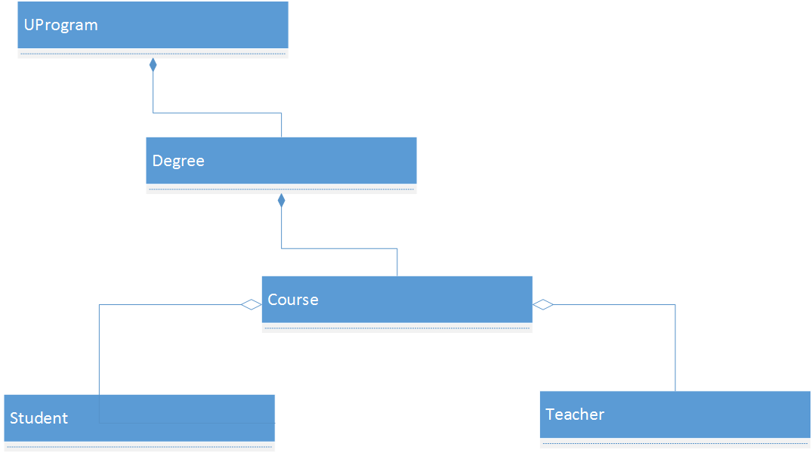

Add a static class variable to the Student class to track the number of students currently enrolled in a school.   Increment a student object count every time a Student is created.

In the Main() method of Program.cs:

1. Instantiate three Student objects.
2. Instantiate a Course object called **Programming with C#**.
3. Add your three students to this Course object.
4. Instantiate at least one Teacher object.
5. Add that Teacher object to your Course object
6. Instantiate a Degree object, such as **Bachelor**.
7. Add your Course object to the Degree object.
8. Instantiate a UProgram object called **Information Technology**.
9. Add the Degree object to the UProgram object.
10. Using Console.WriteLine statements, output the following information to the console window:
    1. The name of the program and the degree it contains
    2. The name of the course in the degree
    3. The count of the number of students in the course.
    4. Your output should look similar to this:

