UML Mapping to IDL

# Introduction

This document describes the main elements of the UML to IDL mapping implemented by the Enterprise Architect IDL4 Add-in.

# Mapping rules

Please refer to Figure 1 below for an example of how the Basic rules are applied.

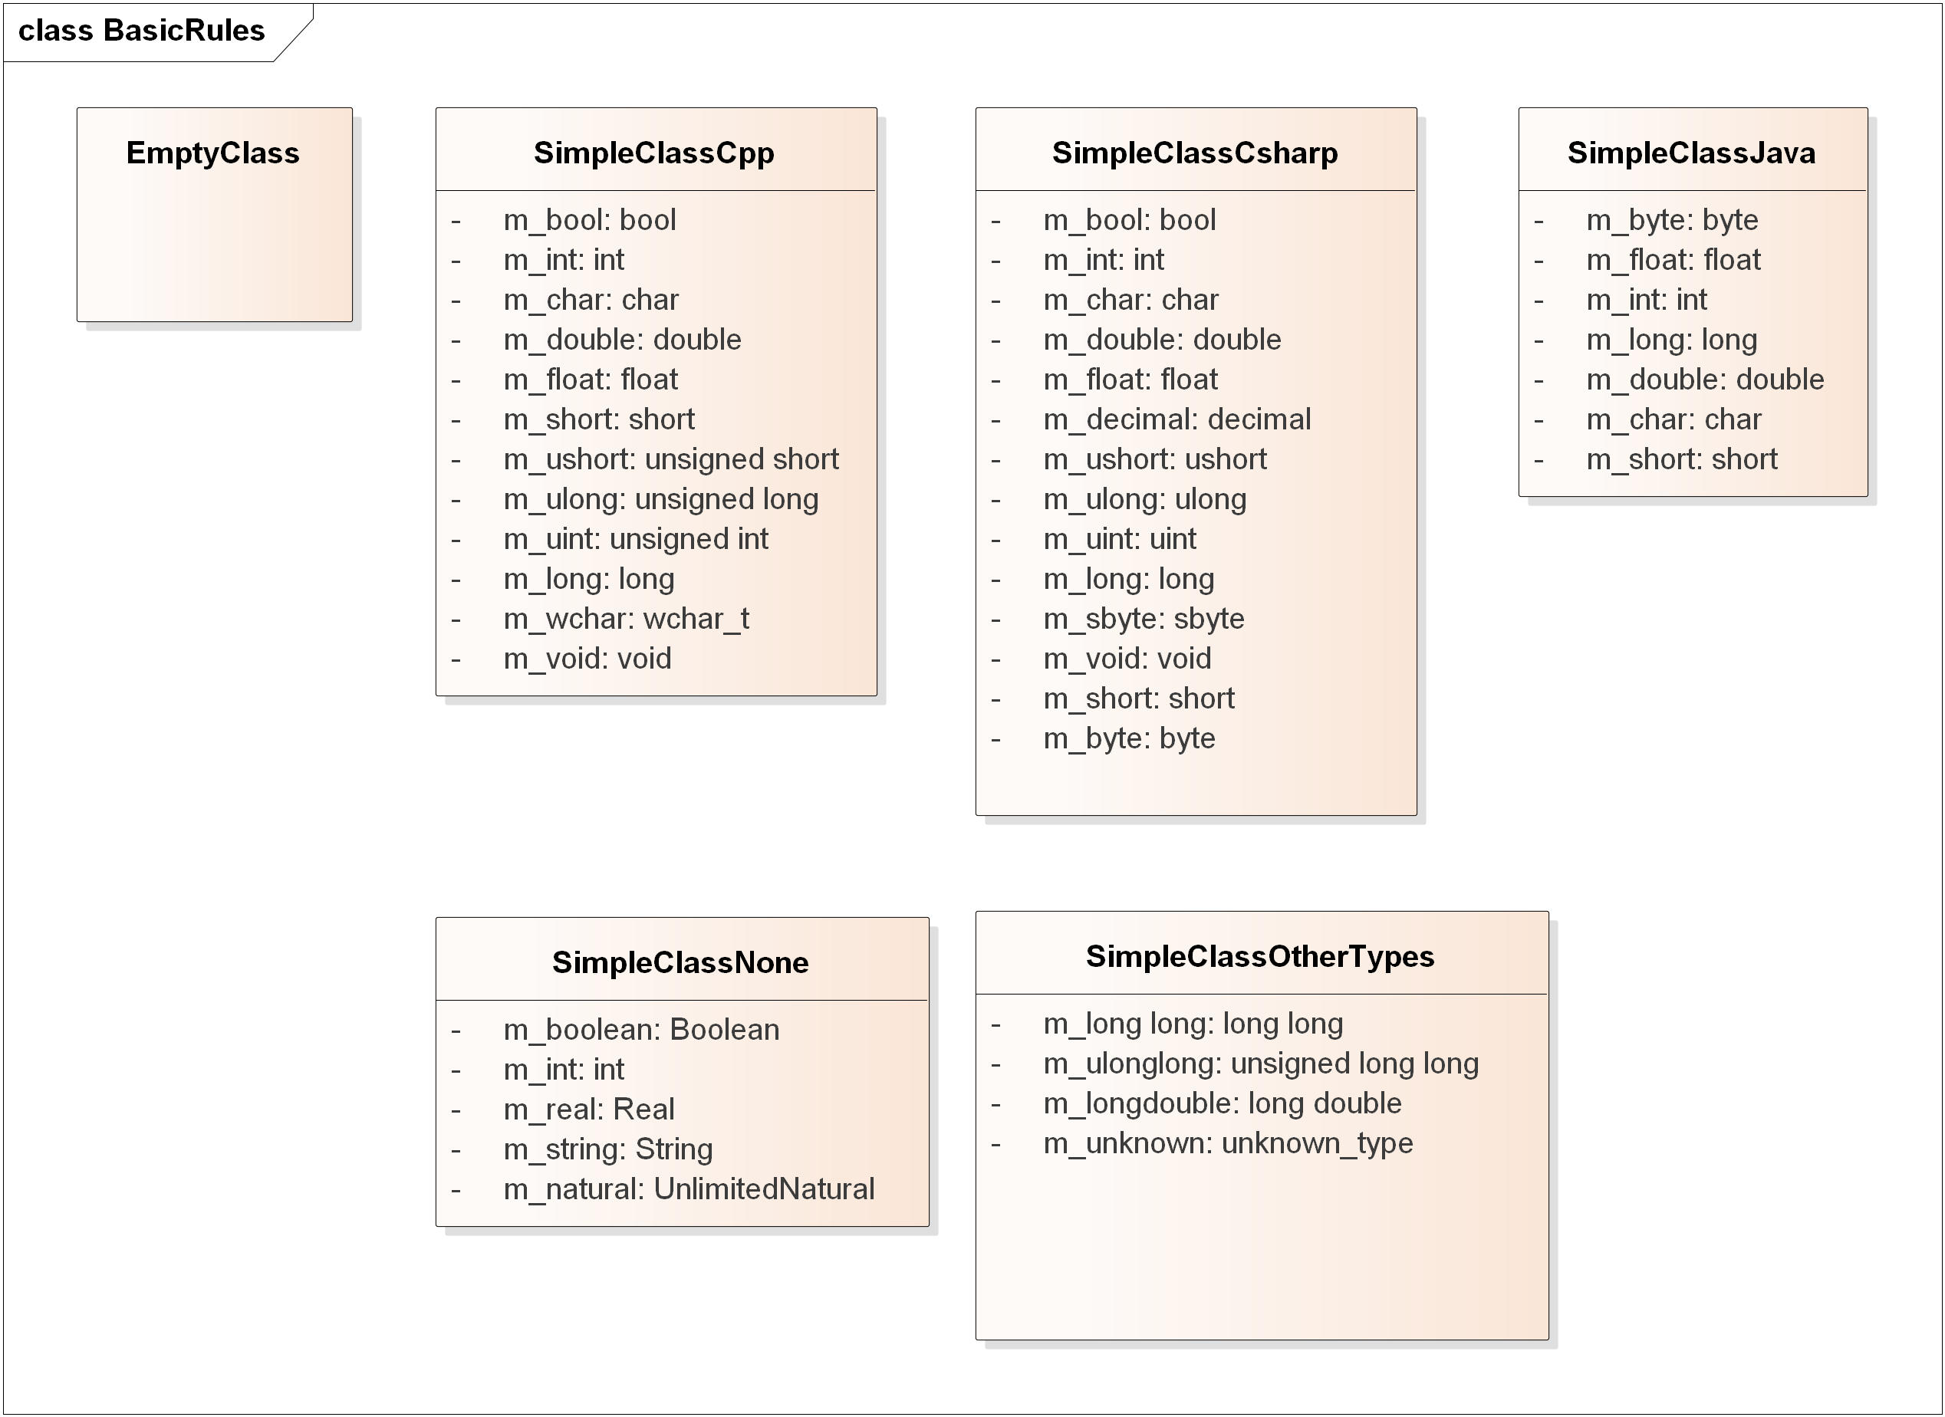

Figure Example Model for basic rules.

## Classes

Classes are mapped to IDL4 structures. Note that IDL4 structures support single inheritance.

## Empty classes

IDL does not support empty classes. If a UML class is empty the generated structure gets a dummy member of type octet. For example the class named EmptyClass in Figure 1 is mapped to the following IDL:

struct EmptyClass {

octet __dummy_prevent_empty_class_EmptyClass;

};

The class name (EmptyClass in the example) is appended to the member name to ensure member names are unique even in the case of inheritance from empty base classes.

## Class attributes

UML Class attributes appear as IDL structure members of the same name.

### Primitive class attributes

The primitive types offered by Sparx Enterprise Architect depend on the “Programming Language” that has been defined for the Class. To ease the mapping to IDL we recommend you select “C++” or “C#” since the types that Sparx Enterprise Architect will offer for those languages are the ones that most closely resemble the IDL4 types.

For example the class SimpleClassCpp shows the primitive types in the UML model when the programming language for the class is “C++”. This class is mapped to the following IDL4 structure:

struct SimpleClassCpp {

bool m_bool;

long m_int;

char m_char;

double m_double;

float m_float;

short m_short;

unsigned short m_ushort;

unsigned long m_ulong;

unsigned long m_uint;

long m_long;

wchar_t m_wchar;

void m_void;

};

UML primitive types that appear in the model will fit various programming languages as shown in Table 1.

Table Mapping of UML primitive types

|  |  |
| --- | --- |
| *Primitive Member Types in UML model* | *Mapped IDL4 type* |
| "boolean", "bool" | boolean |
| "char" | char |
| "wchar", "wchar_t" | wchar |
| "octet", "byte", "sbyte", "int8", "int8_t", "uint8", "uint8_t" | octet |
| "short", "int16", "int16_t" | short |
| "long", "int", "int32", "int32_t", "integer", "decimal"", "unlimited natural". | long |
| "long long", "int64", "int64_t" | long long |
| "unsigned short", "ushort", "uint16", "uint16_t" | unsigned short |
| "unsigned long", "unsigned int", "ulong", "uint", "uint32", "uint32_t" | unsigned long |
| "unsigned long long", "uint64", "uint64_t" | unsigned long long |
| "float", "float32", "number", “real” | float |
| "double", "float64" | double |
| "string" | string |
| "wstring" | wstring |

### Arrays and sequences as members

Given a UML a class with a member m_t of type T, the corresponding IDL4 Structure may map it to a plain member of a type mapped from T—as described above—or to an array or sequence of the aforementioned type.

The decision on whether the type of the mapped IDL4 member is a simple type, an array, or a sequence is based on the UML class attribute multiplicity; specifically on the values of the LowerBound and UpperBound.

* If LowerBound == UpperBound == 1 then the attribute “a” maps to a plain member: “T m;”
* If LowerBound == UpperBound and UpperBound is different to 1 then it maps to an array as in: T m[UpperBound];
* If LowerBound == 0 AND UpperBound == 1, then it maps to a plain member annotated as Optional as in: @Optional T m;
* If LowerBound < UpperBound, then it maps to a sequence as on: sequence<UpperBound, T> m. Note that in this case the precise value of LowerBound has no consequence to the IDL4 mapping.
* If LowerBound > UpperBound the value of LowerBound is ignored. As if it had been zero. In this case the precise value of LowerBound has no consequence in the IDL
* If UpperBound == 0 the value of LowerBound is ignored and the member maps to an unbounded Sequence: sequence<T> m.

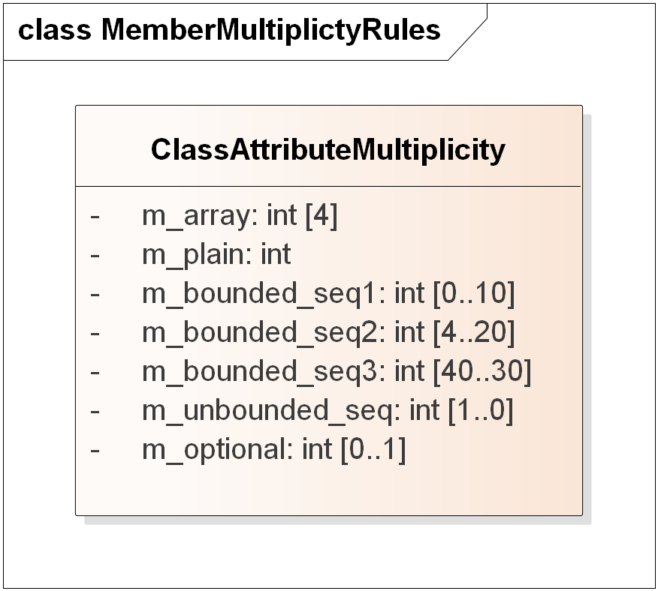

Figure Example Model with attributes having different multiplicity bounds.

For example, the UML class ClassMemberMultiplicity shown in Figure 2 is mapped to the following IDL4 structure:

struct ClassAttributeMultiplicity {

long m_array[4];

long m_plain;

sequence<long,10> m_bounded_seq1;

sequence<long,20> m_bounded_seq2;

sequence<long,30> m_bounded_seq3;

sequence<long> m_unbounded_seq;

long m_optional; //@Optional

};

### UML attribute tags values and IDL4 annotations

UML class attributes may have tagged values. The ones that are recognized are mapped to corresponding IDL4 annotations for the mapped member. Table 2 indicates the recognized UML tagged values and corresponding IDL4 annotation.

Table Mapping of UML attribute tagged values

|  |  |  |
| --- | --- | --- |
| *Attribute Tagged Values in UML model* | *Mapped IDL4 annotation* | *Notes* |
| "key" | @key |  |
| "optional" | @optional |  |
| "must_understand" | @must_understand |  |
| "id” | @id |  |
| "value” | @value | Applies only to members of an enumeration |
| “nested” | long |  |
| "external" | long long |  |
| "unsigned short", "ushort", "uint16", "uint16_t" | unsigned short |  |
| "unsigned long", "unsigned int", "ulong", "uint", "uint32", "uint32_t" | unsigned long |  |
| "unsigned long long", "uint64", "uint64_t" | unsigned long long |  |

Despite being valid IDL4 annotations, the following tagged values are currently not recognized: default, range, min, max, unit, and verbatim.

### UML Attribute properties and IDL @key

Some attribute properties affect the IDL4 mapping to the corresponding structure member. In section 2.3.2 we saw the impact of the UML attribute “multiplicity” property. In addition the attribute property “Is ID” also affects the generated member. If the “Is ID” is set to true then the generated IDL4 member will have the @key annotation. Note that the @key annotation may also be obtained using a UML Tag Value as described in section 2.3.3.

### UML class operations

UML class operations are currently ignored in the IDL4 mapping.

# UML Class tagged values and IDL Annotations

UML classes may have associated tagged values. The ones that are recognized are mapped to corresponding IDL4 annotations for the whole structure. Table 3 indicates the recognized UML tagged values and corresponding IDL4 annotation.

Table Mapping of UML class tagged values

|  |  |  |
| --- | --- | --- |
| *Class Tagged Values in UML model* | *Mapped IDL4 annotation* | *Notes* |
| "extensibility" | @extensibility |  |
| "mutable" | @mutable |  |
| "extensible" | @extensible |  |
| "final” | @final |  |
| "autoid” | @autoid |  |
| “nested” | @nested |  |

Despite being valid IDL4 annotations, the following tagged values are currently not recognized: verbatim, service.

# Class inheritance

Class inheritance maps to IDL4 structure inheritance. Multiple structure inheritance is unsupported in IDL4 so only the “first” base class will appear as the IDL base structure.

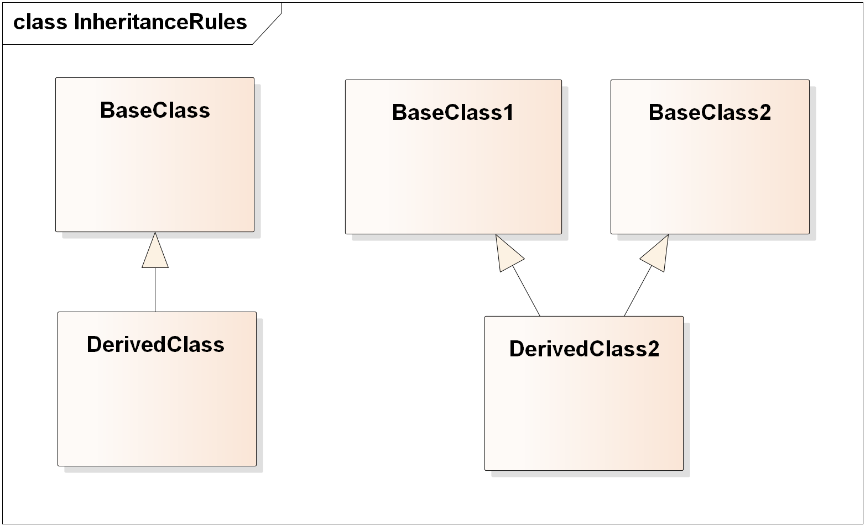

Figure Example Model with class inheritance.

For example, the UML classes DerivedClass and DerivedClass2 shown in Figure 3 above are mapped to the following IDL4 structures:

struct DerivedClass : BaseClass {

octet __dummy_prevent_empty_class_DerivedClass;

};

struct DerivedClass2 : BaseClass1 {

octet __dummy_prevent_empty_class_DerivedClass;

};

# Order of the generated classes

In IDL and many programming languages like C and C++, a type must be declared before it is referenced by another type.

Given that the iterators on the UML model can return classes in any order, the IDL generator may have to iterate through the model multiple times, each time generating types that only depend on types that have already been generated.

# UML relationships between classes

Certain class relationships result in the generation of IDL4 structure members on the source or target IDL4 structure.

The decision of generating an IDL4 structure member as a result of the relationship, the name of the generated member, its characteristic (plain member, array, or sequence), and annotations depends on the relationship role properties.

## Rules for generation of a structure member from a relationship

Please refer to Figure 4 below for an example of how the generation rules are applied. Assume class SourceClass has an association with class TargetClass. The association name is association_name. The Source role name is source_rolename and the target role name is target_rolename.

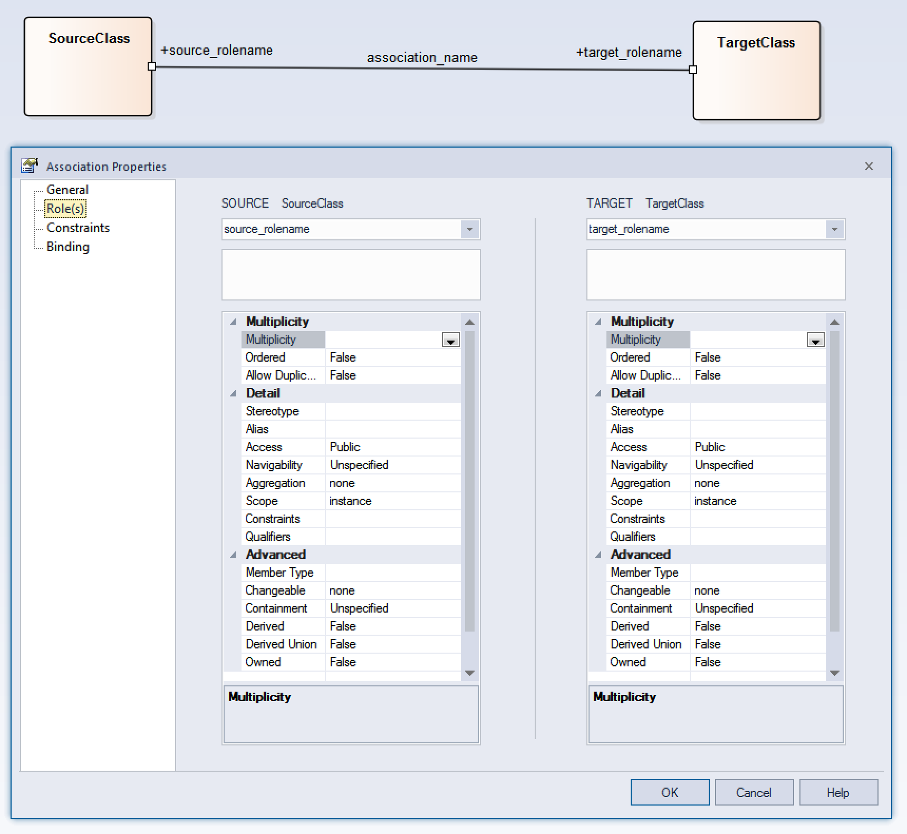

Figure Example association

All the following conditions must be met in for the association source_rolename to result on the generation of a member in the IDL4 structure SourceClass.

* The relationship must be of kind “Aggregation”, “Composition”, or “Nesting” (see Figure 1). In the case of an association it means the **Aggregation** must be either “Shared” or “Composite”.
* The association must be navigable from SourceClass to TargetClass. This can be seen in the value of the **Navigability** property set to “navigable” on the TARGET role (i.e., not “none” or “non-navigable”).
* The SOURCE role **Aggregation** property must be set to “shared” or “composite” (i.e., not “none”).

Note: In previous versions (1.6 and earlier) there was an additional requirement on the TARGET role **Containment**:

* The TARGET role **Containment** (see Advanced properties) must be “Value” as opposed to “Unspecified” or “Reference”.

This requirement has been removed because it is understood that the relationship kind (Shared/Composite) already captures the intent that the related class appears as member and the TARGET role **Containment** should affect only *how* the member appears, not whether the member appears or not.

Figure 5 shows how the different kinds of class relationships appear visually in Enterprise Architect:



Figure Example associations: non-navigable association, navigable association (Aggregation = “none”), navigable aggregation (Aggregation=”Shared”), navigable composition (“Aggregation=”Shared”), and navigable nesting.

Applying the rules to the associations that appear in Figure 5 results on SourceClass1 having members for navigable_aggregation, navigable_composition, and navigable_nesting. It does not have members for the non_navigable_association and navigable_association because they are either non-navigable or the **Aggregation** property is “none”. Consequently the IDL4 structure generated for SourceClass1 is:

struct SourceClass1 {

TargetClass1 navigable_aggregation;

TargetClass1 navigable_composition;

TargetClass1 navigable_nesting;

};

## Name for members generated from associations

If the presence of an association between a SOURCE class and a TARGET class results in the generation of a member in the IDL4 mapping of the SOURCE class the generator must choose a name for the generated member. The name is chosen according to the following rules:

* If the TARGET role has been given a name, the use the TARGET rolename.
* Otherwise if the overall association has been given a name, use the association name.
* Otherwise if the typename of the TARGET class starts with upper case, use the TARGET typename but changing to starting with lowercase.
* Otherwise use the TARGET typename preceded by m_.

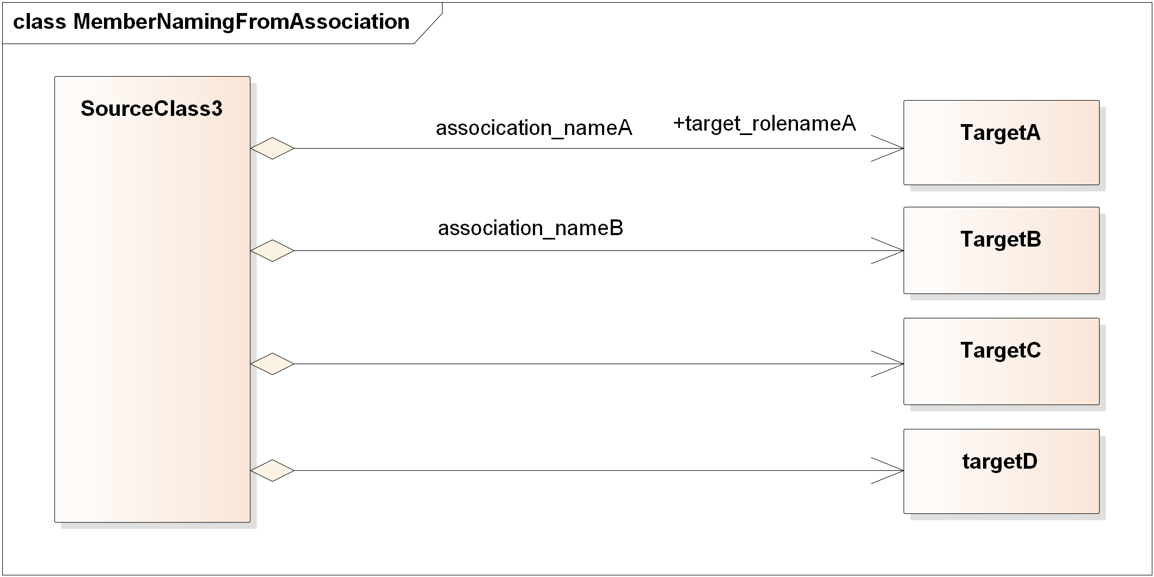

Figure 6 The member name is determined by the association target rolename, the association name, or the name of the target class

For example, the relationship between the SOURCE class SourceClass2 and the classes shown in Figure 6 are mapped to the following IDL4 structure:

struct SourceClass3 {

TargetA target_rolenameA;

TargetB association_nameB;

TargetC targetC;

targetD m_targetD;

};

## Multiplicity of members generated from associations

Similar to IDL structure members created from UML class attributes, the structure members created from class relationships can also appear directly or in a sequence collection.

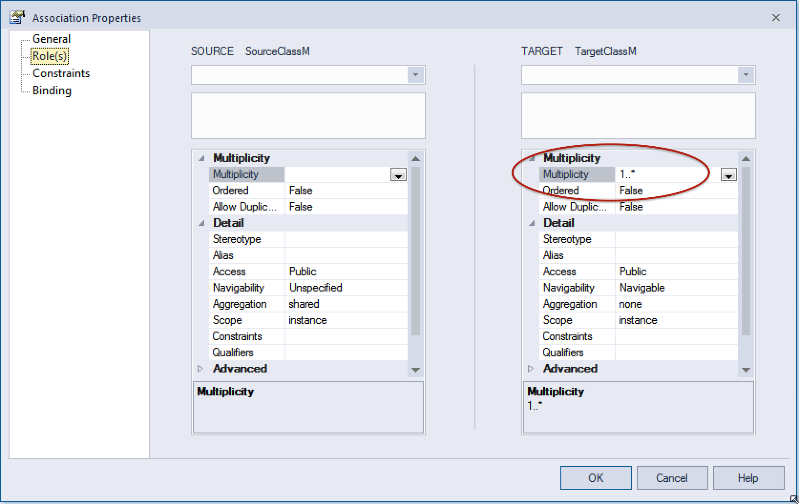

Figure The multiplicity of the TARGET role in a relationship is used to determine whether the member is created as a plain member or a sequence collection

The decision is based on the association TARGET role and more specifically on the value of the **Multiplicity** property. See Figure 6.

* If Multiplicity == 1 or Multiplicity == 0, or it is unspecified, then the association maps to a regular member
* If Multiplicity == 0..1, the association maps to an @Optional member.
* If Multiplicity == * or it ends in “*” as in “1..* ”, “..*”, “1..”, the association maps to an unbounded sequence.
* In other cases it maps to a bounded sequence with max size the upper limit of the multiplicity range.
  + In this case the lower limit is ignored
  + If the upper limit is set to 0 then it is treated as if it was 1

This same logic can be presented in terms of a decision table as shown below:

Table Decision of whether a UML reference is mapped to a plain reference or a sequence in the IDL

|  |  |  |  |
| --- | --- | --- | --- |
| ***TARGET Multiplicity*** | ***TARGET Containment*** | ***SOURCE Aggregation*** | ***Resulting member in IDL*** |
| 0, 1, Unspecified |  |  | TargetType m; |
| 0..1 |  |  | @Optional TargetType m; |
| *, 1..*, ..* |  |  | sequence< TargetType > m; |
| M..N |  |  | sequence< TargetType , N> m; |



Figure The member name qualifiers (@Optional or sequence) is determined by the association target multiplicity.

For example, the relationships between the SOURCE class SourceClassM and the TARGET classes shown in Figure 7 are mapped to the following IDL4 structure:

struct SourceClassM {

TargetClassM multiplicity_unspecified;

TargetClassM multiplicity_zero;

sequence<TargetClassM> multiplicity_zero_to_star;

@Optional TargetClassM multiplicity_zero_to_one;

TargetClassM multiplicity_one;

sequence<TargetClassM> multipliticy_1_to_dots;

sequence<TargetClassM> multiplicity_1_to_star;

sequence<TargetClassM,10> multiplicity_zero_to_10;

sequence<TargetClassM,10> multiplicity_5_to_10;

};

## @Shared annotation for members generated from associations

Similar to IDL structure members created from UML class attributes, the structure members created from class relationships may be annotated as @Shared members (pointers in RTI Connext DDS 5.2).

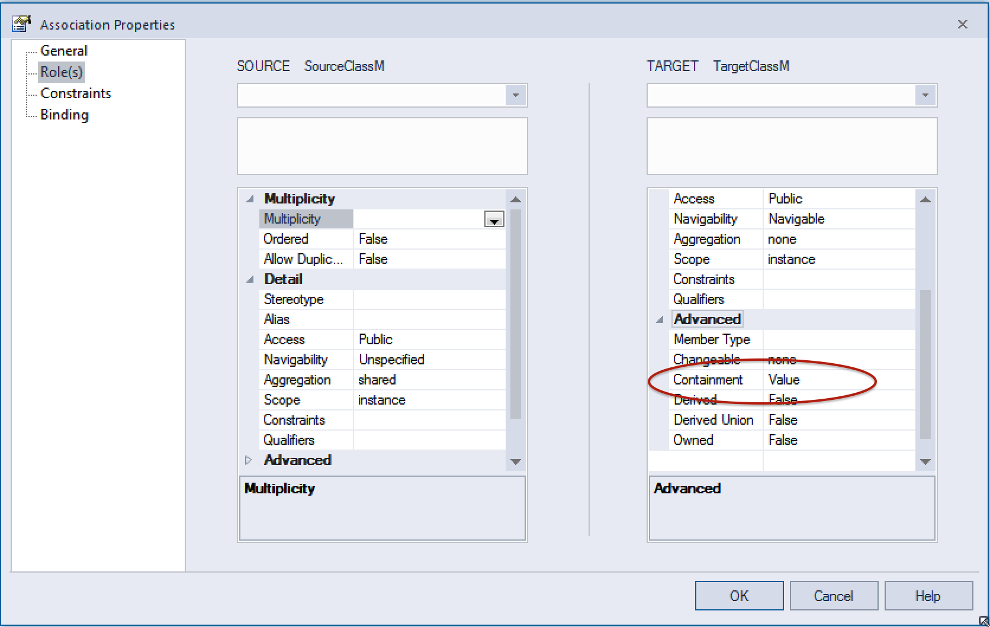

Figure The containment of the TARGET role in a relationship is used to determine whether the member is annotated as @Shared

The decision is based on the association TARGET role and more specifically on the value of the **Containment** property. See Figure 8.

* If Containment == Reference, the member is generated with the @Shared annotation.
* If Containment == Value, the member is generated without the @Shared annotation.
* If Containment == Unspecified the decision is based on the SOURCE **Aggregation** property.
  + If Aggregation == Shared the member is generated **with** the @Shared annotation.
  + If Aggregation == Composite the member is generated **without** the @Shared annotation.

This same logic can be presented in terms of a decision table as shown below:

Table Decision of whether a UML reference is mapped member in IDL having the @Shared annotation

|  |  |  |  |
| --- | --- | --- | --- |
| ***TARGET Multiplicity*** | ***TARGET Containment*** | ***SOURCE Aggregation*** | ***Resulting member*** |
|  | Value |  | TargetType m; |
|  | Reference |  | @Shared TargetType m; |
|  | Unspecified | Shared | @Shared TargetType m; |
|  | Unspecified | Composite | TargetType m; |



Figure The member attribute @Shared is determined by the target role containment property

For example, the relationships between the SOURCE class SourceClassC and the TARGET classes shown in Figure 9 are mapped to the following IDL4 structure:

struct SourceClassC {

TargetClassC containment_value;

@Shared TargetClassC contained_reference;

@Shared TargetClassC aggregation_shared_containment_unspecified;

TargetClassC aggregation_composite_containment_unspecified;

sequence<TargetClassC> mult_sequence_containment_value;

@Shared sequence<TargetClassC> mult_sequence_containment_reference;

@Optional TargetClassC mult_optional_containment_value;

@Shared @Optional TargetClassC mult_optional_containment_reference;

};

# Debugging the IDL4 generated from a model

One of the most useful ways to debug a model and modify it such that the generated IDL is what is expected is using the “Mapping Details” option menu.

At the bottom of the window that the IDL4 Extension opens there is an option pull down that allows the selection between: “Mapping Details – Suppressed”, “Mapping Details – Basic”, and “Mapping Details – Full”.

By default, the menu is selecting “Mapping Details – Suppressed”, which omits any details on the rules applied from the output. If “Mapping Details – Basic” or “Mapping Details – Full” is selected, the output IDL will contain in-line comments explaining the reasons why certain members were produced or not, and why they were mapped to optional members, pointers, sequences, etc. By looking at the comments that appear and iteratively modifying the model according to those comments, it is often possible to obtain the desired IDL.

# Open Issues and ToDo’s