1077710 CS 516000 FPGA Architecture & CAD

Homework 3(Due: 11/22/2018)

1. (a) Prove or disapprove the following statement. Any decomposition of a *K*-bounded logic gate network before technology mapping will never increase the minimum number of *K*-LUTs needed to map the network.

(b) Give an example of a *K*-bounded logic gate network where the minimum number of *K*-LUTs needed to map the network is reduced when some of its logic gates are decomposed.

(c) By (a) and (b), argue that it is always desirable to decompose a K-bounded logic gate network into an equivalent 2-bounded logic gate network before running technology mapping.

1. In the class, we presented a dynamic programming-based approach (DP Tree-map) to compute duplication-free area-optimal mapping for tree. Describe how to modify it to compute duplication-free *depth*-optimal mapping for tree.
2. Consider applying FlowMap to map the circuit below to 3-input LUTs.

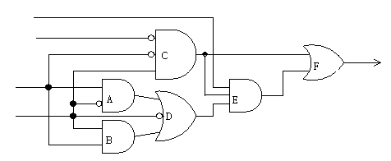

1. In topological order, derive label(*v*) and the 3-input LUT for *v* in the optimal mapping solution of *Nv* for each node *v* by inspection.
2. Suppose that the labels for all ancestors of F are known (with values as in (a) above) but we have yet to compute the label of F. Explain how we can determine the label of F using network flow computation. Draw a flow network after applying the node-splitting technique to aid your explanation.
3. Run the mapping phase of FlowMap to derive a depth-optimal 3-input LUT mapping of the circuit.

4. In our class, we introduced the simulated annealing approach for solving combinatorial optimization problems. It is important that we set an appropriate initial temperature *T0* for simulated annealing. So before simulated annealing, we can randomly move from the initial solution for a certain number of times to get the average uphill cost change Δavg. Suppose we want to set *T0* so that the initial probability of accepting an uphill move by simulated annealing will be approximately *P*, suggest how we should set T0 in terms ofΔavg and *P*.

5. Consider the log-sum-exp method (p.39 of unit 11) for approximating the maximum function of a set of numbers.

(a) Choose four numbers arbitrarily in the range of 0 to 1.

(b) Use a calculator to compute the error of approximating the maximum function of the four numbers in using the log-sum-exp method when γ=1.

(c) Use a calculator to compute the error of approximating the maximum function of the four numbers in using the log-sum-exp method when γ=0.01.

(d) Prove that, in general, the error of approximating the maximum function of *n* numbers is strictly less than γlog *n* when the *n* numbers are not all the same, and the error is exactly equal to γlog *n* when the *n* numbers are all the same.