National Central University
CSIE
Programming Language Final Project
Title:五子棋

Members:陳履軒(102502023)、徐爾賢()
Index
- work assignment
- how to execute
- features
- how to implement
- memo

Work assignment
陳履軒：
Coding (including chess board, rules, etc.).
徐爾賢：
Debug.

How to execute
We just use the integrated API, so what you have to do is to run MATLAB main program.
There are five .m files: chessboard.m, chess.m, winLose.m, playAgain.m, and gamestart.m. To open the program, please run gamestart.m.

Features
After starting gameStart.m, it will appear a message box which has three buttons: start, exit, and help (1). Press start button will play the game. Press exit will exit the whole program. Press help will appear a message box which indicates the rules of this game (2). This game only allows 2P mode, so after two players choose who goes first (that is, choose red or blue), the game will start (3). While playing, you can press the left-down ‘restart’ button to restart the game if you think you are going to lose. When one of the player wins (4), it will appear a message box which asks you want to play again or quit the program (5).
(1)
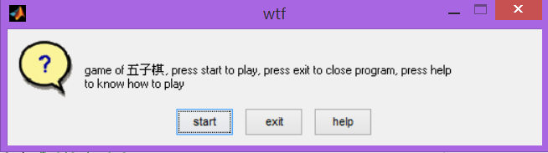
(2)
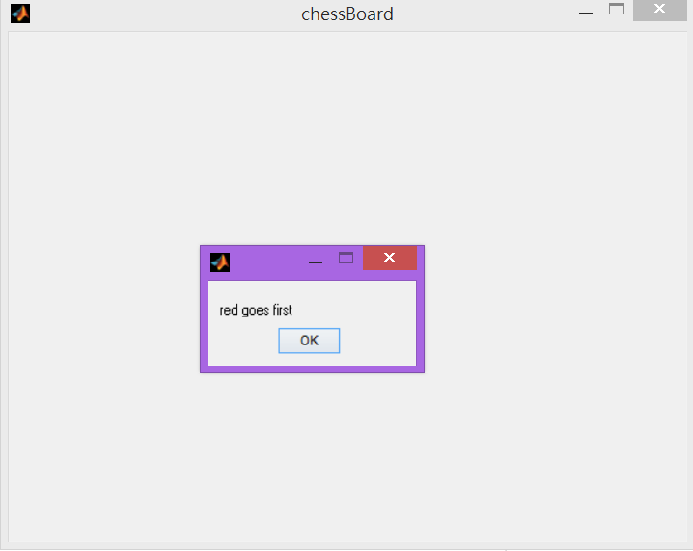
(3)
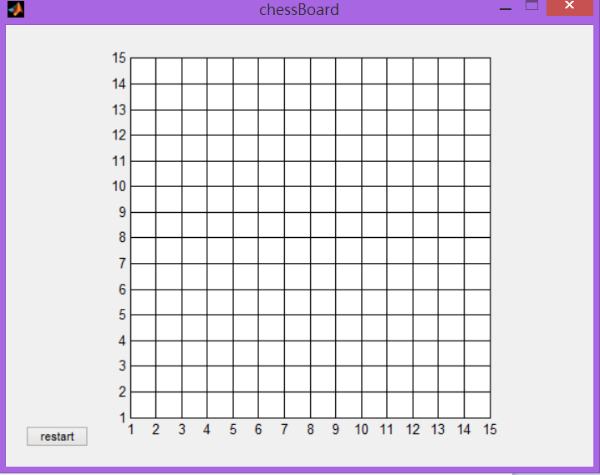
(4)
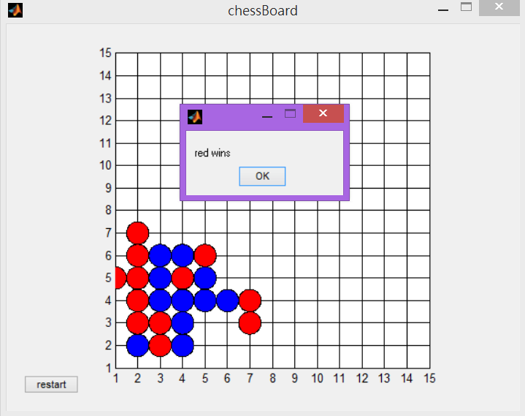
(5)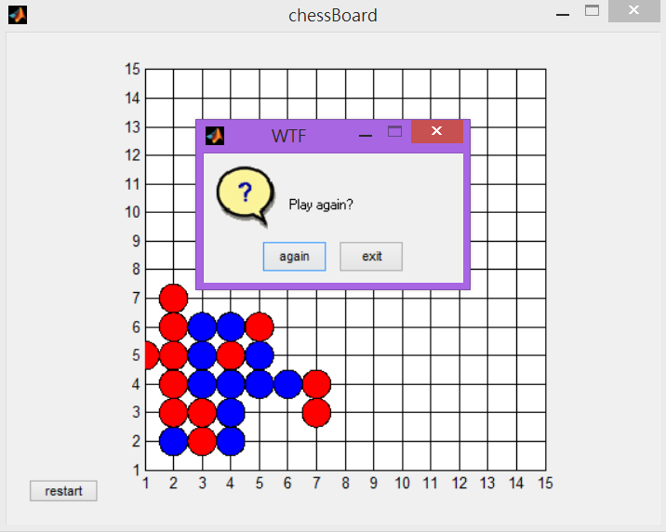
How to implement
Game start
Choose color

Start to play game

One player wins
yes
no
Play again?
End program

Memo
102502023 陳履軒：
Although I encountered a lot of problem, I finally conquered them successfully. The most problem was that the rules of win. I used a static array with eight elements to store the statues of chesses in the beginning, however, due to the algorithm, it may have bugs in some condition. So I overwritten all the code about the rules of win finally and use another procedure. I use four for-loop to examine four condition to win: from left to right, from up to down, from left-up to right-down, and from left-down, to right-up. Hopefully, it works very well. In conclusion, even though we don’t do want we were desired first, we two did a really good job about this final project.
徐爾賢:
我負責地是美工設計，在過程中遇到的最大的困難是，在程式執行過程中，回叫程式並無法控制事件發生之順序，亦無法確定何者會被執行。有時甚至另一個回叫在執行期間，另一個回叫程式又被啟動，且同時進行，其情況變得更為複雜。最後，藉著參考網路上的資料，以及不斷的DEBUG，終於抓到當中的BUG，使地程式碼跑的流暢，我在這過程中學到許多東西，我認為注解是非常重要的，除了能讓別人看懂你的程式碼，還能使DEBUG更為簡單!!

