night_warming_treatments

Debora

5/3/2022

Historical temperatures recorded every 15 minutes from 1998 to 2020 were downloaded from the Data Archives webpage (<http://weather.uwaterloo.ca/data.html>) maintained by the University of Waterloo Weather Station (43°28’27.5“N 80°33’24.4”W), Ontario, Canada. Date and temperature formatting was standardized and data cleaning was performed to remove any incorrect entries caused by technical errors (such as unrealistic temperature entries of 100 °C) using R Studio software. This dataset was then subset to the period of June 1-10, which represents late Spring in temperate regions. This period has been chosen because it occurs in the growing season, where any effects to performance can be more readily observed. In addition, other night warming experiments were conducted using this same timeframe (e.g., Zhao et al., 2014; Barton & Schmitz, 2017; Higashi, Barton, & Oliver, 2020). To simulate night warming treatments, the clean file saved on GitHub was then downloaded to R.

refjune <- read.csv("https://raw.githubusercontent.com/Cuddington-Lab/thermal-experiments/main/historical_temperatures_uwaterloo_june_1_10.csv", header=TRUE, stringsAsFactors = TRUE)

Next, very cold and very hot years, such as 1998 and 2020, have been excluded from the dataset so that it contains mostly years representative of average current conditions.

boxplot(Temperature~year, data=refjune, main="Fig. 1: Waterloo historical temperatures",   
 outline=FALSE, xlab="Year", ylab="Temperature (°C)",   
 names = levels(as.factor(refjune$year)))

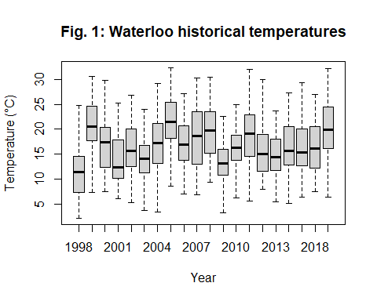

refjune<-subset(refjune, !(year==1998 | year==1999 | year== 2005 | year== 2009| year== 2020))

Mean hourly temperatures were then obtained across years. This composed a reference 24-hour temperature sequence.

refjune <- aggregate(list(control=refjune$Temperature),   
 by = list(time=refjune$hour), mean)

Minimum and maximum temperatures were extracted from this reference temperature sequence (note: “time2” column represents fictitious hours from 1-15, as it would be hard to fit a linear model using actual hours which are not in a crescent order, ie. start at 3pm and end at 5am).

reftemps <- data.frame(cbind(time2 = c(15,1),   
 subset(refjune,   
 control == max(refjune$control) | control == min(refjune$control))))

Temperature regimes were based on Higashi, Barton, & Oliver (2020). The control group is characterized by maximum and minimum temperatures equivalent to local conditions. In the night warming regime (nw), minimum temperatures are increased by 5°C, while in the daytime warming (dw), maximum temperatures are increased by 5°C. Finally, a whole day warming regime (ww) was created with all hourly temperatures being increased by 2.5°C. Across all treatments, maximum temperatures occurred at 3pm, while minimum temperatures occurred at 5am, which corresponds to historical data and results in 14 hours from minima to maxima and 10 hours from maxima to minima. The photoperiod consisted of 16 hours of light and 8 hours of darkness, which is also close to local conditions in the growing season (National Research Council, 2022).

reftemps$nw <- ifelse(reftemps$control==min(reftemps$control), reftemps$control+5, reftemps$control)  
reftemps$dw <- ifelse(reftemps$control==max(reftemps$control), reftemps$control+5, reftemps$control)  
reftemps$ww <- reftemps$control+2.5

Next, linear models were created based on maximum and minimum temperatures, along with the respective hours in which they occurred.

lm_func <- function(y) lm(y ~ time, data = reftemps)  
  
lapply(reftemps[,3:6], lm_func)

## $control  
##   
## Call:  
## lm(formula = y ~ time, data = reftemps)  
##   
## Coefficients:  
## (Intercept) time   
## 8.2986 0.8149   
##   
##   
## $nw  
##   
## Call:  
## lm(formula = y ~ time, data = reftemps)  
##   
## Coefficients:  
## (Intercept) time   
## 15.7986 0.3149   
##   
##   
## $dw  
##   
## Call:  
## lm(formula = y ~ time, data = reftemps)  
##   
## Coefficients:  
## (Intercept) time   
## 5.799 1.315   
##   
##   
## $ww  
##   
## Call:  
## lm(formula = y ~ time, data = reftemps)  
##   
## Coefficients:  
## (Intercept) time   
## 10.7986 0.8149

fit <- lm(cbind(control, nw, dw, ww) ~ time, data = reftemps)  
  
thermalseq <- data.frame(time=c(5:15))  
thermalseq <- data.frame(cbind(time=thermalseq$time,(predict(fit,thermalseq))))

A linear function was applied to allow for an even ramp-up from minimum to maximum temperatures based on the “time” column (actual hours in which temperatures occurred) (control and whole day warming: 0.814879 °C/hour; daytime warming: 1.314879 °C/hour; night warming: 0.314879 °C/hour).

lm_func2 <- function(y) lm(y ~ time2, data = reftemps)  
  
lapply(reftemps[,3:6], lm_func2)

## $control  
##   
## Call:  
## lm(formula = y ~ time2, data = reftemps)  
##   
## Coefficients:  
## (Intercept) time2   
## 21.1038 -0.5821   
##   
##   
## $nw  
##   
## Call:  
## lm(formula = y ~ time2, data = reftemps)  
##   
## Coefficients:  
## (Intercept) time2   
## 20.7467 -0.2249   
##   
##   
## $dw  
##   
## Call:  
## lm(formula = y ~ time2, data = reftemps)  
##   
## Coefficients:  
## (Intercept) time2   
## 26.4610 -0.9392   
##   
##   
## $ww  
##   
## Call:  
## lm(formula = y ~ time2, data = reftemps)  
##   
## Coefficients:  
## (Intercept) time2   
## 23.6038 -0.5821

fit2 <- lm(cbind(control, nw, dw, ww) ~ time2, data = reftemps)  
  
thermalseq2 <- data.frame(time2=c(1:15))  
thermalseq2 <- data.frame(cbind(time2=thermalseq2$time2,(predict(fit2,thermalseq2))))

A second linear function was applied from maximum to minimum temperatures based on the “time2” column (fictitious hours to provide a crescent ordering for model fitting) (control and whole day warming: -0.5820564 °C/hour; daytime warming: -0.9391993 °C/hour; night warming: -0.5820564 °C/hour). Predicted temperatures based on these linear models were then obtained for a 24-hour period.

Fitctitious hours were replaced by actual hours and predictions from the 2 linear models were bound together.

thermalseq2$time2 <- c(15:23,0:5)  
colnames(thermalseq2)[1] <- "time"  
  
thermalseq3 <- rbind(thermalseq,thermalseq2)  
thermalseq3 <- thermalseq3[order(thermalseq3$time),]  
thermalseq3 <- thermalseq3[!duplicated(thermalseq3$time), ]  
rownames(thermalseq3) <- NULL

The obtained daily sequence was multiplied in order to obtain a thermal sequence of 10 days in total.

rows= c(1:nrow(thermalseq3))  
times = 11  
thermalseq3 <- thermalseq3[rep(rows, times),]  
thermalseq3 <- thermalseq3[-(1:12),]  
thermalseq3 <- thermalseq3[-(242:252),]

Each thermal sequence can be visualized in Fig. 2.

plot(thermalseq3[,2],type="l",col="black",ylim=c(10,30),  
 main="Fig. 2: Night warming experiment treatments",  
 xlab="Time (hours)", ylab="Temperature (°C)")  
lines(thermalseq3[,3],type="l",col="red")  
lines(thermalseq3[,4],type="l",col="green")  
lines(thermalseq3[,5],type="l",col="orange")  
legend(1, 30, legend=c("control", "night warming", "day warming", "whole day warming"),  
 col=c("black", "red", "green", "orange"), lty=1, cex=0.6,bty = "n")

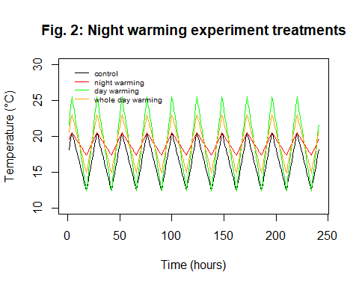

All of the warming treatments (nighttime, daytime, and whole day) treatments have daily average temperatures which are 2.5 °C higher than the ambient conditions represented by the control group. This increase is within IPCC projections for this region (IPCC, 2018). The night warming treatment allows for testing the effect of increased minimum temperatures and a consequent reduction in daily temperature variation (as observed below in the reduced standard deviation values for this group on the summary statistics below). While daily maxima are the same in the night warming and control groups, daily maxima are increased in the daytime warming treatment proportionally to nighttime temperature reductions, to test for potential differential effects following warmer days vs warmer nights. A whole day warming treatment also tests for the importance of the timing of warming.

summary(thermalseq3[,c(2:5)],digits=2)

## control nw dw ww   
## Min. :12 Min. :17 Min. :12 Min. :15   
## 1st Qu.:15 1st Qu.:18 1st Qu.:16 1st Qu.:17   
## Median :16 Median :19 Median :19 Median :19   
## Mean :16 Mean :19 Mean :19 Mean :19   
## 3rd Qu.:18 3rd Qu.:20 3rd Qu.:22 3rd Qu.:21   
## Max. :21 Max. :21 Max. :26 Max. :23

References

Higashi, C., Barton, B., & Oliver, K. (2020). Warmer nights offer no respite for a defensive mutualism. Journal of animal ecology, 89(8), 1895-1905.

Intergovernmental Panel on Climate Change (IPCC). (2018). Global warming of 1.5°C. An IPCC Special Report on the impacts of global warming of 1.5°C above pre-industrial levels and related global greenhouse gas emission pathways, in the context of strengthening the global response to the threat of climate change, sustainable development, and efforts to eradicate poverty. Cambridge University Press, Cambridge, United Kingdom and New York, NY, USA.

National Research Council (Canada). Sun Calculator. <https://nrc.canada.ca/en/research-development/products-services/software-applications/sun-calculator/>