**REPORTE #4:**

**Juego de Carreras en TIVA C**

Link de repositorio: <https://github.com/Cue19275/Digital2>

**Pre-lab:**

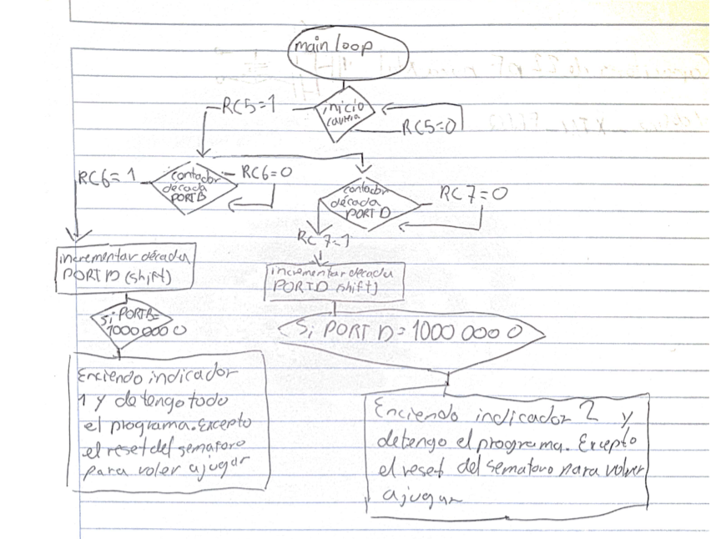

**Circuito:**

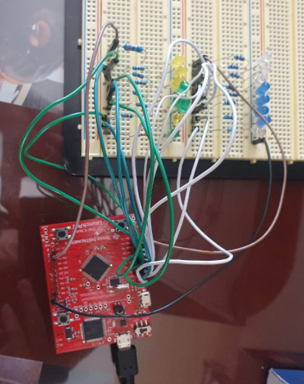

**Código:**

#define J1_1 PB_5

#define J1_2 PB_0

#define J1_3 PB_1

#define J1_4 PE_4

#define J1_5 PE_5

#define J1_6 PB_4

#define J1_7 PA_5

#define J1_8 PA_6

#define J2_1 PD_0

#define J2_2 PD_1

#define J2_3 PD_2

#define J2_4 PD_3

#define J2_5 PE_1

#define J2_6 PE_2

#define J2_7 PE_3

#define J2_8 PD_7

int estadoSalida;

int estado;

int estadoSalidaC2;

int estadoC2;

int enable_J = 0;

int terminado = 0;

int flagJ1 = 0;

int flagJ2 = 0;

int contaJ1 = 0;

int contaJ2 = 0;

void semaforo (void);

void cont1 (void);

void cont2 (void);

void ganador (void);

void debounce (void);

void debounce2 (void);

void apagado(void);

void setup() {

pinMode(J1_1, OUTPUT);

pinMode(J1_2, OUTPUT);

pinMode(J1_3, OUTPUT);

pinMode(J1_4, OUTPUT);

pinMode(J1_5, OUTPUT);

pinMode(J1_6, OUTPUT);

pinMode(J1_7, OUTPUT);

pinMode(J1_8, OUTPUT);

pinMode(J2_1, OUTPUT);

pinMode(J2_2, OUTPUT);

pinMode(J2_3, OUTPUT);

pinMode(J2_4, OUTPUT);

pinMode(J2_5, OUTPUT);

pinMode(J2_6, OUTPUT);

pinMode(J2_7, OUTPUT);

pinMode(J2_8, OUTPUT);

pinMode(BLUE_LED, OUTPUT);

pinMode(GREEN_LED, OUTPUT);

pinMode(RED_LED, OUTPUT);

pinMode(PUSH1, INPUT_PULLUP);

pinMode(PUSH2, INPUT_PULLUP);

}

void loop() {

// put your main code here, to run repeatedly:

if (enable_J ==0){

semaforo();

}

else if (enable_J == 1){

cont1();

cont2();

/*if (terminado == 1){

estado = digitalRead(PUSH1);

if (estado == LOW){

estadoSalida=1;

}

if (estadoSalida==1){

if (estado == HIGH){

estadoSalida =0;

flagJ1 = 1;

}

}

estadoC2 = digitalRead(PUSH2);

if (estadoC2 == LOW){

estadoSalidaC2=1;

}

if (estadoSalidaC2==1){

if (estadoC2 == HIGH){

estadoSalidaC2 =0;

flagJ2 = 1;

}

}

if (flagJ1 == 1 && flagJ2 == 1){

flagJ2 = 0;

flagJ1 = 0;

enable_J = 0;

terminado = 0;

}

}*/

}

delay(200);

}

void semaforo(void){

estado = digitalRead(PUSH1);

if (estado == LOW){

estadoSalida=1;

}

if (estadoSalida==1){

if (estado == HIGH){

estadoSalida =0;

flagJ1 = 1;

}

}

estadoC2 = digitalRead(PUSH2);

if (estadoC2 == LOW){

estadoSalidaC2=1;

}

if (estadoSalidaC2==1){

if (estadoC2 == HIGH){

estadoSalidaC2 =0;

flagJ2 = 1;

}

}

if (flagJ1 == 1 && flagJ2 == 1){

apagado();

enable_J = 1;

flagJ1 = 0;

flagJ2 = 0;

digitalWrite(RED_LED, HIGH);

digitalWrite(GREEN_LED, LOW);

digitalWrite(BLUE_LED, LOW);

delay(500);

digitalWrite(BLUE_LED, LOW);

digitalWrite(RED_LED, HIGH);

digitalWrite(GREEN_LED, HIGH);

delay(500);

digitalWrite(GREEN_LED, HIGH);

digitalWrite(RED_LED, LOW);

digitalWrite(BLUE_LED, LOW);

}

}

void apagado (void){

digitalWrite(RED_LED, LOW);

digitalWrite(BLUE_LED, LOW);

digitalWrite(GREEN_LED, LOW);

digitalWrite(J1_1, LOW);

digitalWrite(J1_2, LOW);

digitalWrite(J1_3, LOW);

digitalWrite(J1_4, LOW);

digitalWrite(J1_5, LOW);

digitalWrite(J1_6, LOW);

digitalWrite(J1_7, LOW);

digitalWrite(J1_8, LOW);

digitalWrite(J2_1, LOW);

digitalWrite(J2_2, LOW);

digitalWrite(J2_3, LOW);

digitalWrite(J2_4, LOW);

digitalWrite(J2_5, LOW);

digitalWrite(J2_6, LOW);

digitalWrite(J2_7, LOW);

digitalWrite(J2_8, LOW);

}

void cont1 (void) {

estado = digitalRead(PUSH1);

if (estado == LOW){

estadoSalida=1;

}

if (estadoSalida==1){

if (estado == HIGH){

estadoSalida =0;

contaJ1++;

switch(contaJ1){

case 1:

digitalWrite(J1_1, HIGH);

digitalWrite(J1_2, LOW);

digitalWrite(J1_3, LOW);

digitalWrite(J1_4, LOW);

digitalWrite(J1_5, LOW);

digitalWrite(J1_6, LOW);

digitalWrite(J1_7, LOW);

digitalWrite(J1_8, LOW);

break;

case 2:

digitalWrite(J1_1, LOW);

digitalWrite(J1_2, HIGH);

digitalWrite(J1_3, LOW);

digitalWrite(J1_4, LOW);

digitalWrite(J1_5, LOW);

digitalWrite(J1_6, LOW);

digitalWrite(J1_7, LOW);

digitalWrite(J1_8, LOW);

break;

case 3:

digitalWrite(J1_1, LOW);

digitalWrite(J1_2, LOW);

digitalWrite(J1_3, HIGH);

digitalWrite(J1_4, LOW);

digitalWrite(J1_5, LOW);

digitalWrite(J1_6, LOW);

digitalWrite(J1_7, LOW);

digitalWrite(J1_8, LOW);

break;

case 4:

digitalWrite(J1_1, LOW);

digitalWrite(J1_2, LOW);

digitalWrite(J1_3, LOW);

digitalWrite(J1_4, HIGH);

digitalWrite(J1_5, LOW);

digitalWrite(J1_6, LOW);

digitalWrite(J1_7, LOW);

digitalWrite(J1_8, LOW);

break;

case 5:

digitalWrite(J1_1, LOW);

digitalWrite(J1_2, LOW);

digitalWrite(J1_3, LOW);

digitalWrite(J1_4, LOW);

digitalWrite(J1_5, HIGH);

digitalWrite(J1_6, LOW);

digitalWrite(J1_7, LOW);

digitalWrite(J1_8, LOW);

break;

case 6:

digitalWrite(J1_1, LOW);

digitalWrite(J1_2, LOW);

digitalWrite(J1_3, LOW);

digitalWrite(J1_4, LOW);

digitalWrite(J1_5, LOW);

digitalWrite(J1_6, HIGH);

digitalWrite(J1_7, LOW);

digitalWrite(J1_8, LOW);

break;

case 7:

digitalWrite(J1_1, LOW);

digitalWrite(J1_2, LOW);

digitalWrite(J1_3, LOW);

digitalWrite(J1_4, LOW);

digitalWrite(J1_5, LOW);

digitalWrite(J1_6, LOW);

digitalWrite(J1_7, HIGH);

digitalWrite(J1_8, LOW);

break;

case 8:

digitalWrite(J1_1, LOW);

digitalWrite(J1_2, LOW);

digitalWrite(J1_3, LOW);

digitalWrite(J1_4, LOW);

digitalWrite(J1_5, LOW);

digitalWrite(J1_6, LOW);

digitalWrite(J1_7, LOW);

digitalWrite(J1_8, HIGH);

break;

case 9:

contaJ1 = 0;

contaJ2 = 0;

enable_J = 0;

digitalWrite(GREEN_LED, LOW);

digitalWrite(RED_LED, HIGH);

digitalWrite(BLUE_LED, HIGH);

break;

}

}

}

}

void cont2 (void) {

estadoC2 = digitalRead(PUSH2);

if (estadoC2 == LOW){

estadoSalidaC2=1;

}

if (estadoSalidaC2==1){

if (estadoC2 == HIGH){

estadoSalidaC2 =0;

contaJ2++;

switch(contaJ2){

case 1:

digitalWrite(J2_1, HIGH);

digitalWrite(J2_2, LOW);

digitalWrite(J2_3, LOW);

digitalWrite(J2_4, LOW);

digitalWrite(J2_5, LOW);

digitalWrite(J2_6, LOW);

digitalWrite(J2_7, LOW);

digitalWrite(J2_8, LOW);

break;

case 2:

digitalWrite(J2_1, LOW);

digitalWrite(J2_2, HIGH);

digitalWrite(J2_3, LOW);

digitalWrite(J2_4, LOW);

digitalWrite(J2_5, LOW);

digitalWrite(J2_6, LOW);

digitalWrite(J2_7, LOW);

digitalWrite(J2_8, LOW);

break;

case 3:

digitalWrite(J2_1, LOW);

digitalWrite(J2_2, LOW);

digitalWrite(J2_3, HIGH);

digitalWrite(J2_4, LOW);

digitalWrite(J2_5, LOW);

digitalWrite(J2_6, LOW);

digitalWrite(J2_7, LOW);

digitalWrite(J2_8, LOW);

break;

case 4:

digitalWrite(J2_1, LOW);

digitalWrite(J2_2, LOW);

digitalWrite(J2_3, LOW);

digitalWrite(J2_4, HIGH);

digitalWrite(J2_5, LOW);

digitalWrite(J2_6, LOW);

digitalWrite(J2_7, LOW);

digitalWrite(J2_8, LOW);

break;

case 5:

digitalWrite(J2_1, LOW);

digitalWrite(J2_2, LOW);

digitalWrite(J2_3, LOW);

digitalWrite(J2_4, LOW);

digitalWrite(J2_5, HIGH);

digitalWrite(J2_6, LOW);

digitalWrite(J2_7, LOW);

digitalWrite(J2_8, LOW);

break;

case 6:

digitalWrite(J2_1, LOW);

digitalWrite(J2_2, LOW);

digitalWrite(J2_3, LOW);

digitalWrite(J2_4, LOW);

digitalWrite(J2_5, LOW);

digitalWrite(J2_6, HIGH);

digitalWrite(J2_7, LOW);

digitalWrite(J2_8, LOW);

break;

case 7:

digitalWrite(J2_1, LOW);

digitalWrite(J2_2, LOW);

digitalWrite(J2_3, LOW);

digitalWrite(J2_4, LOW);

digitalWrite(J2_5, LOW);

digitalWrite(J2_6, LOW);

digitalWrite(J2_7, HIGH);

digitalWrite(J2_8, LOW);

break;

case 8:

digitalWrite(J2_1, LOW);

digitalWrite(J2_2, LOW);

digitalWrite(J2_3, LOW);

digitalWrite(J2_4, LOW);

digitalWrite(J2_5, LOW);

digitalWrite(J2_6, LOW);

digitalWrite(J2_7, LOW);

digitalWrite(J2_8, HIGH);

break;

case 9:

contaJ2 = 0;

contaJ1 = 0;

enable_J = 0;

digitalWrite(GREEN_LED, HIGH);

digitalWrite(BLUE_LED, HIGH);

break;

}

}

}

}