**REPORTE #5:**

**Almacenamiento SD en TIVA C**

Link de repositorio: <https://github.com/Cue19275/Digital2>

**Pre-lab:**

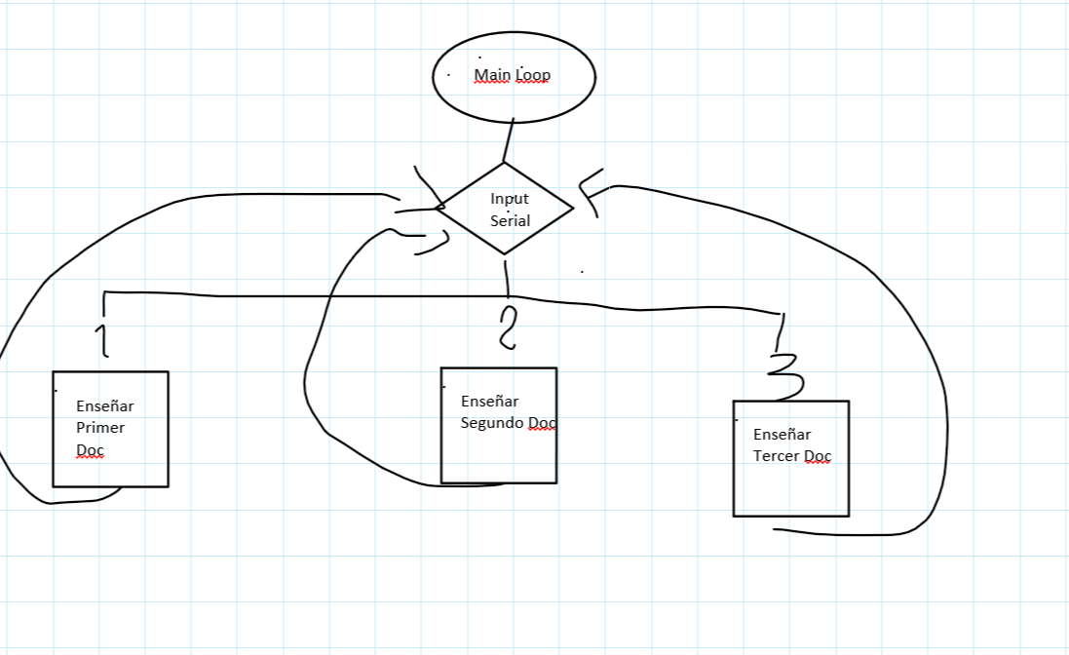

**Código:**

#include <SPI.h>

#include <SD.h>

File root;

File myFile;

int input;

void setup()

{

// Open serial communications and wait for port to open:

Serial.begin(9600);

SPI.setModule(0);

Serial.print("Initializing SD card...");

pinMode(PA_3, OUTPUT);

if (!SD.begin(PA_3)) {

Serial.println("initialization failed!");

return;

}

Serial.println("initialization done.");

Serial.println("INGRESE 1, 2 O 3 PARA IMPRIMIR EL ARCHIVO DESEADO");

root = SD.open("/");

printDirectory(root, 0);

Serial.println("done!");

}

void loop()

{

input = Serial.read();

if(input = 49){

myFile = SD.open("hongo.txt");

if (myFile) {

Serial.println("hongo.txt:");

// read from the file until there's nothing else in it:

while (myFile.available()) {

Serial.write(myFile.read());

}

// close the file:

myFile.close();

} else {

// if the file didn't open, print an error:

Serial.println("error opening test.txt");

}

Serial.println("INGRESE 1, 2 O 3 PARA IMPRIMIR EL ARCHIVO DESEADO");

root = SD.open("/");

printDirectory(root, 0);

while(true) {

File entry = dir.openNextFile();

if (! entry) {

// no more files

break;

}

for (uint8_t i=0; i<numTabs; i++) {

Serial.print('\t');

}

Serial.print(entry.name());

if (entry.isDirectory()) {

Serial.println("/");

printDirectory(entry, numTabs+1);

} else {

// files have sizes, directories do not

Serial.print("\t\t");

Serial.println(entry.size(), DEC);

}

entry.close();

}

}

else if(input = 50){

myFile = SD.open("egg.txt");

if (myFile) {

Serial.println("egg.txt:");

// read from the file until there's nothing else in it:

while (myFile.available()) {

Serial.write(myFile.read());

}

// close the file:

myFile.close();

} else {

// if the file didn't open, print an error:

Serial.println("error opening test.txt");

}

Serial.println("INGRESE 1, 2 O 3 PARA IMPRIMIR EL ARCHIVO DESEADO");

root = SD.open("/");

printDirectory(root, 0);

while(true) {

File entry = dir.openNextFile();

if (! entry) {

// no more files

break;

}

for (uint8_t i=0; i<numTabs; i++) {

Serial.print('\t');

}

Serial.print(entry.name());

if (entry.isDirectory()) {

Serial.println("/");

printDirectory(entry, numTabs+1);

} else {

// files have sizes, directories do not

Serial.print("\t\t");

Serial.println(entry.size(), DEC);

}

entry.close();

}

}

else if(input = 51){

myFile = SD.open("trifo.txt");

if (myFile) {

Serial.println("trifo.txt:");

// read from the file until there's nothing else in it:

while (myFile.available()) {

Serial.write(myFile.read());

}

// close the file:

myFile.close();

} else {

// if the file didn't open, print an error:

Serial.println("error opening test.txt");

}

Serial.println("INGRESE 1, 2 O 3 PARA IMPRIMIR EL ARCHIVO DESEADO");

root = SD.open("/");

printDirectory(root, 0);

while(true) {

File entry = dir.openNextFile();

if (! entry) {

// no more files

break;

}

for (uint8_t i=0; i<numTabs; i++) {

Serial.print('\t');

}

Serial.print(entry.name());

if (entry.isDirectory()) {

Serial.println("/");

printDirectory(entry, numTabs+1);

} else {

// files have sizes, directories do not

Serial.print("\t\t");

Serial.println(entry.size(), DEC);

}

entry.close();

}

}

}

void printDirectory(File dir, int numTabs) {

while(true) {

File entry = dir.openNextFile();

if (! entry) {

// no more files

break;

}

for (uint8_t i=0; i<numTabs; i++) {

Serial.print('\t');

}

Serial.print(entry.name());

if (entry.isDirectory()) {

Serial.println("/");

printDirectory(entry, numTabs+1);

} else {

// files have sizes, directories do not

Serial.print("\t\t");

Serial.println(entry.size(), DEC);

}

entry.close();

}

}