







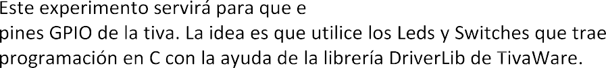

|  |  |
| --- | --- |
|  |  |
|  | SysTick Control and Status (STCTRL), SysTick Reload Value (STRELOAD), SysTick Current Value (STCURRENT) |
|  | UARTCTL (UART control), UARTLCRH, GPIOAFSEL, RCGCGPIO, RCGCUART |
|  | RCGCGPIO, GPIOAFSEL, GPIOPCTL, GPIODEN, SRCR2, USBPOWER, USBDEVCTL, RCGCUSB, USBGPCS |
|  | RCGC0, RCGC2, GPIOAFSEL, GPIOPCTL, PWMENABLE |
|  | **RCGCADC,** RCGC0, PRADC, GPIOADCCTL |



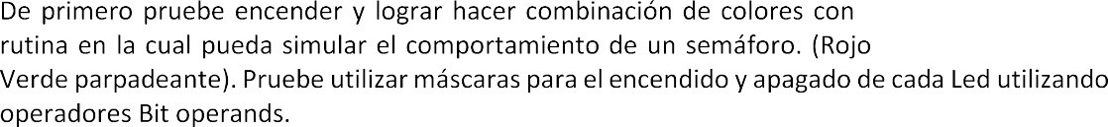





  



|  |  |
| --- | --- |
|  |  |
| SysCtlDelay | ui32Count; Número de repeticiones de loop a esperar |



**Demostración de Funcionamiento: <https://youtu.be/08s9HZx_MUo>**