**Práctica #7:**

***Labview: Comunicación Serial***

*Link donde se encuentra el vídeo de demostración:*

*<https://youtu.be/7_ND2vr7Tt4>*

*Interfaz:*

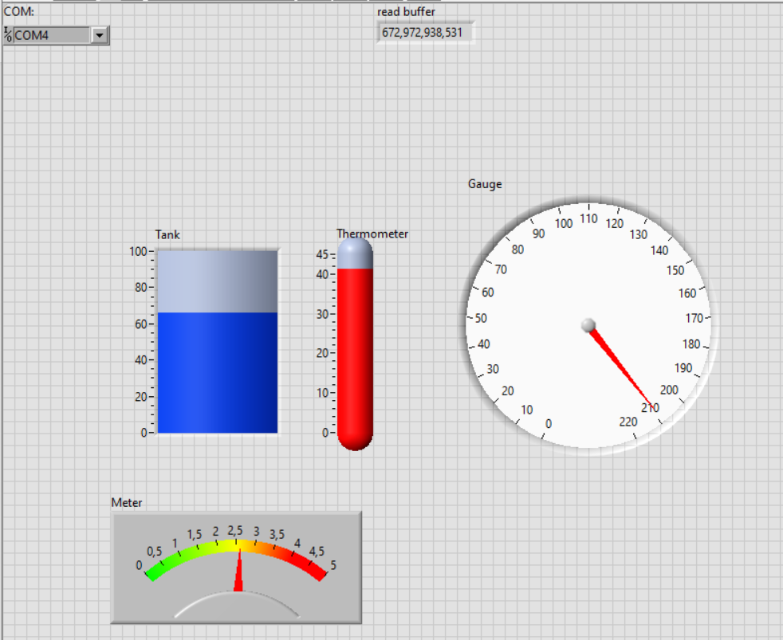

*Diagrama de bloques:*

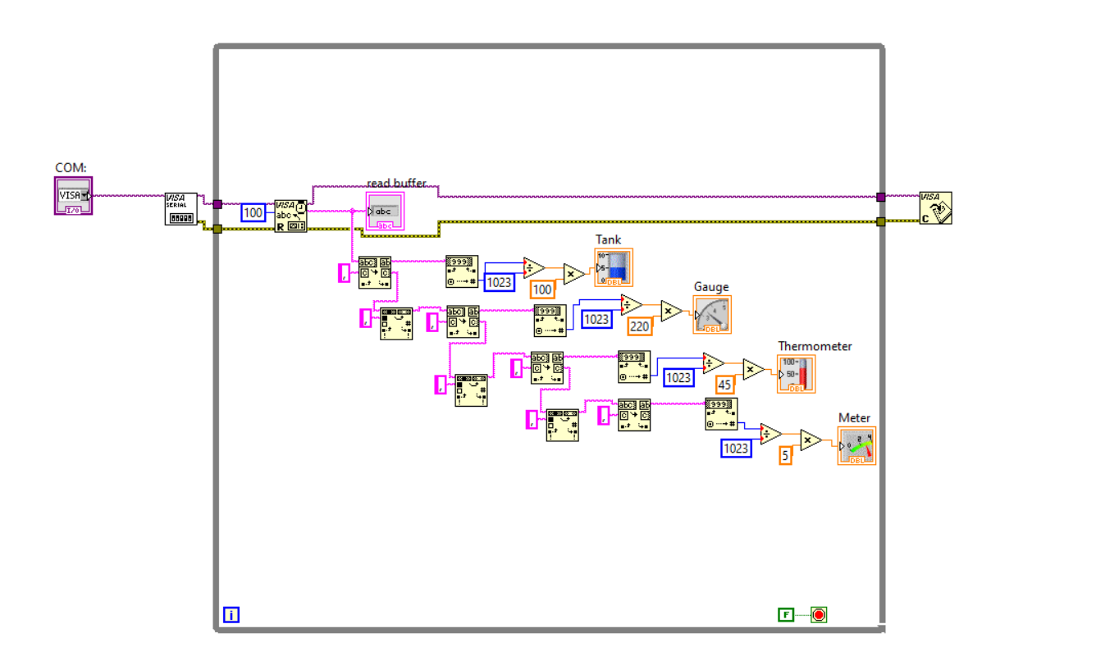

*Código de Arduino:*

const int analogInPin0 = A0; // Analog input pin that the potentiometer is attached to

const int analogInPin1 = A1;

const int analogInPin2 = A2;

const int analogInPin3 = A3;

int sensorValue0 = 0; // value read from the pot

int sensorValue1 = 0; // value read from the pot

int sensorValue2 = 0; // value read from the pot

int sensorValue3 = 0; // value read from the pot

void setup() {

// initialize serial communications at 9600 bps:

Serial.begin(9600);

}

void loop() {

// read the analog in value:

sensorValue0 = analogRead(analogInPin0);

sensorValue1 = analogRead(analogInPin1);

sensorValue2 = analogRead(analogInPin2);

sensorValue3 = analogRead(analogInPin3);

// print the results to the Serial Monitor:

Serial.print(sensorValue0);

Serial.print(",");

Serial.print(sensorValue1);

Serial.print(",");

Serial.print(sensorValue2);

Serial.print(",");

Serial.println(sensorValue3);

// wait 2 milliseconds before the next loop for the analog-to-digital

// converter to settle after the last reading:

delay(50);

}