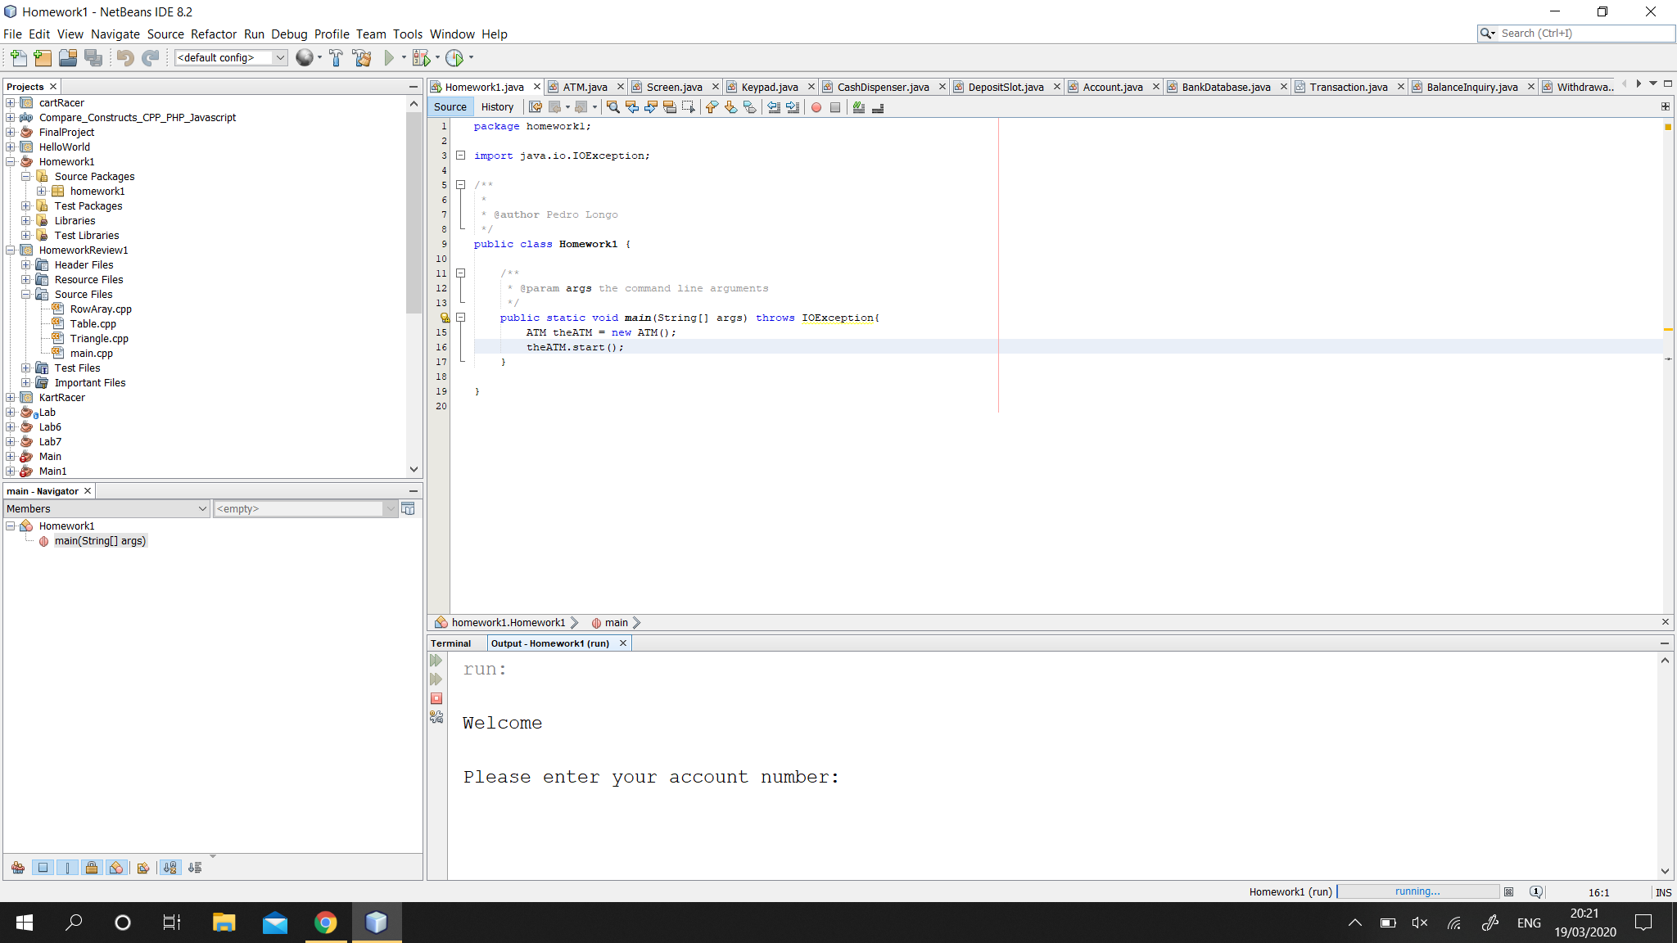

Testing project runs and IOException.

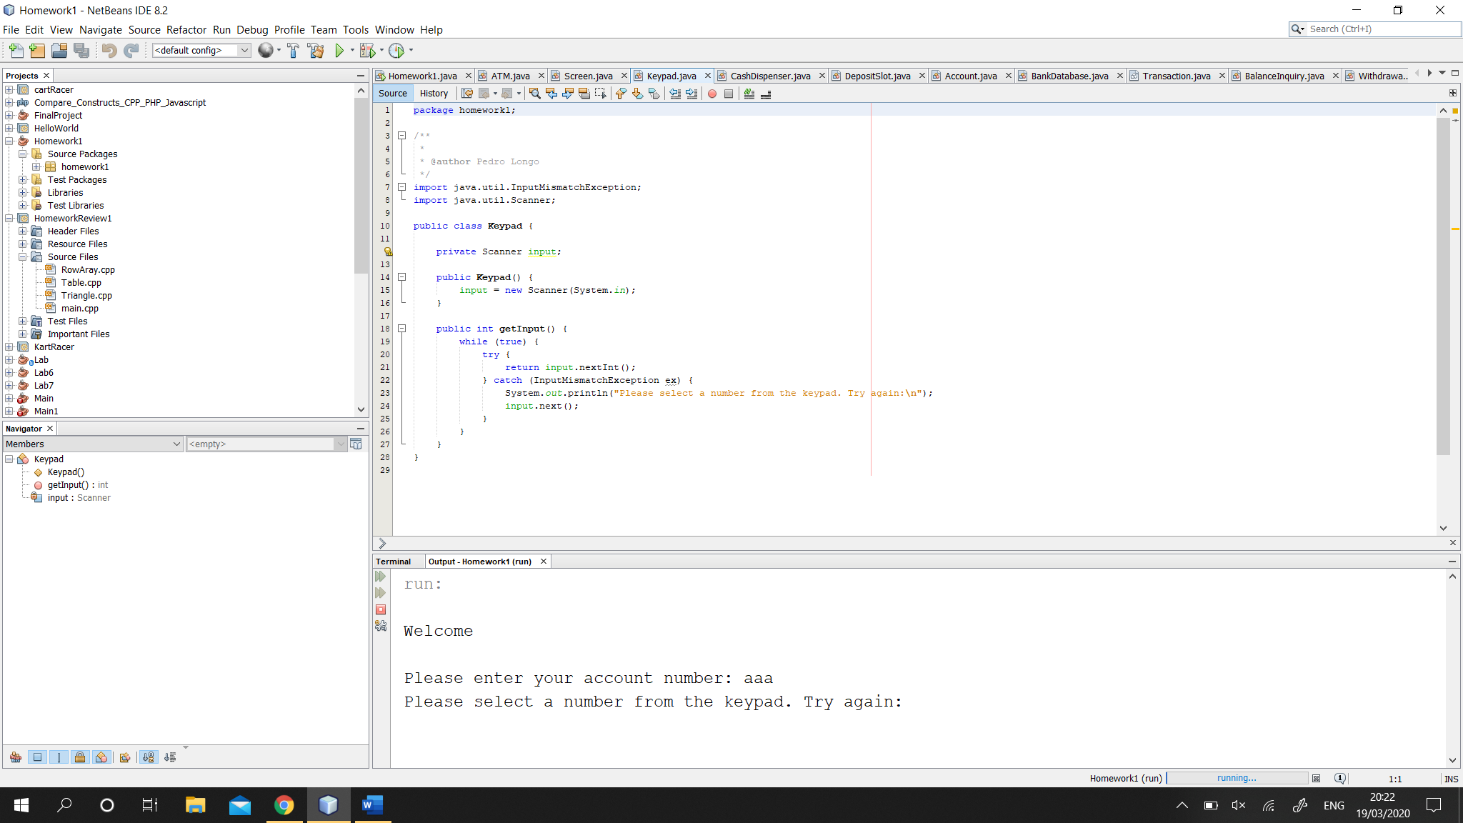 Here, I tested a bad input, such a string. The try catch will run and check input, if it’s not an integer it will loop and ask you to try again.

Testing if the withdrawal option works, plus the error if invalid input is given.

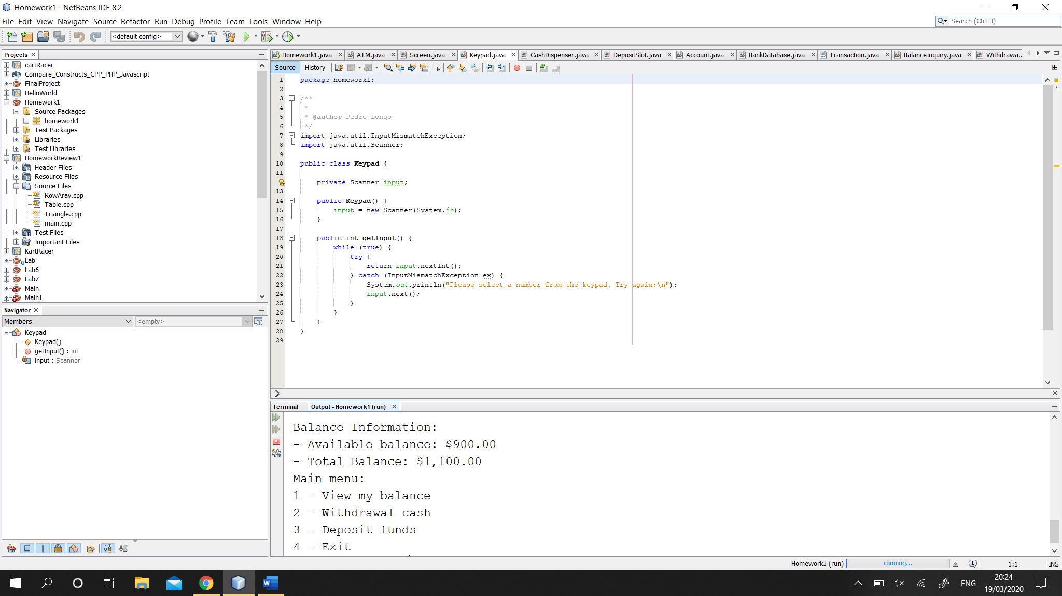 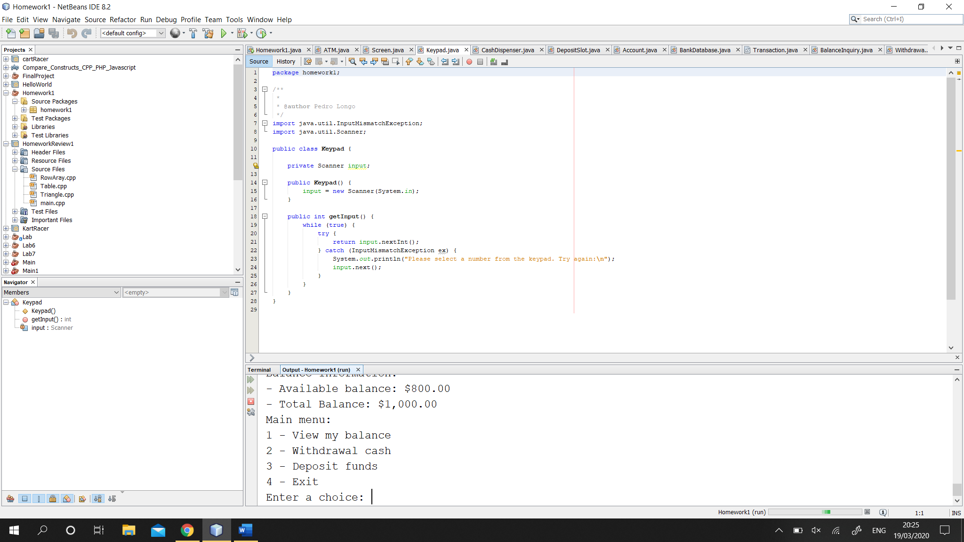   
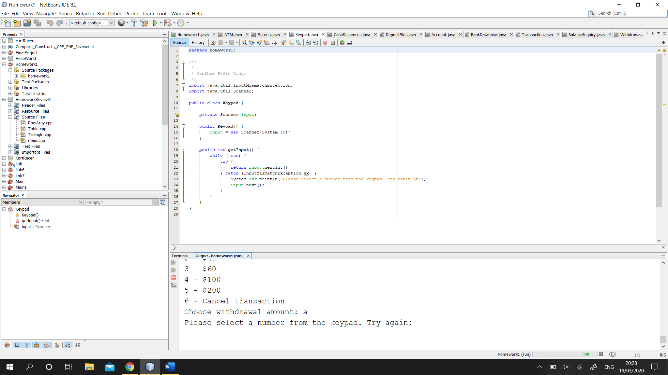

Invalid input in deposit.

