Here’s a first test of the program, along with the main java class.

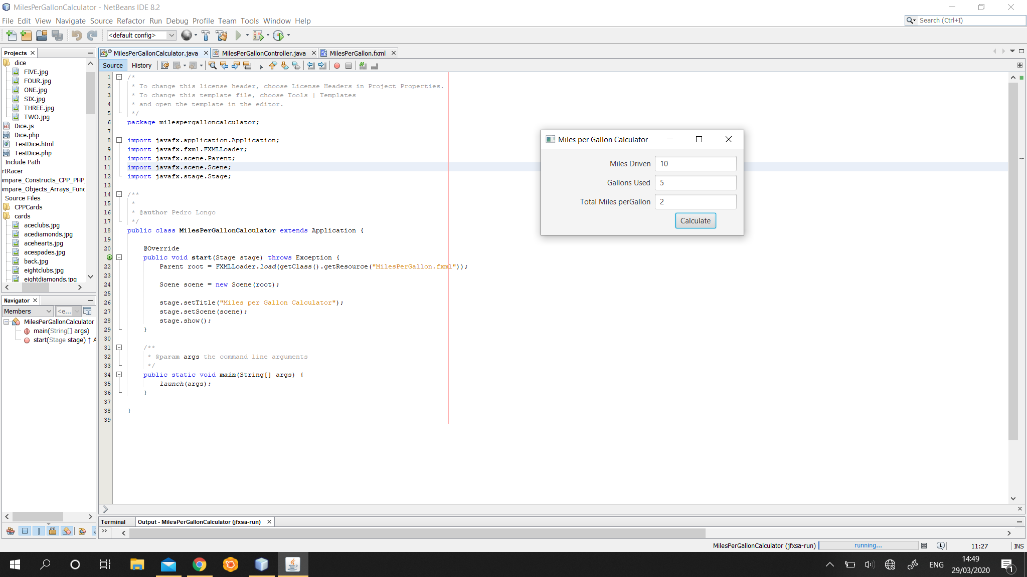

Here’s a second test along with the controller class.

I imported the BigDecimal and the RoundingMode so the program will round the calculation and give us an answer. I’ve got this idea from the Tip Calculator project explained in the book.

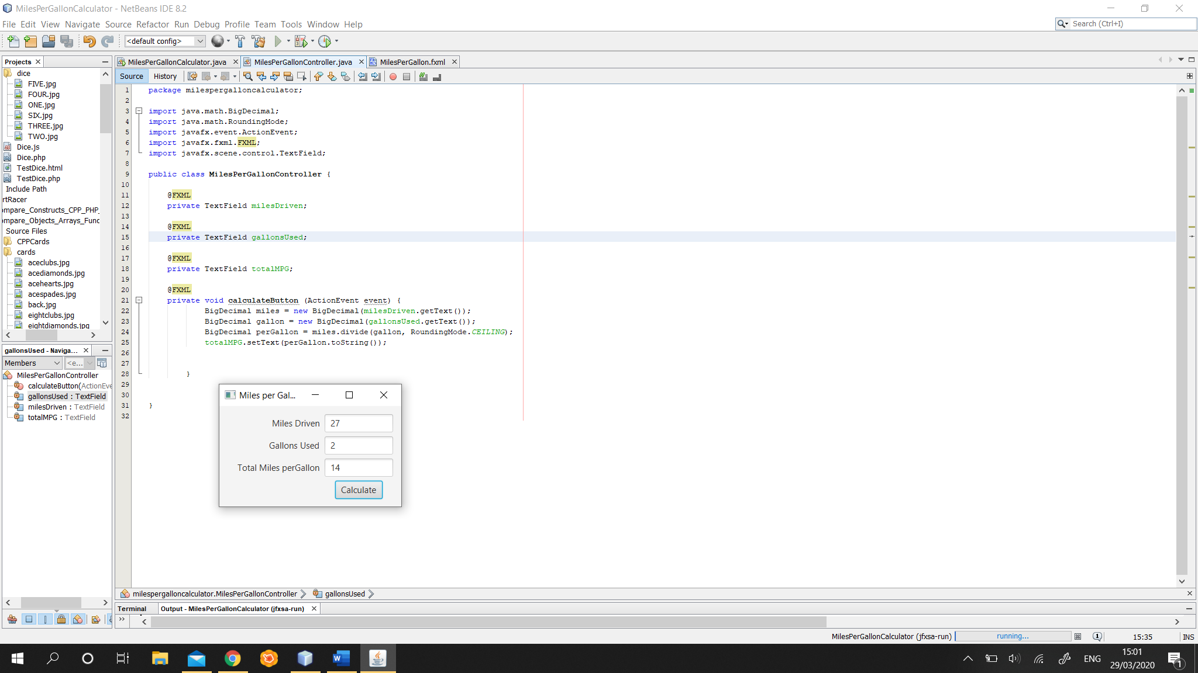

Third test with the XML file.

