付款通知书

|  |  |  |  |  |  |  |
| --- | --- | --- | --- | --- | --- | --- |
| 付款通知书编号:KB.6890451  客户 ID:ZHANG_SAN_091 |  | |  |  | | --- | --- | | 抬头: | 收货方: | | 深圳XX家装有限公司 | 丙丁 | |

|  |  |  |  |  |  |  |
| --- | --- | --- | --- | --- | --- | --- |
| 日期 | 订单编号 | 销售代表 | 离岸价 | 发货方式 | 条款 | 税号 |
| 2018-06-12 | SN18090 | 李四 | 5000元 | 快递 | 附录A | T11090 |

|  |  |  |  |  |  |  |
| --- | --- | --- | --- | --- | --- | --- |
| 货物明细 | | | | | | |
| 数量 | 货物 | 说明 | 折扣 | 应纳税 | 单价 | 总计 |
| 4 | 墙纸1 | 书房+卧室 | / | 400 | 1500 | 1600 |
| 4 | 墙纸2 | 书房+卧室 | / | 400 | 1500 | 1600 |
| 4 | 墙纸3 | 书房+卧室 | / | 400 | 1500 | 1600 |
| 人工费 | | | | | | |
| 种类 | | | | 人数 | 单价 |  |
| 油漆工1 | | | | 2 | 201 | 402 |
| 油漆工2 | | | | 2 | 202 | 404 |
| 油漆工3 | | | | 2 | 203 | 406 |
| 油漆工4 | | | | 2 | 204 | 408 |
| 总共：[{{total}}](expr:entity.totalCost) | | | | | | |

|  |  |
| --- | --- |
| 小计: | 8000 |
| 税额: | 600 |
| 运输: | 120 |
| 其他: | 250 |
| 未付余额: | 6600 |

内容

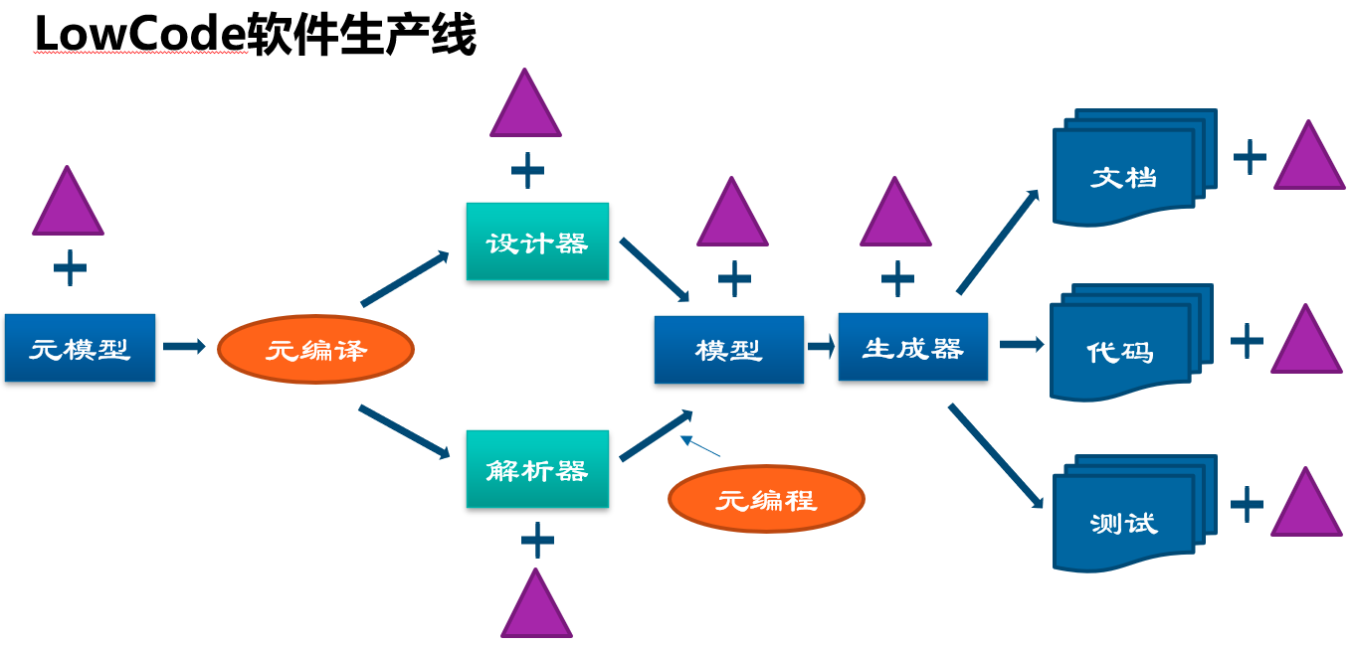

内容1

内容

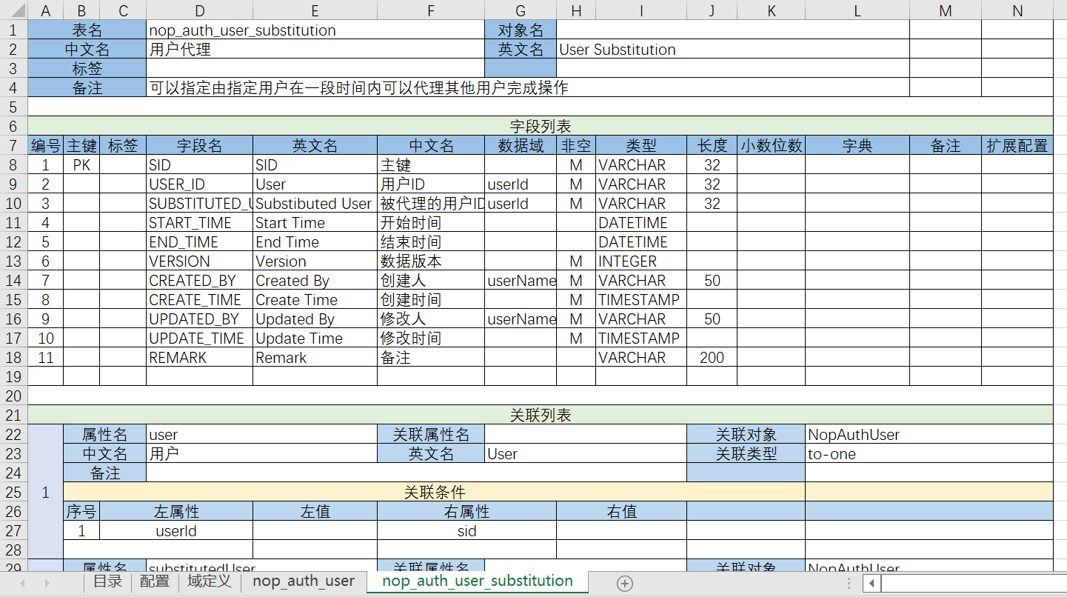

内容2