补充材料
本补充材料用于支持正文中的实验复现性、算法稳定性、统计可靠性和真实树位输入兼容性说明，内容包括实验环境与任务配置、基准算法参数与公平性设置、算法关键参数、收敛曲线、消融实验补充图、ROS 2/RViz 离线路径可视化结果、执行层代理评价、统计显著性检验以及真实树位案例说明。
表 S1 实验环境与任务配置
参数 | 取值
果园区域尺寸 | 120 m × 120 m
果树数量 | 80
障碍物数量 | 11
障碍物类型 | 静态圆形障碍
UGV 数量 | 4
UGV 初始位置 | (0,0), (120,0), (0,120), (120,120)
初始电量 | 100, 80, 60, 40
观测半径 | 2.0 m
安全边界 | 1.5 m
单株果树理论观测点数 | 4
随机种子集合 | 42–61
重复实验次数 | 20
场景生成方式 | 统一环境生成机制下的一一对应随机实例
表 S2 基准算法参数与公平性设置
Algorithm | Population / Search agents | Maximum search budget | Key setting | Fairness note
F-LCA | — | 1500 | Energy-aware task allocation, multi-view observation mapping, pheromone-guided path construction, and late-stage cooperative restructuring | Same environment generation mechanism, same random seed set, same multi-view observation model, and same evaluation protocol
SISR-VRP | — | 1500 | Slack induction by string removals, contiguous string removal, greedy reinsertion, and limited intra-route 2-opt refinement | Same environment generation mechanism, same random seed set, same multi-view observation model, and same evaluation protocol; no F-LCA-specific energy-aware cooperative task allocation or late-stage cooperative restructuring is used
ACO | 20 | 1500 | Ant-based candidate search with pheromone update and heuristic transition rule; candidate set size k = 8 | Same random seed set, same instance generation logic, same multi-view observation model, and same metric calculation method
GA | 20 | 1500 | Genetic encoding with selection, crossover, and mutation operators | Same random seed set, same instance generation logic, same multi-view observation model, and same metric calculation method
PSO | 20 | 1500 | Discrete assignment encoding and priority-based ordering update | Same random seed set, same instance generation logic, same multi-view observation model, and same metric calculation method
注：F-LCA 和 SISR-VRP 均不采用传统种群规模参数，因此在 Population / Search agents 一栏中记为“—”。所有算法均在 20 组匹配随机实例上运行，随机种子集合为 42–61。运行时间仅作为工程计算代价指标报告，不作为唯一公平性标准。需要说明的是，本文中的统一搜索预算指各算法在自身搜索结构下的最大外层搜索次数或路径重构尝试次数，并不表示不同算法具有完全相同的基础目标函数评价次数。由于 F-LCA、SISR-VRP 和群智能算法的内部搜索结构不同，本文将统一问题实例、统一观测任务定义、统一随机种子集合和统一评价协议作为公平比较基础，并将运行时间作为额外工程代价指标单独报告。
表 S3 算法关键参数设置
Parameter category | Parameter name | Value
General setting | Random seed set | 42–61
General setting | Number of repeated runs | 20
General setting | Maximum search budget | 1500
General setting | Orchard area size | 120 m × 120 m
General setting | Number of citrus trees | 80
General setting | Number of obstacles | 11
General setting | Number of UGVs | 4
General setting | Initial battery levels | 100, 80, 60, 40
General setting | Observation radius | 2.0 m
General setting | Safety boundary | 1.5 m
General setting | Theoretical observation poses per tree | 4
F-LCA | Basic candidate set size | 10
F-LCA | Late-stage candidate set size | 9
F-LCA | Number of path candidates | 4
F-LCA | Pheromone weight α | 1.00 → 1.20
F-LCA | Heuristic weight β | 2.80 → 3.80
F-LCA | Pheromone evaporation coefficient | 0.94 → 0.90
F-LCA | Path balance weight | 0.68
F-LCA | Obstacle penalty weight | 0.19
F-LCA | Missing observation pose penalty | 18.0
F-LCA | Incomplete tree penalty | 22.0
F-LCA | Energy protection term | 18.0
F-LCA | Local search frequency | Every 20 iterations
F-LCA | Late-stage local search frequency | Every 12 iterations
F-LCA | Minimum / expected observation poses per tree | 4 / 4
SISR-VRP | Initial route construction | Nearest-start partition + nearest-neighbor ordering
SISR-VRP | Minimum string removal length | 2
SISR-VRP | Maximum string removal length | 5
SISR-VRP | Number of removed strings per iteration | 1–2
SISR-VRP | Removal bias | Expensive route segment / long route / random route
SISR-VRP | Removal bias probability | 0.40 / 0.30 / 0.30
SISR-VRP | Repair strategy | Greedy insertion
SISR-VRP | Candidate insertion positions | All positions if route length ≤ 12; otherwise route endpoints and up to 8 sampled intermediate positions
SISR-VRP | Load-balance insertion penalty coefficient | 3.0
SISR-VRP | Local refinement | Limited intra-route 2-opt
SISR-VRP | Local refinement frequency | Every 100 iterations
SISR-VRP | Maximum 2-opt trials per refinement | 8
SISR-VRP | Acceptance rule | Accept improving moves only
GA | Population size | 20
GA | Number of generations | 1500
PSO | Number of particles | 20
PSO | Number of iterations | 1500
PSO | Inertia weight w | 0.72
PSO | Learning factors c1, c2 | 1.45, 1.45
ACO | Number of ants | 20
ACO | Number of iterations | 1500
ACO | Candidate set size k | 8
ACO | Pheromone weight α | 1.0
ACO | Heuristic weight β | 2.0
ACO | Pheromone evaporation coefficient | 0.90
注：SISR-VRP 作为 VRP-oriented ruin-and-recreate 基线，仅采用字符串移除、贪婪重插入和有限 2-opt 局部优化，不包含 F-LCA 的能量感知协同任务分配、区域边界修正、边界交换、分层精修或后期协同重构机制。除场景参数外，其余算法参数均由预实验统一确定，并在全部 20 组随机种子实验中保持不变，不针对单个实例单独调参。
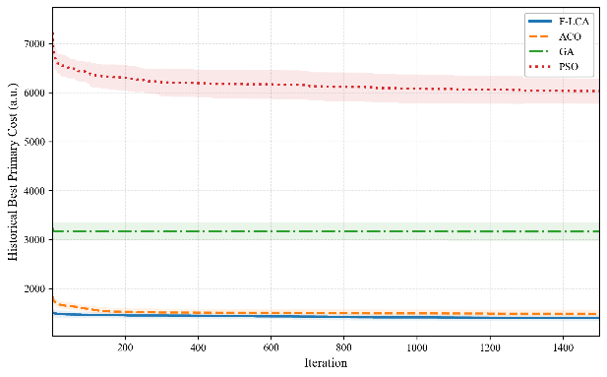 | 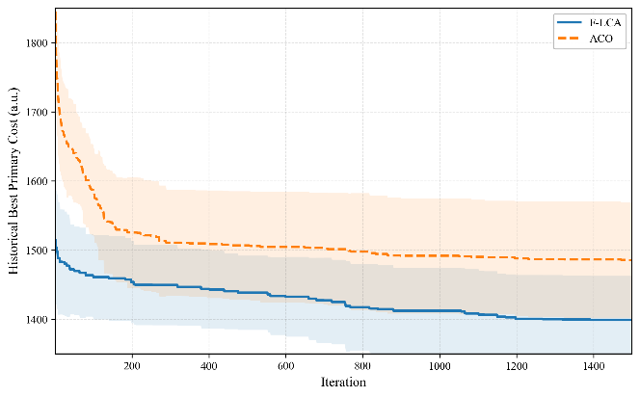
图 S1 统一搜索预算下四种迭代型算法的收敛特性对比
（a）四种迭代型群智能算法的平均历史最优主目标值收敛曲线；（b）F-LCA 与 ACO 的平均历史最优主目标值局部收敛曲线。结果基于 20 组随机种子统计。SISR-VRP 采用字符串移除与重插入的 ruin-and-recreate 搜索过程，其搜索轨迹与 F-LCA、ACO、GA 和 PSO 的种群迭代型历史最优序列不完全同构，因此不纳入该收敛曲线比较；其最终性能已在正文图 3、补充材料表 S7、表 S5a 和表 S5b 中统一报告。
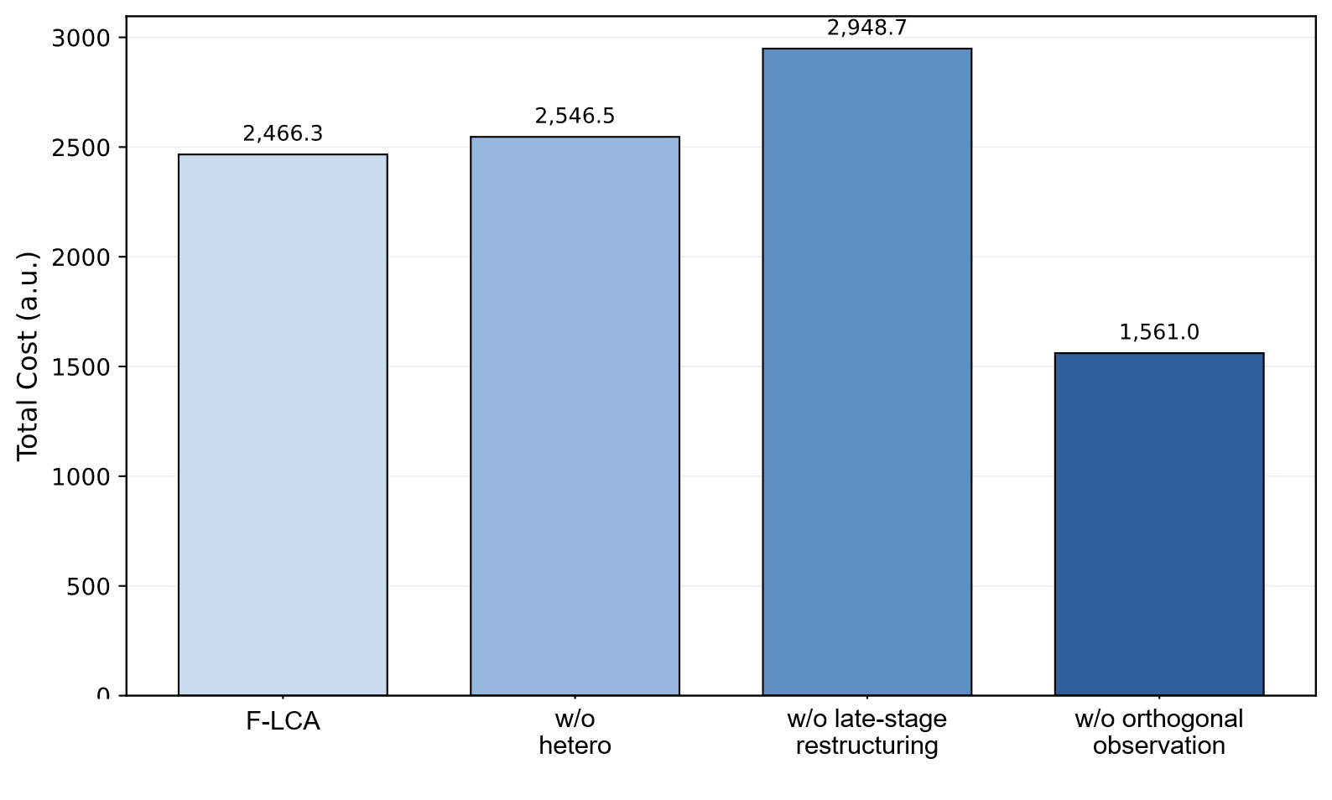  (a) | 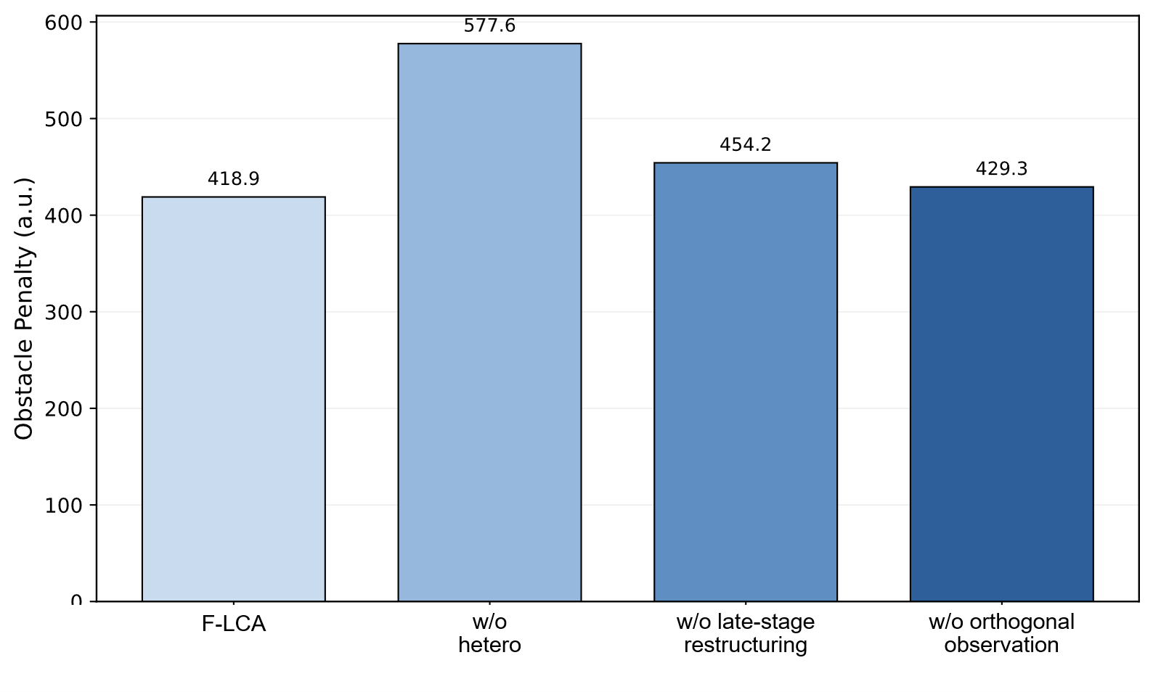  (b)
图 S2 消融实验中各版本综合性能对比
注：（a）全局总代价均值对比；（b）障碍惩罚均值对比。结果基于 20 组随机种子重复实验统计。
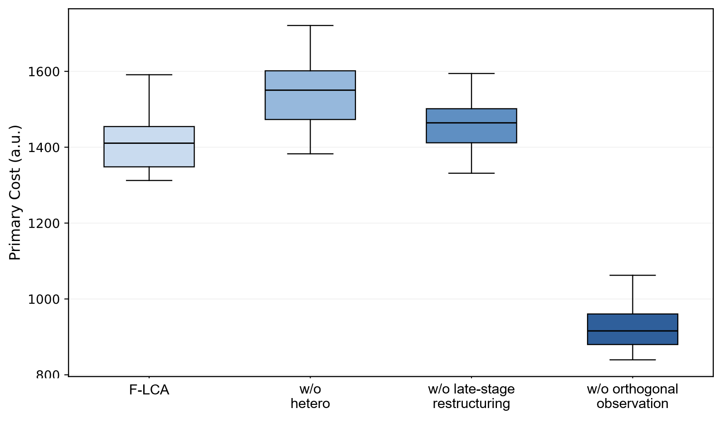
图 S3 消融实验中各版本主目标值分布箱线图
注：箱线图基于 20 组随机种子重复实验绘制，箱体表示四分位区间，中间横线表示中位数。
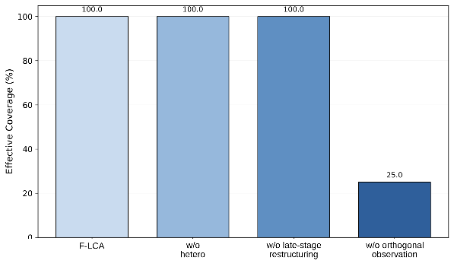 | 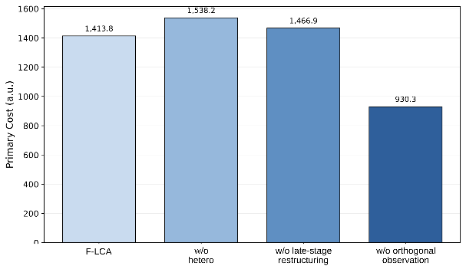
图 S4 多视角观测完整性消融结果
注：（a）有效覆盖率对比；（b）主目标值均值对比。
Supplementary Algorithm S1. Pseudocode of the late-stage cooperative restructuring mechanism
Line | Operation
Input | Current vehicle-task sets A = {A1, A2, ..., Am}, route set P = {P1, P2, ..., Pm}, visiting-order set R = {R1, R2, ..., Rm}, multi-view observation poses Q, obstacle set O, battery levels E, current metric vector M, maximum search budget T, stagnation thresholds, and cooldown intervals.
Output | Restructured vehicle-task sets A*, routes P*, and visiting orders R*.
1 | Initialize A* ← A, P* ← P, and R* ← R.
2 | At each search iteration, evaluate total distance, obstacle penalty, energy-load ratio, primary cost, and reference total cost for all UGVs.
3 | If the energy-load gap or task-load gap exceeds the preset threshold, perform adaptive region correction.
3.1 | Select the UGV with the largest energy-load ratio as the donor vehicle and the UGV with the smallest energy-load ratio as the receiver vehicle.
3.2 | Rank candidate trees in the donor task set according to boundary distance, transfer cost, and local task complexity.
3.3 | Move a candidate boundary tree to the receiver only if the transfer preserves multi-view coverage and reduces load imbalance or path cost.
3.4 | Repair the updated task partition to avoid excessive task concentration in any vehicle.
4 | If the search stagnates and the boundary-exchange cooldown condition is satisfied, perform boundary exchange.
4.1 | Sort donor candidates by decreasing energy-load ratio and receiver candidates by increasing energy-load ratio.
4.2 | Select a boundary tree from the donor task set.
4.3 | Remove the selected tree from the donor visiting order and insert it into the receiver visiting order at the position with the lowest local route cost.
4.4 | Apply local visiting-order refinement to both donor and receiver routes.
4.5 | Recompute the primary cost, reference total cost, obstacle penalty, total distance, and energy range of the candidate solution.
4.6 | Accept the exchange if the candidate solution improves the layered evaluation key, or if it maintains the primary cost within the relaxation margin while reducing the energy-range indicator.
5 | If the layered-refinement trigger condition is satisfied, perform progressive refinement.
5.1 | Save the current task sets, routes, and visiting orders.
5.2 | Transfer selected boundary trees from overloaded vehicles to underloaded vehicles.
5.3 | Rebuild the affected UGV routes and refine their local visiting orders.
5.4 | Accept the refined solution if it improves the layered evaluation key or reduces the energy-range indicator under the primary-cost relaxation condition; otherwise, roll back to the saved solution.
6 | If long-term stagnation persists and a historical best solution is available, perform destroy-and-repair.
6.1 | Remove a short contiguous segment from the historical visiting order of a selected vehicle.
6.2 | Reinsert the removed trees into positions with lower local route cost.
6.3 | Apply local visiting-order refinement and accept the reconstructed solution only if it improves the current evaluation metric.
7 | Whenever a restructuring operation is accepted, update A*, P*, R*, and the best recorded metric vector.
8 | Repeat Steps 2–7 until the maximum search budget or termination condition is reached.
9 | Return A*, P*, and R*.
Note: The layered evaluation key prioritizes observation completeness, incomplete-tree ratio, energy feasibility, primary cost, energy-range indicator, and reference total cost in sequence. Therefore, the late-stage restructuring procedure improves route organization without relaxing the predefined multi-view observation requirement.

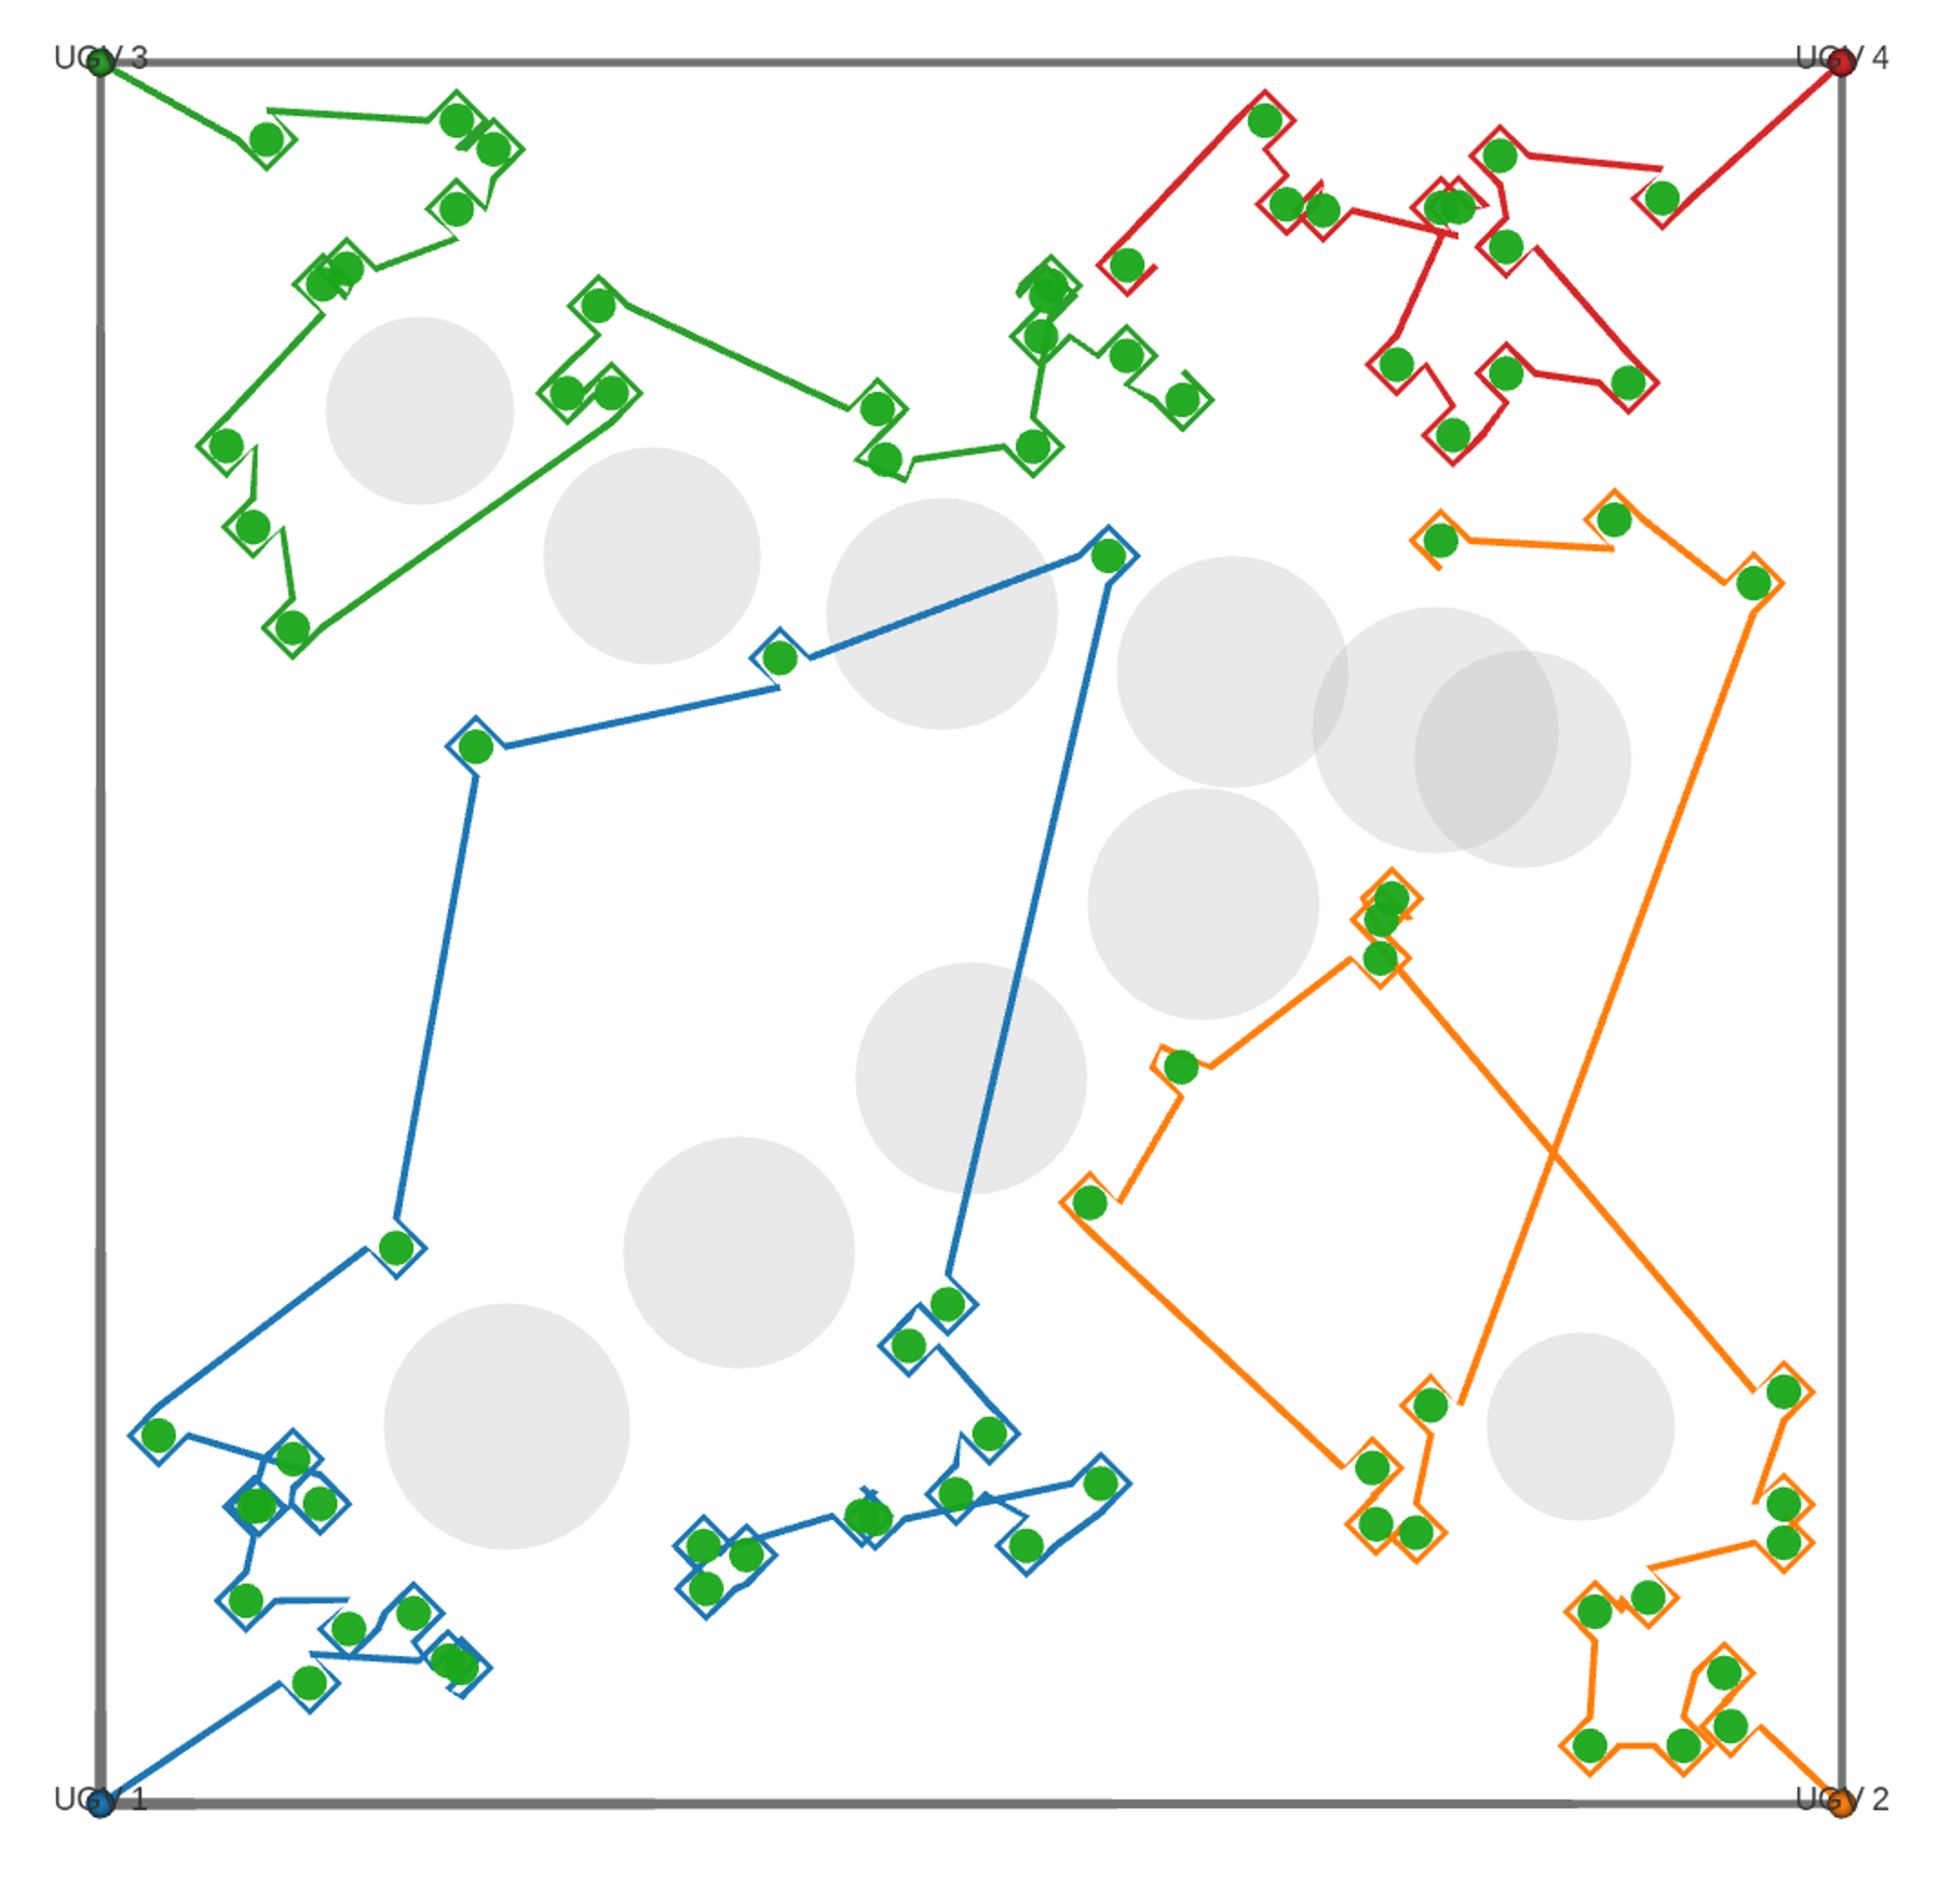
图 S5 基于 ROS 2/RViz 的 F-LCA 离线协同观测路径可视化结果
注：图中展示了 ROS 2/RViz 环境下的 F-LCA 代表性离线协同观测路径可视化结果。不同颜色路径对应不同车辆，灰色圆形区域表示障碍物。该图用于说明离线规划路径能够进一步映射到 ROS 2/RViz 可视化环境中，不表示本文已经完成真实 UGV 闭环控制或实地部署验证。
执行层代理指标定义
为补充说明离线规划路径在统一后处理口径下的执行友好性，本文进一步定义执行轨迹长度、执行时间估算、最小障碍实体净空、最小安全净空和转弯约束违例比例等代理指标。
第 k 辆 UGV 经平滑处理后的执行轨迹为：
 | $$P_{k}^{exe}=\left\{p_{k,1}^{exe},p_{k,2}^{exe},…,p_{k,n_{k}}^{exe}\right\}$$ | （S1）
则第 k 辆 UGV 的执行轨迹长度定义为：
 | $$L_{k}^{exe}=\sum_{r=1}^{n_{k}-1}{{∥p_{k,r+1}^{exe}-p_{k,r}^{exe}∥}_{2}}$$ | （S2）
若车辆平均线速度、单观测点停留时间及实际访问观测点数量已知，则简化执行时间估算为：
 | $$T_{k}^{exe}=\frac{L_{k}^{exe}}{\overset{‾}{v}}+n_{k}^{obs}t_{obs}$$ | （S3）
设第 j 个障碍物的中心位置、实体半径及安全边界宽度已知，则第 k 辆 UGV 的最小障碍实体净空和最小安全净空分别定义为：
 | $$C_{k,min}^{safe}=\min_{p∈P_{k}^{exe}}\left(d_{obs}\left(p\right)-d_{safe}\right)$$ | （S4）
进一步地，设轨迹中连续三点构成的局部等效转弯半径，当其低于最小转弯半径阈值时记为一次转弯约束违例，则曲率约束违例比例定义为：
 | $$V_{k}^{turn}=\frac{\sum_{q=2}^{n_{k}-1}{I}\left(R_{k,q} < R_{min}\right)}{n_{k}-2}×100\%$$ | （S5）
其中，$I(⋅)$ 为指示函数。当条件成立时取 1，否则取 0。表 S4 中的 Turn Violation Ratio / % 表示转弯约束违例比例，而非单纯违例次数。上述执行层代理指标仅作为补充评价，用于说明离线规划结果在统一后处理口径下进一步映射到执行层分析的潜力，不重新并入主优化目标，也不作为本文判断各算法主性能优劣的依据。
表 S4 统一后处理口径下的执行层代理评价结果
Algorithm | Execution Path Length / m | Estimated Execution Time / s | Minimum Obstacle Clearance / m | Minimum Safety Clearance / m | Turn Violation Ratio / %
F-LCA | 1433.84 ± 46.37 | 2752.30 ± 57.96 | 0.964 ± 0.120 | -0.536 ± 0.120 | 12.67 ± 2.18
SISR-VRP | 1554.04 ± 94.78 | 2902.55 ± 118.47 | 0.983 ± 0.078 | -0.517 ± 0.078 | 11.22 ± 2.15
ACO | 1877.20 ± 148.60 | 3306.51 ± 185.75 | 0.854 ± 0.556 | -0.646 ± 0.556 | 10.48 ± 1.56
注：结果为 20 组随机种子重复实验的均值 ± 标准差。Minimum Obstacle Clearance 表示轨迹到障碍物实体边界的最小净空，Minimum Safety Clearance 表示相对于预设安全边界的净空裕度。由于 Minimum Safety Clearance 是相对于安全边界而非障碍物实体边界计算的，因此其数值可以为负；负值表示轨迹进入预设安全缓冲区，但不等同于与障碍物实体发生碰撞。Turn Violation Ratio 表示局部转弯半径低于最小允许转弯半径的轨迹段比例。本评价选择 F-LCA、SISR-VRP 与 ACO，是为了在统一后处理口径下比较所提方法、强 VRP-oriented 基线和经典蚁群路径基线的执行友好性，并不构成所有基线算法的完整执行层比较。该执行层代理评价仅用于说明离线规划路径进一步映射到执行层分析的潜力，不作为五种算法的主性能比较依据。
表 S5a Friedman 检验结果
Metric | Algorithms included | Number of paired instances | Friedman test result | Interpretation
Primary Cost | F-LCA, SISR-VRP, ACO, GA, PSO | 20 | p < 0.001 | Significant overall difference among algorithms
Total Cost | F-LCA, SISR-VRP, ACO, GA, PSO | 20 | p < 0.001 | Significant overall difference among algorithms
Total Distance | F-LCA, SISR-VRP, ACO, GA, PSO | 20 | p < 0.001 | Significant overall difference among algorithms
Obstacle Penalty | F-LCA, SISR-VRP, ACO, GA, PSO | 20 | p < 0.001 | Significant overall difference among algorithms
Energy Range | F-LCA, SISR-VRP, ACO, GA, PSO | 20 | p < 0.001 | Significant overall difference among algorithms
Runtime | F-LCA, SISR-VRP, ACO, GA, PSO | 20 | p < 0.001 | Significant overall difference among algorithms
Theoretical Coverage | F-LCA, SISR-VRP, ACO, GA, PSO | 20 | Not tested | All algorithms achieved 100.00 ± 0.00%
Effective Coverage | F-LCA, SISR-VRP, ACO, GA, PSO | 20 | Not tested | All algorithms achieved 100.00 ± 0.00%

注：Friedman 检验基于 20 组匹配随机实例进行。由于五种算法在理论覆盖率和有效覆盖率上均为 100.00 ± 0.00%，覆盖率指标不再进行显著性检验。
表 S5b 以 F-LCA 为参照的 Wilcoxon-Holm 配对检验结果
Metric | Pairwise comparison | Direction of difference | Wilcoxon test result after Holm correction | Interpretation
Primary Cost | F-LCA vs SISR-VRP | F-LCA lower | p < 0.001 | F-LCA significantly improves the core objective over SISR-VRP
Primary Cost | F-LCA vs ACO | F-LCA lower | p < 0.001 | F-LCA significantly improves the core objective over ACO
Primary Cost | F-LCA vs GA | F-LCA lower | p < 0.001 | F-LCA significantly improves the core objective over GA
Primary Cost | F-LCA vs PSO | F-LCA lower | p < 0.001 | F-LCA significantly improves the core objective over PSO
Total Distance | F-LCA vs SISR-VRP | F-LCA lower | p < 0.001 | F-LCA generates shorter cooperative observation paths than SISR-VRP
Total Distance | F-LCA vs ACO | F-LCA lower | p < 0.001 | F-LCA generates shorter paths than ACO
Total Distance | F-LCA vs GA | F-LCA lower | p < 0.001 | F-LCA generates shorter paths than GA
Total Distance | F-LCA vs PSO | F-LCA lower | p < 0.001 | F-LCA generates shorter paths than PSO
Obstacle Penalty | F-LCA vs SISR-VRP | SISR-VRP lower | p < 0.001 | SISR-VRP shows lower obstacle penalty than F-LCA
Obstacle Penalty | F-LCA vs ACO | F-LCA lower | p < 0.001 | F-LCA significantly reduces obstacle penalty compared with ACO
Obstacle Penalty | F-LCA vs GA | F-LCA lower | p < 0.001 | F-LCA significantly reduces obstacle penalty compared with GA
Obstacle Penalty | F-LCA vs PSO | F-LCA lower | p < 0.001 | F-LCA significantly reduces obstacle penalty compared with PSO
Energy Range | F-LCA vs SISR-VRP | SISR-VRP lower | p < 0.001 | SISR-VRP shows better load-balance indicator under this metric
Energy Range | F-LCA vs ACO | F-LCA lower | p < 0.001 | F-LCA shows lower energy range than ACO
Energy Range | F-LCA vs GA | GA lower | p < 0.001 | GA shows lower energy range but with much longer paths and higher obstacle penalty
Energy Range | F-LCA vs PSO | PSO lower | p < 0.001 | PSO shows lower energy range but with much longer paths and higher obstacle penalty
Runtime | F-LCA vs SISR-VRP | SISR-VRP lower | p < 0.001 | SISR-VRP has lower computational time
Runtime | F-LCA vs ACO | F-LCA lower | p < 0.001 | F-LCA is faster than ACO
Runtime | F-LCA vs GA | GA lower | p < 0.05 | GA has lower computational time
Runtime | F-LCA vs PSO | PSO lower | p < 0.05 | PSO has lower computational time
注：Wilcoxon 配对符号秩检验以 20 组匹配随机实例为配对单位，并采用 Holm 方法进行多重比较校正。Primary Cost 和 Total Distance 是本文用于评价完整多视角观测约束下路径组织质量的核心指标；Obstacle Penalty、Energy Range 和 Runtime 作为辅助指标，用于解释不同算法在障碍代价、负载均衡和计算代价方面的权衡。SISR-VRP 在障碍惩罚、能耗极差和运行时间方面表现较好，但 F-LCA 在 Primary Cost 和 Total Distance 上保持优势。完整的 Wilcoxon-Holm 配对检验结果，包括 Total Cost 指标，见数据仓库中的 wilcoxon_holm_results.csv；本表列出正文重点讨论的主要配对比较指标。
综合统计结果表明，F-LCA 在 Primary Cost 和 Total Distance 两个核心路径组织指标上相较于 SISR-VRP 及三种经典基线算法保持优势。由于五种算法在理论覆盖率和有效覆盖率上均达到 100.00 ± 0.00%，覆盖率指标不再进行显著性检验，而是作为完整观测约束是否满足的前提条件。与此同时，SISR-VRP 在 Obstacle Penalty、Energy Range 和 Runtime 方面表现更好，说明其基于字符串移除与重插入的 VRP-oriented 路径重构策略具有较强的局部连接优化能力和计算效率。因此，F-LCA 与 SISR-VRP 的比较应理解为完整多视角观测约束下路径紧凑性与局部路径重构效率之间的权衡关系。
表 S6 真实树位案例数据与规划结果说明
Item | Value / Description
Source of tree locations | KML-exported citrus tree markers
Number of real tree locations | 43
Coordinate system before conversion | WGS84 longitude-latitude
Coordinate system after conversion | Local planar x-y coordinates
Planning region size | 62.43 m × 50.45 m
Number of UGVs | 4
Theoretical coverage | 100.00%
Effective coverage | 100.00%
Total path length | 588.88 m
Energy range | 5.91%
Output files | real_citrus_tree_points_xy.csv; real_orchard_best_path.json; real_orchard_case_metrics.csv
注：该真实树位案例用于验证 F-LCA 对真实树位空间输入的兼容性，以及从 KML 树位点到局部平面坐标再到协同观测路径生成的流程可行性。该案例不作为额外的多算法统计对比实验，也不等同于真实 UGV 闭环部署验证。
表 S7 统一环境下五种算法的性能对比
Algorithm | Primary Cost | Total Cost | Total Distance / m | Theoretical Coverage / % | Effective Coverage / % | Obstacle Penalty | Energy Range / % | Runtime / s
F-LCA | 1413.76 ± 72.88 | 2466.33 ± 328.64 | 1334.18 ± 59.11 | 100.00 ± 0.00 | 100.00 ± 0.00 | 418.85 ± 192.70 | 14.27 ± 3.31 | 86.42 ± 1.23
SISR-VRP | 1535.19 ± 91.29 | 1818.11 ± 416.37 | 1487.43 ± 91.21 | 100.00 ± 0.00 | 100.00 ± 0.00 | 251.37 ± 124.76 | 3.49 ± 4.13 | 21.17 ± 4.42
ACO | 2024.11 ± 177.68 | 4137.78 ± 492.35 | 1754.35 ± 96.47 | 100.00 ± 0.00 | 100.00 ± 0.00 | 1419.75 ± 543.76 | 20.18 ± 6.05 | 433.48 ± 130.70
GA | 3771.39 ± 250.84 | 4064.03 ± 267.24 | 3330.73 ± 194.30 | 100.00 ± 0.00 | 100.00 ± 0.00 | 2319.27 ± 492.89 | 0.65 ± 0.17 | 62.53 ± 30.93
PSO | 6624.41 ± 396.82 | 7115.08 ± 424.58 | 5185.52 ± 254.46 | 100.00 ± 0.00 | 100.00 ± 0.00 | 7573.13 ± 1026.67 | 0.63 ± 0.37 | 75.75 ± 43.86
注：结果为 20 组随机种子重复实验的均值 ± 标准差。

