Supplementary Materials
Observation-complete cooperative multi-view path planning for multi-UGV citrus orchard phenotyping
These Supplementary Materials support the reproducibility, algorithmic stability, statistical reliability, and real-tree-location input compatibility analyses of the Fusion Leaf-Cutter Ant-inspired Algorithm (F-LCA) reported in the main text. This document includes the experimental environment and task configuration, baseline algorithm parameters and fairness settings, key algorithm parameters, parameter sensitivity analysis, convergence curves, supplementary ablation figures, ROS 2/RViz offline route visualization results, execution-oriented proxy assessment, statistical significance tests, and the real-tree-location planning case for Unmanned Ground Vehicle (UGV)-based cooperative observation.
Table S1
Experimental environment and task configuration.
Parameter | Value
Orchard dimensions | 120 m × 120 m
Number of citrus trees | 80
Number of obstacles | 11
Obstacle type | Static circular obstacles
Number of UGVs | 4
Initial UGV positions | (0,0), (120,0), (0,120), (120,120)
Initial battery levels | 100, 80, 60, 40
Observation radius | 2.0 m
Safety boundary | 1.5 m
Theoretical observation poses per tree | 4
Random seed set | 42–61
Number of repeated runs | 20
Scenario generation method | Matched random instances generated under a unified environment-generation mechanism
Table S2
Baseline algorithm parameters and fairness settings.
Algorithm | Population / Search agents | Maximum search budget | Key setting | Fairness note
F-LCA | — | 1500 | Energy-aware task allocation, multi-view observation mapping, pheromone-guided path construction, and late-stage cooperative restructuring | Same environment generation mechanism, same random seed set, same multi-view observation model, and same evaluation protocol
SISR-VRP | — | 1500 | Tree-level nearest-start partition, nearest-neighbor ordering, contiguous string removal, greedy reinsertion, and limited intra-route 2-opt refinement; multi-view observation poses are rendered using the shared observation model during evaluation | Same environment generation mechanism, same random seed set, same tree-level task ownership, same multi-view observation renderer, and same evaluation protocol; no F-LCA-specific residual-energy-aware cooperative task allocation, boundary exchange, layered refinement, or late-stage cooperative restructuring is used
ACO | 20 | 1500 | Ant-based candidate search with pheromone update and heuristic transition rule; candidate set size k = 8 | Same random seed set, same instance generation logic, same multi-view observation model, and same metric calculation method
GA | 20 | 1500 | Genetic encoding with selection, crossover, and mutation operators | Same random seed set, same instance generation logic, same multi-view observation model, and same metric calculation method
PSO | 20 | 1500 | Discrete assignment encoding and priority-based ordering update | Same random seed set, same instance generation logic, same multi-view observation model, and same metric calculation method
Note: F-LCA and SISR-VRP do not use conventional population-size parameters; therefore, “—” is reported in the Population / Search agents column. All algorithms were run on 20 matched random instances with random seeds ranging from 42 to 61. The unified search budget refers to the maximum number of outer search iterations or route-reconstruction attempts under the internal search structure of each algorithm and does not imply identical numbers of basic objective-function evaluations. Because F-LCA, SISR-VRP, and the swarm-intelligence algorithms have different internal search structures, fair comparisons were based on the same problem instances, observation task definition, random seed set, and evaluation protocol. Runtime was reported separately as an engineering computational-cost indicator.
Table S3
Key algorithm parameter settings.
Parameter category | Parameter name | Value
General setting | Random seed set | 42–61
General setting | Number of repeated runs | 20
General setting | Maximum search budget | 1500
General setting | Orchard dimensions | 120 m × 120 m
General setting | Number of citrus trees | 80
General setting | Number of obstacles | 11
General setting | Number of UGVs | 4
General setting | Initial battery levels | 100, 80, 60, 40
General setting | Observation radius | 2.0 m
General setting | Safety boundary | 1.5 m
General setting | Theoretical observation poses per tree | 4
F-LCA | Basic candidate set size | 10
F-LCA | Late-stage candidate set size | 9
F-LCA | Number of path candidates | 4
F-LCA | Pheromone weight α | 1.00 → 1.20
F-LCA | Heuristic weight β | 2.80 → 3.80
F-LCA | Pheromone evaporation coefficient | 0.94 → 0.90
F-LCA | Path balance weight | 0.68
F-LCA | Obstacle penalty weight | 0.19
F-LCA | Missing observation pose penalty | 18.0
F-LCA | Incomplete tree penalty | 22.0
F-LCA | Energy protection term | 18.0
F-LCA | Local search frequency | Every 20 iterations
F-LCA | Late-stage local search frequency | Every 12 iterations
F-LCA | Minimum / expected observation poses per tree | 4 / 4
SISR-VRP | Initial route construction | Nearest-start partition + nearest-neighbor ordering
SISR-VRP | Minimum string removal length | 2
SISR-VRP | Maximum string removal length | 5
SISR-VRP | Number of removed strings per iteration | 1–2
SISR-VRP | Removal bias | Expensive route segment / long route / random route
SISR-VRP | Removal bias probability | 0.40 / 0.30 / 0.30
SISR-VRP | Repair strategy | Greedy insertion
SISR-VRP | Candidate insertion positions | All positions if route length ≤ 12; otherwise route endpoints and up to 8 sampled intermediate positions
SISR-VRP | Load-balance insertion penalty coefficient | 3.0
SISR-VRP | Local refinement | Limited intra-route 2-opt
SISR-VRP | Local refinement frequency | Every 100 iterations
SISR-VRP | Maximum 2-opt trials per refinement | 8
SISR-VRP | Acceptance rule | Accept improving moves only
GA | Population size | 20
GA | Number of generations | 1500
PSO | Number of particles | 20
PSO | Number of iterations | 1500
PSO | Inertia weight w | 0.72
PSO | Learning factors c₁, c₂ | 1.45, 1.45
ACO | Number of ants | 20
ACO | Number of iterations | 1500
ACO | Candidate set size k | 8
ACO | Pheromone weight α | 1.0
ACO | Heuristic weight β | 2.0
ACO | Pheromone evaporation coefficient | 0.90
Note: SISR-VRP was used as a tree-level VRP-oriented ruin-and-recreate baseline. It first performs vehicle assignment and visiting-sequence reconstruction at the tree-task-unit level, and then generates observation-viewpoint routes through the same multi-view observation rendering and evaluation procedure used for F-LCA. This baseline uses only string removal, greedy reinsertion, and limited 2-opt local refinement. It does not include the residual-energy-aware cooperative task allocation, region boundary correction, boundary exchange, layered refinement, or late-stage cooperative restructuring mechanisms of F-LCA. Except for scenario parameters, the remaining algorithm parameters were determined through preliminary experiments and kept unchanged across all 20 random-seed experiments. No instance-specific parameter tuning was performed.
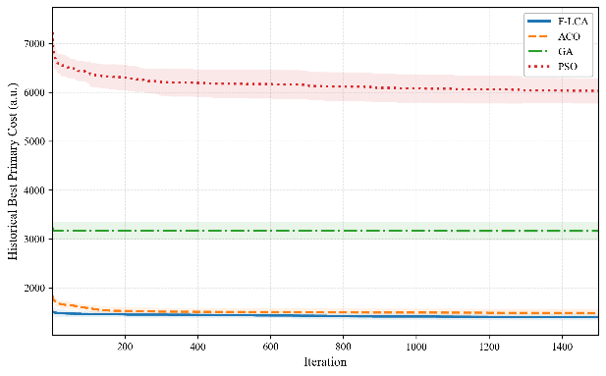 | 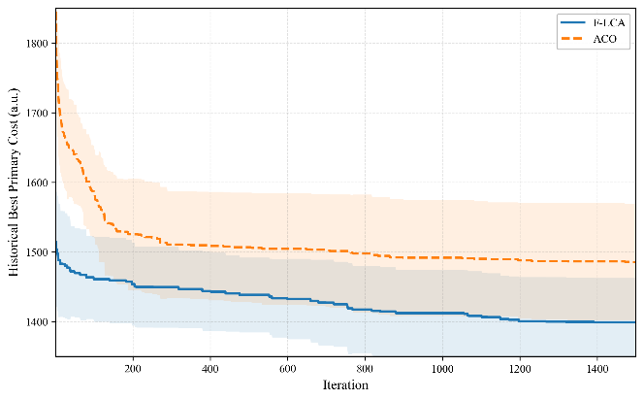
Fig. S1. Convergence comparison of the four iterative algorithms under the unified search budget.
Panels (a) and (b) show the average historical best Primary Cost curves of the four iterative algorithms and the enlarged comparison between F-LCA and ACO, respectively. SISR-VRP was not included because it follows a ruin-and-recreate process rather than a population-iterative search trajectory; its final performance is reported in Fig. 4, Supplementary Table S7, Supplementary Table S5a, and Supplementary Table S5b.
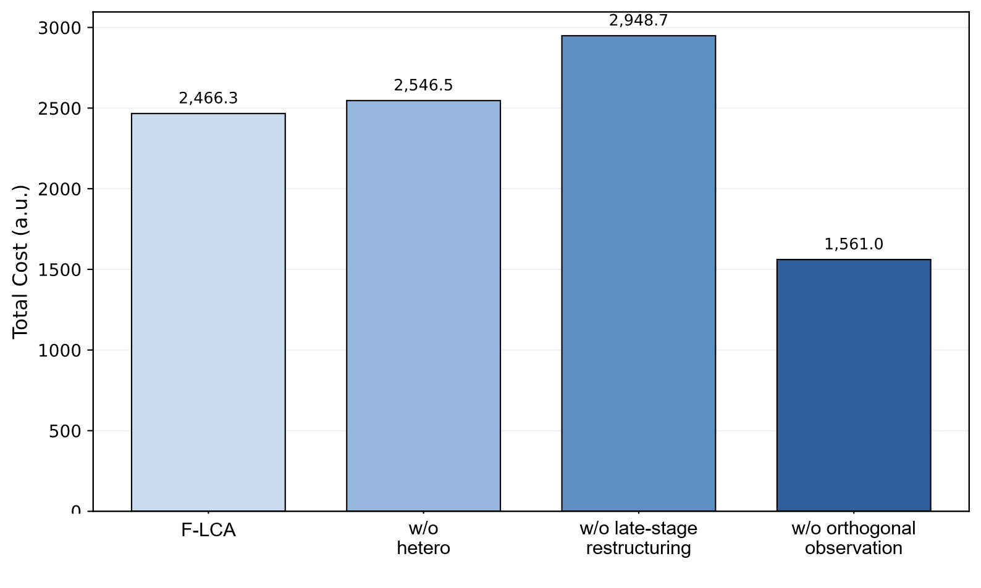  (a) Mean Total Cost | 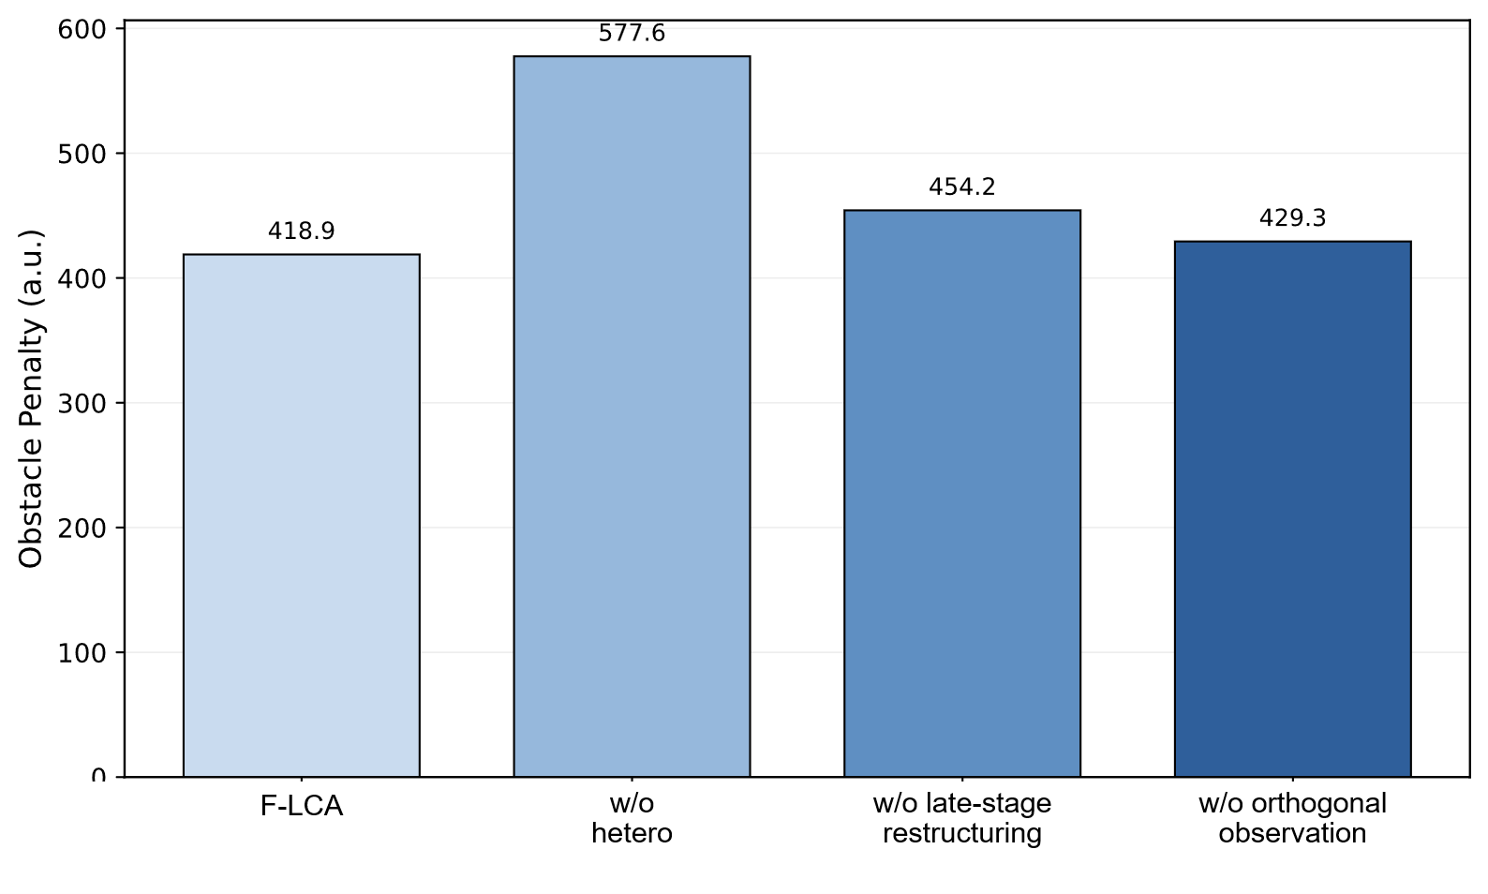  (b) Mean Obstacle Penalty
Fig. S2. Supplementary ablation comparison.
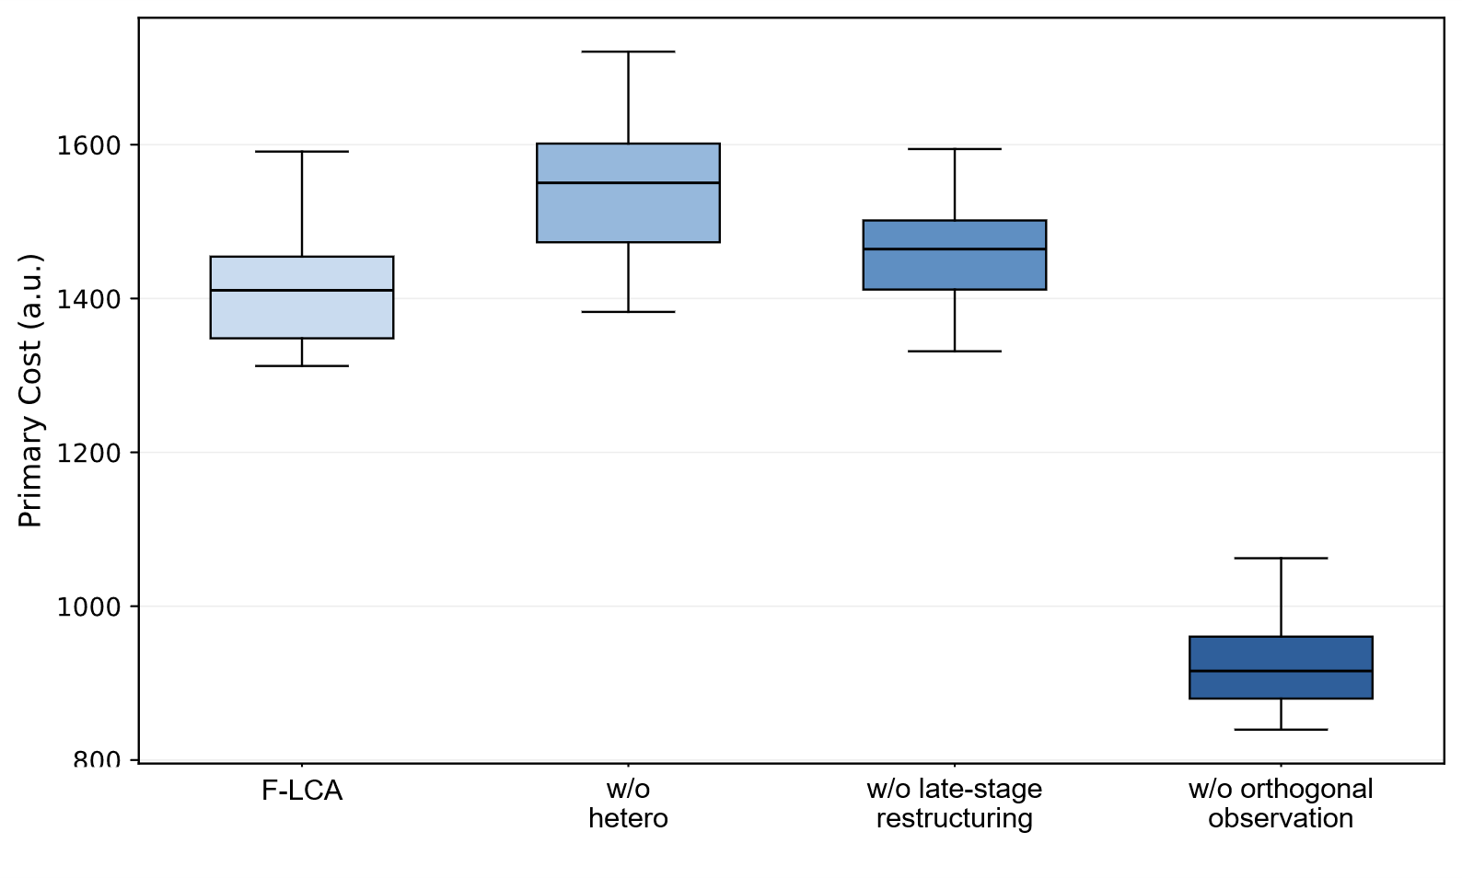
Fig. S3. Primary Cost distributions of different ablated variants.
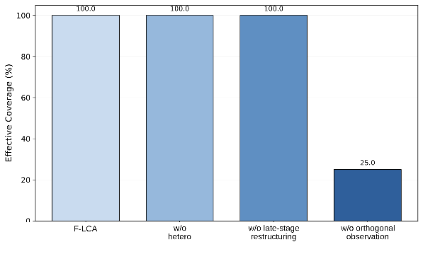  - Effective Coverage | 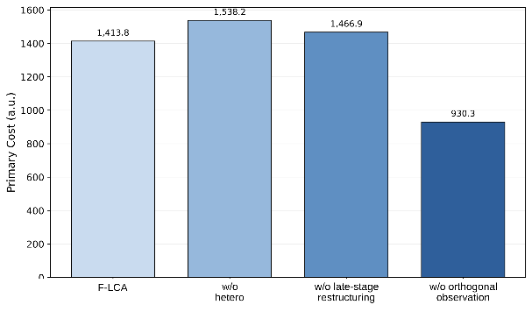  - Mean Primary Cost
Fig. S4. Ablation results for multi-view observation completeness.
Supplementary Algorithm S1.
Pseudocode of the late-stage cooperative restructuring mechanism.
Line | Operation
Input | Current vehicle-task sets A = {A1, A2, ..., Am}, route set P = {P1, P2, ..., Pm}, visiting-order set R = {R1, R2, ..., Rm}, multi-view observation poses Q, obstacle set O, battery levels E, current metric vector M, maximum search budget T, stagnation thresholds, and cooldown intervals.
Output | Restructured vehicle-task sets A*, routes P*, and visiting orders R*.
1 | Initialize A* ← A, P* ← P, and R* ← R.
2 | At each search iteration, evaluate total distance, obstacle penalty, energy-load ratio, primary cost, and reference total cost for all UGVs.
3 | If the energy-load gap or task-load gap exceeds the preset threshold, perform adaptive region correction.
3.1 | Select the UGV with the largest energy-load ratio as the donor vehicle and the UGV with the smallest energy-load ratio as the receiver vehicle.
3.2 | Rank candidate trees in the donor task set according to boundary distance, transfer cost, and local task complexity.
3.3 | Move a candidate boundary tree to the receiver only if the transfer preserves multi-view coverage and reduces load imbalance or path cost.
3.4 | Repair the updated task partition to avoid excessive task concentration in any vehicle.
4 | If the search stagnates and the boundary-exchange cooldown condition is satisfied, perform boundary exchange.
4.1 | Sort donor candidates by decreasing energy-load ratio and receiver candidates by increasing energy-load ratio.
4.2 | Select a boundary tree from the donor task set.
4.3 | Remove the selected tree from the donor visiting order and insert it into the receiver visiting order at the position with the lowest local route cost.
4.4 | Apply local visiting-order refinement to both donor and receiver routes.
4.5 | Recompute the primary cost, reference total cost, obstacle penalty, total distance, and energy range of the candidate solution.
4.6 | Accept the exchange if the candidate solution improves the layered evaluation criterion, or if it maintains the primary cost within the relaxation margin while reducing the energy-range indicator.
5 | If the layered-refinement trigger condition is satisfied, perform progressive refinement.
5.1 | Save the current task sets, routes, and visiting orders.
5.2 | Transfer selected boundary trees from overloaded vehicles to underloaded vehicles.
5.3 | Rebuild the affected UGV routes and refine their local visiting orders.
5.4 | Accept the refined solution if it improves the layered evaluation criterion or reduces the energy-range indicator under the primary-cost relaxation condition; otherwise, roll back to the saved solution.
6 | If long-term stagnation persists and a historical best solution is available, perform a ruin-and-recreate operation.
6.1 | Remove a short contiguous segment from the historical visiting order of a selected vehicle.
6.2 | Reinsert the removed trees into positions with lower local route cost.
6.3 | Apply local visiting-order refinement and accept the reconstructed solution only if it improves the current evaluation metric.
7 | Whenever a restructuring operation is accepted, update A*, P*, R*, and the best recorded metric vector.
8 | Repeat Steps 2–7 until the maximum search budget or termination condition is reached.
9 | Return A*, P*, and R*.
Note: The layered evaluation criterion prioritizes observation completeness, incomplete-tree ratio, energy feasibility, Primary Cost, Energy Range, and reference Total Cost in sequence. Therefore, the late-stage restructuring procedure improves route organization without relaxing the predefined multi-view observation requirement.
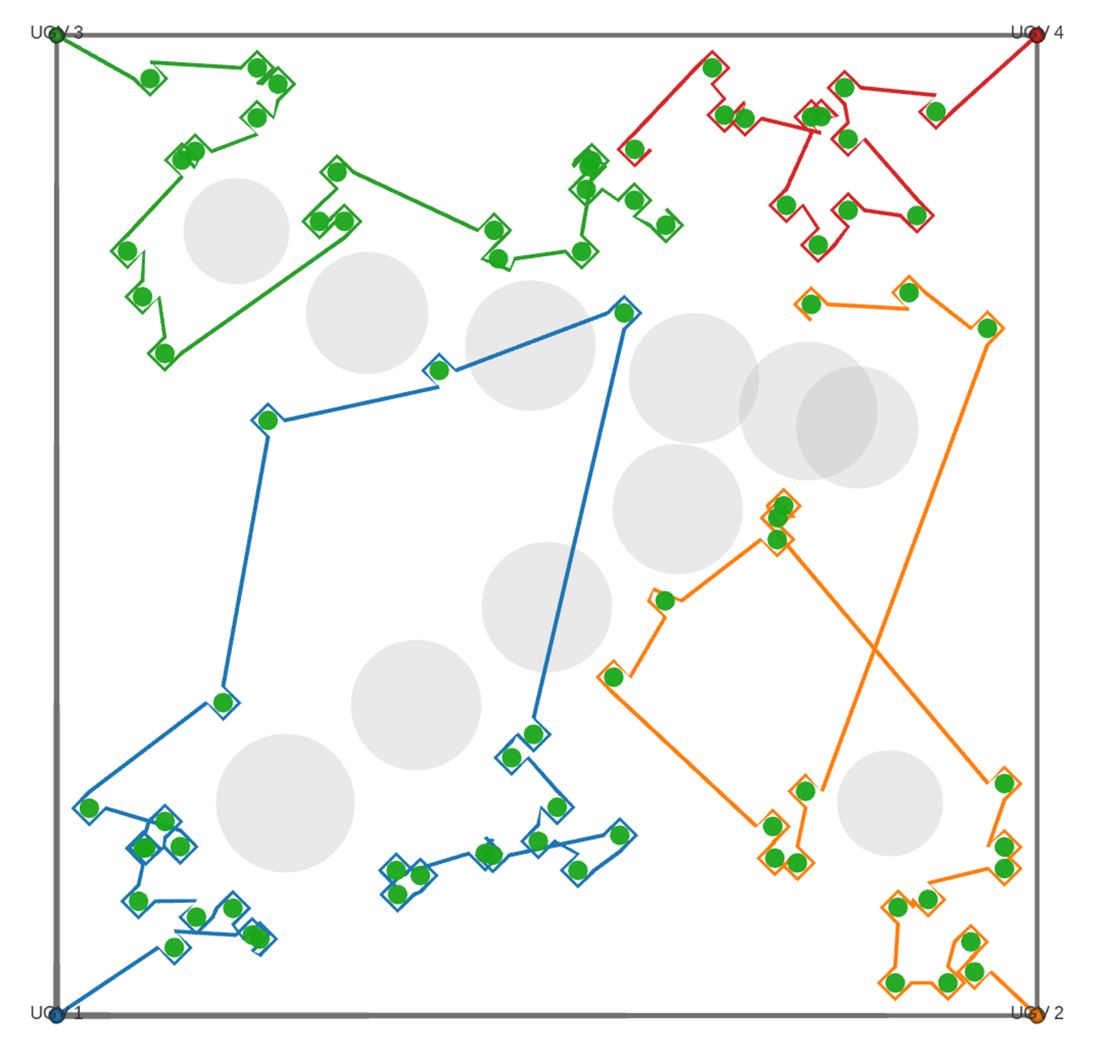
Fig. S5. ROS 2/RViz-based visualization of F-LCA offline cooperative observation routes.
Note: Routes with different colors correspond to different vehicles, and gray circular regions represent obstacles. This visualization illustrates ROS 2/RViz mapping of offline planned routes and does not represent closed-loop UGV field validation.
Definitions of execution-oriented proxy metrics
To characterize the execution friendliness of offline planned routes using a unified post-processing protocol, several proxy metrics were defined, including execution trajectory length, estimated execution time, minimum obstacle-entity clearance, minimum safety clearance, and turning-constraint violation ratio.
The smoothed execution trajectory of the k-th UGV is defined as:
 | $$P_{k}^{exe}=\left\{p_{k,1}^{exe},p_{k,2}^{exe},…,p_{k,n_{k}}^{exe}\right\}$$ | (S1)
The execution trajectory length of the k-th UGV is then defined as:
 | $$L_{k}^{exe}=\sum_{r=1}^{n_{k}-1}{{∥p_{k,r+1}^{exe}-p_{k,r}^{exe}∥}_{2}}$$ | (S2)
Given the average vehicle speed, dwell time at each observation point, and the number of actually visited observation viewpoints, the simplified estimated execution time is calculated as:
 | $$T_{k}^{exe}=\frac{L_{k}^{exe}}{\overset{‾}{v}}+n_{k}^{obs}t_{obs}$$ | (S3)
Given the center position, physical radius, and safety-boundary width of the j-th obstacle, the minimum obstacle-entity clearance and minimum safety clearance of the k-th UGV are defined as:
 | $$C_{k,min}^{safe}=\min_{p∈P_{k}^{exe}}\left(d_{obs}\left(p\right)-d_{safe}\right)$$ | (S4)
Furthermore, let the local equivalent turning radius be calculated from three consecutive trajectory points. When this radius is lower than the minimum turning-radius threshold, the corresponding segment is counted as a turning-constraint violation. The turning-constraint violation ratio is defined as:
 | $$V_{k}^{turn}=\frac{\sum_{q=2}^{n_{k}-1}{I}\left(R_{k,q} < R_{min}\right)}{n_{k}-2}×100\%$$ | (S5)
where $I(⋅)$ is the indicator function, which takes the value of 1 when the condition is satisfied and 0 otherwise. The Turn Violation Ratio / % reported in Table S4 represents the proportion of trajectory segments that violate the turning constraint, rather than the absolute number of violations. These execution-oriented proxy metrics were used only as supplementary evaluation metrics to characterize the potential of mapping offline planning results to execution-layer analysis using a unified post-processing protocol. They were not incorporated into the main optimization objective and were not used to determine the main performance ranking of the algorithms.
Table S4
Execution-oriented proxy assessment results using a unified post-processing protocol.
Algorithm | Execution Path Length / m | Estimated Execution Time / s | Minimum Obstacle Clearance / m | Minimum Safety Clearance / m | Turn Violation Ratio / %
F-LCA | 1433.84 ± 46.37 | 2752.30 ± 57.96 | 0.964 ± 0.120 | -0.536 ± 0.120 | 12.67 ± 2.18
SISR-VRP | 1554.04 ± 94.78 | 2902.55 ± 118.47 | 0.983 ± 0.078 | -0.517 ± 0.078 | 11.22 ± 2.15
ACO | 1877.20 ± 148.60 | 3306.51 ± 185.75 | 0.854 ± 0.556 | -0.646 ± 0.556 | 10.48 ± 1.56
Note: Results are reported as mean ± standard deviation over 20 repeated experiments with random seeds. Minimum Obstacle Clearance denotes the minimum clearance between the trajectory and the physical obstacle boundary, whereas Minimum Safety Clearance denotes the clearance margin relative to the predefined safety boundary. Because Minimum Safety Clearance is calculated relative to the safety boundary rather than the physical obstacle boundary, its value can be negative. A negative value indicates that the trajectory enters the predefined safety buffer, but it does not indicate collision with the physical obstacle entity. Turn Violation Ratio denotes the proportion of trajectory segments whose local turning radius is lower than the minimum allowable turning radius. F-LCA, SISR-VRP, and ACO were selected for this assessment to compare the proposed method, a strong VRP-oriented baseline, and a classical ant-colony path-planning baseline using the same post-processing protocol. This assessment does not constitute a complete execution-layer comparison of all baseline algorithms. It was used only to illustrate the potential of mapping offline planned routes to execution-layer analysis and was not used to determine the main performance ranking among the five algorithms.
Table S5a
Friedman test results.
Metric | Algorithms included | Number of paired instances | Friedman test result | Interpretation
Primary Cost | F-LCA, SISR-VRP, ACO, GA, PSO | 20 | p < 0.001 | Statistically significant overall difference among algorithms
Total Cost | F-LCA, SISR-VRP, ACO, GA, PSO | 20 | p < 0.001 | Statistically significant overall difference among algorithms
Total Distance | F-LCA, SISR-VRP, ACO, GA, PSO | 20 | p < 0.001 | Statistically significant overall difference among algorithms
Obstacle Penalty | F-LCA, SISR-VRP, ACO, GA, PSO | 20 | p < 0.001 | Statistically significant overall difference among algorithms
Energy Range | F-LCA, SISR-VRP, ACO, GA, PSO | 20 | p < 0.001 | Statistically significant overall difference among algorithms
Runtime | F-LCA, SISR-VRP, ACO, GA, PSO | 20 | p < 0.001 | Statistically significant overall difference among algorithms
Theoretical Coverage | F-LCA, SISR-VRP, ACO, GA, PSO | 20 | Not tested | All algorithms achieved 100.00 ± 0.00%
Effective Coverage | F-LCA, SISR-VRP, ACO, GA, PSO | 20 | Not tested | All algorithms achieved 100.00 ± 0.00%
Note: The Friedman test was conducted based on 20 matched random instances. Because all five algorithms achieved 100.00 ± 0.00% in both Theoretical Coverage and Effective Coverage, significance tests were not conducted for the coverage metrics.
Table S5b
Wilcoxon-Holm paired test results using F-LCA as the reference.
Metric | Pairwise comparison | Direction of difference | Wilcoxon test result after Holm correction | Interpretation
Primary Cost | F-LCA vs SISR-VRP | F-LCA lower | p < 0.001 | F-LCA achieved significantly lower Primary Cost than SISR-VRP
Primary Cost | F-LCA vs ACO | F-LCA lower | p < 0.001 | F-LCA achieved significantly lower Primary Cost than ACO
Primary Cost | F-LCA vs GA | F-LCA lower | p < 0.001 | F-LCA achieved significantly lower Primary Cost than GA
Primary Cost | F-LCA vs PSO | F-LCA lower | p < 0.001 | F-LCA achieved significantly lower Primary Cost than PSO
Total Distance | F-LCA vs SISR-VRP | F-LCA lower | p < 0.001 | F-LCA generates shorter cooperative observation paths than SISR-VRP
Total Distance | F-LCA vs ACO | F-LCA lower | p < 0.001 | F-LCA generates shorter paths than ACO
Total Distance | F-LCA vs GA | F-LCA lower | p < 0.001 | F-LCA generates shorter paths than GA
Total Distance | F-LCA vs PSO | F-LCA lower | p < 0.001 | F-LCA generates shorter paths than PSO
Obstacle Penalty | F-LCA vs SISR-VRP | SISR-VRP lower | p < 0.001 | SISR-VRP shows lower obstacle penalty than F-LCA
Obstacle Penalty | F-LCA vs ACO | F-LCA lower | p < 0.001 | F-LCA significantly reduces obstacle penalty compared with ACO
Obstacle Penalty | F-LCA vs GA | F-LCA lower | p < 0.001 | F-LCA significantly reduces obstacle penalty compared with GA
Obstacle Penalty | F-LCA vs PSO | F-LCA lower | p < 0.001 | F-LCA significantly reduces obstacle penalty compared with PSO
Energy Range | F-LCA vs SISR-VRP | SISR-VRP lower | p < 0.001 | SISR-VRP shows better load-balance indicator under this metric
Energy Range | F-LCA vs ACO | F-LCA lower | p < 0.001 | F-LCA shows lower energy range than ACO
Energy Range | F-LCA vs GA | GA lower | p < 0.001 | GA showed a lower Energy Range, but at the cost of substantially longer paths and higher obstacle penalties
Energy Range | F-LCA vs PSO | PSO lower | p < 0.001 | PSO showed a lower Energy Range, but at the cost of substantially longer paths and higher obstacle penalties
Runtime | F-LCA vs SISR-VRP | SISR-VRP lower | p < 0.001 | SISR-VRP has lower computational time
Runtime | F-LCA vs ACO | F-LCA lower | p < 0.001 | F-LCA is faster than ACO
Runtime | F-LCA vs GA | GA lower | p < 0.05 | GA has lower computational time
Runtime | F-LCA vs PSO | PSO lower | p < 0.05 | PSO has lower computational time
Note: The Wilcoxon signed-rank test was conducted using the 20 matched random instances as paired samples, and the Holm method was used for multiple-comparison correction. Primary Cost and Total Distance are the core metrics used in this study to evaluate route-organization quality under complete multi-view observation constraints. Obstacle Penalty, Energy Range, and Runtime are auxiliary metrics used to explain the trade-offs among obstacle cost, load balancing, and computational cost. SISR-VRP performed better in Obstacle Penalty, Energy Range, and Runtime, whereas F-LCA maintained advantages in Primary Cost and Total Distance. The complete Wilcoxon-Holm paired test results, including the Total Cost metric, are provided in the data repository as wilcoxon_holm_results.csv. This table lists the main pairwise comparison metrics discussed in the manuscript.
Overall, the statistical results show that F-LCA maintained advantages over SISR-VRP and the three classical baseline algorithms in the two core route-organization metrics, namely Primary Cost and Total Distance. Because all five algorithms achieved 100.00 ± 0.00% in both Theoretical Coverage and Effective Coverage, the coverage metrics were not further subjected to significance testing, but were treated as prerequisite conditions indicating whether the complete observation constraint was satisfied. Meanwhile, SISR-VRP performed better in Obstacle Penalty, Energy Range, and Runtime, indicating that its VRP-oriented route-restructuring strategy based on string removal and reinsertion has strong local connection optimization capability and computational efficiency. Therefore, the comparison between F-LCA and SISR-VRP should be interpreted as a trade-off between route compactness and local route-restructuring efficiency under complete multi-view observation constraints.
Table S6
Data and planning-result summary of the real-tree-location case.
Item | Value / Description
Source of tree locations | KML-exported citrus tree markers
Number of real tree locations | 43
Coordinate system before conversion | WGS84 longitude-latitude
Coordinate system after conversion | Local planar x-y coordinates
Planning region size | 62.43 m × 50.45 m
Number of UGVs | 4
Theoretical coverage | 100.00%
Effective coverage | 100.00%
Total path length | 588.88 m
Energy range | 5.91%
Output files | real_citrus_tree_points_xy.csv; real_orchard_best_path.json; real_orchard_case_metrics.csv
Note: This real-tree-location case was used to verify the compatibility of F-LCA with real spatial tree-location inputs and the feasibility of the workflow from KML tree-location points to local planar coordinates and then to cooperative observation route generation. This case was not used as an additional multi-algorithm statistical comparison experiment and does not constitute real closed-loop UGV deployment validation.
Fig. S6. KML-derived citrus tree centers in the local planning frame.
Note: The 43 citrus tree centers were extracted from KML annotations and converted from WGS84 longitude–latitude coordinates into local planar coordinates for the real tree-location planning case. The point span denotes the minimum bounding range of the extracted tree centers and is therefore different from the planning region size reported in Table S6.
Table S7
Performance comparison of the five algorithms under the unified environment.
Algorithm | Primary Cost | Total Cost | Total Distance / m | Theoretical Coverage / % | Effective Coverage / % | Obstacle Penalty | Energy Range / % | Runtime / s
F-LCA | 1413.76 ± 72.88 | 2466.33 ± 328.64 | 1334.18 ± 59.11 | 100.00 ± 0.00 | 100.00 ± 0.00 | 418.85 ± 192.70 | 14.27 ± 3.31 | 86.42 ± 1.23
SISR-VRP | 1535.19 ± 91.29 | 1818.11 ± 416.37 | 1487.43 ± 91.21 | 100.00 ± 0.00 | 100.00 ± 0.00 | 251.37 ± 124.76 | 3.49 ± 4.13 | 21.17 ± 4.42
ACO | 2024.11 ± 177.68 | 4137.78 ± 492.35 | 1754.35 ± 96.47 | 100.00 ± 0.00 | 100.00 ± 0.00 | 1419.75 ± 543.76 | 20.18 ± 6.05 | 433.48 ± 130.70
GA | 3771.39 ± 250.84 | 4064.03 ± 267.24 | 3330.73 ± 194.30 | 100.00 ± 0.00 | 100.00 ± 0.00 | 2319.27 ± 492.89 | 0.65 ± 0.17 | 62.53 ± 30.93
PSO | 6624.41 ± 396.82 | 7115.08 ± 424.58 | 5185.52 ± 254.46 | 100.00 ± 0.00 | 100.00 ± 0.00 | 7573.13 ± 1026.67 | 0.63 ± 0.37 | 75.75 ± 43.86
Note: Results are reported as mean ± standard deviation over 20 repeated experiments with random seeds.
Table S8
Ablation experiment results for key F-LCA mechanisms.
Algorithm | Primary Cost | Total Cost | Total Distance / m | Theoretical Coverage / % | Effective Coverage / % | Obstacle Penalty | Energy Range / % | Runtime / s
F-LCA | 1413.76 ± 72.88 | 2466.33 ± 328.64 | 1334.18 ± 59.11 | 100.00 ± 0.00 | 100.00 ± 0.00 | 418.85 ± 192.70 | 14.27 ± 3.31 | 86.42 ± 1.23
F-LCA w/o hetero | 1538.17 ± 85.76 | 2546.52 ± 392.45 | 1428.43 ± 57.04 | 100.00 ± 0.00 | 100.00 ± 0.00 | 577.61 ± 216.90 | 12.71 ± 3.92 | 73.09 ± 1.49
F-LCA w/o orthogonal observation | 930.29 ± 64.04 | 1561.02 ± 240.03 | 848.73 ± 45.09 | 100.00 ± 0.00 | 25.00 ± 0.00 | 429.26 ± 184.23 | 14.54 ± 3.62 | 49.46 ± 0.58
F-LCA w/o late-stage cooperative route refinement | 1466.86 ± 69.93 | 2948.72 ± 640.27 | 1380.56 ± 55.67 | 100.00 ± 0.00 | 100.00 ± 0.00 | 454.20 ± 189.36 | 18.53 ± 5.83 | 72.77 ± 1.25
Note: F-LCA w/o hetero, F-LCA w/o orthogonal observation, and F-LCA w/o late-stage cooperative route refinement denote the ablated variants in which the residual-energy-aware cooperative task allocation mechanism, orthogonal observation mechanism, and late-stage cooperative route refinement mechanism were removed, respectively. Because each tree was defined as a four-view observation unit, Effective Coverage can also be interpreted as the proportion of required observation viewpoints completed. Therefore, 100.00% Effective Coverage corresponds to all four required observation viewpoints being completed for each tree, whereas 25.00% Effective Coverage corresponds to approximately one of the four required viewpoints being visited per tree.
Parameter sensitivity analysis
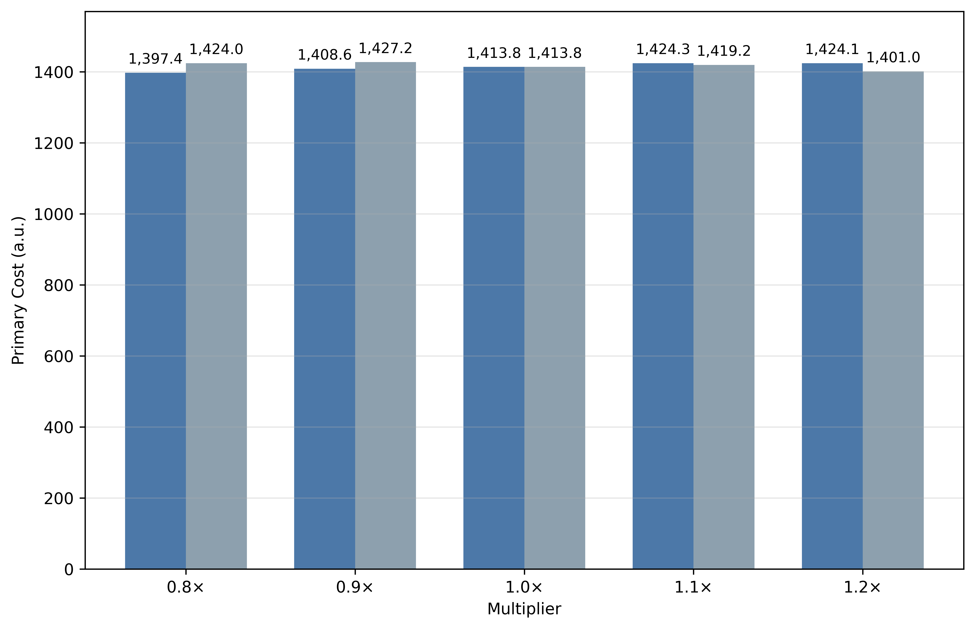 | 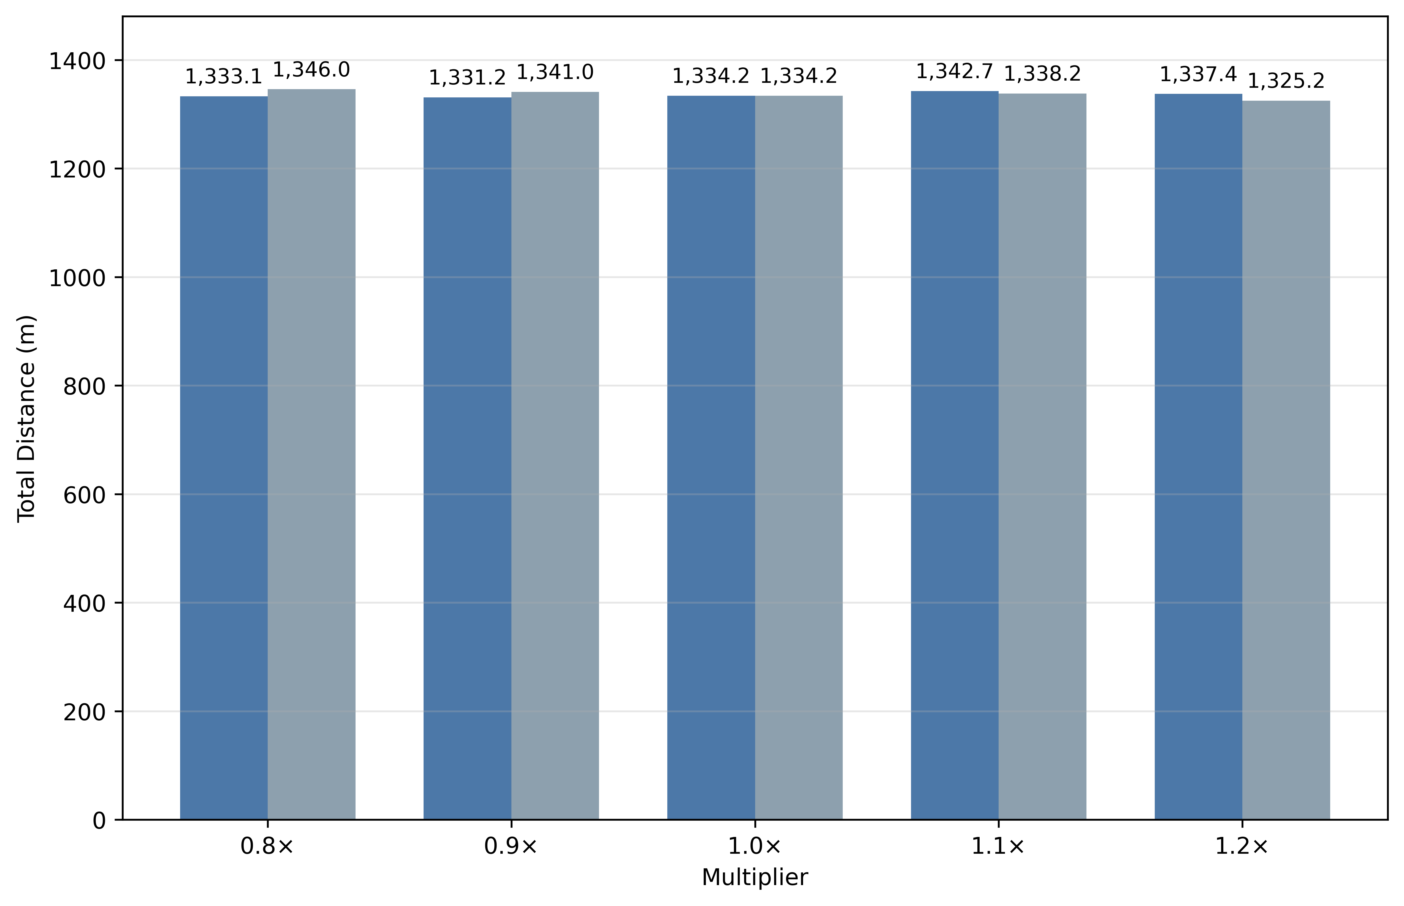
(a) | (b)
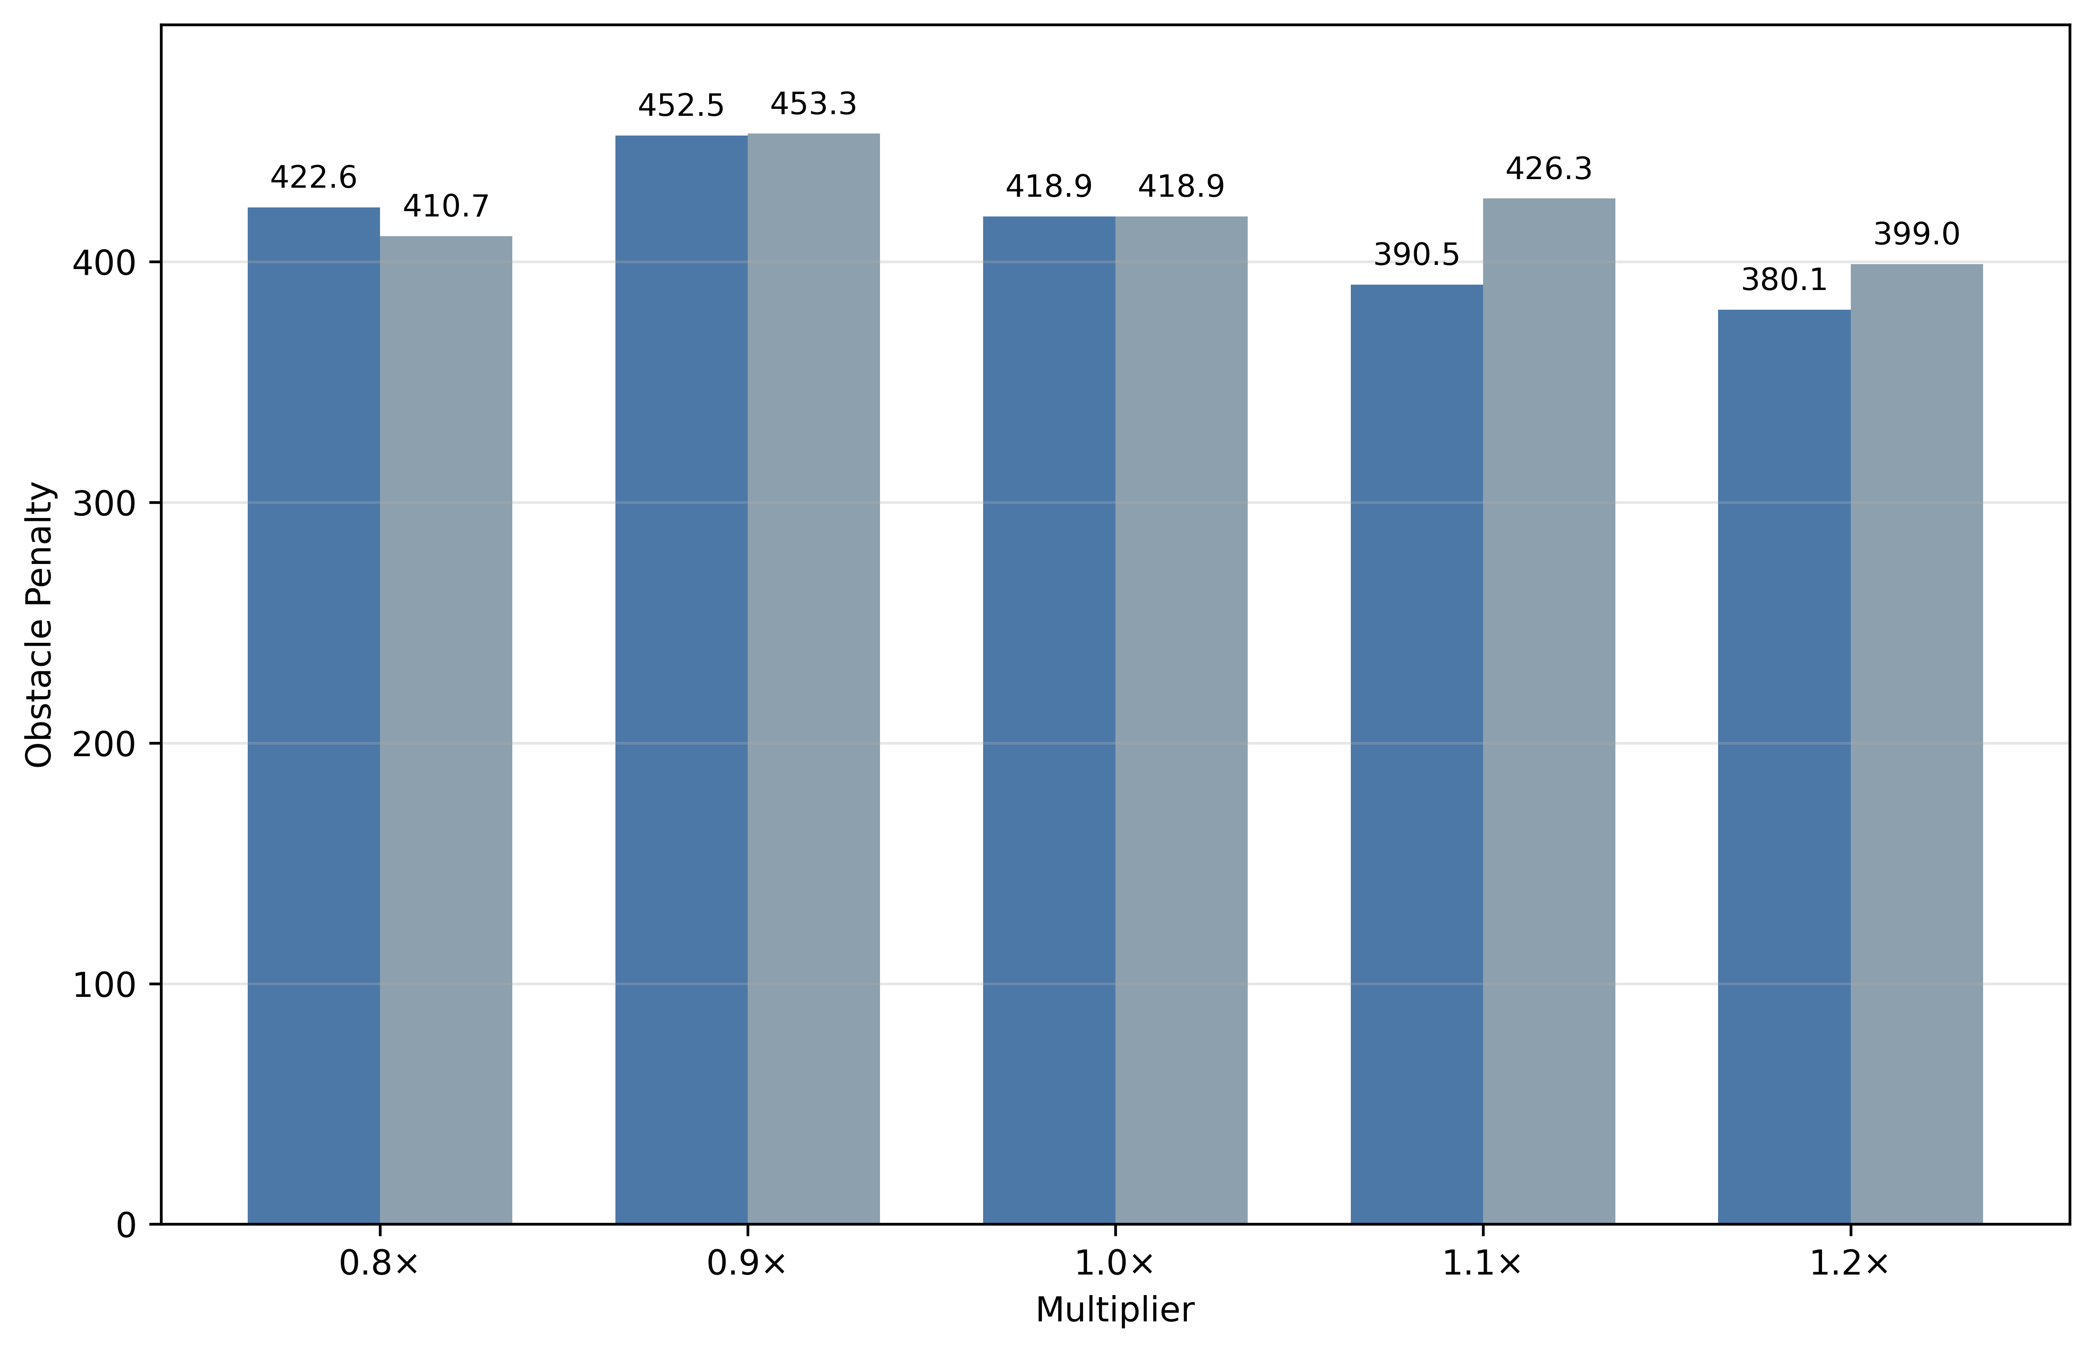
(c)
Fig. S7. Sensitivity analysis of F-LCA under key parameter perturbations.
Note: Panels (a)–(c) show Primary Cost, Total Distance, and Obstacle Penalty, respectively. Dark-blue and gray-blue bars denote λ_{o} and p_{bat} perturbations, respectively. Complete numerical results are provided in Table S9.
The results show that F-LCA maintained 100.00% Theoretical Coverage and Effective Coverage under ±20% perturbations of key parameters, indicating that the generated multi-view observation routes were stable under moderate parameter changes. Changes in the obstacle-penalty weight mainly affected the trade-off between obstacle risk and path compactness, whereas changes in the residual-energy-aware task allocation exponent mainly affected initial task-region organization and the distribution of path costs. In contrast, moderate changes in the path-balancing weight λ_{b} and the observation-completeness penalty multiplier λ_{c} did not change the final route structure. Specifically, λ_{b} mainly changed the contribution of the balancing term to Total Cost, whereas λ_{c} did not trigger additional coverage penalties once the complete observation constraint was already satisfied. The complete numerical summary is provided in Table S9.
Table S9
Sensitivity analysis results for key F-LCA parameters.
Parameter | Multiplier | Actual value |  | Primary Cost | Total Cost | Total Distance / m | Obstacle Penalty | Energy Range / %
λ_{o} | 0.8× | 0.152 | 1397.38 ± 69.09 |  | 2424.70 ± 354.46 | 1333.14 ± 56.87 | 422.60 ± 174.57 | 13.98 ± 3.64
λ_{o} | 0.9× | 0.171 | 1408.61 ± 54.79 |  | 2404.49 ± 163.87 | 1331.23 ± 45.36 | 452.51 ± 181.80 | 13.72 ± 2.26
λ_{o} | 1.0× | 0.190 | 1413.76 ± 72.88 |  | 2466.33 ± 328.64 | 1334.18 ± 59.11 | 418.85 ± 192.70 | 14.27 ± 3.31
λ_{o} | 1.1× | 0.209 | 1424.34 ± 69.23 |  | 2455.40 ± 282.18 | 1342.72 ± 54.65 | 390.51 ± 161.21 | 13.95 ± 3.07
λ_{o} | 1.2× | 0.228 | 1424.10 ± 69.51 |  | 2452.72 ± 243.60 | 1337.43 ± 56.84 | 380.13 ± 165.15 | 14.06 ± 2.70
p_{bat} | 0.8× | 0.680 | 1424.05 ± 58.82 |  | 2572.09 ± 292.81 | 1346.01 ± 57.75 | 410.74 ± 154.33 | 15.47 ± 2.75
p_{bat} | 0.9× | 0.765 | 1427.17 ± 75.34 |  | 2530.09 ± 306.79 | 1341.05 ± 54.66 | 453.27 ± 212.29 | 14.76 ± 3.22
p_{bat} | 1.0× | 0.850 | 1413.76 ± 72.88 |  | 2466.33 ± 328.64 | 1334.18 ± 59.11 | 418.85 ± 192.70 | 14.27 ± 3.31
p_{bat} | 1.1× | 0.935 | 1419.18 ± 53.70 |  | 2498.59 ± 290.31 | 1338.19 ± 39.39 | 426.30 ± 142.95 | 14.51 ± 3.28
p_{bat} | 1.2× | 1.020 | 1401.00 ± 70.59 |  | 2440.67 ± 275.53 | 1325.19 ± 63.13 | 399.01 ± 190.59 | 14.24 ± 3.39
λ_{b} | 0.8× | 0.544 | 1413.76 ± 72.88 |  | 2441.46 ± 327.67 | 1334.18 ± 59.11 | 418.85 ± 192.70 | 14.27 ± 3.31
λ_{b} | 0.9× | 0.612 | 1413.76 ± 72.88 |  | 2453.90 ± 328.15 | 1334.18 ± 59.11 | 418.85 ± 192.70 | 14.27 ± 3.31
λ_{b} | 1.0× | 0.680 | 1413.76 ± 72.88 |  | 2466.33 ± 328.64 | 1334.18 ± 59.11 | 418.85 ± 192.70 | 14.27 ± 3.31
λ_{b} | 1.1× | 0.748 | 1413.76 ± 72.88 |  | 2478.76 ± 329.13 | 1334.18 ± 59.11 | 418.85 ± 192.70 | 14.27 ± 3.31
λ_{b} | 1.2× | 0.816 | 1413.76 ± 72.88 |  | 2491.20 ± 329.62 | 1334.18 ± 59.11 | 418.85 ± 192.70 | 14.27 ± 3.31

Table S9
Continued.
Parameter | Multiplier | Actual value | Primary Cost | Total Cost | Total Distance / m | Obstacle Penalty | Energy Range / %
λ_{c} | 0.8× | 14.4 / 17.6 | 1413.76 ± 72.88 | 2466.33 ± 328.64 | 1334.18 ± 59.11 | 418.85 ± 192.70 | 14.27 ± 3.31
λ_{c} | 0.9× | 16.2 / 19.8 | 1413.76 ± 72.88 | 2466.33 ± 328.64 | 1334.18 ± 59.11 | 418.85 ± 192.70 | 14.27 ± 3.31
λ_{c} | 1.0× | 18.0 / 22.0 | 1413.76 ± 72.88 | 2466.33 ± 328.64 | 1334.18 ± 59.11 | 418.85 ± 192.70 | 14.27 ± 3.31
λ_{c} | 1.1× | 19.8 / 24.2 | 1413.76 ± 72.88 | 2466.33 ± 328.64 | 1334.18 ± 59.11 | 418.85 ± 192.70 | 14.27 ± 3.31
λ_{c} | 1.2× | 21.6 / 26.4 | 1413.76 ± 72.88 | 2466.33 ± 328.64 | 1334.18 ± 59.11 | 418.85 ± 192.70 | 14.27 ± 3.31
Note: Results are reported as mean ± standard deviation over 20 matched random instances. λ_{o} denotes the obstacle-penalty weight, λ_{b} denotes the path-balancing weight, p_{bat} denotes the residual-energy-aware task allocation exponent implemented as partition_battery_power, and λ_{c} denotes the observation-completeness penalty multiplier. For λ_{c}, the two values in the Actual value column denote the missing observation pose penalty and the incomplete tree penalty, respectively. Theoretical Coverage and Effective Coverage were 100.00 ± 0.00% under all parameter perturbation settings. The multiplier 1.0× indicates the baseline parameter setting used in the main experiment.

