
数据库实 验 报 告

姓 名： | 崔志颖
专 业 班 级： | 计算机科学与技术1405班
学 号： | 0902140203
指导教师： | 盛津芳
完成日期： | 2016/6/6

实验4：数据库设计

实验报告要求：
- 列出所有的SQL语句和源代码；
- 程序要求有适当的注释；
- 对数据完整性约束实施要求给出相应的测试用例。
- 实验报告提交电子档。

实验内容：
- 设计一个图书馆借阅管理数据库，此数据库中对每个借阅者保存记录，包括：读者号、姓名、地址、性别、年龄、单位等信息。对每本书保存有：编号、书号、书名、作者、价格、出版社等信息。对每个出版社保存有：出版社编号、名称、地址、简介等信息。对每个作者保存有：编号、名字、对每本被借出的书保存有读者号、借出日期、还书日期、逾期罚款等信息。
- 利用一种数据库设计工具（例如Powerdesigner,Erwin）画出ER图；
ER图如下图所示：
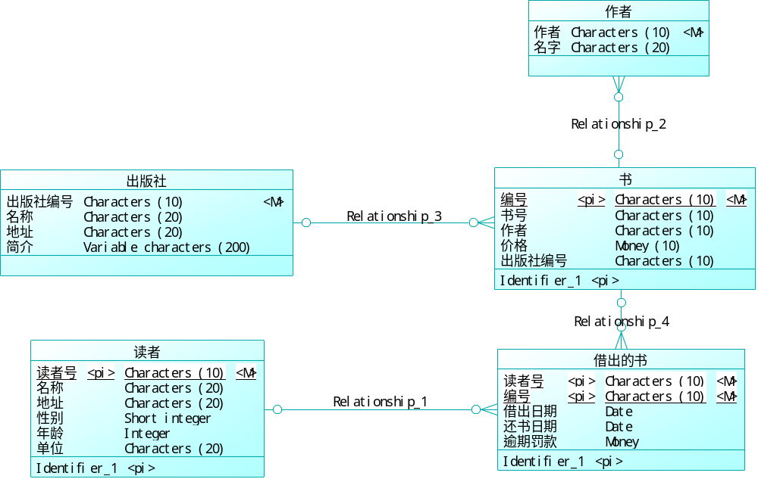

- 利用该设计工具生成相应的关系模型，并连接到SQL Server上，自动生成数据库；
按照要求进行转化，生成的数据库如下：
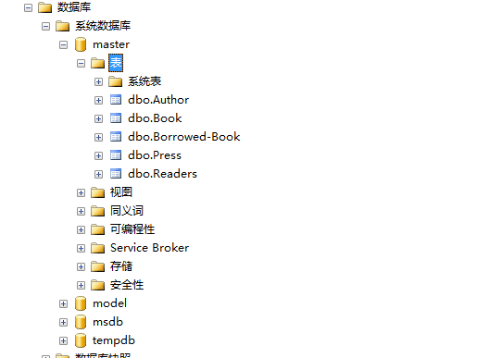
- 利用SQL语句向数据库中增加5条读者记录，10条书籍记录以及50条借阅记录。
插入5条读者记录：

insert Readers(ReaderNo,Name,Address,Sex,Age,Company) values('0001','adel','hunan',1,19,'csu')
insert Readers(ReaderNo,Name,Address,Sex,Age,Company) values('0002','bob','shanghai',0,21,'lenovo')
insert Readers(ReaderNo,Name,Address,Sex,Age,Company) values('0003','cindy','beijing',1,32,'baidu')
insert Readers(ReaderNo,Name,Address,Sex,Age,Company) values('0004','david','fujian',0,49,'tencent')
insert Readers(ReaderNo,Name,Address,Sex,Age,Company) values('0005','evil','浙江',0,26,'alibaba')

运行结果如下：
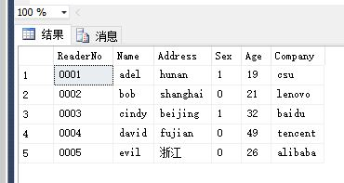
插入10条书籍记录：

insert Press(PressNo,PressName,Address,Intro) values('0001','huazhang press','beijing','computer book press')
insert Press(PressNo,PressName,Address,Intro) values('0002','jixie press','shanghai','art book press')
insert Press(PressNo,PressName,Address,Intro) values('0003','gongye press','guangzhou','novel book press')
insert Press(PressNo,PressName,Address,Intro) values('0004','shangwu press','shenzhen','dictionary book press')

insert Author(AuthorNo,Name) values('0001','jinyong')
insert Author(AuthorNo,Name) values('0002','gulong')
insert Author(AuthorNo,Name) values('0003','qiongyao')
insert Author(AuthorNo,Name) values('0004','knuth')
insert Author(AuthorNo,Name) values('0005','turing')
insert Author(AuthorNo,Name) values('0006','bethoven')
insert Author(AuthorNo,Name) values('0007','nobel')

insert Book(BookNo,BookCode,Price,PressNo,AuthorNo,BookName) values('0001','0001',39.88,'0001','0004','computer book')
insert Book(BookNo,BookCode,Price,PressNo,AuthorNo,BookName) values('0002','0001',39.88,'0001','0004','computer book')
insert Book(BookNo,BookCode,Price,PressNo,AuthorNo,BookName) values('0003','0002',19.88,'0002','0006','art book')
insert Book(BookNo,BookCode,Price,PressNo,AuthorNo,BookName) values('0004','0002',19.88,'0002','0006','art book')
insert Book(BookNo,BookCode,Price,PressNo,AuthorNo,BookName) values('0005','0002',19.88,'0002','0006','art book')
insert Book(BookNo,BookCode,Price,PressNo,AuthorNo,BookName) values('0006','0003',39.88,'0004','0001','music book')
insert Book(BookNo,BookCode,Price,PressNo,AuthorNo,BookName) values('0007','0004',29.88,'0003','0002','novel book')
insert Book(BookNo,BookCode,Price,PressNo,AuthorNo,BookName) values('0008','0005',15.88,'0002','0003','science book')
insert Book(BookNo,BookCode,Price,PressNo,AuthorNo,BookName) values('0009','0006',69.88,'0001','0005','java book')
insert Book(BookNo,BookCode,Price,PressNo,AuthorNo,BookName) values('0010','0006',69.88,'0001','0005','java book')
运行结果如下图所示：
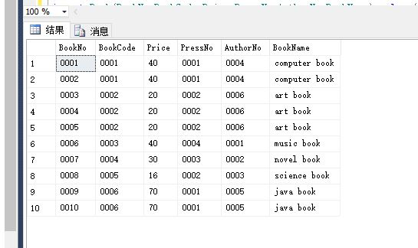
插入50条借阅记录的代码如下：

insert [Borrowed-Book](ReaderNo,BookNo,Borrowed_Date,Returned_Date,Penalty) values('0001','0001','2015-05-13','2015-08-30',80)
insert [Borrowed-Book](ReaderNo,BookNo,Borrowed_Date,Returned_Date,Penalty) values('0001','0002','2015-05-13','2015-08-30',80)
insert [Borrowed-Book](ReaderNo,BookNo,Borrowed_Date,Returned_Date,Penalty) values('0001','0003','2015-05-13','2015-08-30',80)
insert [Borrowed-Book](ReaderNo,BookNo,Borrowed_Date,Returned_Date,Penalty) values('0001','0004','2015-05-13','2015-08-30',80)
insert [Borrowed-Book](ReaderNo,BookNo,Borrowed_Date,Returned_Date,Penalty) values('0001','0005','2015-05-13','2015-08-30',80)
insert [Borrowed-Book](ReaderNo,BookNo,Borrowed_Date,Returned_Date,Penalty) values('0001','0006','2015-05-13','2015-08-30',80)
insert [Borrowed-Book](ReaderNo,BookNo,Borrowed_Date,Returned_Date,Penalty) values('0001','0007','2015-05-13','2015-08-30',80)
insert [Borrowed-Book](ReaderNo,BookNo,Borrowed_Date,Returned_Date,Penalty) values('0001','0008','2015-05-13','2015-08-30',80)
insert [Borrowed-Book](ReaderNo,BookNo,Borrowed_Date,Returned_Date,Penalty) values('0001','0009','2015-05-13','2015-08-30',80)
insert [Borrowed-Book](ReaderNo,BookNo,Borrowed_Date,Returned_Date,Penalty) values('0001','00010','2015-05-13','2015-08-30',80)
insert [Borrowed-Book](ReaderNo,BookNo,Borrowed_Date,Returned_Date,Penalty) values('0002','0001','2015-05-13','2015-08-30',80)
insert [Borrowed-Book](ReaderNo,BookNo,Borrowed_Date,Returned_Date,Penalty) values('0002','0002','2015-05-13','2015-08-30',80)
insert [Borrowed-Book](ReaderNo,BookNo,Borrowed_Date,Returned_Date,Penalty) values('0002','0003','2015-05-13','2015-08-30',80)
insert [Borrowed-Book](ReaderNo,BookNo,Borrowed_Date,Returned_Date,Penalty) values('0002','0004','2015-05-13','2015-08-30',80)
insert [Borrowed-Book](ReaderNo,BookNo,Borrowed_Date,Returned_Date,Penalty) values('0002','0005','2015-05-13','2015-08-30',80)
insert [Borrowed-Book](ReaderNo,BookNo,Borrowed_Date,Returned_Date,Penalty) values('0002','0006','2015-05-13','2015-08-30',80)
insert [Borrowed-Book](ReaderNo,BookNo,Borrowed_Date,Returned_Date,Penalty) values('0002','0007','2015-05-13','2015-08-30',80)
insert [Borrowed-Book](ReaderNo,BookNo,Borrowed_Date,Returned_Date,Penalty) values('0002','0008','2015-05-13','2015-08-30',80)
insert [Borrowed-Book](ReaderNo,BookNo,Borrowed_Date,Returned_Date,Penalty) values('0002','0009','2015-05-13','2015-08-30',80)
insert [Borrowed-Book](ReaderNo,BookNo,Borrowed_Date,Returned_Date,Penalty) values('0002','0010','2015-05-13','2015-08-30',80)
insert [Borrowed-Book](ReaderNo,BookNo,Borrowed_Date,Returned_Date,Penalty) values('0003','0001','2015-05-13','2015-08-30',80)
insert [Borrowed-Book](ReaderNo,BookNo,Borrowed_Date,Returned_Date,Penalty) values('0003','0002','2015-05-13','2015-08-30',80)
insert [Borrowed-Book](ReaderNo,BookNo,Borrowed_Date,Returned_Date,Penalty) values('0003','0003','2015-05-13','2015-08-30',80)
insert [Borrowed-Book](ReaderNo,BookNo,Borrowed_Date,Returned_Date,Penalty) values('0003','0004','2015-05-13','2015-08-30',80)
insert [Borrowed-Book](ReaderNo,BookNo,Borrowed_Date,Returned_Date,Penalty) values('0003','0005','2015-05-13','2015-08-30',80)
insert [Borrowed-Book](ReaderNo,BookNo,Borrowed_Date,Returned_Date,Penalty) values('0003','0006','2015-05-13','2015-08-30',80)
insert [Borrowed-Book](ReaderNo,BookNo,Borrowed_Date,Returned_Date,Penalty) values('0003','0007','2015-05-13','2015-08-30',80)
insert [Borrowed-Book](ReaderNo,BookNo,Borrowed_Date,Returned_Date,Penalty) values('0003','0008','2015-05-13','2015-08-30',80)
insert [Borrowed-Book](ReaderNo,BookNo,Borrowed_Date,Returned_Date,Penalty) values('0003','0009','2015-05-13','2015-08-30',80)
insert [Borrowed-Book](ReaderNo,BookNo,Borrowed_Date,Returned_Date,Penalty) values('0003','0010','2015-05-13','2015-08-30',80)
insert [Borrowed-Book](ReaderNo,BookNo,Borrowed_Date,Returned_Date,Penalty) values('0003','0001','2015-05-13','2015-08-30',80)

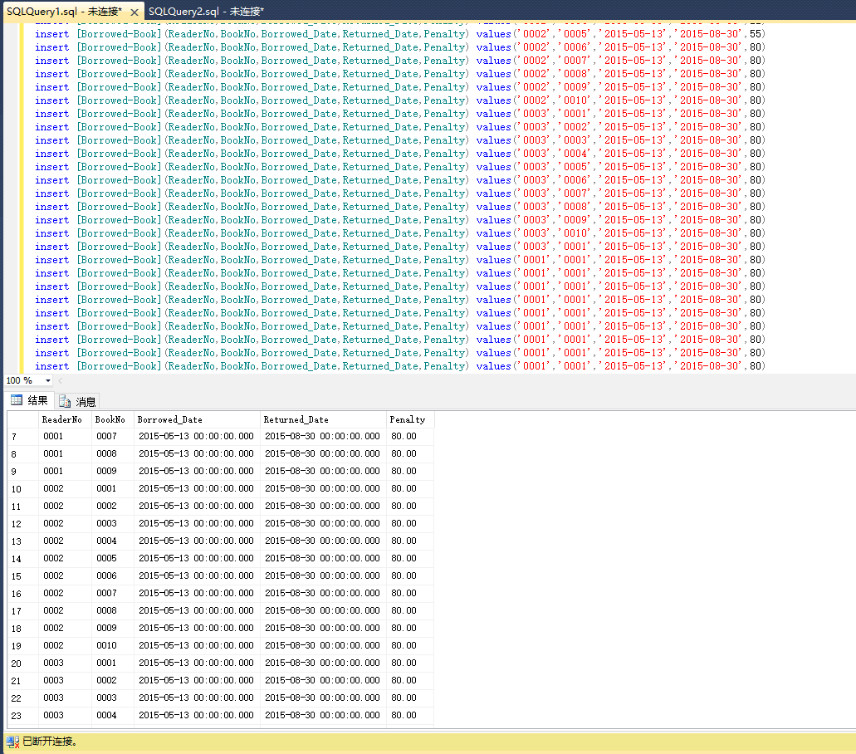

- 利用数据库设计工具的逆向工程功能，将GlobalToyz数据库的设计模型还原出来。
自动还原的数据模型如下图所示：
