实验任务书（实验四）

课程名称：数据库原理与技术

实验报告要求：
- 列出所有的SQL语句和源代码；
- 程序要求有适当的注释；
- 对数据完整性约束实施要求给出相应的测试用例。
- 实验报告提交电子档。

实验4：数据库设计

1、设计一个图书馆借阅管理数据库，此数据库中对每个借阅者保存记录，包括：读者号、姓名、地址、性别、年龄、单位等信息。对每本书保存有：编号、书号、书名、作者、价格、出版社等信息。对每个出版社保存有：出版社编号、名称、地址、简介等信息。对每个作者保存有：编号、名字、对每本被借出的书保存有读者号、借出日期、还书日期、逾期罚款等信息。
1）、利用一种数据库设计工具（例如Powerdesigner,Erwin）画出ER图；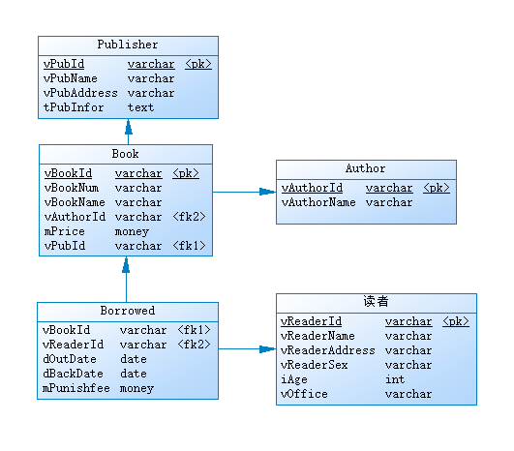
2）、利用该设计工具生成相应的关系模型，并连接到SQL Server上，自动生成数据库；
下图是生成数据库的关系结构图：
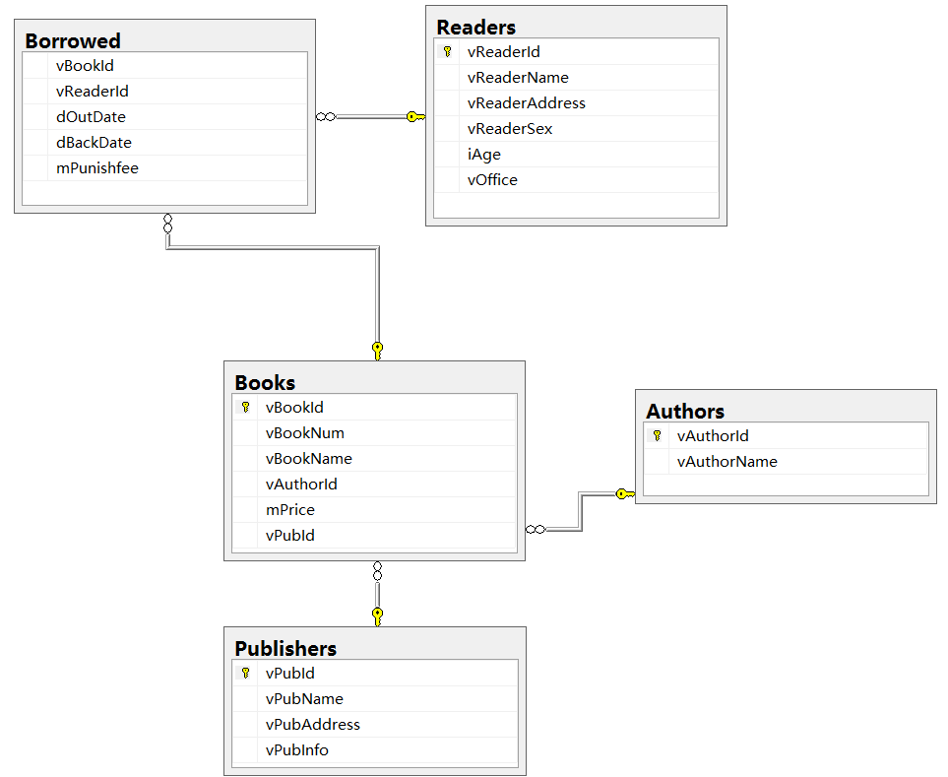
3）、利用SQL语句向数据库中增加5条读者记录，10条书籍记录以及50条借阅记录。
insert into Readers values('00001','Tom','28栋','男',20,'信息院')
insert into Readers values('00002','Jerry','29栋','男',21,'医学院')
insert into Readers values('00003','Lily','31栋','女',19,'医学院')
insert into Readers values('00004','Jack','25栋','男',20,'资生院')
insert into Readers values('00005','Cherry','20栋','女',20,'数学院')

insert into AUthors values('001','奥斯特洛夫斯基')
insert into authors values('002','罗贯中')
insert into AUthors values('003','曹雪芹')
insert into authors values('004','吴承恩')
insert into AUthors values('005','施耐庵')
insert into authors values('006','泰戈尔')
insert into AUthors values('007','安徒生')
insert into authors values('008','海明威')
insert into AUthors values('009','简.奥斯丁')

insert into publishers values('0001','人民教育出版社','北京市海淀区中关村南大街17号','www.pep.com.cn')
insert into publishers values('0002','新疆青少年出版社','乌鲁木齐市胜利路100号','新疆青少年出版社成立于1956年，是以出版维吾尔文、汉文、哈萨克文图书为主的综合性出版社')
insert into publishers values('0003','机械工业出版社','北京西城区百万庄大街22号','机械工业出版社是国内知名信息出版内容提供商')

insert into Books values('000001','01','钢铁是怎样炼成的','001',26.3,'0001')
insert into Books values('000002','01','三国演义','002',76.3,'0002')
insert into Books values('000003','01','红楼梦','003',86.4,'0003')
insert into Books values('000004','01','西游记','004',54.8,'0001')
insert into Books values('000005','01','水浒传','005',46.8,'0003')
insert into Books values('000006','01','泰戈尔诗选集','006',46.9,'0002')
insert into Books values('000007','01','飞鸟集','006',16.8,'0003')
insert into Books values('000008','01','安徒生童话','007',46.0,'0001')
insert into Books values('000009','01','老人与海','008',36.5,'0002')
insert into Books values('000010','01','傲慢与偏见','009',26.8,'0003')

insert into Borrowed values('000001','00001','09/10/2001','02/11/2002',0.0)
insert into Borrowed values('000002','00002','11/10/2001','02/02/2002',5.0)
insert into Borrowed values('000005','00001','12/10/2001','02/12/2002',3.0)
insert into Borrowed values('000002','00001','12/09/2001','02/11/2002',1.0)
insert into Borrowed values('000005','00001','12/10/2001','02/11/2002',0.0)
insert into Borrowed values('000002','00001','11/10/2001','02/01/2002',4.1)
insert into Borrowed values('000007','00001','11/10/2001','02/11/2002',0.0)
insert into Borrowed values('000008','00001','10/31/2001','02/11/2002',0.0)
insert into Borrowed values('000009','00002','10/21/2001','02/11/2002',0.0)
insert into Borrowed values('000002','00002','10/13/2001','02/11/2002',0.0)
insert into Borrowed values('000003','00002','10/24/2001','02/01/2002',3.0)
insert into Borrowed values('000005','00002','10/25/2001','02/11/2002',0.0)
insert into Borrowed values('000001','00002','10/26/2001','02/11/2002',0.0)
insert into Borrowed values('000006','00002','10/02/2001','02/11/2002',0.0)
insert into Borrowed values('000004','00002','10/01/2001','02/01/2002',4.0)
insert into Borrowed values('000001','00002','10/04/2001','02/11/2002',0.0)
insert into Borrowed values('000006','00002','10/06/2001','02/11/2002',0.0)
insert into Borrowed values('000009','00003','10/09/2001','02/11/2002',0.0)
insert into Borrowed values('000002','00004','10/15/2001','02/11/2002',0.0)
insert into Borrowed values('000003','00003','10/18/2001','02/12/2002',2.0)
insert into Borrowed values('000001','00003','10/31/2001','02/11/2002',0.0)
insert into Borrowed values('000004','00003','10/28/2001','02/11/2002',0.0)
insert into Borrowed values('000005','00003','10/24/2001','02/12/2002',3.0)
insert into Borrowed values('000006','00003','10/26/2001','02/11/2002',0.0)
insert into Borrowed values('000007','00002','10/17/2001','02/11/2002',0.0)
insert into Borrowed values('000008','00004','10/28/2001','02/11/2002',0.0)
insert into Borrowed values('000010','00001','10/21/2001','02/11/2002',0.0)
insert into Borrowed values('000002','00005','10/20/2001','02/01/2002',4.0)
insert into Borrowed values('000009','00003','10/19/2001','02/11/2002',0.0)
insert into Borrowed values('000001','00004','10/29/2001','02/11/2002',0.0)
insert into Borrowed values('000002','00005','10/18/2001','02/11/2002',0.0)
insert into Borrowed values('000003','00005','10/23/2001','02/11/2002',0.0)
insert into Borrowed values('000004','00005','10/02/2001','02/12/2002',1.0)
insert into Borrowed values('000010','00005','10/01/2001','02/11/2002',0.0)
insert into Borrowed values('000005','00001','10/21/2001','02/11/2002',0.0)
insert into Borrowed values('000006','00005','10/29/2001','02/11/2002',0.0)
insert into Borrowed values('000009','00005','10/20/2001','02/12/2002',2.0)
insert into Borrowed values('000008','00004','10/15/2001','02/11/2002',0.0)
insert into Borrowed values('000010','00004','10/19/2001','02/11/2002',0.0)
insert into Borrowed values('000001','00004','10/20/2001','02/11/2002',0.0)
insert into Borrowed values('000002','00004','10/18/2001','02/11/2002',0.0)
insert into Borrowed values('000003','00004','10/17/2001','02/11/2002',3.0)
insert into Borrowed values('000004','00004','10/19/2001','02/11/2002',0.0)
insert into Borrowed values('000005','00001','10/31/2001','02/11/2002',0.0)
insert into Borrowed values('000007','00004','10/31/2001','02/11/2002',0.0)
insert into Borrowed values('000008','00004','10/31/2001','02/12/2002',1.0)
insert into Borrowed values('000009','00003','10/31/2001','02/11/2002',0.0)
insert into Borrowed values('000010','00004','10/31/2001','02/11/2002',0.0)
insert into Borrowed values('000001','00004','10/31/2001','02/11/2002',0.0)
insert into Borrowed values('000002','00003','10/31/2001','02/12/2002',1.0)

2、利用数据库设计工具的逆向工程功能，将GlobalToyz数据库的设计模型还原出来。
