数据库原理实验一实验报告

**一**：创建表和实施数据完整性

1. 运行给定的SQL Script，建立数据库GlobalToyz。

执行实验所给的建库语句建立数据库GlobalToyz如下：

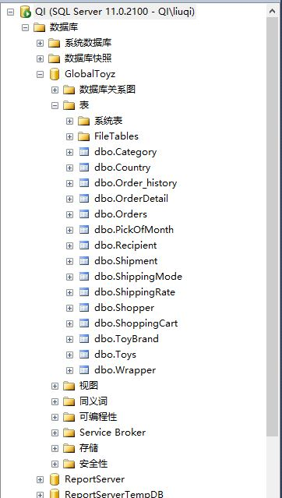

1. 了解表的结构。
2. 利用系统预定义的存储过程sp_helpdb查看数据库的相关信息，例如所有者、大小、创建日期等。

执行

exec sp_helpdb

go

结果如下：

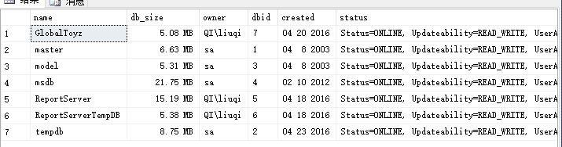

1. 利用系统预定义的存储过程sp_helpconstraint查看表中出现的约束（包括Primary key, Foreign key, check constraint, default, unique）

执行下列语句

use GlobalToyz

go

exec sp_helpconstraint 'dbo.Category', 'Primary key'

go

exec sp_helpconstraint 'dbo.Category', 'Foreign key'

go

exec sp_helpconstraint 'dbo.Category', 'Check constriant'

go

exec sp_helpconstraint 'dbo.Category', 'unique'

go

exec sp_helpconstraint 'dbo.Category', 'default'

go

结果如下：

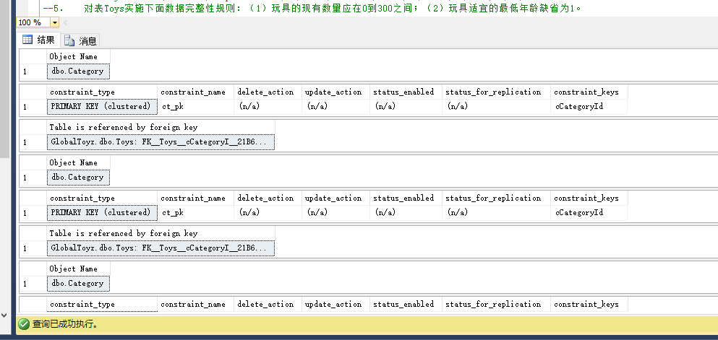

1. 对表Toys实施下面数据完整性规则：（1）玩具的现有数量应在0到300之间；（2）玩具适宜的最低年龄缺省为1。

执行：

add constraint Toys_currentNumber check(siToyQoh between 0 and 300);

alter table Toys

add constraint Toys_lowerAge Default (1) for siLowerAge

--test测试用例

insert into Toys values('000033','Supermanhaha','','','100.00','','','400','','12','','')

insert into Toys values('000033','Supermanhaha','','001','100.00','001','','200','','12','','')

结果如下：

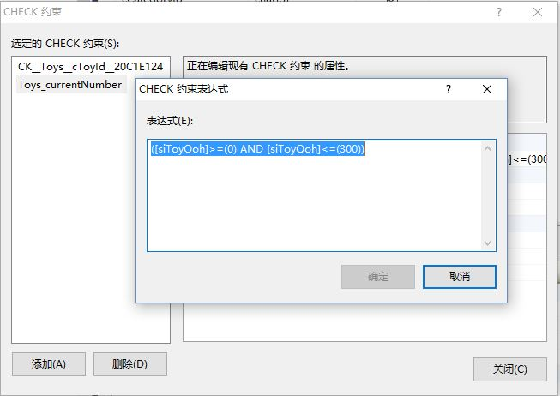

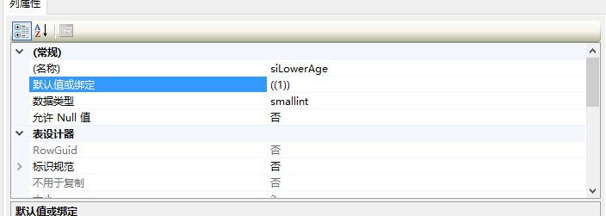

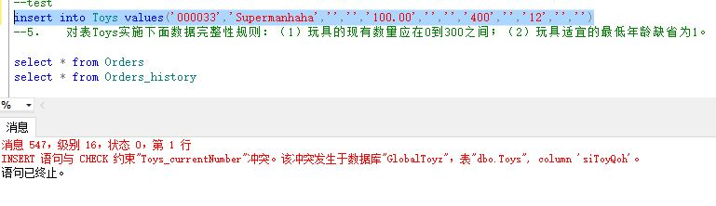

1. 向表Orders中增加10条2016年1月的订单记录（注意Orders表与其它表的关联）。
2. 创建一张表Orders_history，表的结构与Orders相同，将Orders表中2001年5月的订单记录复制到表Orders_history中。

执行：

Create Table Orders_history

(

cOrderNo char(6) constraint COH_PK Primary key,

dOrderDate datetime not null,

cCartId char(6) not null,

cShopperId char(6) not null references Shopper(cShopperId),

cShippingModeId char(2) null references ShippingMode(cModeId),

mShippingCharges money null,

mGiftWrapCharges money null,

cOrderProcessed char null ,

mTotalCost money null,

dExpDelDate DateTime null

)

use GlobalToyz

go

insert into Orders_history select * from Orders where dOrderDate like “2001-05%”

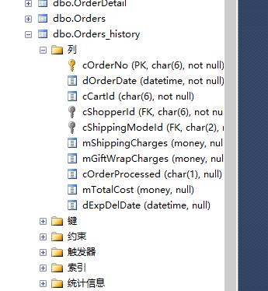

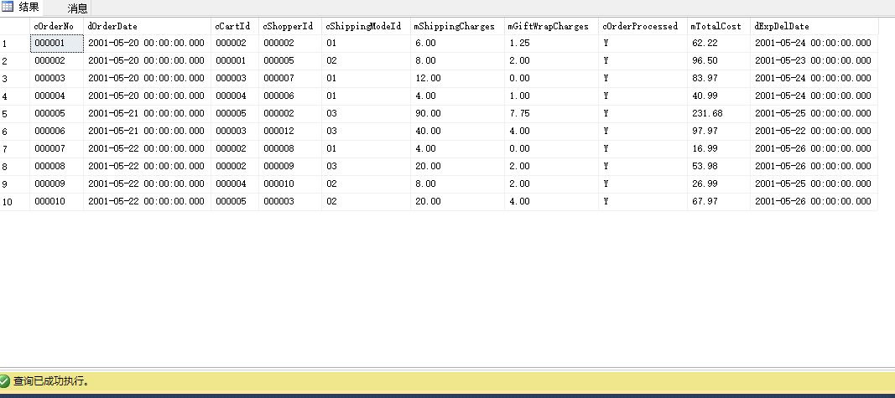

二：查询、更新数据库

1. 显示属于California和Illinois州的顾客的名、姓和emailID。

执行

select vFirstName,vLastName,vEmailId from Shopper where cState='California' or cState='Illinois'

结果如下：

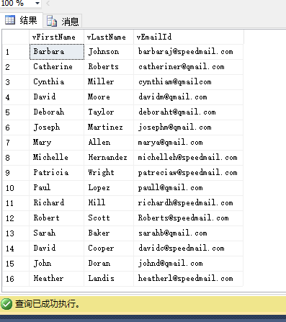

1. 显示定单号码、顾客ID，定单的总价值，并以定单的总价值的升序排列。

执行

select cOrderNo,cShopperId,mTotalCost from Orders order by mTotalCost

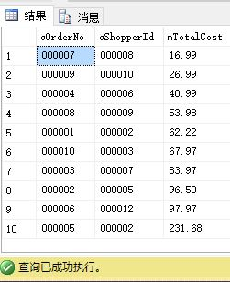

1. 显示在orderDetail表中vMessage为空值的行。

select * from OrderDetail where vMessage is NULL

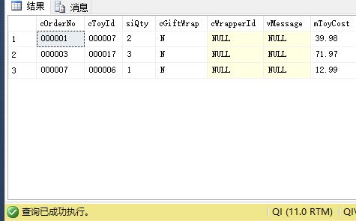

1. 显示玩具名字中有“Racer”字样的所有玩具的基本资料。

select * from Toys where vToyName like '%Racer%'

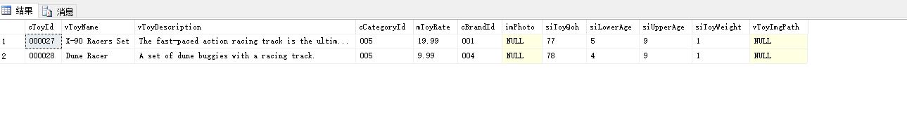

1. 列出表PickofMonth中的所有记录，并显示中文列标题。

select p.cToyId as 玩具id,siMonth as 月份,p.iYear as 年份,p.iTotalSold as 销量 from PickOfMonth as p

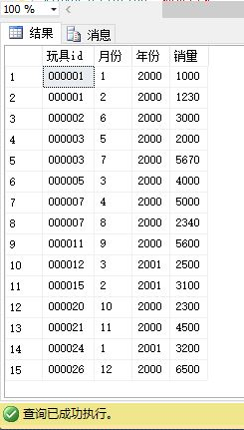

1. 根据2000年的玩具销售总数，显示“Pick of the Month”玩具的前五名玩具的ID。

select top 5 cToyid from PickOfMonth where iYear='2000' order by iTotalSold desc

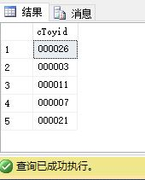

1. 根据OrderDetail表，显示玩具总价值大于￥50的定单的号码和玩具总价值。

select distinct cOrderNo, sum(mToyCost)as sumprice from OrderDetail group by cOrderNo having sum(mToyCost)>50

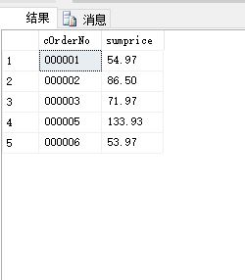

1. 显示一份包含所有装运信息的报表，包括：Order Number, Shipment Date, Actual Delivery Date, Days in Transit. (提示：Days in Transit = Actual Delivery Date – Shipment Date)

select cOrderNo as 'Order Number',dShipmentDate as 'Shipment Date',dActualDeliveryDate as 'Actual Delivery Date',dActualDeliveryDate-dShipmentDate as 'Days in Transit' from Shipment

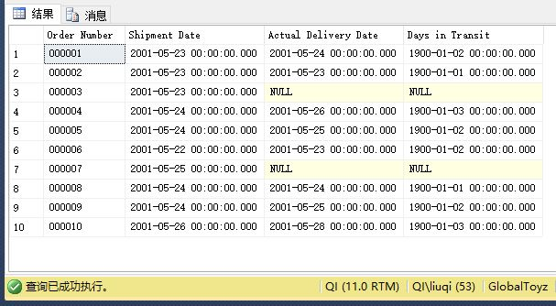

1. 显示所有玩具的名称、商标和种类（Toy Name, Brand, Category）。

select t.vToyName,b.cBrandName,c.cCategory from Toys t join ToyBrand b on t.cBrandId=b.cBrandId join Category c on t.cCategoryId=c.cCategoryId

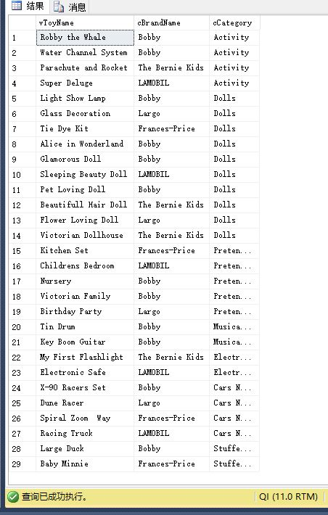

1. 以下列格式显示所有购物者的名字和他们的简称：（Initials, vFirstName, vLastName）,例如Angela Smith的Initials为A.S。

select left((select vFirstName from Shopper s2 where s1.vFirstName=s2.vFirstName and s1.vLastName=s2.vLastName ),1)+'.'+left((select vLastName from Shopper s2 where s1.vLastName=s2.vLastName and s1.vFirstName=s2.vFirstName),1) as Initials,s1.vFirstName,s1.vLastName from Shopper s1

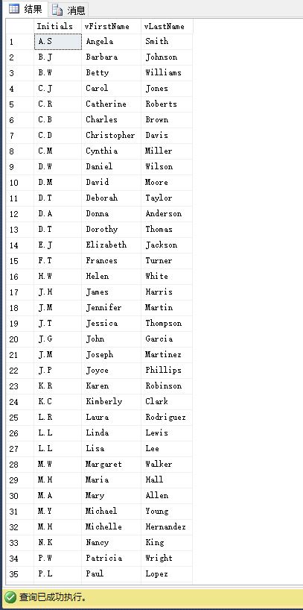

1. 显示所有玩具的平均价格，并舍入到整数。

select round(avg(mToyRate),0) as ToysAvePrice from Toys

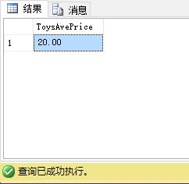

1. 显示所有购买者和收货人的名、姓、地址和所在城市，要求显示结果中的重复记录。

select s.vFirstName,s.vLastName,r.vAddress,r.vLastName,r.cCity from Orders o join Shopper s on o.cShopperId=s.cShopperId join Recipient r on o.cOrderNo=r.cOrderNo

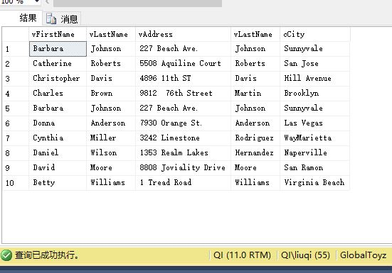

1. 显示没有包装的所有玩具的名称。（要求用子查询实现）

select cToyId,vToyName from Toys where cToyId not in(select cToyId from OrderDetail o join Wrapper w on o.cWrapperId=w.cWrapperId)

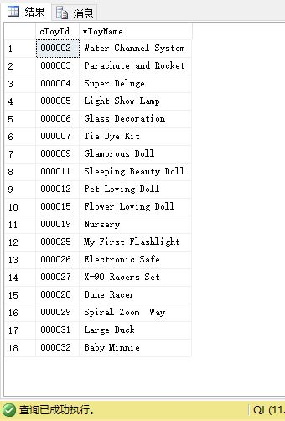

1. 显示已收货定单的定单号码以及下定单的时间。（要求用子查询实现）

select cOrderNo,dOrderDate from Orders where cOrderNo in (select cOrderNo from Shipment where cDeliveryStatus='d')

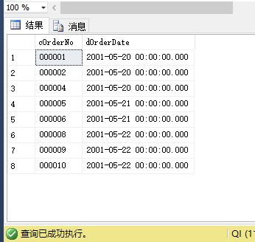

1. 显示一份基于Orderdetail的报表，包括cOrderNo,cToyId和mToyCost，记录以cOrderNo升序排列，并计算每一笔定单的玩具总价值。

select o1.cOrderNo,o1.cToyid,o1.mToyCost,o2.sumprice from(select cOrderNo,cToyId,mToyCost from OrderDetail ) o1 join (select cOrderNo,sum(mToyCost) as sumprice from OrderDetail group by cOrderNo) o2 on o1.cOrderNo=o2.cOrderNo

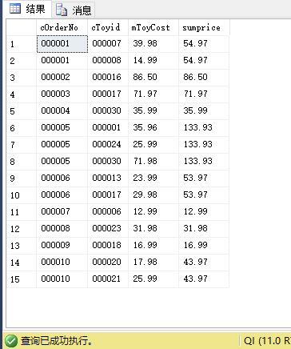

1. 给id为‘000001’玩具的价格增加$1。

update Toys

set mToyRate=mToyRate-1

where cToyId='000001'

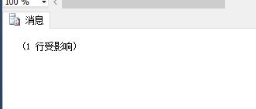

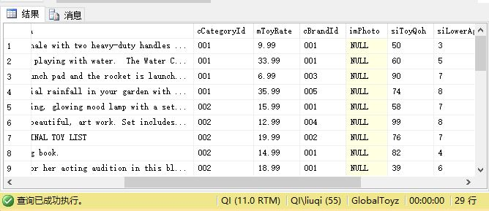

1. 删除“Largo”牌的所有玩具。

delete from ShoppingCart where cToyId in(select cToyId from Toys where cBrandId in (select cBrandId from ToyBrand where cBrandName='Largo'))

delete from OrderDetail where cToyId in(select cToyId from Toys where cBrandId in (select cBrandId from ToyBrand where cBrandName='Largo'))

delete from PickOfMonth where cToyId in(select cToyId from Toys where cBrandId in (select cBrandId from ToyBrand where cBrandName='Largo'))

delete from Toys where cBrandId in (select cBrandId from ToyBrand where cBrandName='Largo')

select * from Toys where cBrandId in (select cBrandId from ToyBrand where cBrandName='Largo')

